Mandatory Case | 
CMandatory
Periode Berlaku Semester Ganjil 2015/2016  Valid on Odd Year 2015/2016 | Software Laboratory Center  Assistant Recruitment 16-1

Soal
Case

Adu Pingatan

Adu Pingatan is a game that build by a programmer in 1996, this game is so popular and has reached over one million subscriber. As the time passes, the programmer no longer maintain this program anymore because of his age. This game is about memory game, how you can find a symbol and memorize its coordinate to find the other matching symbol. Every symbol has their own couple. This game consists of 3 maps, the higher map that you choose, more couples of symbol that you must find and the more score that you can reach. This year, the owner of this game wants to maintain this game again. You, as a programmer are asked to build this program to pull new interest from public gamers.
Here are the requirements of this game :
- When the program start, it will display a splash screen.

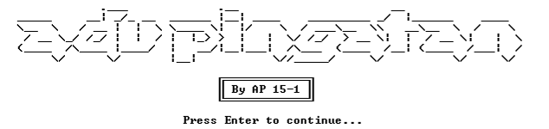

- Then the program will ask player to input:
- Name, validate the name length must between 5 and 20. Otherwise, the program will show message “Name length must between 5 and 20 and ask to input name again
- Gender, validate the gender must be Male or Female. Otherwise, the program will show message “Gender must be Male of Female!” and ask to input gender again

- After that, program will read “highscore.txt” to get top players in this game. Then the data will be stored in array. Then the program will display all the player’s data and 4 menus that consists of :
- Play game
- Show top Player
- How to play
- Exit
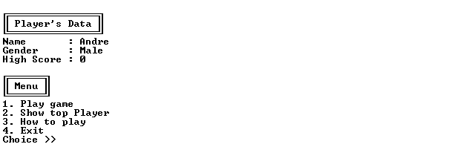

- If the player chooses menu 1 (“Play game”) then:
- The program will ask the player to choose the map level :
- Map 1 -> 4x4
- Map 2 -> 6x6
- Map 3 -> 8x8
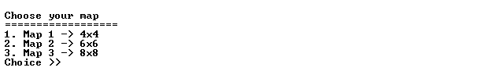
- If the player chooses one of the menu above, then:
- Display the player’s data
- Generate the map with size based on the menu
- Ask the player to input the x and y coordinate, validate the player cannot input the coordinates of the empty place and larger than the size of the map, then display the symbol on the selected coordinate in the map
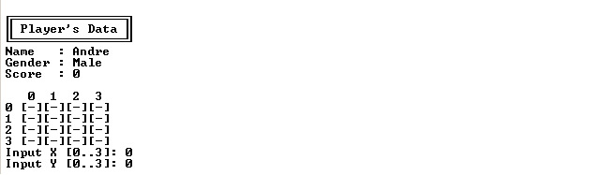
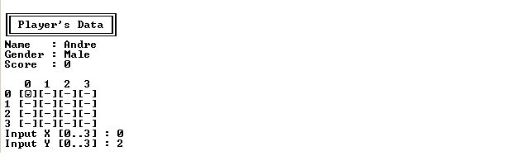
- If the symbol is match, then display “Find success !!! Your score added by 100”. Player score will be added by 100. Otherwise, display “Find Failed !!!”. Then the program will remove all of the symbol that has been shown, then ask to input the coordinate again and the player won’t get any score
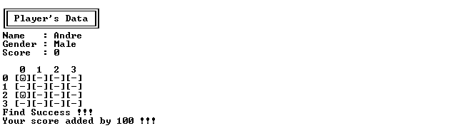
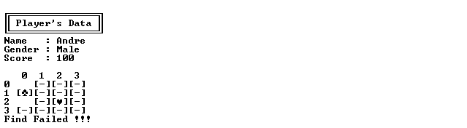
- If all the symbol has been found, then the program will display “Congratulation !! You completed map x !!”. Then the program will go back to main menu
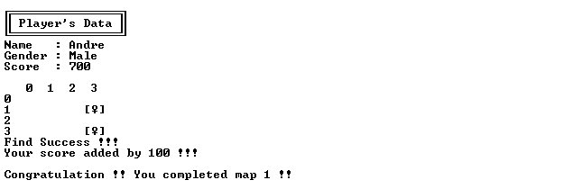
- If the player chooses menu 2 (“Show top Player”) then:
- Display all player’s data in “highscore.txt” which has been sorted descending by highscores
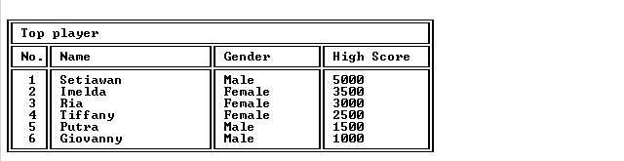
- If the player chooses menu 3 (“How to play”) then:
- Display the manual of the game
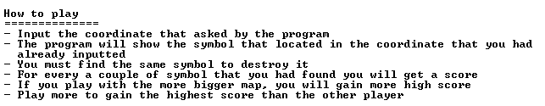
- If the player chooses menu 4 (“Exit”) then:
- The program will write the updated data to “highscore.txt”
- Display splash screen
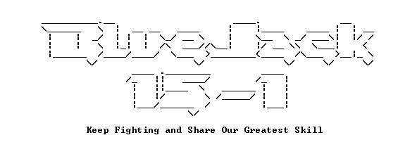

Please run the EXE file to see the sample program.

