Onsite Case | 
DSH1
Periode Berlaku Semester Ganjil 2015/2016  Valid on Odd Year 2015/2016 | Software Laboratory Center  Assistant Recruitment 16-1

Materi
Material
- Deklarasi Struct
- Penggunaan Struct
- Single Linked List
- Pointer of struct
- Malloc
- Free operator
- Push depan, belakang dan tengah
- Pop depan, belakang, tengah dan all

Soal
Case

Bluejack Playlist
Bluejack Playlist is a music player application. The program can save the song list from the user and play it. You as a programmer are asked to create this application using single linked list.
First, the program will show the menus:
- Insert song
- Play song
- Exit
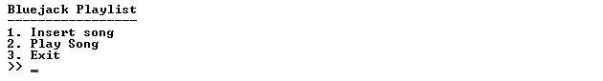
- Insert Song (Menu 1)
- Ask the user to input the song title, artist, album, genre, and published date with the following condition:
  - Validate song title’s length must between 5 and 20 characters.
  - Validate the first letter of artist must be uppercase.
  - Validate album consists of minimum two words.
  - Validate genre must be “Pop”, “Rock”, “Jazz”, or “Blues”.
  - Validate date must be exactly 10 characters with format “dd-mm-yyyy”, where “dd”, “mm”, “yyyy” is numeric. Validate range of date exactly same as the calendar (e.g. 31-04-2015 is forbidden).
  - If the month is 2, validate the day between 1 and 29 when it is leap year, otherwise validate day between 1 and 28.
- After that, the program will sort by the song title ascendingly.
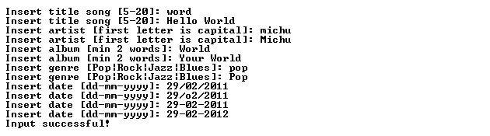
- Play Song (Menu 2)
- If there is no song registered, program will notify the user that his playlist is empty.
- Otherwise, show the available songs.

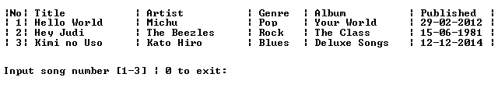
- Then, the program will ask user to input the number song he wants to play.
  - If the user chooses ‘0’, the program will be back to the main menu.
  - Otherwise, delete the chosen song. Validate user can choose between 1 and the amount of the song.

- Exit
- The program will show credits and close itself.

Please run the EXE file to see the sample program.

