Onsite Case | 
DSH2
Periode Berlaku Semester Odd 2015/2016  Valid on Odd Year 2015/2016 | Software Laboratory Center  Assistant Recruitment 16-1

Materi
Material
- Push Head
- Push Tail
- Push Middle
- Pop Head
- Pop Tail
- Pop Middle

Soal
Case

Bali Marathon 2016
Bali Marathon 2016 is an annual road race event held in Bali. The race will feature a combination of flat road and rolling hills. Runners will experience Balinese natural life and traditional art performance along the course. As a programmer, you are asked to create a program for participant registration with following description :
- First program will show splash screen

- The main menus are :
  - View Participant
  - Register Participant
  - Remove Participant
  - Exit
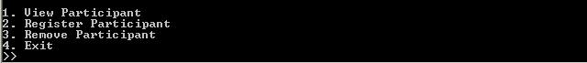

- View Participant
- If there is no registered participant, the program will notify user that data not available.
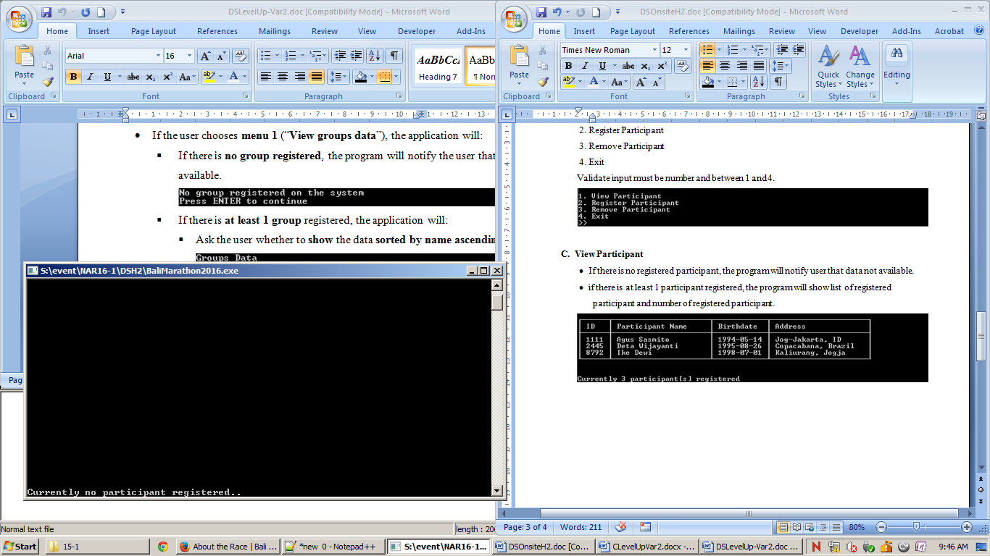
- If there is at least 1 participant registered, the program will show list of registered participant and number of registered participant.
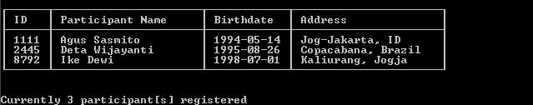
- Register Participant
- Ask user for participant ID generation method. Validate input must be “auto” or “manual”.
- If user choose “auto”, program will generate ID for new participant. Generated ID must between 1000 and 9999. Generated ID must not registered before.
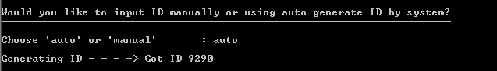
- If user choose “manual”, program will ask user to input ID for new participant. Validate ID must between 1000 and 9999. Inputted ID must not registered before.
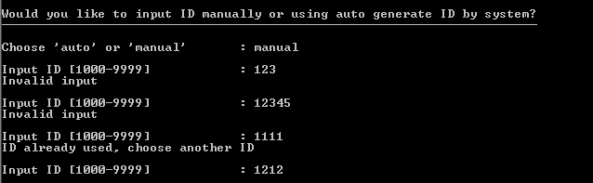
- After that, program will ask user to fill participant info. Ask user to input participant name. Validate the length of participant name must between 4 and 20.
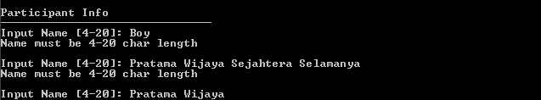
- Ask user to input participant birthdate with format YYYY-MM-DD. Validate input must match with requested date format. Month must between 1 to 12, day is based on month, for example month 01 (january) is between 1 and 31, 02 (february) is between 1 and 29, and so on.
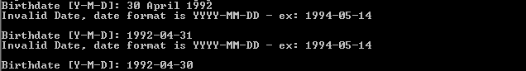
- Ask user to input participant address. Validate address must at least 2 words and length must between 8 to 20.
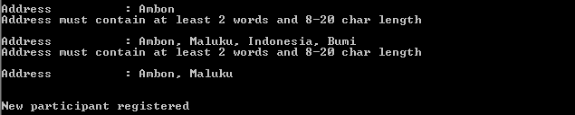
- After user complete input participant information, program will automatically place participant in list based on participant ID. Participant list will sort participant from the smallest to largest ID.
- Remove Participant
- If there is no registered participant, the program will notify user that data not available.
- Otherwise program will show all registered participant and ask user to input participant name to delete.
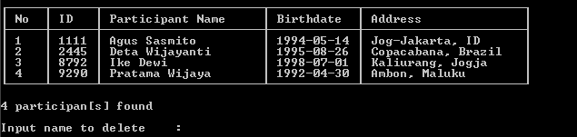
- Program will show participant name which is likely match with inputted name :
- If there no match participant, program will notify user that data not available. After that, program will ask user to repeat search again or not. Validate input must be “y” or “n”. If user input “y” program will back to Remove Participant screen, otherwise if user input is “n” program will back to Main Menu.
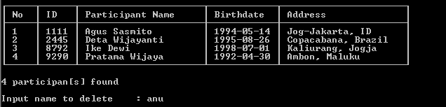
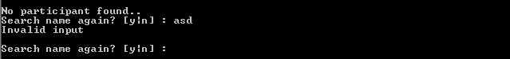
- Otherwise, program will show list of participants which is match with inputed name to delete.
- If there is only one participant found, ask user to confirm delete user. Validate input must be “y” or “n”. If user choose “y” then the participant will be removed, otherwise if user choose “n” program will back to Main Menu.
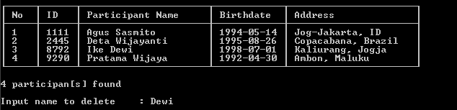
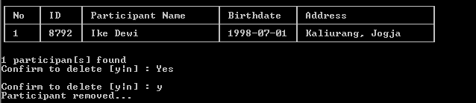

- If two or more participant found, display these participants and ask user to input number of participant to remove, “r” to re-search participant, or “b” to back to Main Menu.
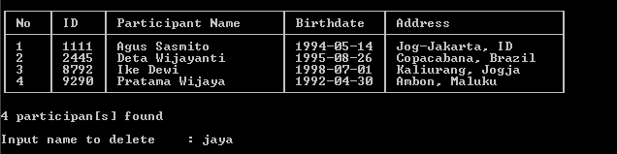
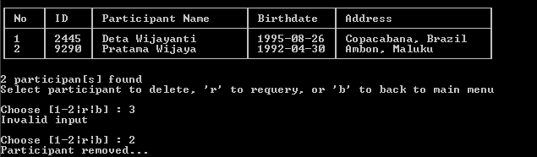
- Exit
- The program will show splash screen and close.
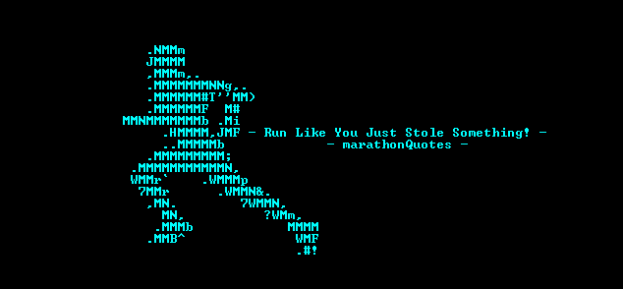
Please run the EXE file to see the sample program.

