Onsite Case | 
DSH3
Periode Berlaku Semester Odd 2015/2016  Valid on Odd Year 2015/2016 | Software Laboratory Center  Assistant Recruitment 16-1

Materi
Material

Konsep dan implementasi Queue

Implementasi Sorting dengan menggunakan Priority queue

Implementasi Stack & queue dengan menggunakan array of struct

Implementasi Stack & queue dengan Linked List

Soal
Case

Baking FAwder
Baking FAwder is a multi-national baking powder seller. They have many orders from all across the country. You as a programmer, are asked to create an order management program using C programming language to help them maintaining their orders. in the program, User can add baking powder’s stock, add order, serve order and cancel order.
Here is description of Program:
- The program display the splash screen.

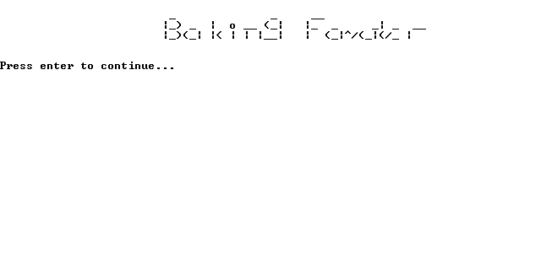

- Automatically insert the powder list at the start of the program:

No. | Name | Stock
1. | Calumet | 10
2. | Clabber Girl | 8
3. | Royal | 13
4. | Davis | 27

- The program will show the user every powder in the list, every order and the main menus are :
- Add Powder Stock
- Add Order
- Serve
- Cancel Order
- Exit

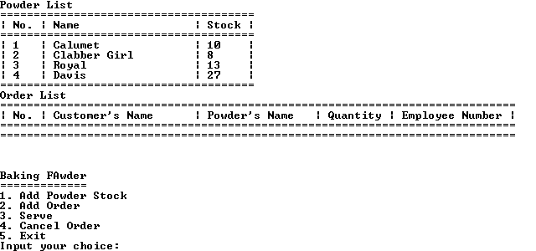

- Add Powder Stock
- The program will display powder list, then ask user for powder’s index. Validate the index must be between 1 and the size of powder’s list.
- After that, the program will display powder’s name, then ask user for powder’s stock to be added. Validate the stock must be more than 1.
- Then, add the stock to the selected powder.
- If the stock was succesfully added, display success message showing the selected powder’s name with the new stock.

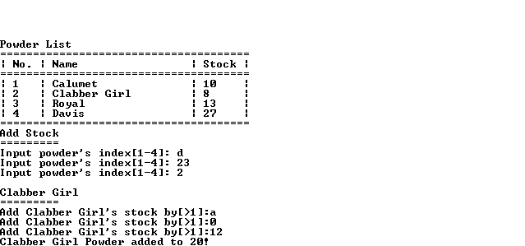

- Add Order
- The program will ask for customer’s name. Validate customer’s name must be between 3 and 20 characters long.
- Then, the program will ask for powder’s name. Validate powder’s name must be the same with one of the powder list’s name (Case sensitive).
- After that, the program will ask for employee number. Validate employee number must be in [XYYY] format:
  - X can only be filled with the following character (Case sensitive):
Character | Rank
‘B’ | Boss
‘O’ | Officer
‘S’ | Staff

  - Y can only be filled with numerical character(0-9)
- And then the program will ask for selected powder’s quantity. Validate quantity must be between 1 and selected powder’s stock.
- After that, add order to the order list using priority queue with the following sequence:
(First served) Boss → Officer → Staff (Last served).
- Then, substract selected powder’s stock by inputted quantity.
- If order added succesfully, display success message.
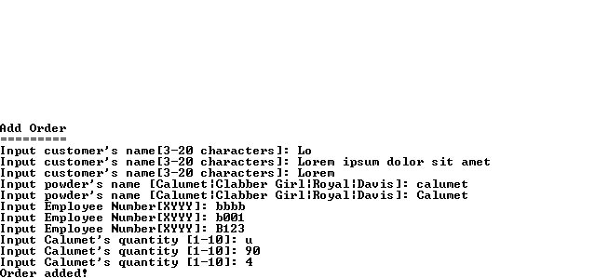
- Serve
- The program will serve the first customer from the order list.
- Then, display success message.

- Cancel Order
- The program will display order list, then ask user for order’s index. Validate the index must be between 1 and the size of order’s list.
- Then, the program will ask for user’s confirmation.

  - If the answer is ‘Y’, then delete the selected order then display success message.
  - Otherwise, the program will display cancelled message.
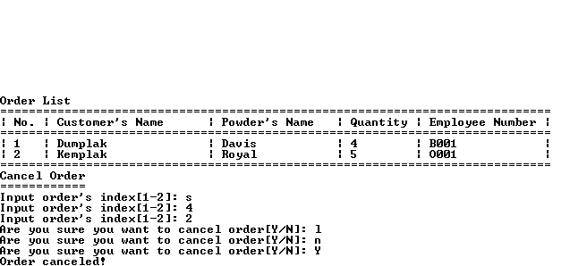
- Exit
The program will display exit message before exiting automatically.


Please run the EXE file to see the sample program.

