Mandatory Case | 
DSMandatory
Periode Berlaku Semester Ganjil 2015/2016  Valid on Odd Year 2015/2016 | Software Laboratory Center  Assistant Recruitment 16-1

Soal
Case

Snake Master
Snake Master is a simple snake game. As a programmer you are asked to make the snake game with the following condition:

- At first, a splash Screen will appear.
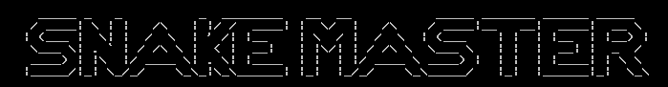

- Then the program will read user.txt file, store them using BST and sorted by name. After that, the program will ask for username and password.
- Validate the username and password must match with the data in BST.
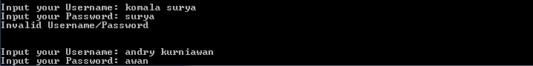

- Then a menu will appear according to the logged in user’s type.
- If the user’s type is member, the menu will consist of:
1. Play Snake
2. View Score
3. Save and Exit
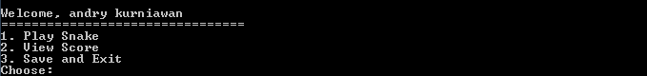
- If the user’s type is admin, the menu will consist of:
1. Play Snake
2. View Score
3. Master User
4. Save And Exit
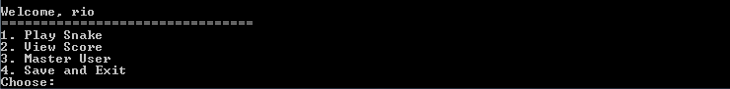

- Play Snake
- Then the user can play snake’s game (120 x 40). You can use either single linked list or double linked list. Validate that:
- There will be wall at the edge of the arena
- The score will go up by 1 for every food eaten
- The snake’s length will go up by 1 for every food eaten
- The food’s position will be randomized each time it is eaten
- The game will be over if the snake collide with the wall or its body
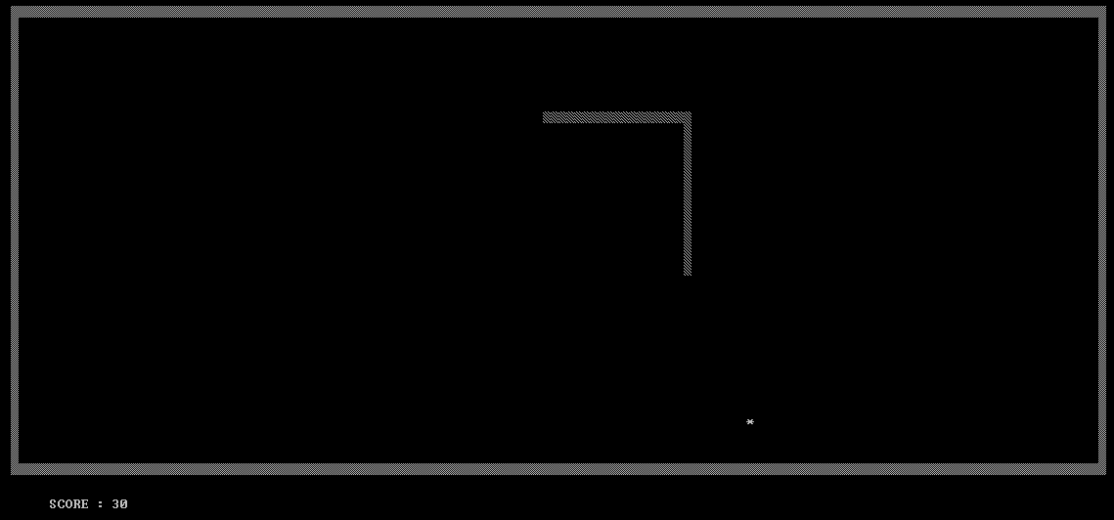
- When the game is over, validate that if the score earned in the game is higher than the score stored in BST, Then the score will be updated.
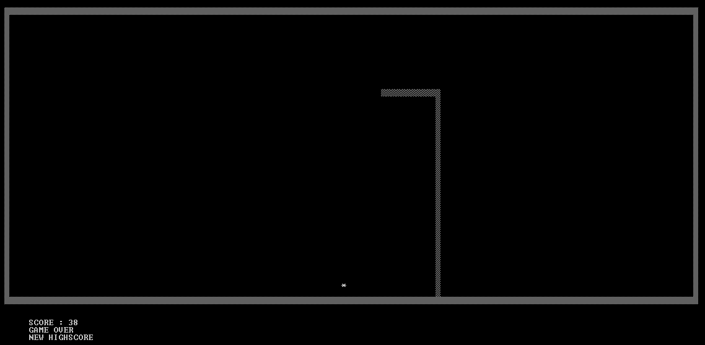

- View Score
- The program will show all user’s name and score.
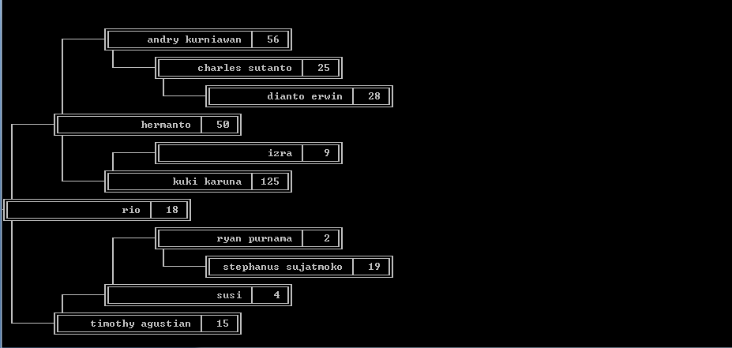

- Master User
- Then another menu will appear
    - Insert New User
    - Delete User
    - Back
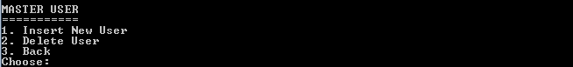

- Insert New User
    - Then the program will ask for a new username, password, and type. Validate that:
      - The username cannot be the same with the username in BST
      - The username’s length must be between 3 and 20
      - The password must be a substring of the username.
Example :
Username | Password | Result
komala surya | kosur | incorrect
komala surya | koma | correct
komala surya | la sur | correct
      - The type must be either “admin” or “member”
    - Then the program will insert a new data into the BST based on the inputted username, password, and type, with its score is 0
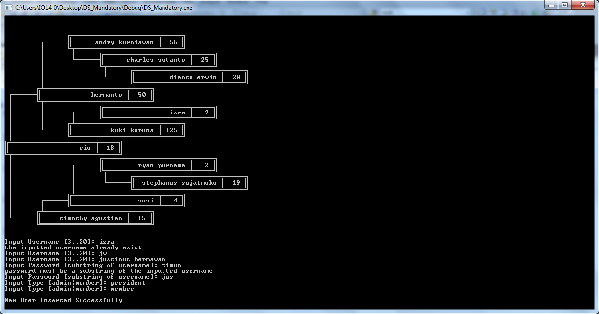
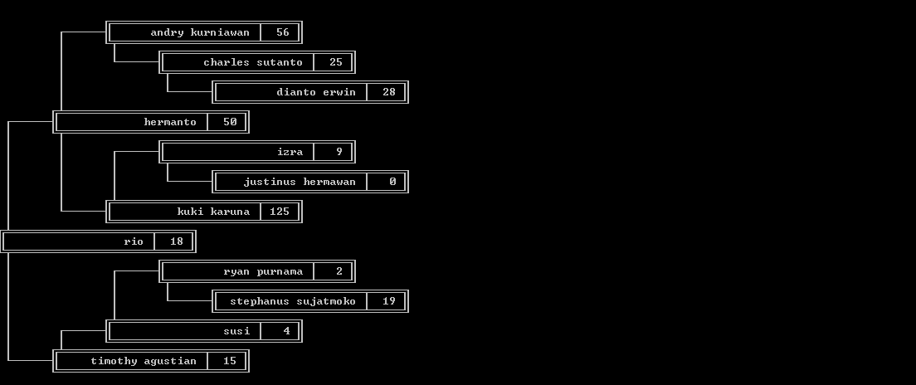
- Delete User
- Then the program will ask for a the username to be deleted. Validate that:
      - If the username exist in the BST. Then the selected user’s data will be deleted
      - The program will refuse, If the username to be deleted is itself or the username to be deleted does not exist in BST
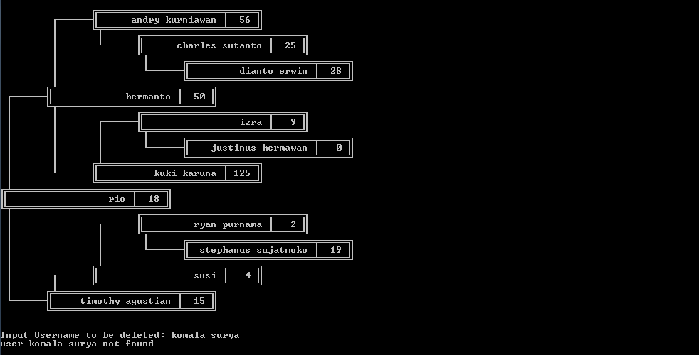
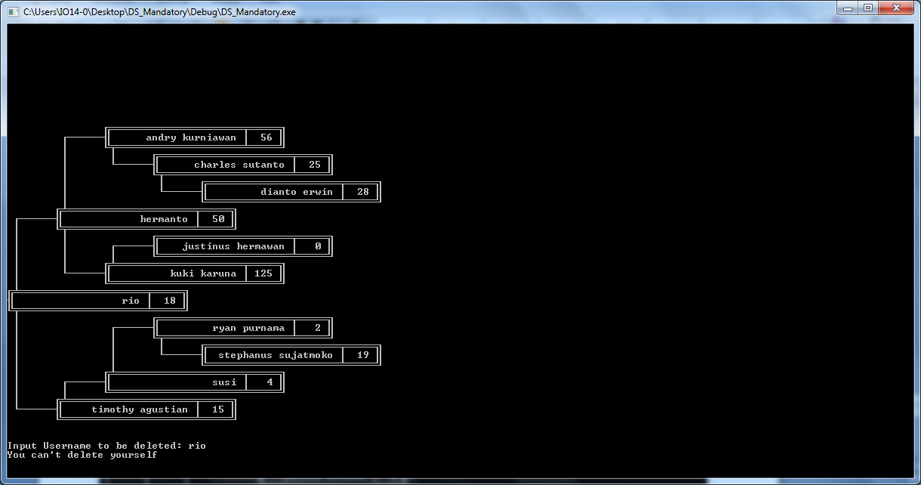
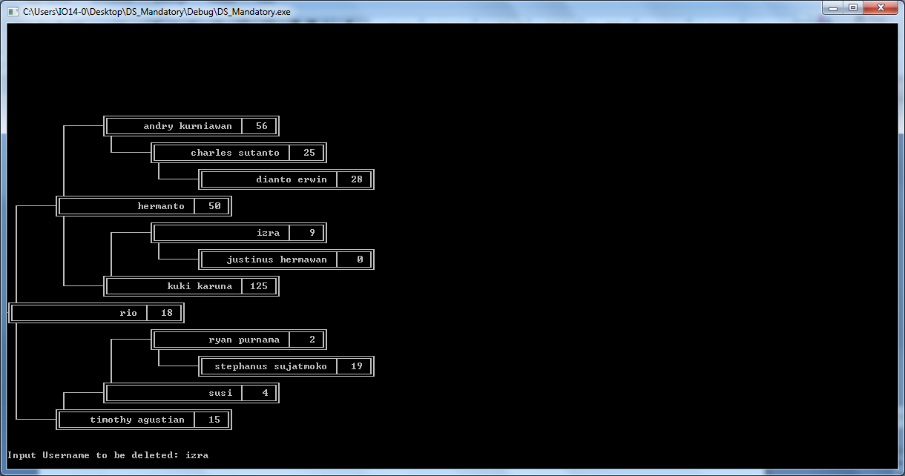
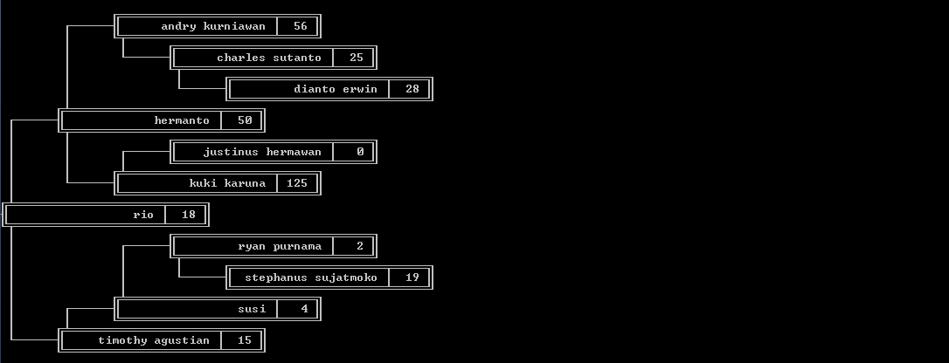
- Back
- If the User choose menu “Back”. Then the program will go back to main menu.

- Save and Exit
- The program will overwrite all the data from BST to file “user.txt”.
- Then the program will close.

Please run the EXE file to see the sample program.

