Onsite Case | 
JavaIIH1
Periode Berlaku Semester Ganjil 2015/2016  Valid on Odd Year 2015/2016 | Software Laboratory Center  Assistant Recruitment 16-1

Materi
Material
- Constructor & Destructor
- Namespaces and Package
- Import keyword
- Directory Structure of Packages
- Class to Object
- Class to Array of Object
- Vector of object

Soal
Case

MDs Restaurant Queue System
MDs Restaurant Queue System is an application that used in MDs Restaurant to arrage the queue of customer order. This application is developed using Java Programming Language and Object Oriented Programming concept (please give class name that relates to the case – don’t give random class name)
- First program will show splash screen, queue order list, and menu
- For each menu, if there is no list, it will show “No queue list”
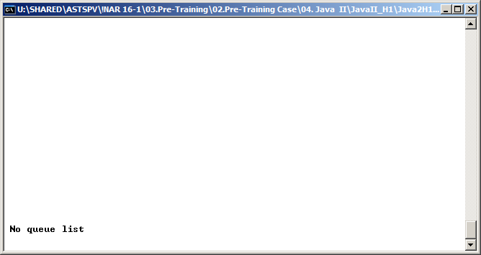
- The main menus are :
1. Add Queue
2. Change Status
3. Delete Delivered Queue
4. Sort by Status
5. Clear Queue List
6. Exit

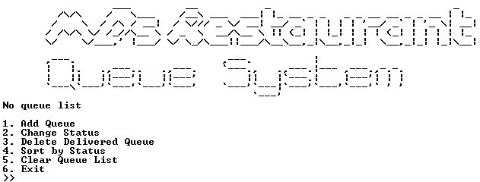

- Add Queue (Menu 1)
- Program will ask input for table number, validate table number must be number and between 1 – 10
- Program will ask input for menu, validate menu character length must be 5 – 15
- Program will ask input for quantity, validate quantity must be in number and between 1 – 20
- Program will ask if want to add more menu. Validate the input must only be ‘Y’ or ‘N’ (case insensitive)
  - If user choose ‘Y’ then program will ask input for menu name and quantity again
  - If user choose ‘N’ program will save the order and generate auto increment order ID and set order status to “Pending”. Then will back to first screen.

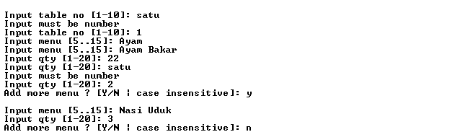

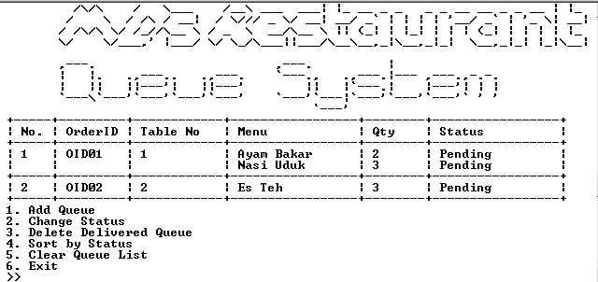

- Change Status (Menu 2)
- Program will only show queue order list with “Pending” status
- User will be asked to input order ID to change the order status (case sensitive). Status will be updated from “Pending” to “Delivered”. Validate can only choose the availabel order
- If user enter “cancel” (case sensitive), program will cancel status change
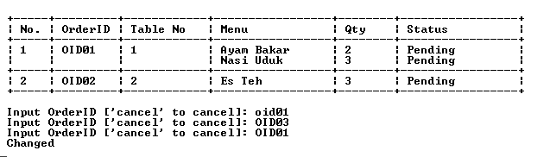

- Delete Delivered Queue (Menu 3)
- Program will delete all orders with “Delivered” status then show “Delivered food deleted”.
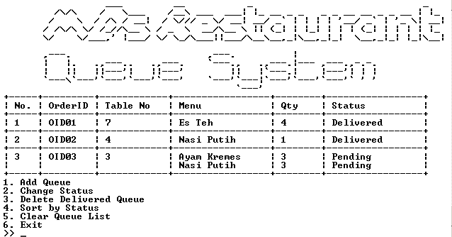
( Before delete delivered queue)
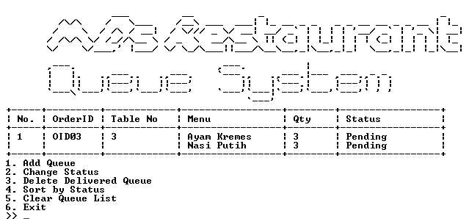
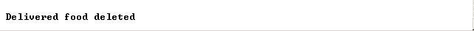
( After delete delivered queue)

- If there is no order with “Delivered” status, program will show “No delivered food”.
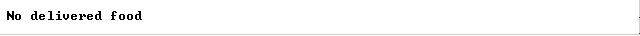

- Sort by Status
- For this menu, program will automatic sort the order by status.
- The program will sort by order status alternately between “Delivered” and “Pending”
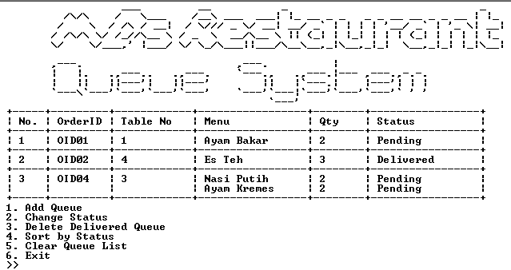
( Before sorting )

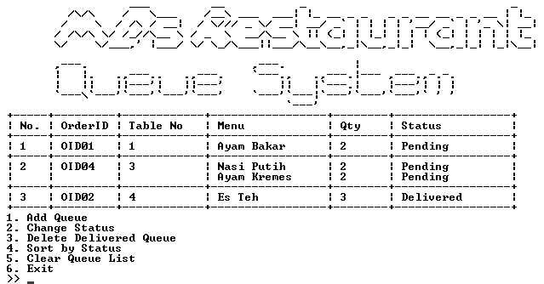
( After sorting )

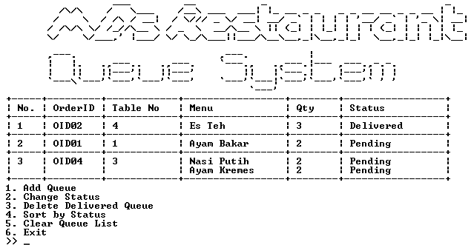
( If sort again )

- Clear Queue List
- The program will ask “Are you sure want to clear all queue data?”
- If the answer is ‘Y’ ( case sensitive ) then all orders will be deleted then show “Cleared!”
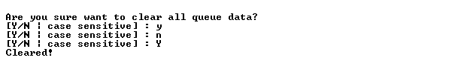
- If the answer is ‘N’ ( case sensitive ) then back to first screen.
Please run the EXE file to see the sample program.

