Onsite Case | 
Java2H3
Periode Berlaku Semester Ganjil 2015/2016  Valid on Odd Year 2015/2016 | Software Laboratory Center  Assistant Recruitment 16-1

Materi
Material
- OOP Concept III (Polymorphism)
- Abstract Class and Interface

Soal
Case
Bluejack Phone Shop
Bluejack Phone Shop is an application developed with Java Programming Language and using the Object Oriented Programming concept. This application will help people to do shopping easier.
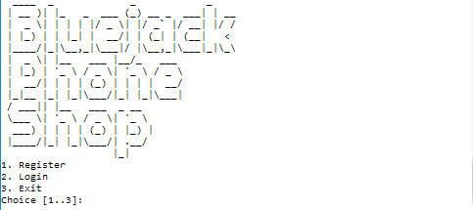

At the beginning of program, program will initiate all the product details as the following :
Product ID | Name | Brand | Memory | Operating System | Screen Size | Stock
1 | Nexus 6 | Nexus | 32 | Android 5.0 | 6 | 7
2 | Blackberry Bold | Blackberry | 4 | BB OS 6.0 | 3 | 10
3 | Iphone 6s | Apple | 32 | IOS 7 | 5 | 9

Then, there are 3 main menus :
1. Register
2. Login
3. Exit

- Register
- Program will ask user to input name, phone number, password and confirm password
- Program will validate :
- Name
- Must be between 5 and 20 characters
- Must be alphabet
- Phone
- Must be between 5 and 11 characters
- Must be number
- Password
Must be between 5 and 10 characters
- Confirm Password
Must be the same with password
- After all data are valid, user will be asked to login
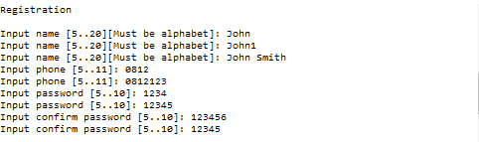
- Validate the user can only register once
2. Login
- Program will ask user to input registered name/phone and password
- Program will validate :
- Name / Phone
Must be the same with registered name/phone
- Password
Must be the same with registered password
- Validate the choice must be between 1 and 4
- After all data valid, program will show menu :
2.1. View Product
2.2. View Cart
2.3. Checkout
2.4. Back
2.1. View Product
- Program will display Product ID, Product Name, Brand, Memory, Operating System, Size, Price and 3 sub menus :
2.1.1. Add to cart
2.1.2. Remove all from cart
2.1.3. Back
- Validate the choice must be between 1 and 3
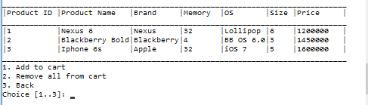
    - Add to cart
- Program will ask user to input Product ID, Quantity
- Validate the Product ID must be between 1 and 3
- Validate the quantity cannot be more than its stock
- Validate the same product cannot be added more than once
- Validate if the cart is full, user cannot add more product
- After all data valid, the chosen product will be added to cart
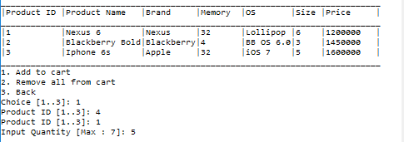
2.1.2. Remove all from cart
- Validate the cart, if it is empty, it cannot remove all from cart. Otherwise, the program will ask user if he/she wants to remove all the product in cart
- Validate the choice can only be yes or no (case sensitive)
- If the user chooses yes, the program will remove all the product from cart
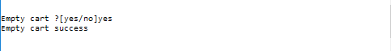
2.1.3. Back
- Program will go back to 2.1 – 2.4 menu
  - View Cart
- Program will display product name, price, quantity, order id and total price
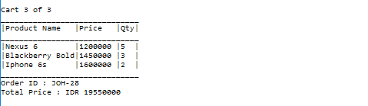
- Validate the view cart, if there is no product in cart, display a message “Cart is empty.”
- Order ID is generated automatically by the program when the user add the first product to cart, the order id generated once only per trancsaction and is based on the following formula :
Order ID = first 3 character from name-random number(0-99)
In uppercase format
e.g. : Name : John Order ID = JOH-12
- Total price is calculated based on the following formula
Total Price = sum ( Price of each product * qty)
  - Checkout
- Program will display Order ID, total price, and change
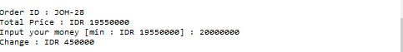
- Validate if the cart is still empty, user cannot checkout
- Program will ask user to input money to pay
- Validate the inputted money cannot be less than total price
- After the inputted money is valid, program will display the change
- Total price is calculated based on the following formula
Total Price = sum ( Price of each product * qty)
- Change is calculated based on the following formula
Change = Money inputted by user – total price
- After checkout success, the program will also empty the cart, and the product stock will reduce by purchased quantity
2.4 Back
- Program will go back to the main menu

Please run the EXE file to see the sample program.

