Case | 
Java2LevelUpVar1
Periode Berlaku Semester Ganjil 2015/2016  Valid on Odd Year 2015/2016 | Software Laboratory Center  Assistant Recruitment 16-1

Soal
Case
BillionR
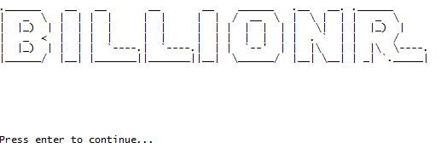
BillionR is a simple business simulation game. BillionR is developed using Java programming language with the OOP concept. The program will show a splashscreen when started.

There are 4 main menus:
- New Game
- Load Game
- How to Play
- Exit
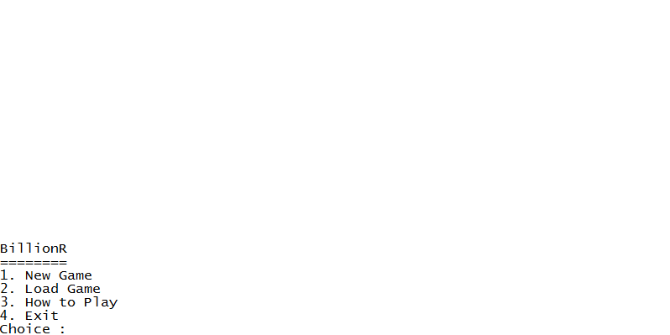

- New Game
- Program will ask player to input name. Validate the name length must be between 3 and 20 characters and only contains alphabets and spaces.
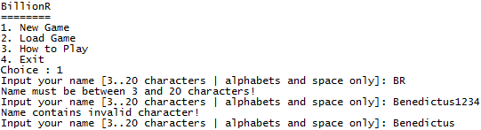
- The player will get $5000 for starting money.
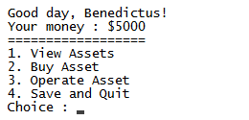
- There are 4 submenus :
- View Assets
- If the player does not have any asset, program will show message “You have no asset.”
- Otherwise, program will show all assets owned by the player.
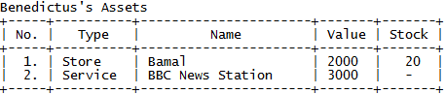

- Buy Asset
- Validate the player’s money must be more than $1000. If the player’s money is less than $1000, program will show message “You don’t have enough money (min. $1000).”
- Otherwise, ask player to input the asset name. Validate the name length must be between 3 and 20 characters and only contains alphabets and space.
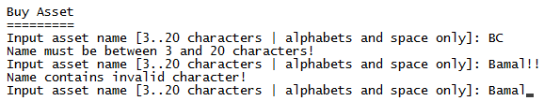

- Ask player to input the asset value. Validate the value must be a number between 1000 and 50000 and lower than the player’s money.
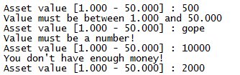

- Ask player to input the asset type. Validate the type must be: ‘Service’, ‘Store’, or ‘Factory’ (case sensitive).
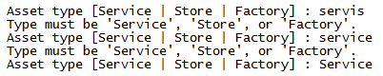

- Program will add the asset to the list. If the asset type is store, the asset will have 20 items as starting stock. Then, program will show message “Asset bought!” and after the player press enter, program will show the new asset detail.
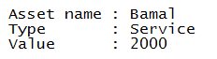

- Operate Asset
- Program will show all the assets owned by the player. After that, program will ask player to input the asset he/she wants to operate. Validate the input must be a number, between 1 and the total of assets owned by the player.
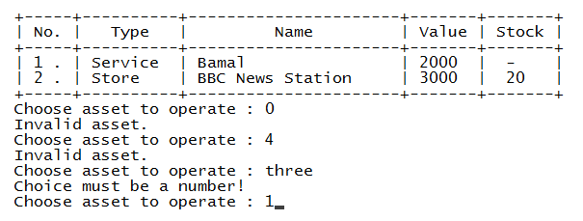

- If the player chooses a service type asset, every second the player will receive money according to the asset’s income with the following formula:
Income = Asset Value / 500

The operation will stop when the user press enter and the player will stop receiving money.
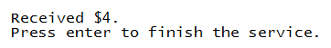

- If the player chooses a store type asset, program will check if the store’s stock is available or not. If the stock is 0, program will show message “No stock to sell.” Otherwise, every second the program will do the following things until user press enter:
- store’s stock will be reduced by 1
- Player’s money will increase according to the asset’s income. Income is obtained from the following formula:
Income = Asset Value / 200

- The operation will stop when the user press enter, the player will stop receiving money, and the store’s stock will stop decreasing. Operation will be automatically stopped if the stock reaches 0.
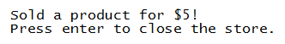
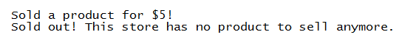

- If the player chooses a factory type asset, program will check whether the player has a store asset or not. If the player does not have any store, program will show message “You don’t have any store”.
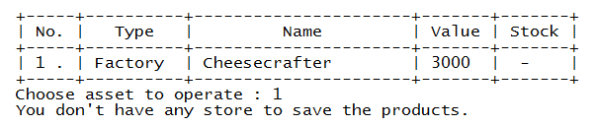
Otherwise, the program will ask user to input the store to save the goods produced. Validate the input must be number between 1 and the total of store owned by the player.
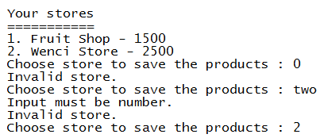
- If the cost is more than the player’s money, program will show message “Insufficient money to start production”. Otherwise, every second the program will do the following things until the user presses enter:
- Store’s stock will increase by 1
- Player’s money will decrease according to the cost. Cost is obtained from the following formula:
Cost = (Store Value / 150) – (Factory Value – 200)

- Operation will be automatically stopped if the player’s money is less than the cost.

- Program will try to find file “save.txt”. If the file exists, program will overwrite the data. Otherwise, the program will create file “save.txt”.
- Data will be saved with the following format:
Asset | Format
Player | [player name]#[money]
Service | 0#[asset name]#[value]
Store | 1#[asset name]#[value]#[stock]
Factory | 2#[asset name]#[value]

- Menu 2 (Load Game)
- Program will try to find file “save.txt”. If the file “save.txt” does not exist, program will show message “File not found.”
- Otherwise, program will load player name, money, and all assets saved in the file. Then, program will continue to the game menu.

- Menu 3 (Exit)
- Program will show a message.
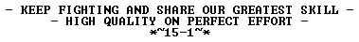
- After player has pressed enter, Program will exit.
Please run the EXE file to see the sample program.

