Onsite Case | 
JavaIH2
Periode Berlaku Semester Ganjil 2015/2016  Valid on Odd Year 2015/2016 | Software Laboratory Center  Assistant Recruitment 16-1

Topic
- Collections

Sub Topics
- Definisi dan karakteristik array
- Inisialisasi Array
- Array dimensi satu
- Arrays of References
- Copying Arrays
- Multidimensional Array
- Import
- Vector & ArrayList

Soal
Case

Bluejack OL-Hardware Shop

Bluejack OL is a company that sells hardware product via online. As a programmer, you had been asked to make a program to help the company to maintain their transaction. User must login before they do some transaction. Program consists of 3 main menus:
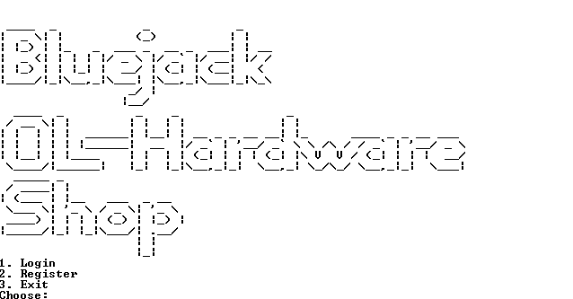

- Menu 1 (Login):
- If user has not been registered program will ask user to register first
- If user already registered, user can login by using registered Username and Password.

- Menu 2 (Register):
- User may register only once.
- Program will ask user to input and validate:
- Username must be alphanumeric and must be between 5 – 20 characters.
- Password must be alphanumeric and must be between 5 – 20 characters.
- Age must be number and must be between 17 – 50.
- Address must be started with “St.” or must be ended with “Street”.
- Email must be ended with “@yahoo.com” or “@gmail.com”.
- Hobby must be between 5 – 10 characters.
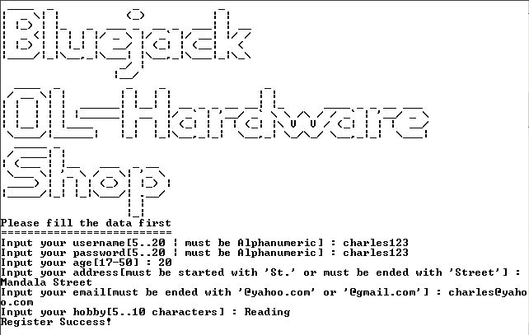
- If user chooses Menu 3 (Exit) then program will shows exit screen and terminates the program
If user has already logged to program, program will show7 main menus:
- View Profile
- Buy Product
- View Product
- Insert Product
- Update Product
- Delete Product
- Exit
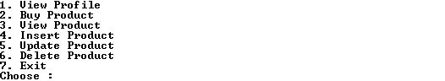

- Menu 1 (View Profile):
- Program will show all user profile except password.
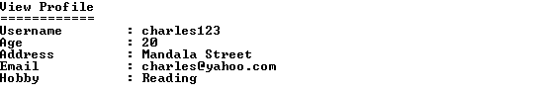

- Menu 2 (Buy Product):
- If user has not inserted any product, program will ask user to insert product first.
  - Program will ask user “Do you want to buy it [Yes|No]?” validate answer must be either “Yes” or “No”. (Case sensitive)
- If user answer “Yes”, program will ask user to input the Money, validate the Money must be numeric and must be more than Grand Total. After that, program will show your change and program will remove all product from list.
- Program will returns to the main menu.

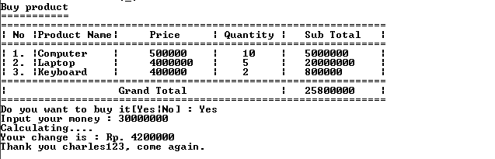

- If user answer “No” the transaction has been canceled and all product list will be cleared
- Program will returns to the main menu and remove all product list.

- Menu 3 (View Product):
- If user has not inserted product, program will ask user to insert product first.
- The program will shows all details of the transaction: Product Name, Price, Quantity, Sub Total and Grand Total.
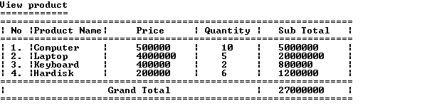

- Menu 4 (Insert Product):
- Program will ask user to input product name, validate product name must be either “Computer”, “Laptop”, “Keyboard” or “Hardisk”.
- Program will ask user to input quantity, validate quantity must be number and must be between 1 – 20.
- Program will calculate sub total and grand total based product quantity and its unit price
Product Name | Product Price
Computer | @Rp. 500.000
Laptop | @Rp. 4000.000
Keyboard | @Rp. 400.000
Hardisk | @Rp. 200.000
Sub Total = Quantity * Product Price

Grand Total += Sub Total

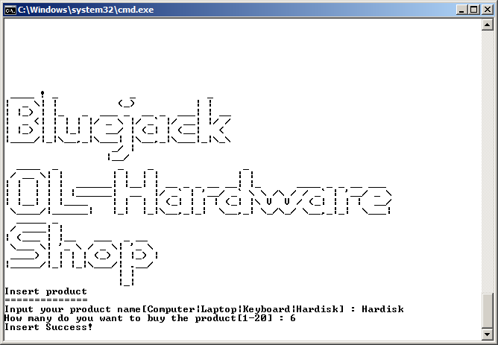
- Then the program will shows message that the product is successfully inserted and returns to the main menu.

- Menu 5 (Update Product):
- Program will show all details of the transaction: Product Name, Price, Quantity and Sub Total

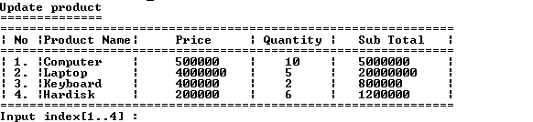

- Program will asks user to input the index to update. If user’s input matches with one of the index data, program will asks user to input:
- Product Name must be either “Computer”, “Laptop”, “Keyboard” or “Hardisk” (Case sensitive)
- Quantity must be number and must be between 1 – 20
- After that, program will update the product, shows message that the product is successfully updated and return to the main menu.
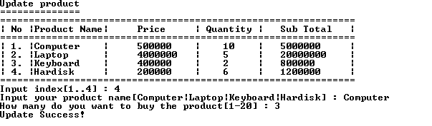

- Menu 6 (Delete Product):
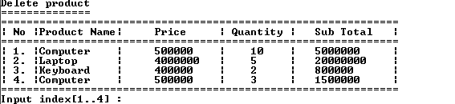
- The program will shows all details of the transaction: Product Name, Price, Quantity and Sub Total

- Then program will asks user to input the index to delete. If user’s input matches with one of the index data, the program will delete the product, shows message that the product is successfully deleted and return to the main menu.
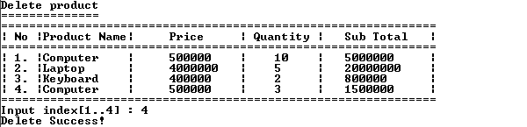

- If user chooses Menu 7 (Exit) then program will remove all user data and return to the login menu.

Please run the EXE file to see the sample program.

