Onsite Case | 
JavaIH3

Periode Berlaku Semester Ganjil 2015/2016  Valid on Odd Year 2015/2016 | Software Laboratory Center  Assistant Recruitment 16-1

Materi
Material
- Fungsi
- Recursif

Soal
Case
Mini Congklak
Mini Congklak is an ancient gameboard which played with 2 players and the target is to gather as many pieces of gems in the storehouses. In this game, we have 8 pits are divided into 2 rows and each of the pits contain 4 pieces of gems. The large 2 pits on the right and left of the board are called player storehouse.
Player 1 and 2 will take turns to move the gems. Each player can select pits number on their row and each time pit is selected, gems inside will be distributed one by one to the next pits in clockwise direction. The game will end if both pits on rows are emptied and player who have the most gems in the storehouse is the winner.
First, program’s will show 3 main menus:
- Start New Game
- How to play
- Exit

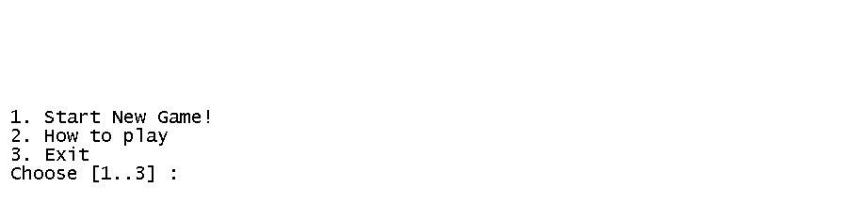
- If the user chooses menu 1 (“Start New Game!”)
- Ask user to input each player username. Validate both players’ username must be between 3 and 10 characters
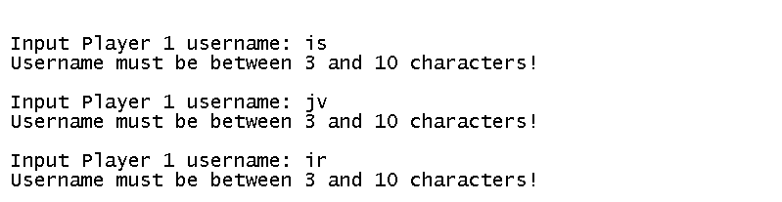
- Validate both players’username are not allowed to use whitespace.

- If username contain whitespace, user should input it again
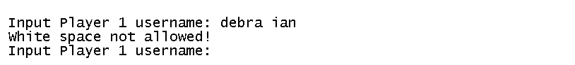

- If input username is success, then player will be directed to gameboard
  - Every pits contain 4 pieces of gems and each storehouse, score and step values should start with number zero (0)
  - Each Player Score represents number of gems stored in player storehouse
  - Step represents value of gems that you pick from pits and step value will decrease each time players distributes gems to another pit
  - Storehouse and score will increased each time player places the gem inside the storehouse.

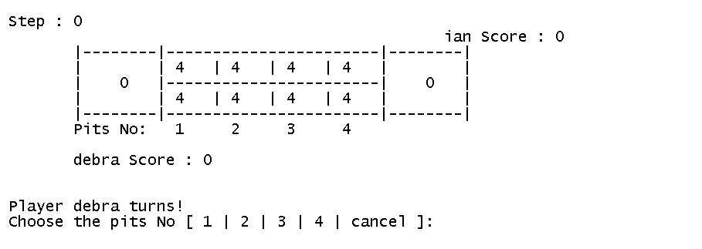
- Game play :
  - Game starts from the Player 1
  - Ask user to input pits number. Validate pits number should between 1 and 4. If the user input is “cancel” (case sensitive), user will return to main menu
  - Validate user cannot pick gems from empty pits.
  - Use recursive function each time players distribute gem to the next pits.
  - 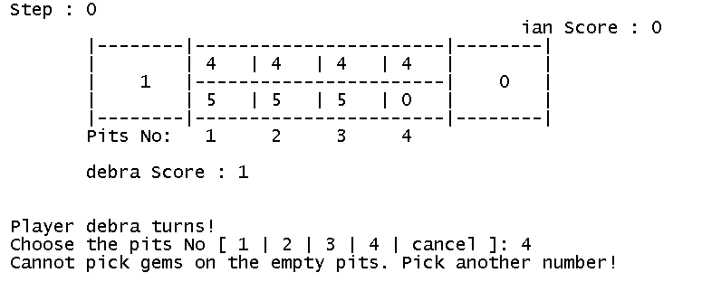If the last gem of move landed on the other player’s (opponent player) storehouse, then you are allowed to move again

  - If the last gem of move landed on other pits, then you must change a turn to opponent player.
  - Gameboard will rotate each time the player change a turns

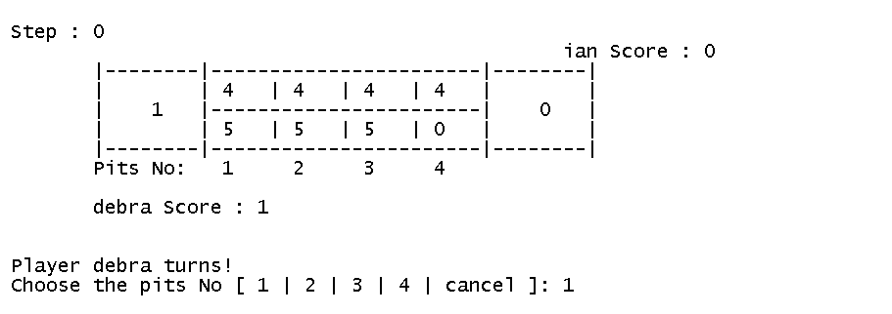
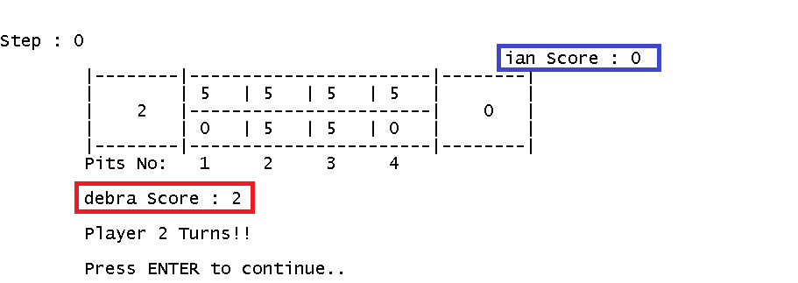
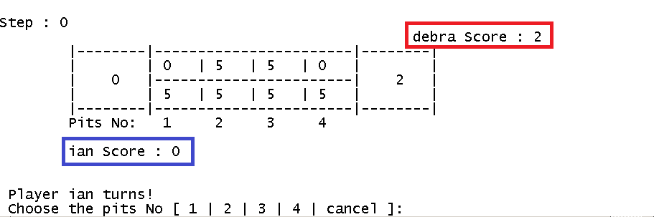

- If all opponent pits are empty, you can move again until all pits is 0
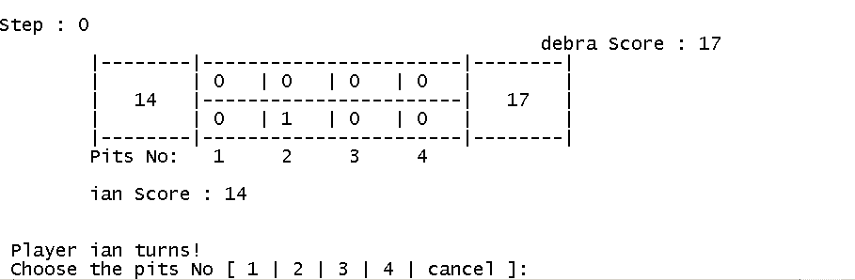
- Game will ended after all pits is 0. And player who have the most gems in the storehouse is the winner.
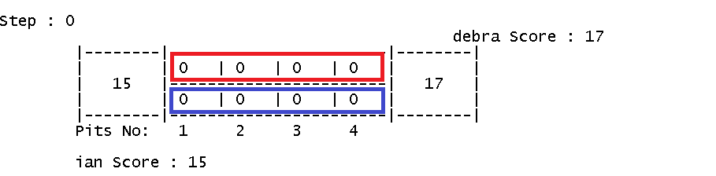
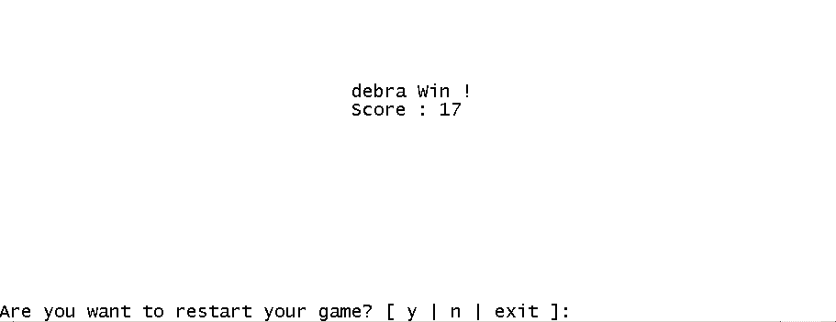
- Ask user to input “y” or “n” (case sensitive),
  - If User Input is “y”, the game will restart
  - If, User Input is “n”, the application will return to main menu
  - Else, User Input is “exit”, the application will exit.
- If user chooses menu 2 (“How to play”), program will show the following instruction
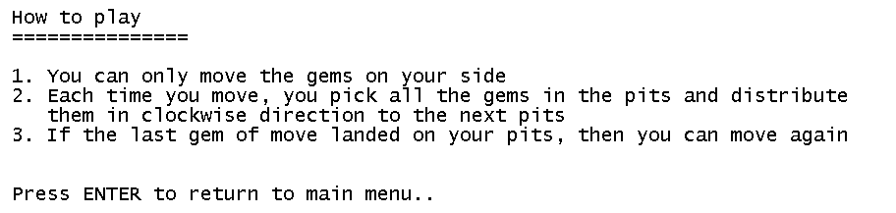

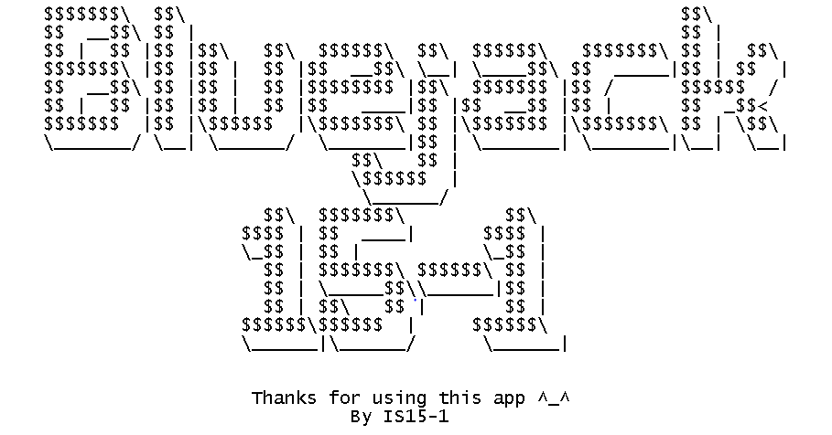
- If user chooses menu 3 (“Exit”), program will show the following animation

Please run the EXE file to see the sample program.

