Mandatory Case | 
JavaIMandatory
Periode Berlaku Semester Ganjil 2015/2016  Valid on Odd Year 2015/2016 | Software Laboratory Center  Assistant Recruitment 16-1

Soal
Case
Crafter Journey
Crafter Journey is a game that mainly focus on crafting weapons and armors. Player has a level in this game and they can be leveled up, to craft an item player needs sufficent material and stamina, and they can travel to a difference place to collect several materials for crafting. First, program will show 3 menus :
- Play Game
- About Game
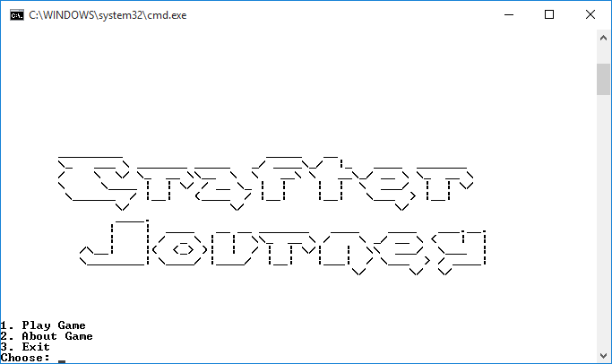
- Exit

- “Play Game” (Menu 1)
  - Ask user to input Player Name and Player Gender, validate the Player Name must be between 5 and 20 characters and must be alphabet
  - Validate Player Gender must be Female or Male (Case Sensitive)
- Program will show player’s name and current player’s stamina and 7 submenus:
- Travel To Somewhere
- View Player Profile
- View Material List
- Crafting
- View Crafted Items
- Sleep
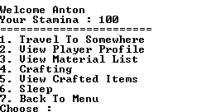
- Back To Menu

- If player chooses:
- “Travel To Somewhere” (Menu 1)
- Program will show player’s initial stamina which is 100
- Every time player does travelling, stamina will be deducted by 20
  - Program will validate player must have minimum 20 stamina to travel
  - Program will show 3 places, which are Mountain Mouthspeak, Forrest Of Blue, Southern Hills that player can explore to find material. If player has visited a place, player will find crafting material. Program will define collected material by following requirement:

Place | Description
Mouthspeak | - Player has 80% chance to find stone, 40% chance to find wood and 60% chance to find leather. For example if the success chance to find stone is 80%, then, program random a number from 1-100 and if the result is less than equals 80 then player will find stone otherwise player won’t find any stone.  - If player success to find stone, random stone type: iron ore, silver ore and gold ore then random the quantity between 1 and 10.  - If player success to find wood, random wood type: oak wood, aspen wood and ancient wood then random the quantity between 1 and 10.  - If player success to find leather, random leather type: soft leather, thin leather and thick leather then random the quantity between 1 and 10.  - After that player’s material quantity will be increased
Forest Of Blue | - Player has 40% chance to find stone, 80% chance to find wood and 60% chance to find leather. For example if the success chance to find stone is 40%, then, if the program random a number from 1-100 and the result is less than equals 40 then player will find stone otherwise player won’t find any stone.  - If player successes to find the stone, random stone type: iron ore, silver ore and gold ore and random the quantity between 1 and 10  - If player successes to find wood, random wood type: oak wood, aspen wood and ancient wood and random the quantity between 1 and 10  - If player successes to find leather, random leather type: soft leather, thin leather and thick leather random the quantity between 1 and 10  - After that player’s material quantity will be increased
Southern Hills | - Player has 40% chance to find stone, 60% chance to find wood and 80% chance to find leather. For example if success chance to find stone is 40%, then, program random a number from 1-100 and if the result is less than equals 40, then player will find stone otherwise player won’t find any stone.  - If player successes to find stone, random stone type: iron ore, silver ore and gold ore and random the quantity between 1 and 10  - If player successes to find wood also random wood type: oak wood, aspen wood and ancient wood and random the quantity between 1 and 10.  - If player successes to find leather then random leather type: soft leather, thin leather and thick leather and random the quantity between 1 and 10.  - After that the player material quantity will be increased
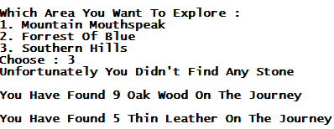
- “View Player Profile” (Menu 2) then:
  - Program will show player’s profile, such as name, gender (generated from the first character of the player gender), current level, current experience, and crafting status with how many crafting has been done, how many have been success and how many have been failed.
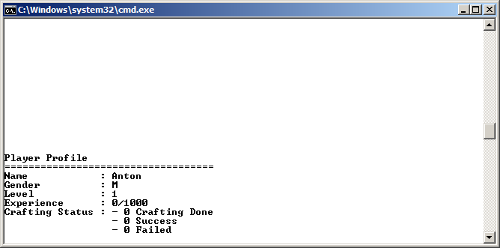

- “View Material List” (Menu 3) :
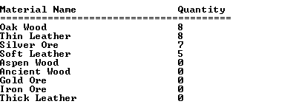
  - Program will show all collected materials (iron ore, silver ore, gold ore, oak wood, aspen wood, ancient wood, soft leather, thin leather and thick leather) in descending sort by quantity.

- “Crafting” (Menu 4) :
  - Program will validate player must have minimum 40 stamina to craft armor or weapon
  - Validate player can only choose craft weapon or armor
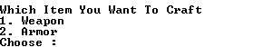

  - If player chooses Weapon (Menu 1) then :
    - Program will show 3 weapons that player can craft:
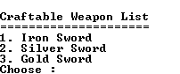

      - Program will validate whether player have sufficient material or not. If player does not have enough material, program will return to main menu
    - Below are the required material and the success chance of each weapon to be crafted:
      - Iron Sword = 3 Iron Ore and 1 Oak Wood and 70% success chance. For example, if success chance is 70%, then,program random a number from 1-100 and the result is less than equals 70 then crafting will be success, otherwise it will fail.
      - Silver Sword = 4 Silver Ore and 2 Aspen Wood and 50% success chance. For example, if success chance is 50%, then, program random a number from 1-100 and the result is less than equals 50 then crafting will be success, otherwise it will fail.
      - Gold Sword = 5 Gold Ore and 3 Ancient Wood and 40% success chance. For example, if success chance is 40%, then, program random a number from 1-100 and the result is less than equals 40 then crafting will be success, otherwise it will fail.
      - Program will show crafting status
      - If crafting is success then:
        - Program will show a success message and player will gain 250 Experience Points and crafted items will be stored to crafted item list and user profile will be updated for quantity of crafting status .
        - Quantity of materials that are used to craft the weapon will be decreased based on the crafting material required.
        - If player experience has reached 1000, player will be leveled up by 1 level and the experience point will be reset to 0 and also has a higher chance to be success in crafting.
        - Every time if player are leveled up by 1, the success chance of Iron , Silver and Gold will be increased by 5%.
      - If the crafting failed, program will show a message that the crafting is failed and materials that used to craft the weapon will be decreased based on the crafting requirement.
      - Program will ask player want to continue crafting. Validate player can only choose “yes” or “no” (case sensitive).If player enters “No” (Case Sensitive) then player will return to the game menu.

  - If player choose Armor (Menu 2) then :
    - Program will show 3 armors that player can craft, which are iron, silver and gold
      - Program will validate whether player have sufficient material or not. If player does not have enough material, program will return to main menu
    - Below are the required material and the success chance of each armor to be crafted:
      - Iron Armor = 3 Iron Ore and 1 Soft Leather and 70% success chance
      - Silver Armor = 4 Silver Ore and 2 Thin Leather and 50% success chance
      - Gold Armor = 5 Gold Ore and 3 Thick Leather and 40% success chance
    - If player is success to craft the armor, program will do the same thing like success crafting weapon ( follow weapon’s requirements and condition)

- “View Crafted Items” (Menu 5):
  - Program will display all of player’s crafted items and the quantity
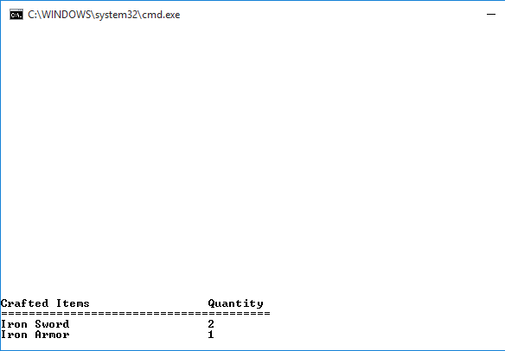

- “Sleep” (Menu 6) then:
  - Player’s stamina will be refilled to 100.

- “Back To Menu” (Menu 7) then:
    - Program will return to the main menu
- Program will change the “Play Game” menu to “Continue Game” menu
- “About Game” (Menu 2):
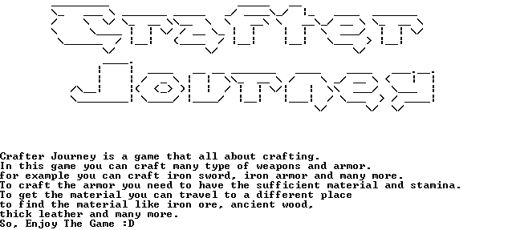
  - Program will show the introduction for this game.

- “Exit” (Menu 3) then:

  - Program will display a splash screen then exit from the program.

Please run the EXE file to see the sample program.

