**Background**

Basically I wanted a point and click method of selecting fin whale (bp) calls in matlab and clipping them out for later analysis. The main function of *findbpclips.m* then is the ‘mark’ mode where a crosshair appears and you can select fin whale 20hz notes. The program looks in a window around your selection, filters, and finds the peak amplitude to center the clip on. This makes an easy and repeatedable way to measure INI, SNR, or other parameters of interest about an individual note.

Still a work in progress!

The program can open an entire directory of wavs or xwavs (automatically detected). For xwavs the appropriate transfer function can be loaded (for SNR calculation). The xwav opening code is stolen directly from triton. I added routines to chunck up deployments along duty cycle breaks (typically 5 minutes but not always), or break up continuous deployments into 5 minute chuncks (stretches). Individual stretches can be marked as containing bp calls and returned to later. Contrast and brightness can be adjusted, and .wav clips of the current stretch can be played or saved for later.

**How to use**

The program relies on key commands mostly. See below for a full list of functioning key commands. To start run findbpclips at the matlab prompt. You should be greated with a blank figure with empty axes.

Type f when the figure is in focus to load a directory of xwavs (or wavs). You’ll be prompted to select a directory, and then a transfer function. If no transfer function exists then you can just click cancel and the program will continue without it.

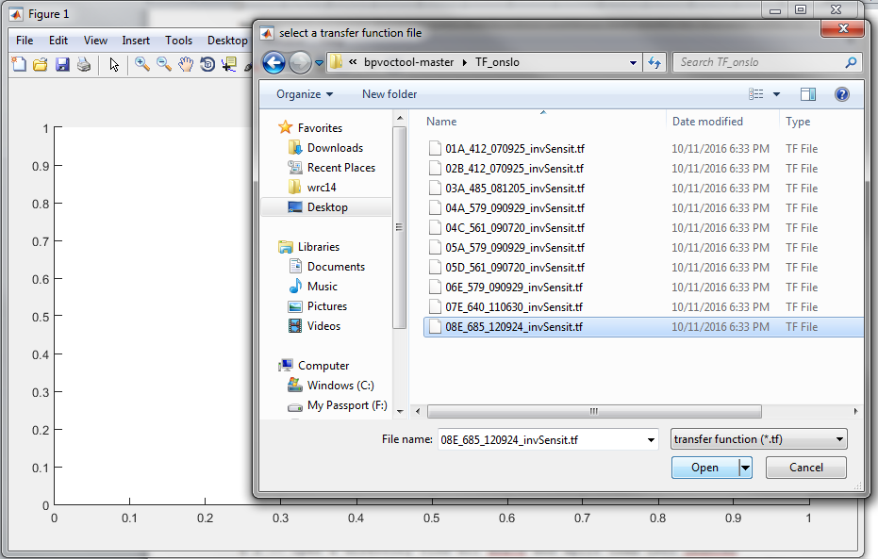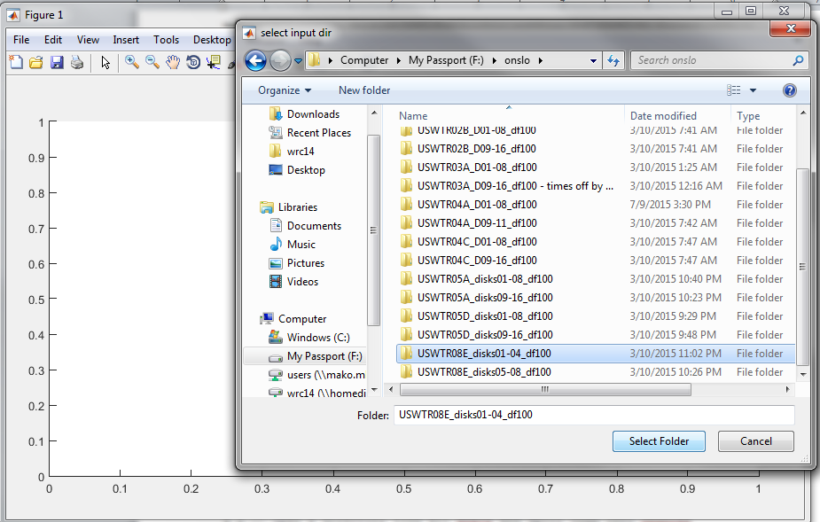

After everything loads you should be greeted with something that looks like this:

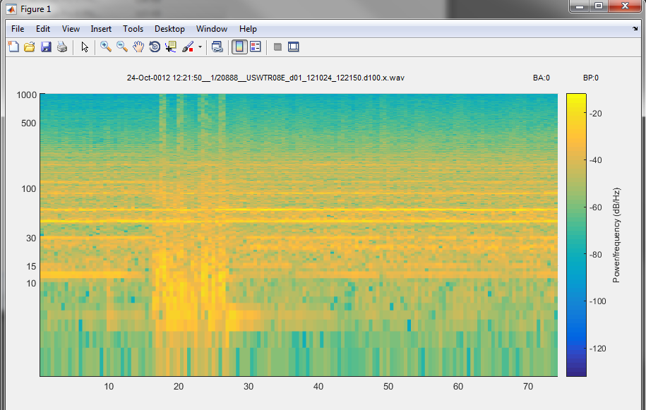

The order duty cycled deployments have little stretches of 75 seconds every once in a while for some reason. This one starts with it. You can see the date, filename, and current stretch at the top of the figure. This deployment is chuncked into 20888 continuous stretches with some sort of duty cycle break in between each of them (usually 5 minutes). At the top right you can see BA and BP both reading 0. If you press B for fin whales or N for minkes you can toggle that reading to 1 and it is saved in a vector.

The basic navigation are like vim controls (sort of). J,K load the previous and next stretch respectively, while H, L load the previous and next stretch marked 1 for BP (if they exist). So you could go through and mark all the stretches you think have bp calls in them and get back to them easily, or export a list for further processing.

Press M to mark calls. Cross hairs should appear. You can click on calls, or press any keystroke. The keystrokes are recorded so if you think you can separate calls from two simultaneous vocalizing animals or want to indicate a break or anything else you can label any call with different keystrokes.

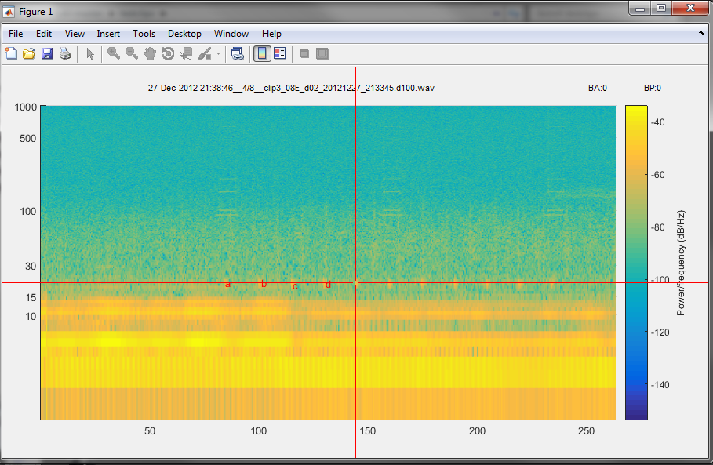

Press <return> when done. Press D to delete marked calls in the current stretch. The program finds the center of these calls as mentioned above and saves the indices and what file to find them in in a cell array for export or later analysis. Also mainly as debugging it’ll display plots of the waveform (filtered) and SNR in two separate figures.

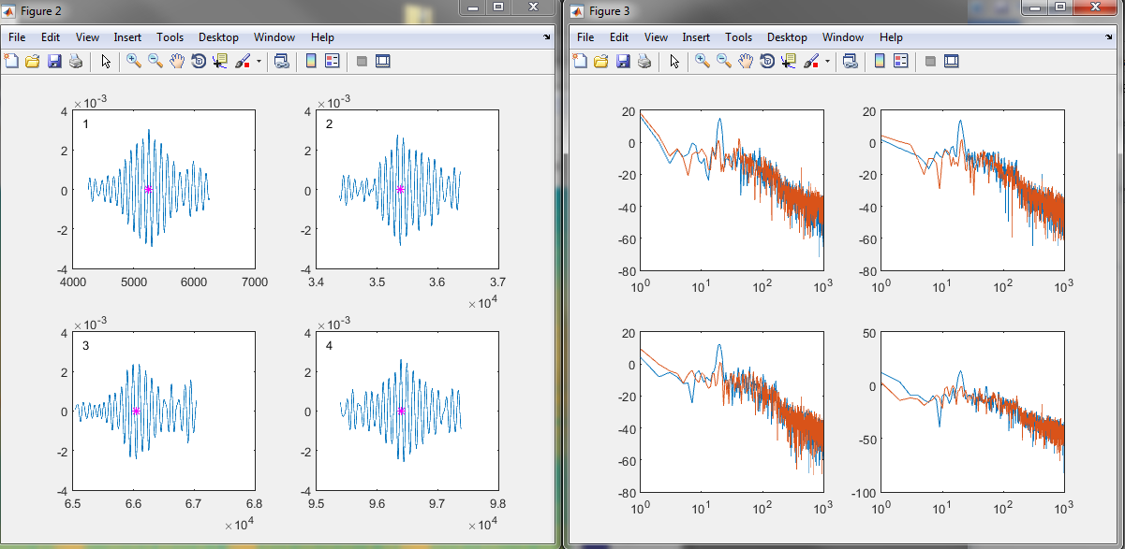

Seconds in the stretch and INI are displayed in the matlab console window along with SNR values. Again, at this point just for debugging, but everything is also saved into cell arrays.

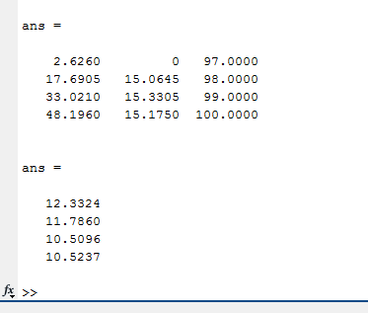

The first matrix has the following columns: seconds, INI, keycode for selection keystroke. The seond matrix is the SNR values.

When you’re done with a session you can save everything to a *.mat* by pressing S and open it later with O.

**Command keys**

% f -- open a directory find all xwavs and split them into chuncks

%(stretches) based on cpmtomis stretcjes om duty cycled data (tend to be

% about 5 minutes). If the whole xwav is continuous it splits it into 5 min

% stretches.

%

% s -- save a .mat file of all vars

% o -- open a .mat file of all vars

% z -- save a .wav of current stretch

% p -- save a table of bp calls with info (currently disabled).

%

% m -- mark calls. looks from a second on either side of the click finds

% the peak and saves that position in bppos{index};

% d -- delete marked calls

% q -- display marked calls

%

% b -- mark a stretch as containing at least one bp 20hz call.

% n -- mark a stretch as containing at least one ba train.

%

% g -- go to a particular chunck (by index)

% hjkl -- vim controls (sort of) j k go up and down one stretch h l go up

% and down one containsbp

%

% t -- load a file of times to mark those stretches as containsbp.

% y -- load xbat detections (currently disabled) and mark strestches as

% containsbp

%

% i -- toggle the spectrogram display between log and linear.

%

% x -- enter debug mode (keyboard).

%

% 1 -- play stretch on screen

% 2 -- pause/resume playing stretch

% 3 -- play at 10x speed (for bp calls)

% 4 -- filter out high freq. and play at 10x speed (for bp calls)

%

% 0 -- filter spectrogram for bp calls

% r -- redraw current stretch

% 9 -- a contrast/brightness preset I like for bp calls

% 8 -- brighter

% 7 -- darker

% 6 -- more contrast

% 5 -- less contrast

%

% c -- reset contrast and brightness to auto

%

%last updated: 13Feb2017

%~wrc