Imagery handwriting EEG data
- Data
  - The data is from EEG (brain signals) recorded during a single participant’s performing of handwriting imagery (imagining the processing of handwriting but not actually doing it). The content of imagined handwriting is the 26 alphabets.
  - The handwriting imagery task goes like this: the participant sat in front of a computer monitor and wore an EEG cap recording the EEG signals from the head. Every three seconds, an alphabet (e.g., “k”) was shown on the screen for 200 ms and the participant was required to imagine the process of handwriting this alphabet.
  - The data is organized as a typical machine learning setting, i.e., data samples + labels. There are 7800 data samples (300 samples for each alphabet). Each data sample is a 2d matrix with size of 24*801 where 24 is the number of electrodes (channels) on the EEG cap and 801 is the number of time points (equally distributed between -200 ms to 3000 ms) after the presentation time of each alphabet, i.e., the sampling frequency (sampling rate) is 250. Thus, the entire data samples were put into a 3d array with size of 24*801*7800. The label information was put into a single vector with matched length (7800). There are 26 different values (1 to 26) in the label, corresponding to each alphabet.
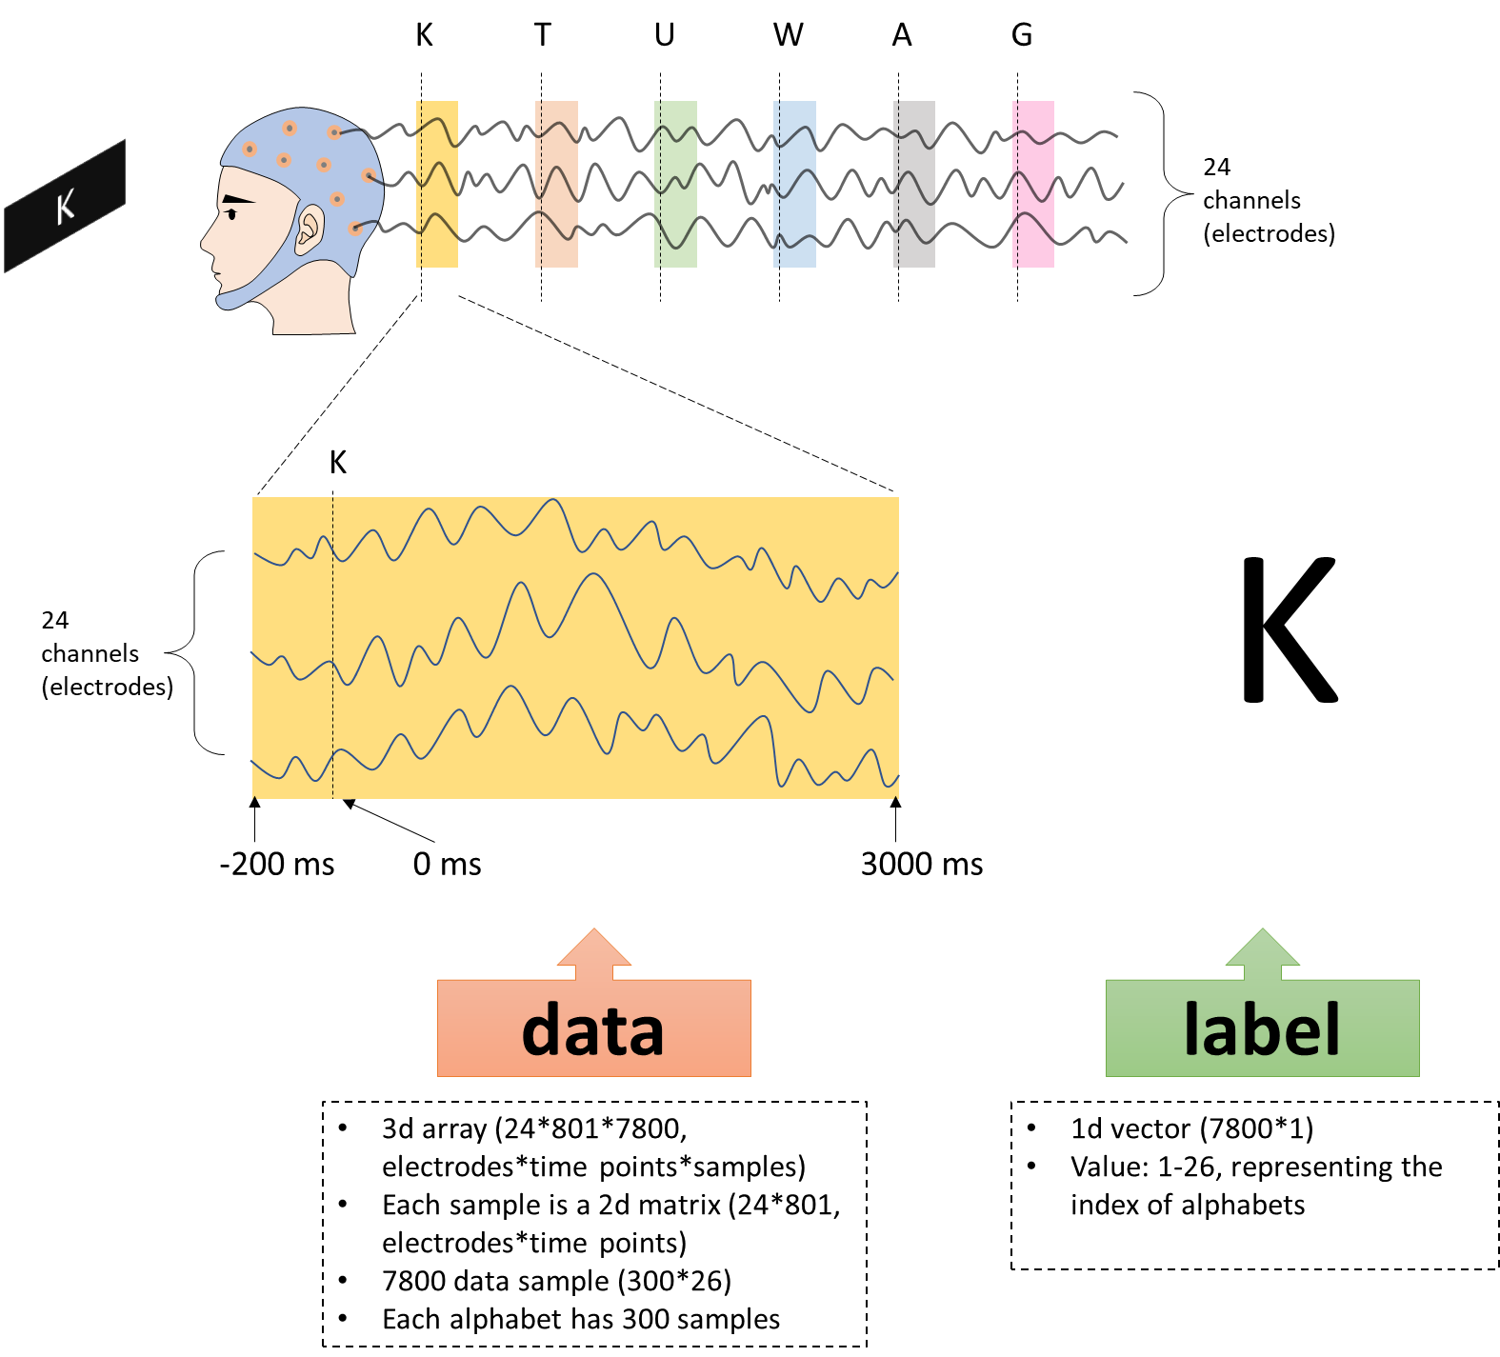
Figure 1.

  - The dataset has been pre-processed with major artifacts removed, baselined, and bandpass filtered between 0.1-45 Hz. Principal Analysis Method had been used to remove large-amplitude artifacts, so it is possible that some data samples are not fully-ranked because a few PC has been removed (but relatively few).
  - The 24 channels (electrodes) with their labels rough positions are shown on Figure 2.
Figure 2.
  - The data can be downloaded from https://www.dropbox.com/s/2ug002c1btxkvvg/data_EEG_AI.mat?dl=0
  - The data is in Matlab format. If you load it into Matlab, you would see the following in the workspace.
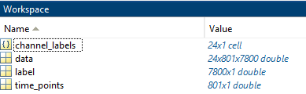
  - The variable ‘channel_labels’ contains the labels of the channels (electrodes, see Figure 2). The variable of ‘time_points’ contains the time information for each single data point in the data sample (‘data’). The meaning of ‘data’ and ‘label’ can be referred to from 1.3. These two are the key information for your classifier development.
  - You can also load the .mat file into different programming language environment (with mat importing package installed). If you load into Python (in Spyder) with the help of ‘loadmat’ package. You would see:
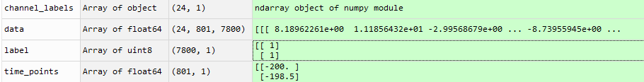
  - To get to know the data, we can try to plot the single trial data sample and the average pattern of data sample from the same alphabet. Figure 3(a,b) shows the data pattern for a single data sample (for the alphabet ‘A’) in two different ways. Figure 3(c,d) shows the data pattern for the average of all data sample for the alphabet ‘A’ (300 in total). It can be seen that the averaged pattern shows clear structure of brain response activity for processing and imagining writing the alphabet ‘A’. However, the classifier should be developed to classify the data sample at single sample level (e.g., Figure 3a and 3b), which is what makes it challenging. The Matlab script for plotting Figure 3 is provided. You can play around with it (e.g., plotting different alphabets and comparing them). You can use the languages you are familiar with (e.g., python, R) to play around with the data.
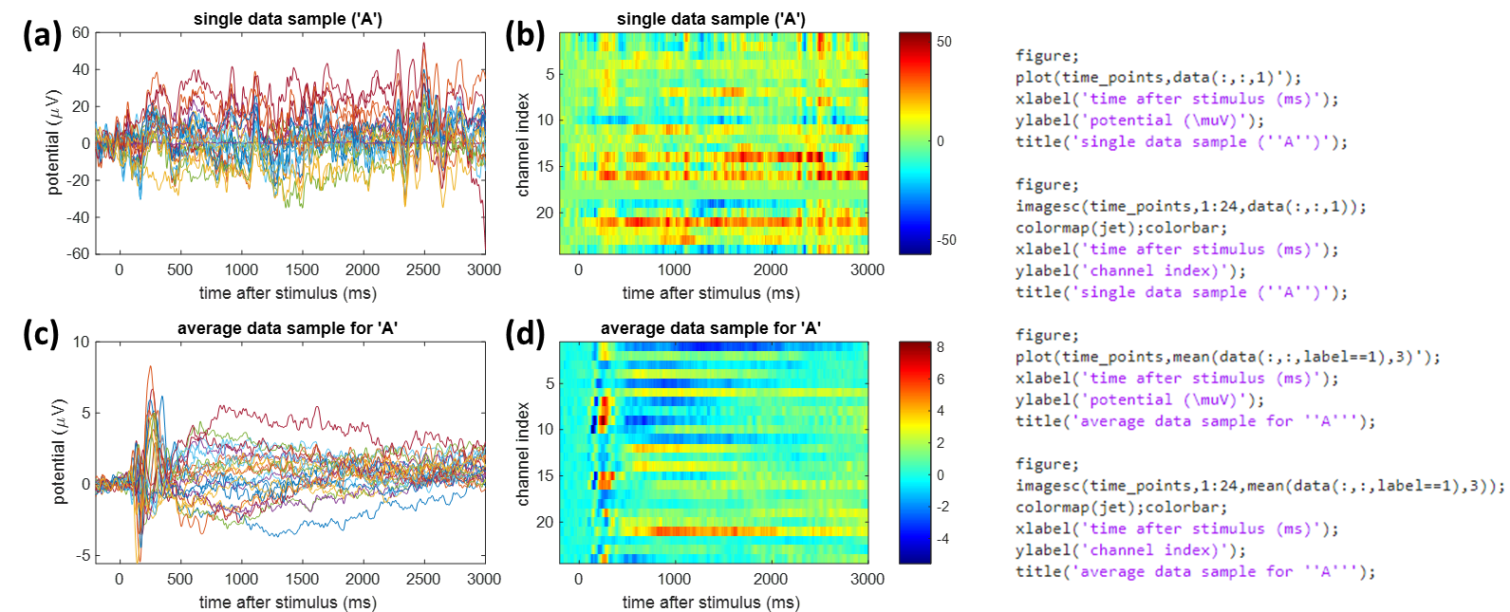
Figure 3.

- Neural decoding
  - You can develop a classifier based on typical machine learning approach: training the classifier on a training data set and applying the classifier on a testing (or called validation) data set. This means that it is required to split the data samples (7800 of them) into training and testing set. You can also use k-fold method to do the training-and-validation work.
  - You may start by deploying a simple CNN neural network to classify this data by treating every sample as a 2D image. After that, we may discuss how to deploy more sophisticated neural networks to improve the classification accuracy.

