**Reports in VDJbase**

## Genotype

Genotype displays a graphical analysis of the alleles observed in selected samples.The left blue column represents the certainty level in log scale (log(lK)). If gene does not appeared in specific genotype samples, compared to other samples, their allele is set to “unknown”(Unk). ‘Del’ represents a double chromosome deletion of this gene, and ‘NRA’ represents non-reliable allele. Genotype interactive graph allows the users to modify parameters to explore the genotype data according to their interests. For instance, users can focus on specific alleles or screen the results by their certainty level(Kdiff parameter). The graph can visualize 1-20 genotypes to allow comparison between individuals. Each column in both panels represents a different sample.

Individual genotypes are also available directly from the Samples window.

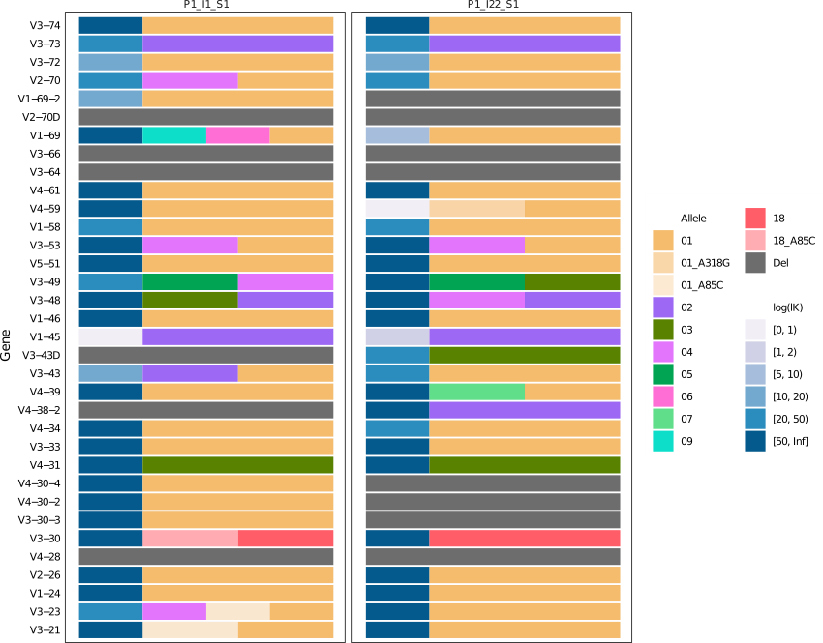

## Genotype Heatmap

Row: each row represents a different sample.

Column: each column represents a different IGH gene.

Colors: correspond to the different alleles.

White lines: correspond to a low lK value (lK <1) of the chromosome haplotype.

White (“NRA”): non-reliable allele (ambiguous allele)

Dark gray (“Del”): inferred double chromosome deletion

Light-gray(“Unk”): unknown

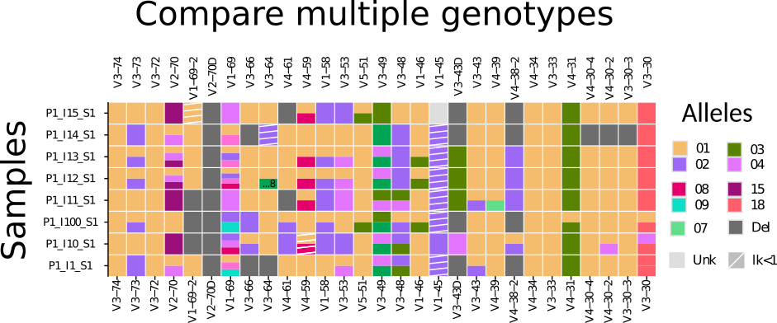

## Haplotype for individual sample (available from the Samples window)

Haplotype inference provides an allele map to the individual chromosomes, hence gene and allele assignments to a sequence are very important. The V haplotype by IGHJ6 for individual “sample”. Each color represents a different allele, dark gray represent a gene deletion event on a certain chromosome, black represents a non reliable gene (NR), and off-white represents a non reliable allele (NRA). Users can generate individual haplotype by click on the value at the Haplotype column. For example, click on "IGHJ6" to generate haplotype graph for "Sample" by IGHJ6 anchor.

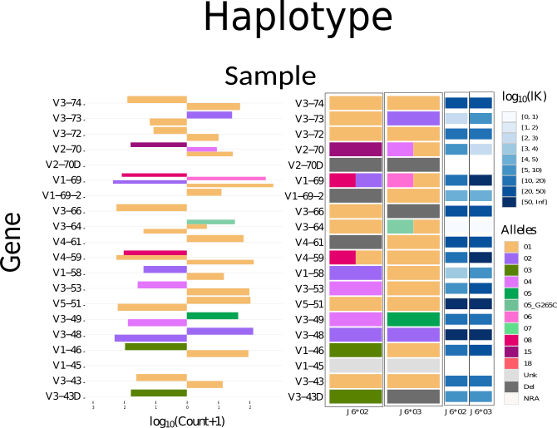

## Haplotype Heatmap

Haplotype must be according to the same anchor for comparison between samples. The upper panel corresponds to IGHJ6*02 and the lower to IGHJ6*03. Each row in both panels represents a different sample. If the evidence is not strong enough (K is lower than a certain threshold (set to 1000 by default)), haplotype inference for this allele is set to “unknown”. The colors correspond to the different alleles, dark gray corresponds to inferred double chromosome deletion, black corresponds to non-reliable gene (NR), off-white to NRA, and white lines to a low lK value (lK <1) of the chromosome haplotype. NRA marked also as e.g “[*3]”, full annotation is displayed at the bottom legends.

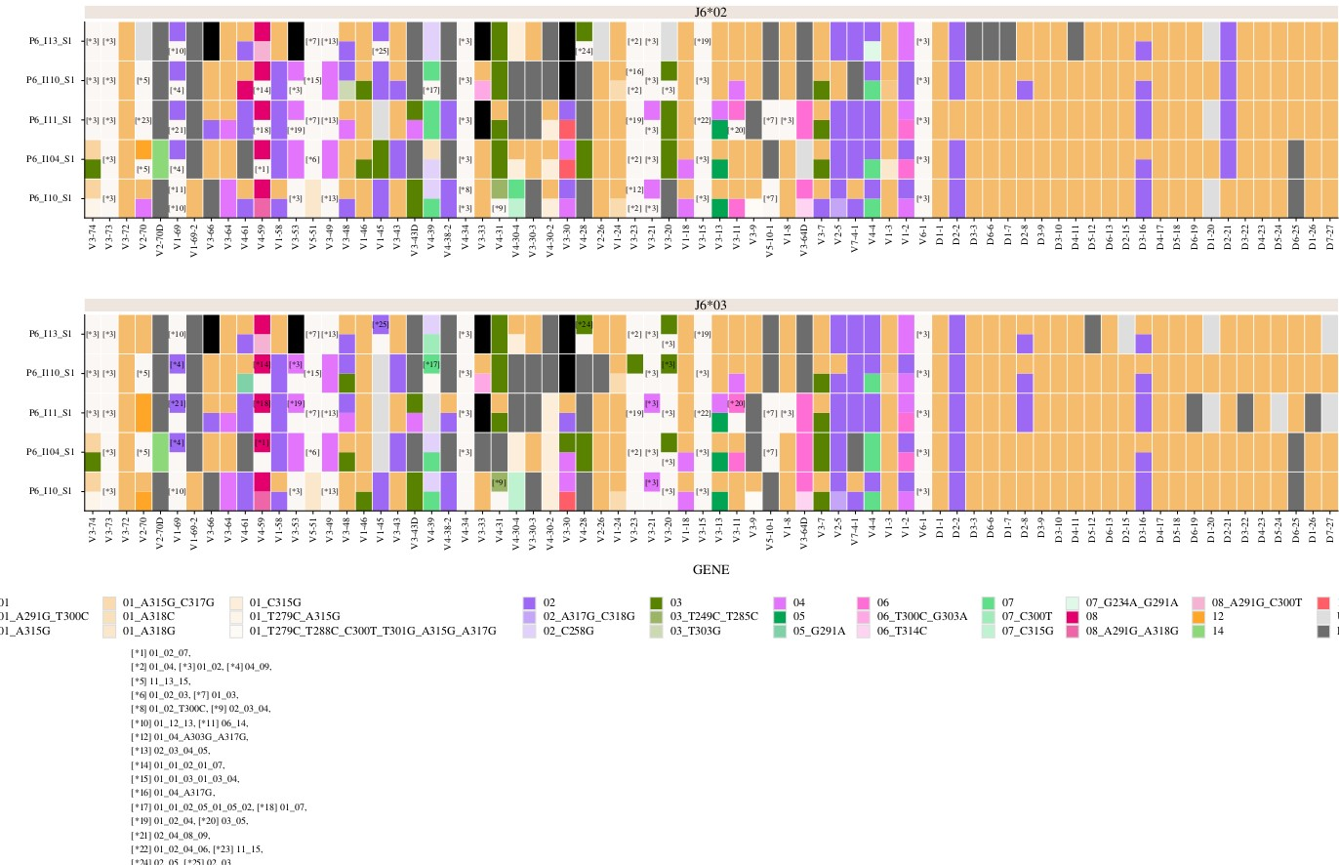

## Allele appearance graph

This graph represents the allele distribution for each gene. Users can compare the distributions of alleles among different populations. The left Y axis represents the number of individuals, the right Y axis represents the frequency in selected population. The word ‘appearance’ is used here to indicate that the report does not distinguish between homozygous and heterozygous usage..

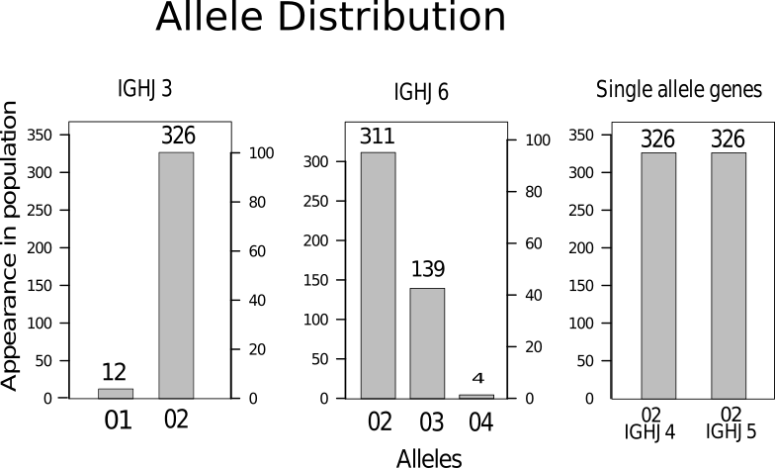

## Heterozygosity graph

Heterozygote graph allows the user to assess the level of homozygousity/heterozygousity for each gene in different populations. Frequency values appear as pop-ups when users move their mouse on the corresponding bar.

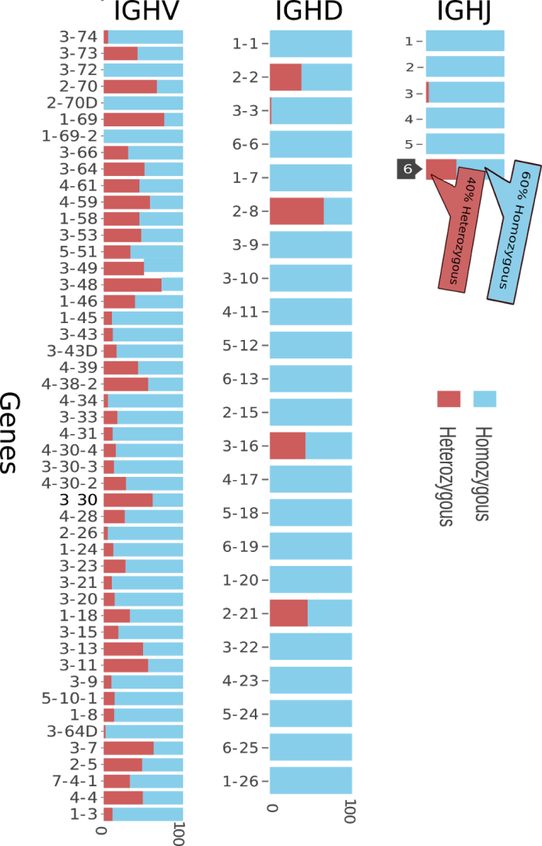

## Allele usage

Provides, for each gene, a count of the number of alleles that are found across the samples selected.

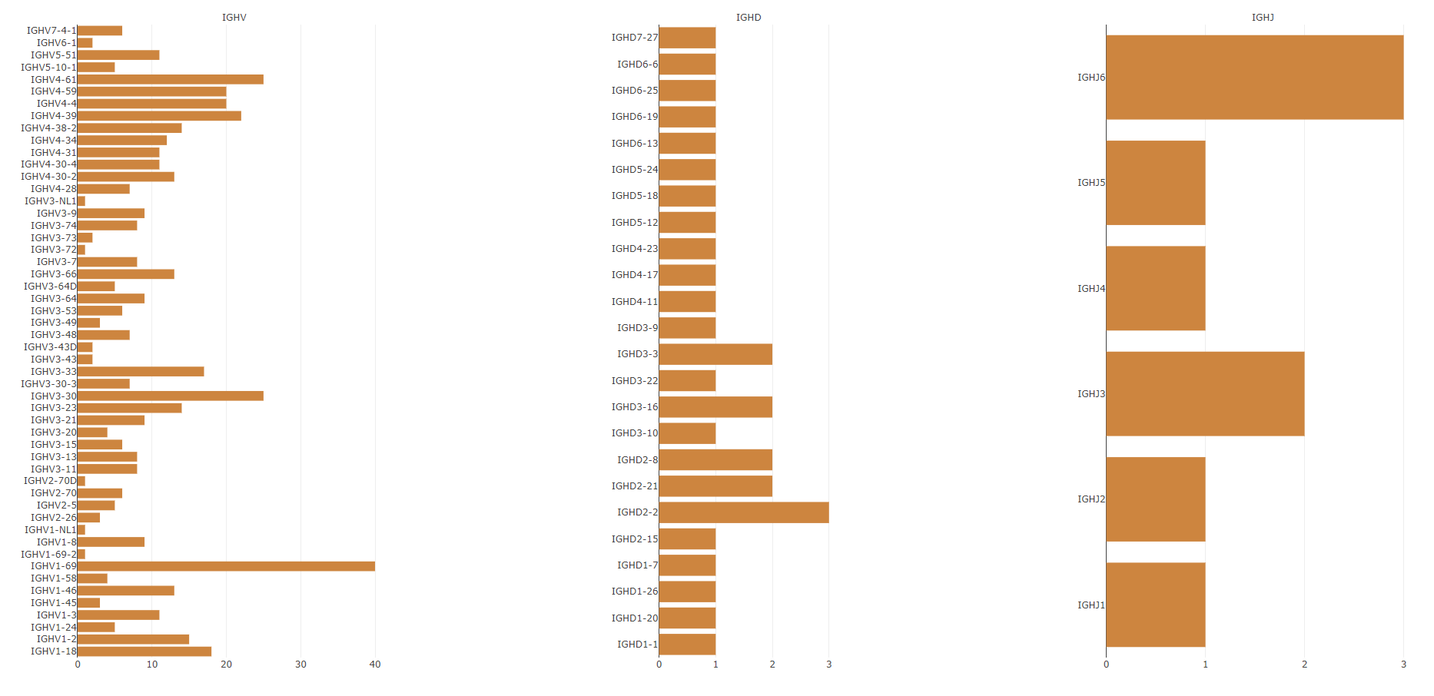

## Gene Frequencies

Provides a view on the gene expression in the population. Each point represents a patient, and color represents the gene's family. The genes ordered by their relative chromosome position.

