Recreating

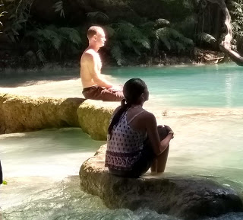

For countless lives my eyes turn toward you,
rolling upward, inward, into that primordial eye,
Peering into these lives and deaths in search of freedom.
Lost in the spirits crown, forgetting world and self
Your formless bliss and gentle Om
release nectar from the spirits crown
and flood me with the intoxication of the gods.
Calling me home, this little mind becomes vast,
soaring into silent infinity beyond even OM.
I open my eyes, and still, I see you everywhere.
OM fills space, becomes pulsation
moves the visible and the invisible
and settles into form and sacred life.
You show me yet you do not release me.
Is this the reason to be here, to see
you striving behind all eyes - reptiles, mammals humans
desiring, suffering, striving for freedom
recalling and remembering yourself?
Forgive me for not seeing you before
trying to escape my isolation
seeking freedom beyond your creation
treating it as an essential nothing,
an accident to be conquered, transcended,
overcome; to put an end to suffering,
not grasping that your creation faithfully
conspires toward your quiet essence.
Quiet, you await for us to become quiet,
learning to do nothing as you do everything.
You make me still and calm amidst your storm,
maturing into purpose and presence,
trusting me as a guardian of your being,
free to be a person and care for other persons.
Within Your acts of recreation,
With infinite tones of color and sound,
you enchant me through her eyes and their glow.
Reflecting the light of your eternal eye
they enter my gaze and become my sight.
You make us one in eternal giving:
recreating, procreating another being
we replicate Your endless, moving image.

Subscribe to my mailing list by sending an email to enckwilliam@protonmail.com

All Essays And Books

