AMAZON SERVICES AGREEMENT
Effective Date: 8-28-26

This Amazon Consulting Agreement (the “Agreement”) is made between Chief Marketplace Officer, Inc. (“CMO”), located at 4449 Nogales Drive, Tarzana, CA 91356, and Ex Import USA Inc. DBA Elleebana an Illinois Corporation with address of 2400 Hassell Road, Hoffman Estates, IL. 60169 (“Company”). Each may be referred to as a “Party” and collectively as the “Parties.”

RECITALS
WHEREAS, Company operates in the business of manufacturing, marketing, and selling products through various sales platforms, and;
WHEREAS, CMO provides consulting services on branding and marketplace strategy for third-party platforms, and;
WHEREAS, Company desires to engage CMO for its expertise in navigating third-party marketplaces.
THEREFORE, in consideration of the mutual promises set forth below, the Parties agree as follows:

1. Scope of Services and Payment Terms
1.1 Services and Payment Terms
(a) Services Provided: Chief Marketplace Officer, Inc. (“CMO”) will perform services on the specified third-party marketplaces listed in Schedule A, as requested by the Company or as needed. These services include protecting the Company's intellectual property rights and preventing unauthorized sales on these marketplaces and other consulting services on branding and marketplace strategy for Amazon.com.
(b) Company’s Responsibilities:
- The Company will provide a list of its trademarks, logos, and copyrighted materials (Schedule C).
- It will implement a Reseller Policy (Schedule E) and notify all resellers about it. The Company must keep proof of these notifications.
- The Company will introduce a warranty for products sold by authorized resellers on these marketplaces.
- It will establish a Minimum Advertised Price Policy.
- The Company will maintain and update a list of authorized and unauthorized resellers (the “Reseller List”).
(c) Weekly Reports: CMO will provide the Company with a weekly list of parties infringing on the Company’s intellectual property. If the Company doesn’t respond, CMO will not take enforcement action unless later instructed to do so.
(d) Enforcement Procedures: CMO will follow enforcement procedures as requested by the Company. This includes notifying unauthorized sellers and the marketplace about infringing products. CMO will only use a Company-assigned email for these activities and comply with any brand requirements.
(e) Reimbursement: CMO can be reimbursed for reasonable pre-approved expenses related to brand protection, like test purchases, provided receipts are submitted with invoices.

1.2 Payment
Company will pay CMO a monthly service fee of $3,500 + 8% of monthly Gross Amazon Sales due on the first business day of each month. Payments can be made via Zelle, Venmo, Check, PayPal, or ACH.

2. Intellectual Property Rights
2.1 Ownership of Intellectual Property
CMO retains ownership of its intellectual property, including all methods, techniques, and tools used during the consulting process. Company retains ownership of its own intellectual property and trademarks, granting CMO a limited, non-exclusive license solely for the purpose of fulfilling this Agreement.
2.2 Work for Hire
All Work Product created specifically for the Company by CMO under this Agreement will be considered a “work for hire” as defined in U.S. law. CMO assigns any rights, title, and interest in such Work Product to Company, effective upon full payment.

3. Term and Termination
3.1 Term
This Agreement begins on the Effective Date and continues for an initial term of 6 months. The Agreement will automatically renew for subsequent one-month terms unless terminated by either Party as outlined below.
3.2 Termination for Cause
Either Party may terminate this Agreement with immediate effect by providing written notice if the other Party materially breaches any provision of this Agreement and fails to remedy such breach within 30 business days.
3.3 Termination for Convenience
Either Party may terminate the Agreement without cause by providing written notice at least 30 days before the end of the current term. Upon termination, all licenses and rights granted to CMO under this Agreement shall cease.
3.4 Effect of Termination
Upon termination, both Parties must return or destroy the other Party’s confidential information. Any outstanding fees owed to CMO must be settled within 30 days of termination.

4. Independent Contractor Relationship
This Agreement does not create any employment, agency, partnership, or joint venture relationship between the Parties. Both Parties agree that CMO is an independent contractor, free to provide similar services to other clients.

5. Confidentiality
5.1 Definition of Confidential Information
Each Party may disclose Confidential Information to the other, which includes proprietary data, trade secrets, business strategies, and other sensitive information.
5.2 Obligations of Confidentiality
Each Party agrees to use the Confidential Information solely for the purposes of this Agreement. Upon termination, each Party shall return or destroy the other Party’s Confidential Information as requested.
5.3 Exceptions
Confidential Information does not include information that is publicly known, disclosed by a third party without restriction, or independently developed by the receiving Party without use of the disclosing Party’s information.

6. Indemnification and Limitation of Liability
6.1 Indemnification
Both Parties agree to indemnify and hold harmless the other Party from claims arising out of any breach, negligence, or wrongful acts under this Agreement. Specific terms are detailed in Schedule D.
6.2 Limitation of Liability
Neither Party shall be liable for indirect, incidental, or consequential damages, including loss of profits, even if advised of the possibility of such damages.

7. Dispute Resolution and Governing Law
7.1 Pre-Litigation Mediation
In the event of a dispute, the Parties agree to seek resolution through non-binding mediation with a mediator from JAMS in Los Angeles, California. Should mediation not resolve the dispute, either Party may pursue legal remedies as detailed below.
7.2 Governing Law
This Agreement shall be governed by the laws of the State of California. Both Parties consent to the exclusive jurisdiction of state or federal courts in Los Angeles County for the resolution of any disputes.

8. General Provisions
8.1 Notices
All notices related to this Agreement shall be in writing and sent to the contact details provided by each Party via email
8.2 Entire Agreement
This Agreement, including all schedules, represents the entire understanding between the Parties and supersedes all prior agreements, written or oral. Any modification must be in writing and signed by both Parties.
8.3 Force Majeure
Neither Party shall be held liable for failure to perform obligations under this Agreement if caused by events beyond their control, such as natural disasters or pandemics.
8.4 Severability
If any provision of this Agreement is found invalid, the remaining provisions will remain in full force and effect.
8.5 Assignment
Neither Party may assign this Agreement without the prior written consent of the other Party.

9. Execution and Signature
The Parties acknowledge that they have read and understood this Agreement, and by signing below, agree to its terms.

Ex Import USA Inc. DBA Elleebana

Signature: ________________________
Name: __ __Gilbert Valverde________
Title:_____COO________
Date: ___8.28.26__________________

Chief Marketplace Officer, Inc.
Signature: ____ William Fikhman_______
Name: William Fikhman
Title: CEO
Date: __8.28.26_______________

Schedule A – Designated Third Party Marketplaces
Chief Marketplace Officer, Inc. agrees to provide Consulting Services for the following third party marketplaces:
- Amazon.com
Additional marketplaces may be included as agreed upon by both Parties through a written amendment to this Schedule.

Schedule B – Consulting Services
As part of the Consulting Services, Chief Marketplace Officer, Inc. will provide the following services to the Company:
Deliverables:
- Manage USA Seller Central Account - Oversee replenishment of USA Seller Central inventory
- Develop product optimization priority list and roadmap
- Optimize product pages – Brand Name, Title, Images, Bullets, A+ Content, Keywords
- Daily/Weekly/Monthly general management of the Seller Central Account
- Setup of any plug-in software – i.e., repricing, review improvement, analytics
- Bi-Weekly status meeting with clear actionable to-do’s for both sides Schedule C – Intellectual Property
The following outlines the Intellectual Property rights granted under this Agreement:
- Chief Marketplace Officer, Inc. IP
  - CMO retains ownership of all methods, tools, and processes used in providing the Consulting Services. The Company receives no rights to these assets, except as required for the delivery of the Services.
- Company IP
  - Company retains all rights to its trademarks, logos, and proprietary content, which CMO may use solely for the purpose of providing the Consulting Services.
- Work Product
  - Any deliverables created specifically for the Company, such as reports, analyses, images/graphic designs and other materials, will be considered “work for hire” and owned by the Company upon full payment.
- Trademarks/Word Marks
  - The following comprise the trademarks and logos of company for which it grants to Chief Marketplace Officer, Inc. a non-exclusive, limited, and revocable license to allow Chief Marketplace Officer, Inc. to perform the Consulting Services.

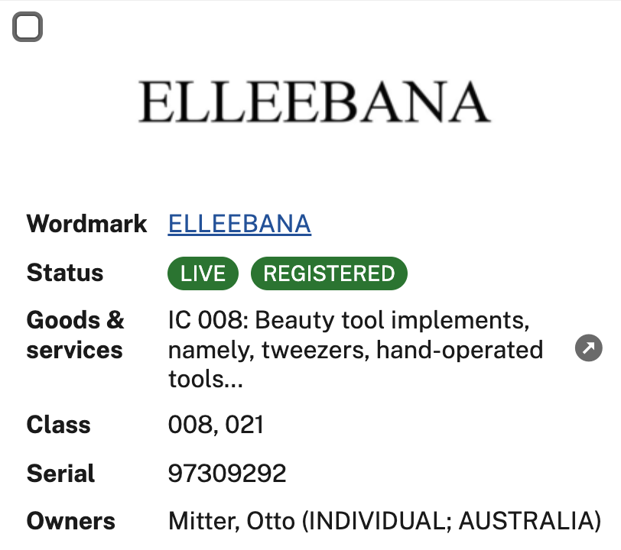

Schedule D – Indemnification Details
- Company Indemnification
  - Company agrees to indemnify and hold harmless CMO from claims arising from:
a. Breach of this Agreement by the Company.
b. The Company’s negligence or misconduct.
c. Any claims related to the Company’s products, including intellectual property disputes.
- CMO Indemnification
  - CMO agrees to indemnify and hold harmless the Company from claims arising from:
a. Breach of this Agreement by CMO.
b. CMO’s negligence or misconduct in providing the Services.
- Notice of Claim
  - The indemnified Party shall promptly notify the indemnifying Party of any claims or actions. Failure to notify will not relieve the indemnifying Party of its obligations except to the extent that the delay has prejudiced the defense of the claim.

Schedule E – Sample Reseller Policy

INSERT BRAND Reseller Policy

To protect our trademarks, logos, copyrighted materials, and ensure clarity for customers, INSERT BRAND has created this Reseller Policy. All authorized resellers (referred to as “Reseller”) who purchase INSERT BRAND products (the “Products”) for resale or distribution are required to follow this Policy. Unauthorized use of INSERT BRAND’s trademarks may violate federal, state, or international laws regarding infringement and unfair competition. If you are an approved Reseller, please refer to your reseller agreement for any additional requirements related to using INSERT BRAND trademarks.

1. Guidelines for Trademark Usage

You are permitted to use INSERT BRAND trademarks (but not logos or taglines) to identify our products, services, and programs in your packaging, promotions, or advertising materials, provided the following rules are met:

- Company Names and Domains: INSERT BRAND trademarks cannot be used in your company name, product name, or domain name.
- Logos and Taglines: Unless you have a separate licensing agreement with INSERT BRAND, our logos cannot be used.
- Avoiding Confusion: Your company name or product name must not be similar enough to any INSERT BRAND trademark to create confusion. Also, you cannot use INSERT BRAND trademarks in a way that implies any form of sponsorship, affiliation, certification, or endorsement by INSERT BRAND unless such an arrangement exists
- Proper Use:
    - Do not shorten, modify, or abbreviate any INSERT BRAND trademark.
    - Trademark Attribution: When using INSERT BRAND trademarks, include this attribution: “[List of marks used] are trademarks of INSERT BRAND.”
    - Original Packaging: You must sell all INSERT BRAND products in their original packaging, without altering labels, specifications, or any advertising content that came with the Products.

2. Reporting Unauthorized Sellers
If you become aware of or suspect anyone reselling or distributing INSERT BRAND products without authorization, please inform INSERT BRAND immediately, including any relevant contact or company information.

3. Restrictions on Online Marketplaces
Resellers are prohibited from advertising or selling INSERT BRAND products on any third-party online marketplaces without prior written consent from INSERT BRAND. This includes selling to other distributors or resellers who may in turn list the Products on such platforms.

4. Handling and Storage of Products
Resellers are required to handle and store INSERT BRAND products according to our handling and storage guidelines, ensuring safety and quality control.

5. Compliance with INSERT BRAND Policies
As a reseller, you must comply with INSERT BRAND’s Minimum Advertised Pricing Policy (MAP), as well as other business practices, including warranty terms.

6. Warranty Support
You are authorized to extend INSERT BRAND’s original manufacturer warranty to your customers under the terms set by INSERT BRAND. You may not alter or misrepresent the manufacturer’s warranty, nor offer additional warranties without authorization. All warranty and customer support obligations must be met in accordance with INSERT BRAND guidelines, which may change over time.

7. Use of Copyrighted Material
Any use of INSERT BRAND’s copyrighted materials, such as website content, images, videos, and text, is strictly prohibited unless prior approval is granted. If authorized, proper copyright notices must accompany any use of these materials.

8. General Provisions
This Policy is considered part of any agreement you have with INSERT BRAND regarding your purchase or sale of the Products. In case of any conflict between this Policy and your agreement, the terms of the agreement will take precedence. INSERT BRAND reserves the right to update this Policy at any time and may prohibit any use of its trademarks that it deems unlawful or improper.

By signing below, you acknowledge and accept the terms and conditions outlined in the INSERT BRAND Reseller Policy, including our right to discontinue business with any reseller who violates this policy. Additionally, international sales of INSERT BRAND products are prohibited. Approved resellers may only sell INSERT BRAND products to end customers in the United States and Canada.

INSERT BRAND
Signature: _______________________
Name: __________________________
Title: ____________________________
Date: ___________________________

Reseller Information
Company Name: _________________
Signature: _______________________
Name: __________________________
Title: ____________________________
Date: ___________________________

