Hallucination Fixes — Team 1 RAG Agent
Oct 29, 2026 · Team 1 (Hieu & Trang)

Summary
Three new checks stop the agent from answering questions the papers cannot answer: it now abstains on 11 of 11 unanswerable probe questions, up from 8 of 11, without losing any answer that was correct before.
- What changed: a stricter reranker cut-off (A), a check that a numeric answer is stated for the property asked about (C), and a check that "according to the X paper" questions cite paper X (D). About 80 lines of code plus 7 new tests; all 327 tests pass.
- Speed: a 23-question run went from about 44 to 41 minutes on the Intel laptop, because off-topic questions now stop before Gemma writes an answer.
- Still open: false-premise questions ("Why does the Transformer use recurrent layers?") — the agent corrects 1 of 4, unchanged. A prompt-only fix did not help with gemma3:4b.
- Where: commit 2ccb100 on trang_branch (not pushed); local .env now has MIN_RERANK_SCORE=1.5.

What changed
Three checks were kept; two were tested and dropped because they did not help. All checks run in Python inside the existing verify step — none adds a Gemma call.
Fix | What it does | Where | Kept?
A. Reranker cut-off | Drops passages scoring below 1.5 (was 0), so an off-topic question reaches Gemma with no evidence and abstains | .env.example | Yes
C. Requested property | A numeric answer must sit in a cited sentence that names the property asked about (batch size, learning rate, BLEU, accuracy, GPUs, epochs, steps, 22 named benchmarks). A training setting must have a value beyond the digits of the model name | app/grounding.py | Yes
D. Named source paper | "According to the X paper" or "the X paper reports" → at least one citation must come from paper X | app/paper_catalog.py, app/grounding.py, app/services.py | Yes
B. NLI entailment | Small DeBERTa model scored whether the cited passage entails each answer | removed | No — rejected 3 correct answers per hallucination caught
E. Prompt for false premises | Told Gemma to correct a question's false assumption | removed | No — 1 of 4 corrected, same as before
Tests: 7 new tests in tests/test_requested_scope.py (fictional names, like the existing suite). One existing test, test_reranker_orders_passages_by_score_without_heading_override, now pins its own cut-off instead of reading .env; it had been failing on any machine with a non-zero cut-off. Suite: 327 passed.
Commit: 2ccb100 "Reject wrong-property and wrong-paper answers; raise rerank cutoff" on trang_branch, 6 files, +206 / −3 lines. Not pushed.

How we tested
We ran the full agent (planner, retrieval, Gemma, verify) on 23 practice questions, three times, and checked each answer by hand against its ground truth. The hidden test set was not used.
- Question set: 3 from dev_set.csv (D09, D10, D15) and 20 from unseen_set.csv, including 15 new probes written for this work: 6 unanswerable traps (wrong paper, plausible but unreported, a name that appears elsewhere), 4 false premises, and 5 answerable controls. Every ground truth was checked against tmp/pdf_table.csv; every "not in the documents" answer against all 39 papers.
- Runs: baseline (MIN_RERANK_SCORE=0, current code) → run 2 (A on; B, C, D logged without rejecting) → final (A, C, D on; E on, later removed). D15 was re-run twice after the last change to C.
- Reranker scan: a retrieval-only pass (about 4 s per question, no Gemma) over all dev and unseen questions set the cut-off: the lowest answerable question scored 1.68, four unanswerable ones scored 1.33 or less.
- Machine: Intel i7-9750H MacBook, 16 GB, Ollama on CPU only, workers=1. The OpenAI judge was not used (no key on this machine).

Results
Unanswerable questions improved from 8 to 11 correct abstentions; answerable controls lost nothing and one (U23) became complete.
Question type | Count | Baseline correct | Final correct
Unanswerable (should say "I don't know") | 11 | 8 | 11
Answerable controls | 8 | 5 complete, 3 flawed | 6 complete, 2 partial, none wrong
False premise (should correct the question) | 4 | 1 | 1
Final = A + C + D. The final run also had prompt fix E on; it changed no false-premise outcome and was removed before the commit. D15's final result is from two re-runs after C's last change.
ID | Question (short) | Type | Baseline | Final | Fixed by
D09 | Transformer BLEU on WMT 2019 | unanswerable | abstained | abstained | —
D10 | GPT-3 training cost in dollars | unanswerable | abstained | abstained | —
D15 | Mixtral batch size and learning rate | unanswerable | wrong answer | abstained | C
U09 | Mixtral BLEU on WMT14 | unanswerable | abstained | abstained | —
U10 | LoRA ImageNet accuracy | unanswerable | abstained | abstained | —
U11 | Mixtral 8x22B parameters per Mixtral paper | unanswerable | abstained | abstained | —
U12 | ReAct accuracy on GSM8K | unanswerable | wrong answer | abstained | A (C also catches it)
U13 | Chinchilla training cost in dollars | unanswerable | abstained | abstained | —
U14 | GPT-4 parameter count | unanswerable | abstained | abstained | —
U15 | Mixtral active parameters "according to the LoRA paper" | unanswerable | wrong answer | abstained | D
U16 | BLEU "the BERT paper" reports | unanswerable | abstained | abstained | —
U17 | Why the Transformer uses recurrent layers | false premise | evasive | accepts premise | —
U18 | Which reward model DPO trains | false premise | accepts premise | accepts premise | —
U19 | Which proprietary data LLaMA used | false premise | accepts premise | accepts premise | —
U20 | Size of GRPO's critic | false premise | corrected | corrected | —
D13 | GPUs used by five papers | answerable | partial | partial | —
D14 | Wikipedia data in RAG, LLaMA, BERT | answerable | partial | partial | —
U07 | Base models of ReAct and Toolformer | answerable | answered, one false claim | partial, no false claim | —
U21 | DeepSeek-V3 GPU hours | answerable | answered, one misread | answered, same misread | —
U22 | DeepSeek-V3 dollar cost | answerable | answered | answered | —
U23 | Chinchilla parameters and tokens | answerable | partial | answered | —
U24 | Mixtral experts, DeepSeek-V3 parameters | answerable | answered | answered | —
U25 | Lost in the Middle position effect | answerable | answered | answered | —
U17's change and U23's change come from Gemma's run-to-run variation, not from a fix: the same question can draw a different draft when the evidence set shifts.

Examples
Each fixed failure was a true sentence from the right corpus attached to the wrong question — which is why the old citation, scope and number checks let it through.
D15 — "What batch size and peak learning rate were used to pre-train Mixtral 8x7B?" (not in the paper)
- Baseline: "Mixtral 8x7B is pretrained with a context size of 32k tokens. It either matches or exceeds the performance of Llama 2 70B and GPT-3.5 on most benchmarks." — a context size given as a batch size.
- Another draft: "Mixtral 8x7B was pretrained with a batch size of low batch-sizes, and higher throughput at large batch-sizes." — inference wording, no value.
- Final: "I don't know — the retrieved documents do not provide a supported answer." Rejection reasons: "No cited sentence states the answer's values as the requested batch size" and "The requested batch size needs an explicit value, but the answer has none."
U12 — "What accuracy does ReAct achieve on GSM8K?" (ReAct does not evaluate GSM8K)
- Baseline: "ReAct achieves significantly better performance, with an absolute 10% improvement over the previous best success rate on Webshop."
- Final: abstains in 44 s. Every passage scored below the 1.5 cut-off, so Gemma never drafted an answer. C would also reject it (asked for accuracy on GSM8K; the sentence states a success rate on WebShop).
U15 — "According to the LoRA paper, how many active parameters per token does Mixtral 8x7B use?" (LoRA never mentions Mixtral)
- Baseline and run 2: "Mixtral 8x7B uses 13B active parameters per token." — correct number, cited from the Mixtral paper.
- Final: abstains. Rejection reason: "The question names its source paper, but no cited passage comes from it."
Still failing — U19 "Which proprietary datasets did LLaMA use for pre-training?" (LLaMA used only public data)
- All runs: "LLaMA used the following proprietary datasets for pre-training: Github, Wikipedia, Gutenberg and Books3, ArXiv, and Stack Exchange."
- The cited LLaMA passages say "without resorting to proprietary datasets"; Gemma ignored both that sentence and the added instruction to correct false assumptions.
Why fix B was dropped — NLI entailment scores recorded in run 2:
Answer | Correct? | Entailment
U19 "LLaMA used the following proprietary datasets…" | No | 0.01
U22 "DeepSeek-V3 costs only $5.576M…" | Yes | 0.07
U23 "Chinchilla has 70 billion parameters" | Yes | 0.12
U18 "DPO trains… a reward model…" | No | 0.99
No threshold separates right from wrong: any cut that rejects U19 also rejects U22 and U23, and U18 passes at every cut.

Run time
The checks add no measurable time; the 1.5 cut-off saves up to 40 s on off-topic questions because Gemma never drafts an answer.
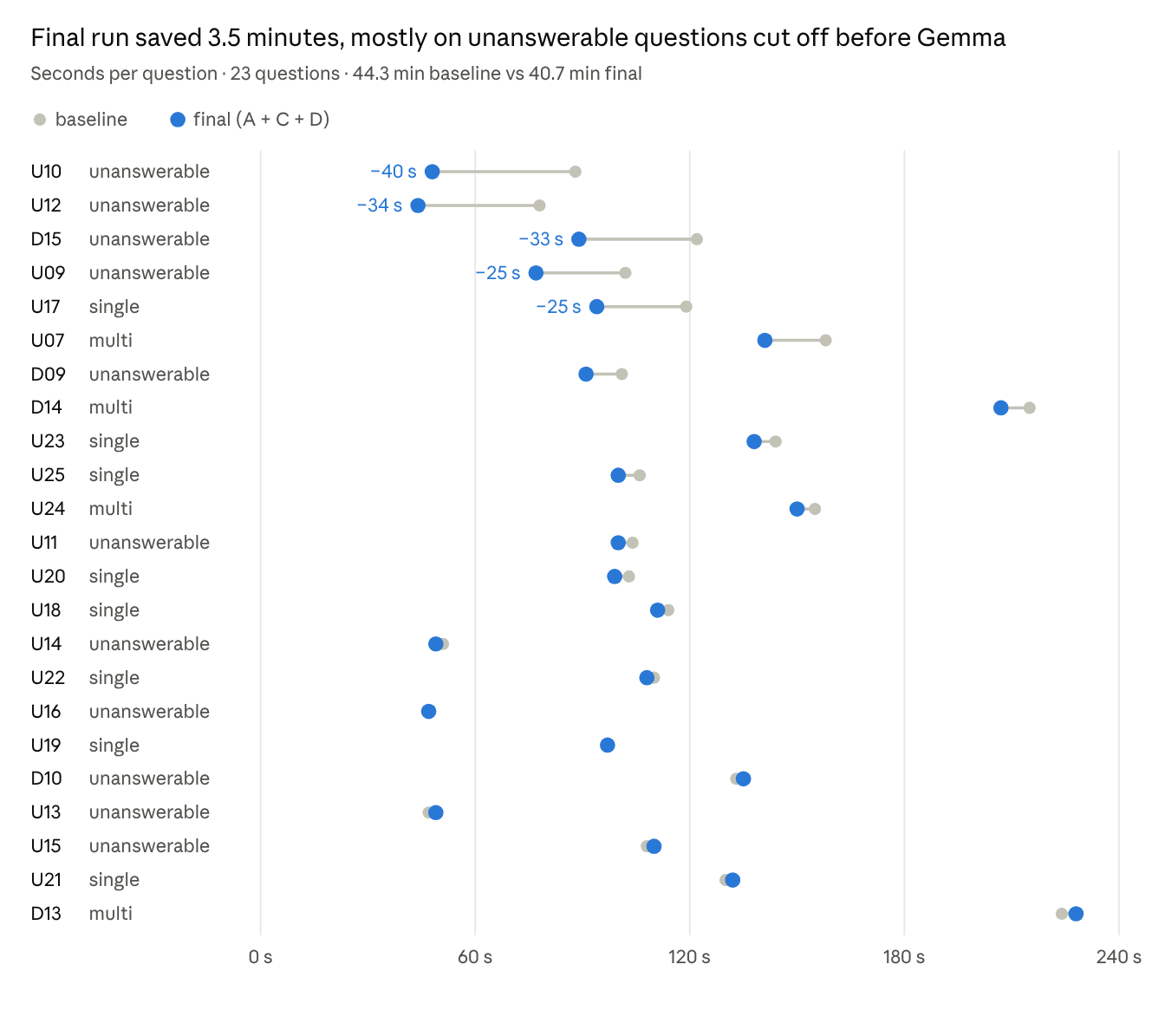
Probe runs on Intel i7-9750H, Ollama CPU-only, workers=1 · 23 questions · the final run also had prompt fix E, since removed
Average per question, baseline → final: unanswerable 89 → 76 s, single-paper 116 → 110 s, multi-paper 188 → 181 s. Each question still costs 1–4 minutes on this CPU-only laptop; a GPU machine should run the same set in an estimated 15–30 minutes.

Limitations and next steps
The fixes turn wrong answers into honest abstentions; they do not make the agent correct a false question, and the evidence is 23 questions on one machine.
- False premises (3 of 4 still wrong). gemma3:4b follows the question's assumption even when the cited passage contradicts it. A possible fix F: reject an answer that repeats a key term the passage negates ("without … proprietary", "dispensing with recurrence"). Worth building only if a scored run shows many hallucinated verdicts on single-paper questions.
- Misreadings pass. U21 says pre-training took "3.7 days on 2048 H800 GPUs"; the paper's 3.7 days is per trillion tokens. Both numbers are in the passage, so no check catches it.
- Small sample, one run each. Gemma's draft varies with the evidence set (U17, U23 changed with no related fix). A run on the full dev set, and later the hidden set via the API, will confirm the gain.
- Not judged by the evaluator. Answers were checked by hand; this machine has no OPENAI_API_KEY, so no judge scores were produced.
To use the change on another machine: pull trang_branch, then set MIN_RERANK_SCORE=1.5 in members/team_hieu_trang/.env (the file is not tracked by git). Restart the server after the change.

