TEAM 1 RESEARCH AGENT

Evaluation Report
26 October 2026 · Team 1 (Hieu & Trang) · Version evaluated: working tree of 26 Oct, 20:50

1 Summary
- Better answers. Dev set score rose from 6.5 to 8.0 out of 15 under the official gpt-4o-mini judge, with fewer hallucinations (2 to 1). Repeat runs vary by about 1-2 points, so expect about 7 on average (section 9).
- About 3x faster. Mean time per question fell from about 280 s to 98 s, and 11 of 15 answers now beat the grader's 120 s timeout (2 of 15 before).
- One Gemma call per answer. Model calls per question fell from 5-10 to 1-2 by removing the per-passage extraction calls and restoring the planner fast path.
- Concurrent runs work. Through the real gateway, 1, 2 and 3 grader workers all completed with zero errors and identical verdicts.
- Still open. Unseen papers are slower (121 s mean), multi-item answers are often incomplete, and two fixes are pending a full re-run (see section 10).
Measure | Before | After
Dev score (15 questions) | 6.5 | 8.0
Correct / partial / idk / hallucinated | 2 / 7 / 4 / 2 | 3 / 7 / 4 / 1
Mean seconds per question | about 280 | 98
Answers under 120 s | 2 of 15 | 11 of 15
Gemma calls per question | 5-10 (mean 7.6) | 1-2 (mean 1.7)
Unseen set (10 questions, other papers) | not measured | 5.5 / 10, 0 hallucinated

2 Method
- Questions. The public dev set (D01-D15: single-paper, multi-paper, unanswerable, hard) and an unseen set of 10 questions written tonight from papers outside the dev set (U01-U10, reference answers taken from the papers and checked by Trang). The hidden test set was not used.
- Grading. The official grader's judge() from evaluation/evaluate.py (gpt-4o-mini, temperature 0): correct +1, partial +0.5, idk 0, hallucinated -0.5; unanswerable questions score +1 only for an explicit abstention. Re-grading every run a second time gave identical verdicts.
- Running. scripts/benchmark.py calls the agent exactly as api_view.team1_agent does, without the HTTP layer, and records stage timings and Ollama token counts. The concurrency test used the real gateway (uvicorn api_view:app) and the official grader command line.
- Machine. Intel i7-9750H (6 cores), 16 GB RAM, no GPU; Ollama 0.40.11 on CPU with gemma3:4b (Q4_K_M), embeddinggemma and the MiniLM-L6 cross-encoder; OLLAMA_NUM_PARALLEL=1.
- Limits. One run per version on small sets (15 + 10 questions), so a one-question change is about 1 point. The 'before' dev column for D06-D15 comes from the saved run of the slightly older pre-session code; D01-D05 were re-measured on the exact pre-change code.

3 Results by version
Version | Dev score | Correct / partial / idk / halluc. | Main change
Baseline (before today) | 6.5 | 2 / 7 / 4 / 2 | -
Step 1: performance | 4.0 | 0 / 9 / 3 / 3 | Removed extraction calls; planner fast path; output caps; caching
Steps 2-4, first pass | 6.0 | 1 / 6 / 6 / 2 | Verifier, retrieval windows, prompt, answer text
Final (tonight) | 8.0 | 3 / 7 / 4 / 1 | Paper scoping, quote repair, abstract-value rule, no batch deferral

Step 1 alone lost points: sending list-style questions down the one-task fast path hid papers, and the verifier rejected correct quotes. Steps 2-4 fixed both, so the final version is measured as a whole rather than as isolated changes.

4 Dev set, question by question
ID | Before | After | Seconds | Note
D01 | partial | correct | 111 | Abstract value 41.8 wins over the stale body value 41.0, but only when Gemma drafts both (not every run).
D02 | hallucinated | idk | 36 | Appendix chunk mislabelled 'References' outranks the model list; needs the ingestion fix.
D03 | correct | partial | 101 | Correct memories; retrieval details (BART, DPR) still missing.
D04 | partial | correct | 94 | Both parts answered; quote shown where the paraphrase would invert 'minimal effects'.
D05 | partial | partial | 195 | DeepSeek-V3 14.8T found; Llama 3 token count still missed.
D06 | partial | partial | 133 | DAPO starts RL from the Qwen-32B Base model. [S1] DeepSeek-R1-Zero-Qwen-32B achieved 47 p…
D07 | idk | partial | 87 | Comparison now answered instead of a forced clarification.
D08 | correct | correct | 144 | The GPT-3 paper observes a power-law trend between performance and the amount of compute…
D09 | idk | idk | 71 | Correct abstention: WMT 2019 is not in the documents.
D10 | idk | idk | 31 | Correct abstention.
D11 | partial | partial | 113 | Now scoped to the BERT paper (was answered from FlashAttention's BERT runs).
D12 | idk | partial | 160 | Correct GPU and duration claims kept; throughput partly.
D13 | partial | idk | 46 | Scoped to a single paper by mistake (fixed after this run); the planner also sometimes makes one task instead of five.
D14 | partial | partial | 102 | BERT uses the BooksCorpus (800M words) and English Wikipedia (2,500M words) for pre-train…
D15 | hallucinated | hallucinated | 49 | Scoped to Mixtral, which lacks the asked values; the model answered other Mixtral facts.

5 Unseen set, question by question
ID | Verdict | Points | Seconds | Answer (start)
U01 | correct | +1.0 | 178 | LoRA can reduce the VRAM consumption during training from 1.2TB to 350GB with GPT-3 175B. [S1] LoRA can reduc…
U02 | partial | +0.5 | 148 | FlashAttention reports an end-to-end wall-clock speedup of 15% for BERT-large compared to the MLPerf 1.1 trai…
U03 | partial | +0.5 | 127 | Each Mixtral 8x7B layer has 8 feedforward blocks, which are referred to as experts. [S1] The router network s…
U04 | correct | +1.0 | 136 | The 1.3B InstructGPT model is preferred to the 175B GPT-3 model in human evaluations, despite having over 100…
U05 | partial | +0.5 | 154 | PaLM 540B achieves state-of-the-art accuracy on GSM8K using chain-of-thought prompting. [S1] Chain-of-thought…
U06 | partial | +0.5 | 104 | DPO eliminates the need for sampling from the LM during fine-tuning. [S1] DPO eliminates the need for perform…
U07 | partial | +0.5 | 132 | Toolformer builds on the GPT-J 6.7B parameter language model. [S2] Toolformer learns to use external tools vi…
U08 | partial | +0.5 | 146 | Mixtral 8x7B uses 13 billion active parameters per token. [S1] LoRA reduces trainable parameters for GPT-3 17…
U09 | idk | +1.0 | 79 | I don't know - this is not in the documents.
U10 | correct | -0.5 | 5 | No matching research-paper evidence was found for this question.

U10 gave the right abstention, but with old wording ('No matching research-paper evidence…') that the judge scored as an answer (-0.5). All abstentions now say "I don't know - this is not in the documents."; with that wording the unseen score would be 7.0 / 10. Not yet re-measured.

6 Speed
Stage (mean per question) | Before (D01-D05) | After (D01-D05) | After (all 15)
Planning (Gemma planner, when used) | 26.8 s | 23.7 s | 23.5 s
Chunk loading, BM25, dense search, windows | 3.4 s | 0.6 s | 0.5 s
Cross-encoder rerank | 7.8 s | 5.5 s | 4.9 s
Per-passage extraction calls | 134.3 s | removed | removed
Answer call | 144.2 s | 76.8 s | 68.6 s
Answer prompt / output tokens | 4,380 / 540 | 3,583 / 443 | 2,732 / 387
Total | 317.5 s | 107.5 s | 98.3 s
Gemma calls | 7.6 | 1.8 | 1.7
Peak Python memory | 616 MB | 787 MB | 787 MB

Measured on this CPU: Gemma reads about 55-65 prompt tokens per second (about 16 s per 1,000) and writes about 8 tokens per second (about 12 s per 100), so prompt size and answer length decide most of the time. The in-memory chunk cache costs about 140-170 MB of extra memory. The planner now runs on most questions (lists such as 'X and Y' trigger it) and is the next speed target.

7 Concurrent runs
Grader workers | Total for 3 questions | Per question | Errors
1 | 435 s | 175 s (cold start), 101 s, 156 s | 0
2 | 299 s | 65 s, 134 s, 231 s | 0
3 | 231 s | 81 s, 149 s, 229 s | 0

Ollama answers one request at a time, so extra workers queue. Total run time still drops because one question's search overlaps another's Gemma call, but each answer takes longer. With the grader's 120 s timeout, 1 worker scores best; with a long timeout, 3 workers finish about twice as fast with the same answers. Memory under concurrency was not measured reliably (only the Ollama server process was counted).

8 What changed and why
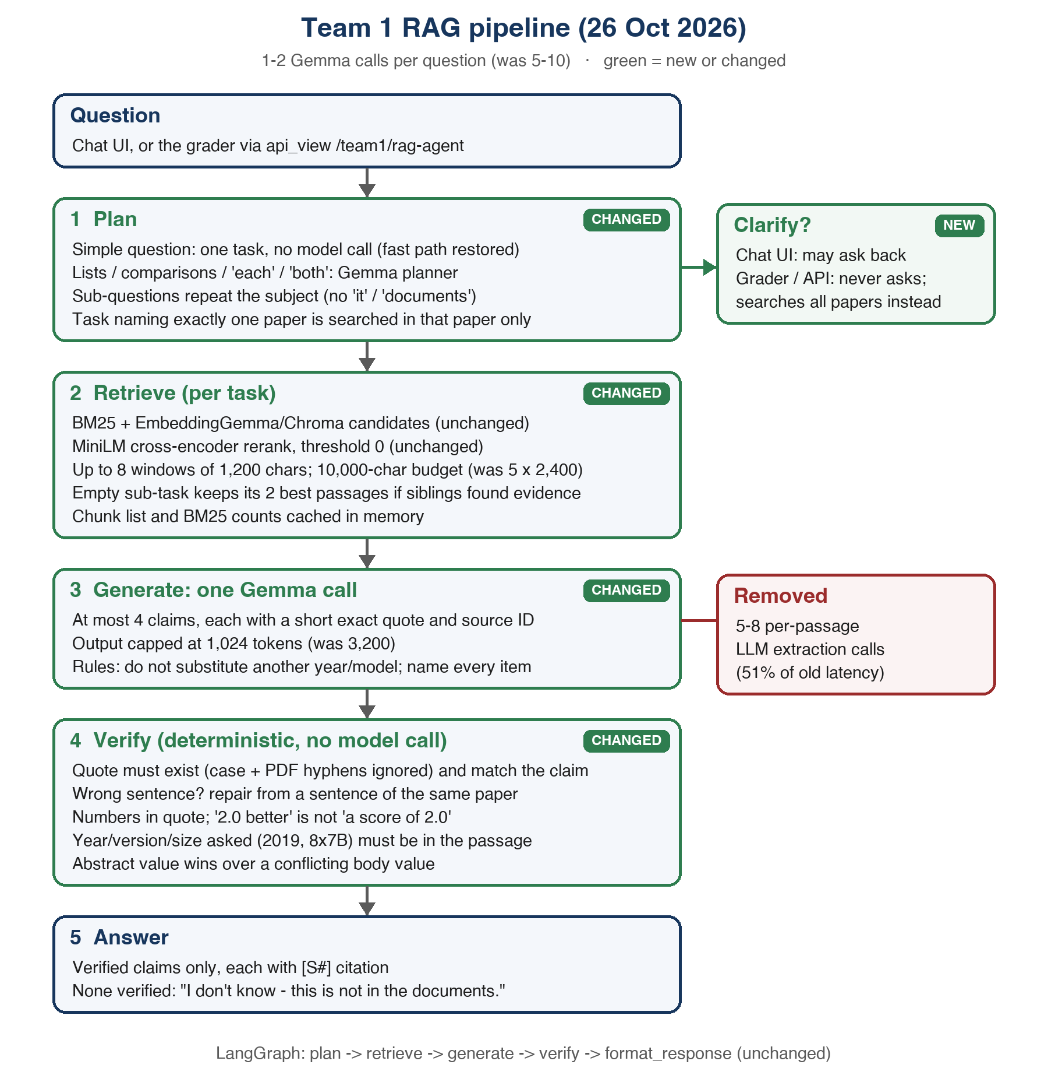
Figure: the pipeline after today's changes; green boxes are new or changed.
Change | Evidence it helped
Removed the per-passage extraction calls | 51% of D01's time; dev latency 318 s to 107 s on D01-D05.
Quote matching ignores case and PDF hyphens | Recovered D14's 'December 2018 dump' and D11's corpus claims.
Quote repair from the same paper | Recovered D05's 14.8T, D07's size comparison, U01's 10,000x.
Abstract value beats a conflicting body value | D01 correct in the full run, the first time in 9 runs; it depends on the draft (section 9).
Year/version/size must be in the cited passage | D09 abstains (was hallucinated in step 1).
Unattended runs never ask for clarification | D04 and D07 answered instead of scoring 0.
Answer text without notes or disclaimers | D04 correct after the 'Not verified' line was removed and quote repair recovered its power-law claim.

Tried and rejected, because the measurements did not support them: rank fusion of reranker, BM25 and dense ranks (found 15 instead of 16 of 24 gold passages), and reserving evidence slots for top BM25 hits (no gain; D02's gold section window holds a figure, not the model list).

9 Check after tonight's last fix
After the full runs, paper scoping was narrowed to questions naming exactly one paper. A 6-question check (the smoke set plus D15) on that final code:
ID | Verdict | Seconds
D01 | partial | 147
D04 | partial | 138
D05 | partial | 156
D09 | idk | 107
D13 | idk | 50
D15 | hallucinated | 54

Smoke score 2.0 / 6; the same six questions scored 3.0 in the full run. The difference is run-to-run variation, not the scoping change: Gemma on CPU is not fully repeatable even at temperature 0. D01 did not draft a 41.8 claim this time, D04 added an extra claim, and the planner split D13 into one task instead of five. Expect about +/-1-2 points on 15 questions between identical runs, so the 8.0 includes some luck; the stable level is probably around 7, still above the 6.5 baseline.

10 Next steps
- Reduce run-to-run variation. Split list questions ('A, B, C and D') into one task per item without the planner model (D13), and run important checks twice.
- Re-run the full dev and unseen sets on the final code to confirm the abstention-wording fix.
- Chunk labels. Detect appendix headings after References (24% of chunks are mislabelled), re-index, and re-measure; the main fix for D02-type questions.
- D01-type conflicts. Check accepted body-text numbers against the same paper's abstract directly, so the headline value wins even when Gemma drafts only the body value.
- Answer relevance. Reject claims that do not address the asked attribute (D15).
- Speed. Cheaper planning for list questions, and try OLLAMA_NUM_PARALLEL=2.
- Completeness. Answers often give one or two of several requested items (U02, U03, U07).

