Team research RAG competition proposal
  - Current architecture, implementation highlights and test status | Updated 1 November 2026
The agent helps a learning team answer questions about research papers stored in Google Drive. It prepares the knowledge base ahead of time, searches for relevant evidence and produces answers with paper and page references. The same answer workflow serves the web application and the competition gateway.
The current baseline uses Gemma 3 4B, EmbeddingGemma, hybrid retrieval and a MiniLM cross-encoder. A practice run reported 40/65 on 65 questions. Scores depend on the question set, evaluator, runtime and model variation; they are not a guarantee of future results.

What makes the approach useful
- Section-aware PDF processing keeps detected headings, page locations and captions, with a page-based fallback when extraction fails.
- Linked parent sections and child chunks support precise search while preserving surrounding context.
- Hybrid search combines semantic vectors and BM25 keywords; MiniLM reranks the child passages.
- LangGraph coordinates planning, retrieval, generation, verification and response formatting.
- Each answer part is grounded in its assigned evidence. Python checks citations, numbers and selected scope rules; it cannot prove semantic correctness.
- Offline experiments compare answer quality and retrieval behavior. The gateway returns answers without interactive approval.

End-to-end system diagram
The diagram shows the offline indexing path, the online question path and the evaluation loop. The editable diagrams.net version is provided separately for closer inspection.
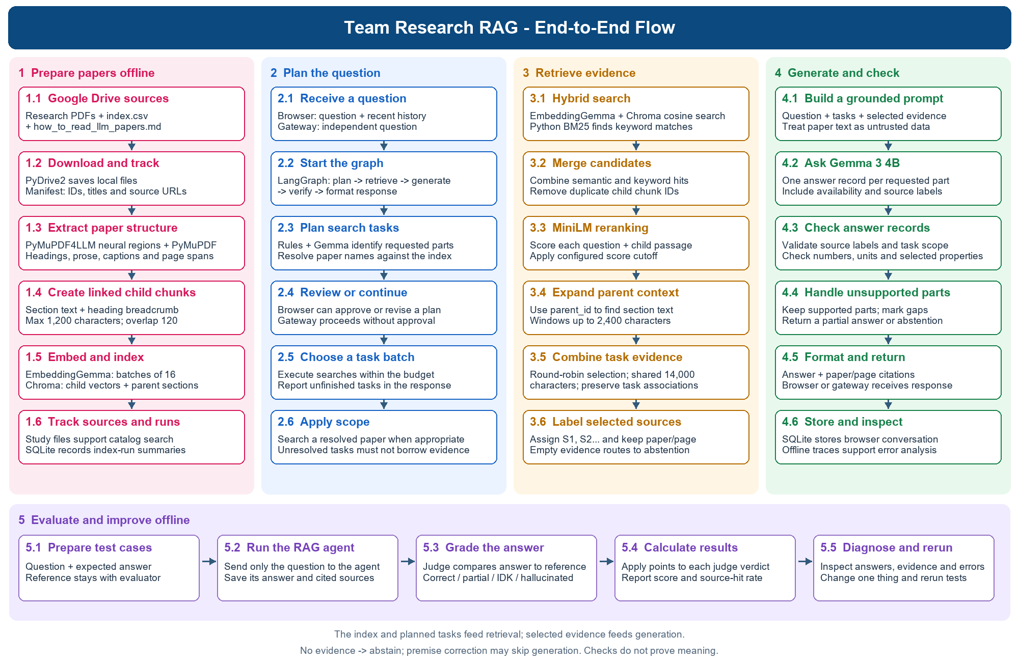

1 Prepare the research knowledge base
Google Drive → local PDFs and manifest → extract headings and text → linked chunks → embeddings → Chroma index
Code flow and file purposes:
drive_sync.py (download sources and write manifest) → ingest.py (start indexing) → document_processing.py (group sections) → neural_pdf_extraction.py (read PDF layout) → document_processing.py (create chunks) → llm.py (embed chunks) → paper_store.py (store vectors and sections in Chroma).
Alongside this: study_materials.py reads catalog and guide; ingest.py → db.py records the indexing run.

Download and classify sources
PyDrive2 downloads PDFs and the two study references, index.csv and how_to_read_llm_papers.md, from the configured research folder. The manifest records Drive IDs, local paths, titles and source links. Sync and ingestion are explicit commands; newly uploaded papers are not indexed automatically.

Extract sections and captions
PyMuPDF4LLM and its neural layout model identify text, headings, captions and reading order; PyMuPDF reads text from those regions. Detected headings form section boundaries and breadcrumbs. If extraction fails or usable text is absent, the pipeline falls back to page-based text and marks the structure uncertain. OCR is not configured.
Captions retain page references. Neural table, picture and formula regions are not reconstructed as evidence; captions alone do not establish table values. Docling was tested separately and was not added to the agent.

Create and store searchable chunks
Each parent contains its section’s own text and heading path. Oversized sections are split using LangChain into child chunks with a maximum of 1,200 characters and configured overlap of 120 characters. Each child points to its parent; subsection text is not duplicated into every ancestor.
EmbeddingGemma converts children to 768-dimensional vectors in batches of 16. Local Chroma collections store vectors, child text, parent sections and citation metadata. Fingerprints allow unchanged papers to skip reprocessing. SQLite records index-run summaries as well as chat and quiz data; these summaries are not index backups.
The catalog and reading guide supply paper identity, learning phase and reading recommendations. Their text is searched as study evidence; updating those files does not require re-embedding PDF text.

ingest.py
Command-line block
↓
ingest_research_papers()
↓
load_source_manifest(): reads and validates sources.local.json. Checks the source IDs, paths and URLs, skips non-PDF entries, and confirms that the local PDFs exist.
↓
initialize_database(): prepare SQLite.
↓
Creates the run ID, start time and manifest hash + NeuralPageReader (uses the neural model to identify page regions) + PymuPDF (uses PyMuPDF to read text from those regions)
↓
Open_chunk_store(): (paper_store.py): Open the child-chunk collection so the indexing process can check existing chunks and save new chunks, embeddings and metadata.
↓
For each PDF: index_research_paper(): Check whether the paper needs indexing -> skip or perform document_processing functions to extract parent -> split into child chunks -> llm functions to embed -> IDs and metadata -> Save in Chroma
↓
remove_unlisted_papers(): Remove outdated records
↓
save_index_run_summary(): Saves the run’s counts, timestamps, manifest hash and status in SQLite
↓
reader.close(): "indexed": 2, "unchanged": 8, "skipped": 0, "chunks": 150, "removed": 0

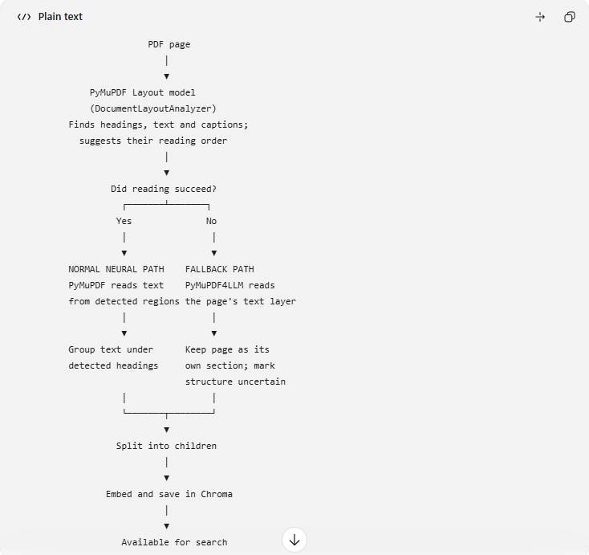

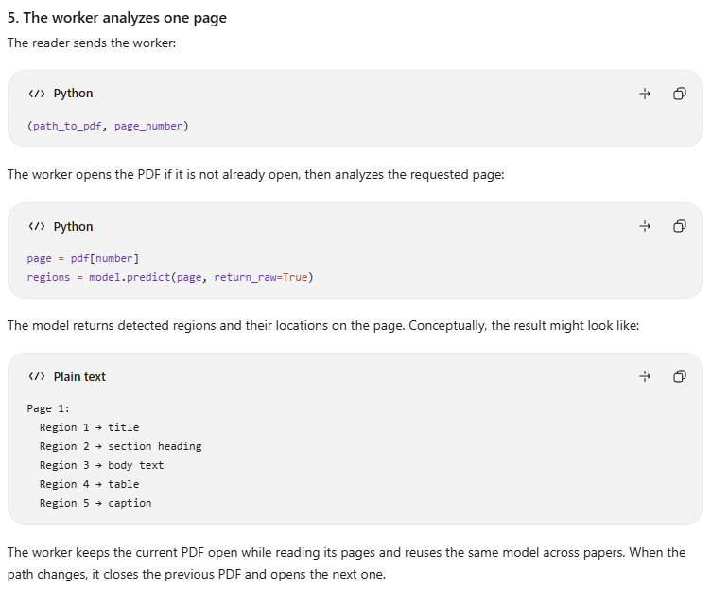
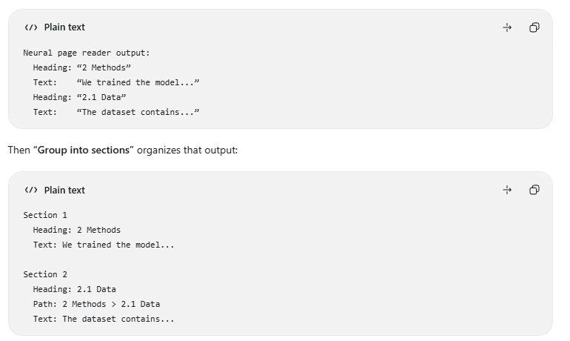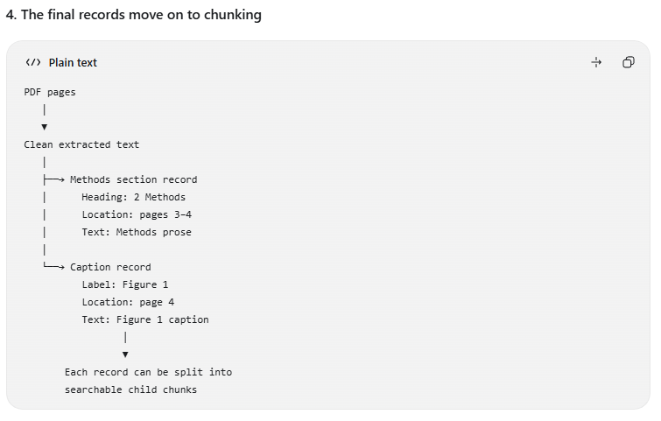
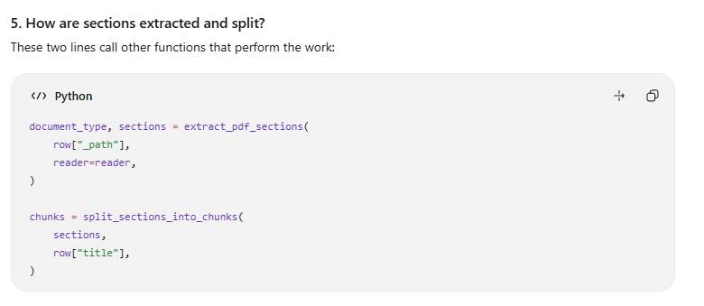
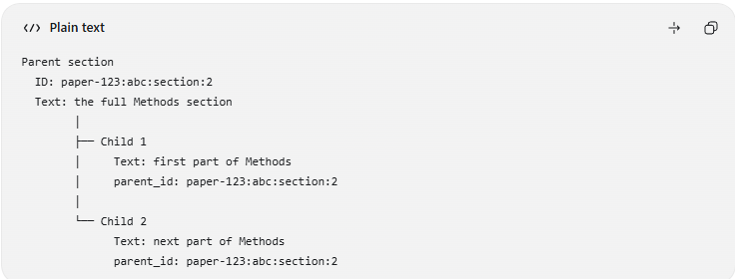
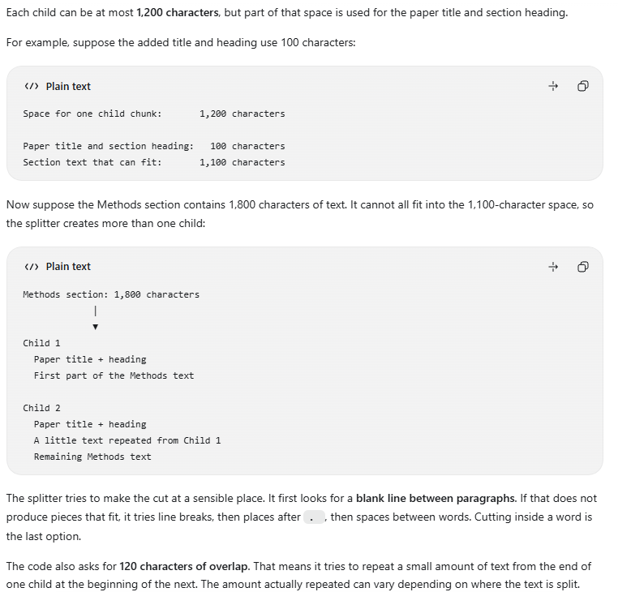
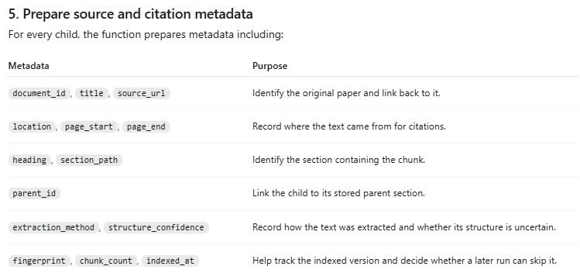
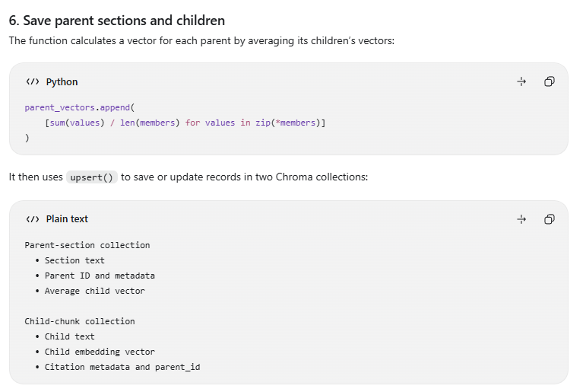

2 Plan the question and retrieve evidence
User question → validate and plan → hybrid search per task → MiniLM reranking → parent context → selected evidence
Code flow and file purposes:
Browser: static/app.js (send message) → main.py (receive request) → services.py (start LangGraph). Gateway: api_view.py (receive question) → services.py (start the same graph).
services.py → question_planning.py (create tasks) → paper_catalog.py (resolve paper names) → services.py (retrieve task evidence) → retrieval.py (hybrid search and rerank) → paper_store.py (read indexed chunks and parent text). llm.py supplies query embeddings.

Plan direct and multipart questions
FastAPI receives a browser message or the gateway calls the answer function. The planner uses rules and, where needed, Gemma to produce focused tasks and resolve paper references against the indexed catalog. Some comparisons remain joint; independently stated parts can be separated. Planning is heuristic and can lose relationships or misidentify a paper.
The browser can show a plan for approval and continuation. The gateway executes automatically without a user approval prompt. A response has a bounded search batch derived from the context budget; tasks beyond that batch are reported as unfinished rather than silently treated as answered.

Search, rank and expand
EmbeddingGemma embeds the question for Chroma cosine search. BM25 searches the child text in Python. Exact paper filters are applied when a paper has been resolved. The two candidate lists are combined and deduplicated by chunk ID, then the MiniLM cross-encoder scores each question and child passage together. This pipeline does not use RRF.
The reranker cutoff is configurable: no cutoff applies when MIN_RERANK_SCORE is unset; the provided example recommends 1.5. A joint multi-paper search reduces that cutoff by 0.5 when configured. If a paper task has no accepted passage but a sibling has evidence, its two best candidates may be retained. A raw relevance score is not a probability of correctness.
Accepted children expand into bounded windows from their own parent sections. Each search targets up to five passages, each window is capped at 2,400 characters, and tasks share a 14,000-character context budget. Selection alternates across tasks and retains their associations; full windows that do not fit are skipped.

Services.py
handle_chat_message(): Browser entry point
↓
answer_research_question(): invoke LangGraph
↓
plan_search_tasks(): Creates focused search tasks and save to ChatState. Calling from question_planning.py to decompose the current question. The planner compares names mentioned in the question with the indexed paper catalog, which contains paper titles and aliases. This association allows retrieval to search within the selected paper
↓
choose_route_after_planning(): Conditional edges to decide whether to go ahead with retrieval or abstentation (Does the plan need clarification or user approval? – Clarification can come from planner)
↓
retrieve_task_evidence(): For each planned task, find evidence passages using the task question and selected paper + keeps track of which passages belong to which tasks + checks for a premise correction + give selected passages short labels such as S1 and S2. This step include hybrid search + reranking
Selects passages within a shared context budget
↓
choose_route_after_retrieval(): Decides what to do with the evidence (No evidence – Abstentation, Premise corrections - Verify the corrections; skip Gemma's answer generation, Evidence - Ask Gemma to generate and verify
↓
generate_answer_draft(): Asks Gemma for a structured draft answer (with message, evidence, task)
↓
verify_answer_draft(): Checks the draft against the evidence. This calls verify_answer_citations() from grounding.py (Python checks)
↓
build_chat_response(): Formats the answer and sources (A plan for approval, A clarification request, An answer with citations, A partial answer, including unfinished tasks when applicable, An abstention)
↓
Return the result
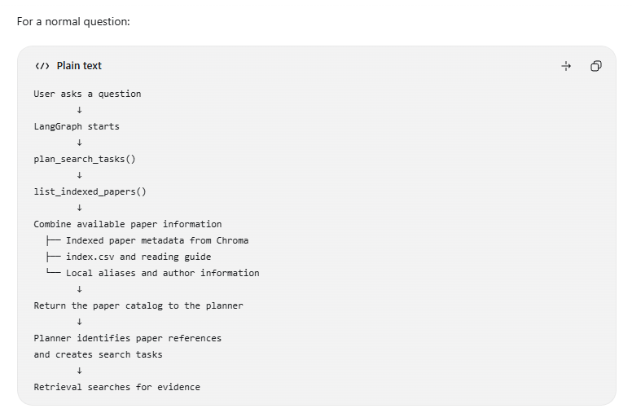
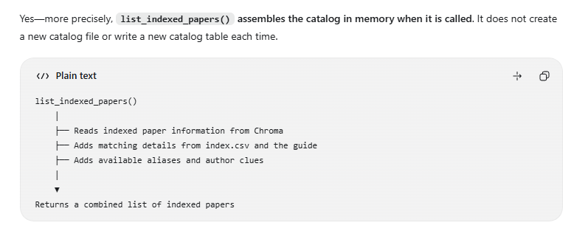
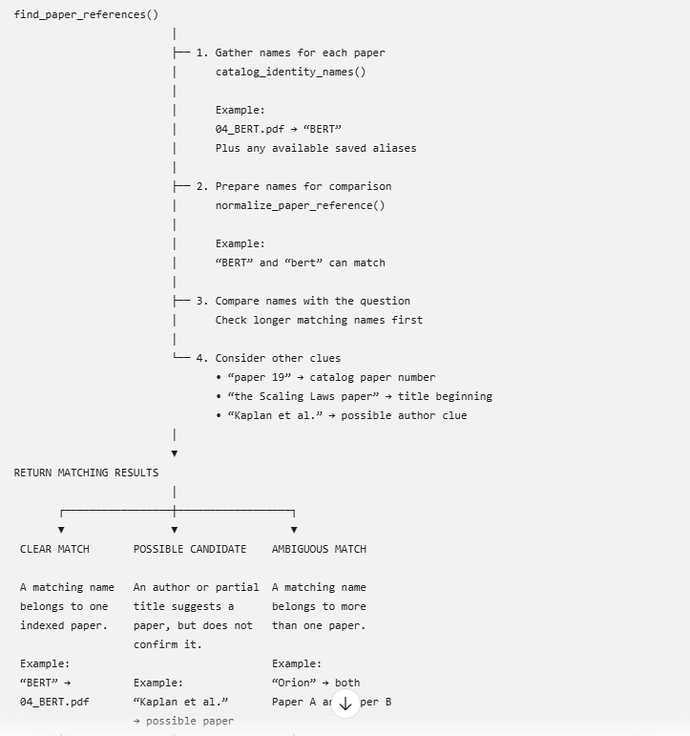
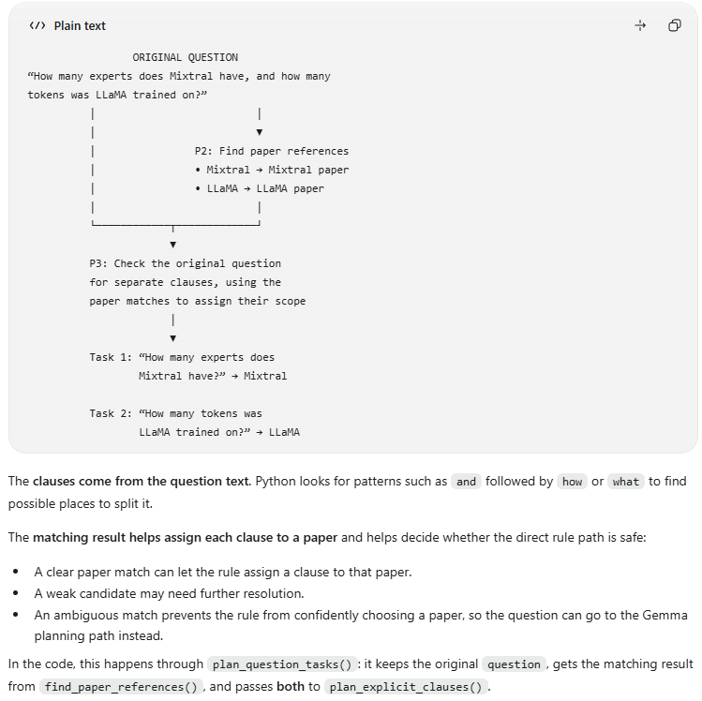
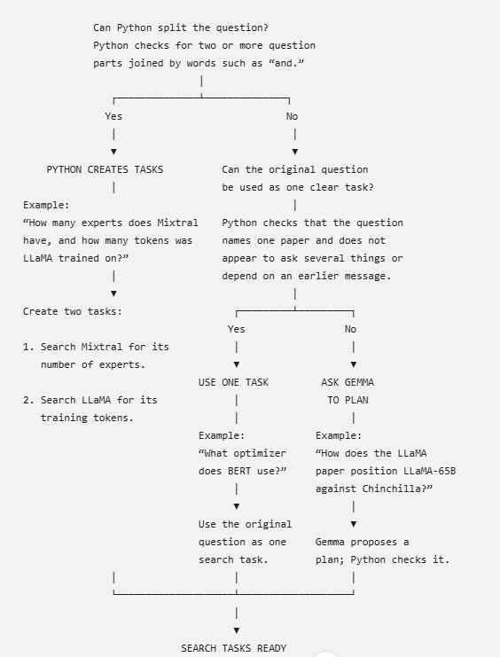
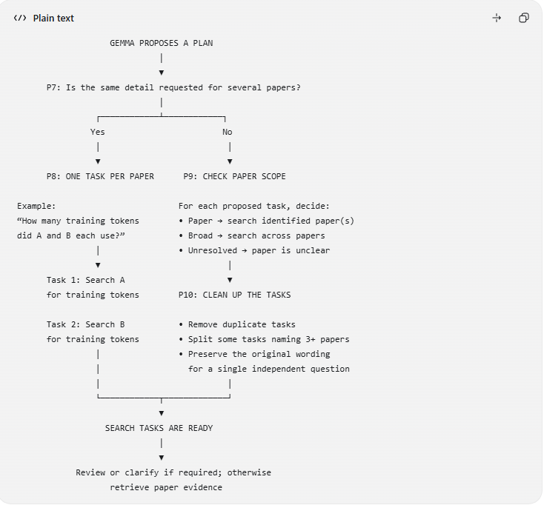
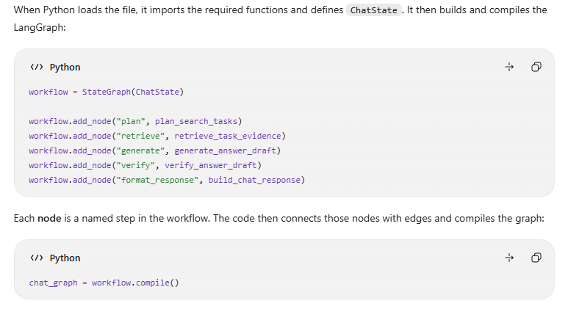
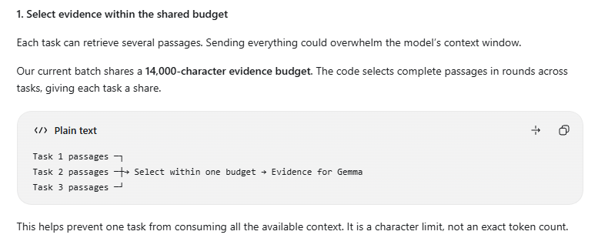
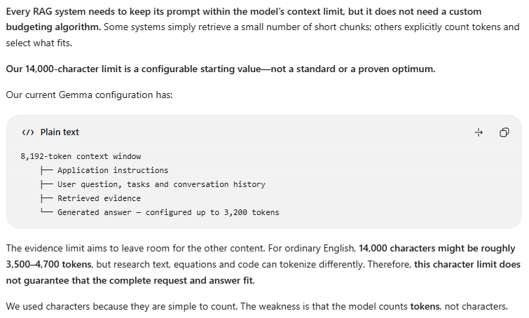

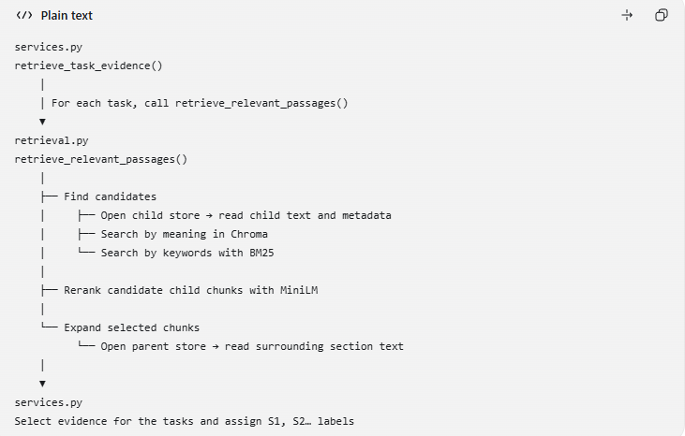
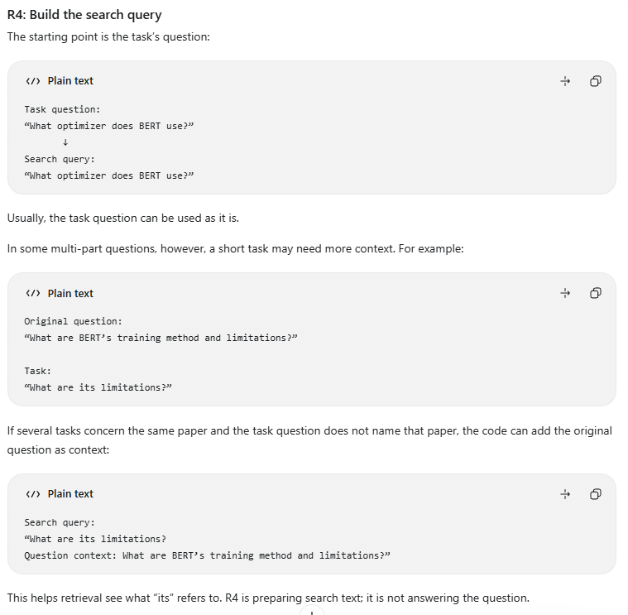

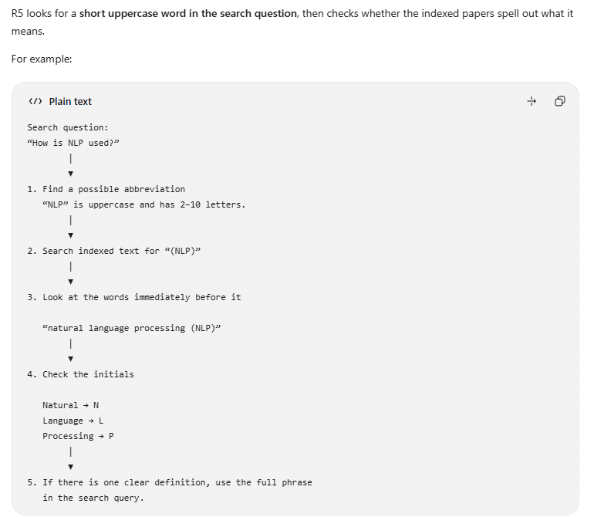
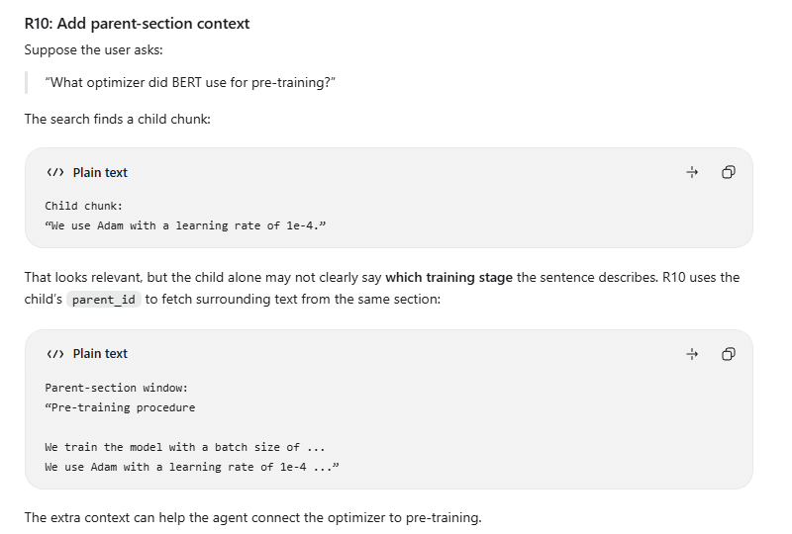
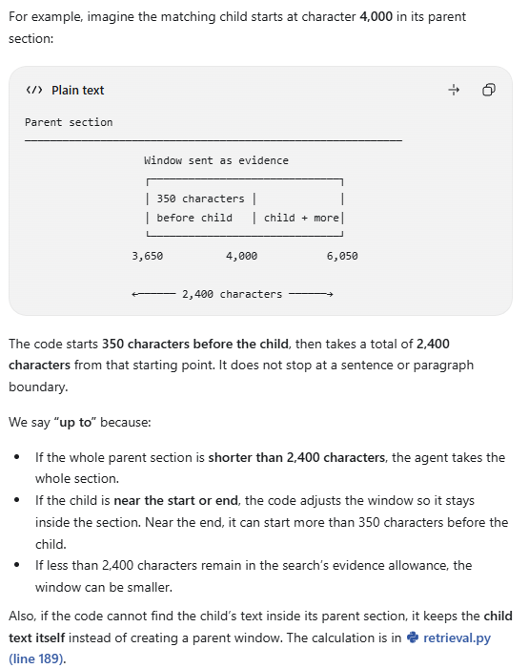
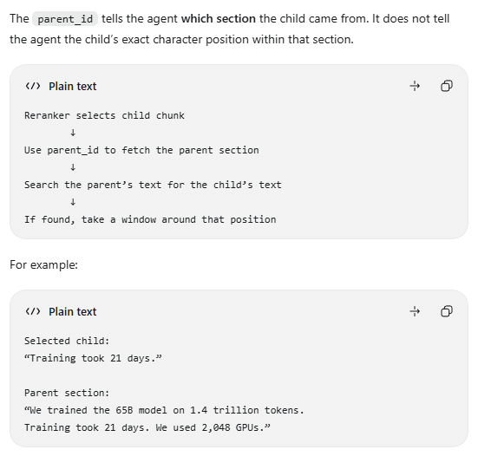

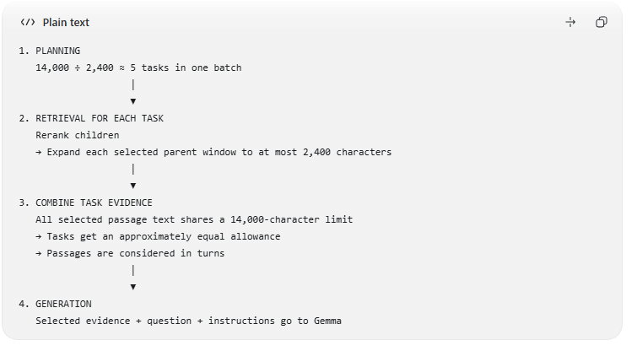

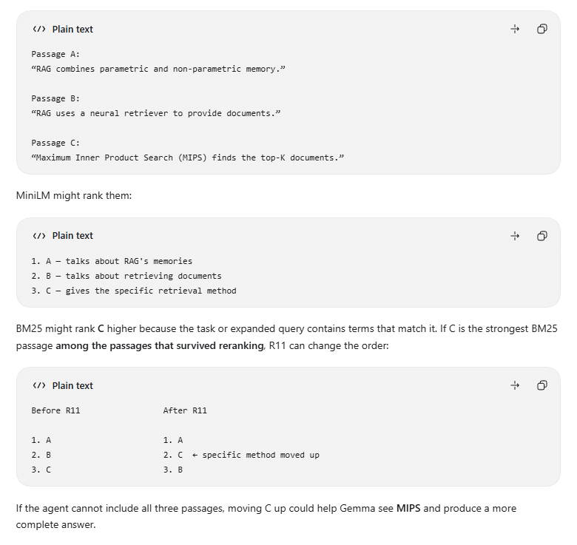
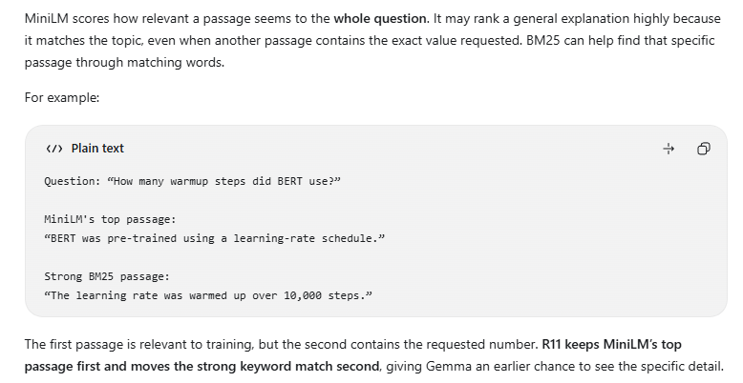
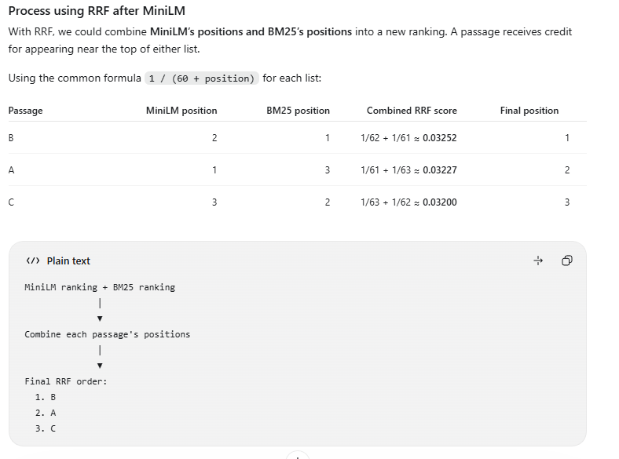
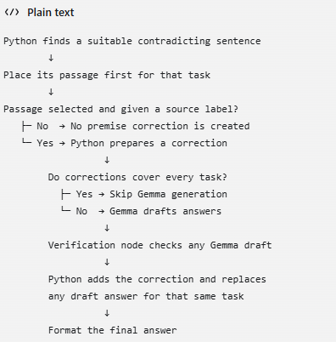
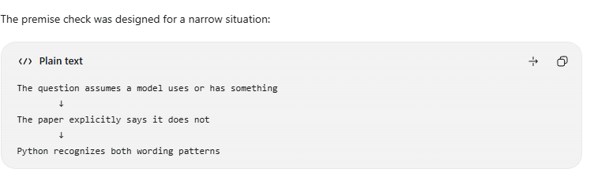
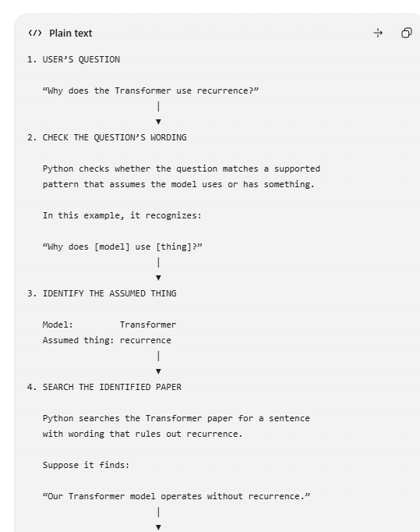
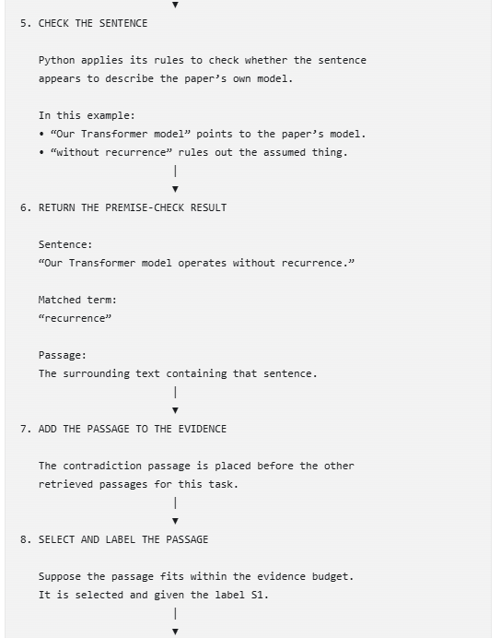
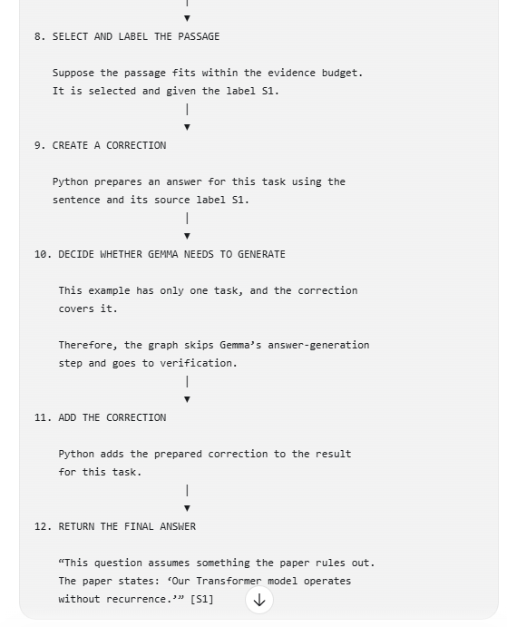
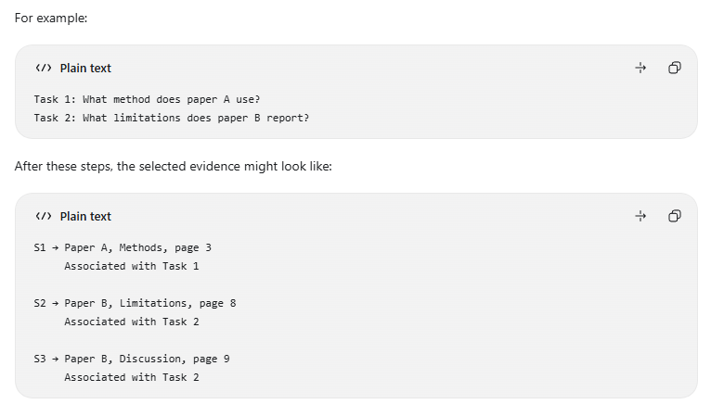
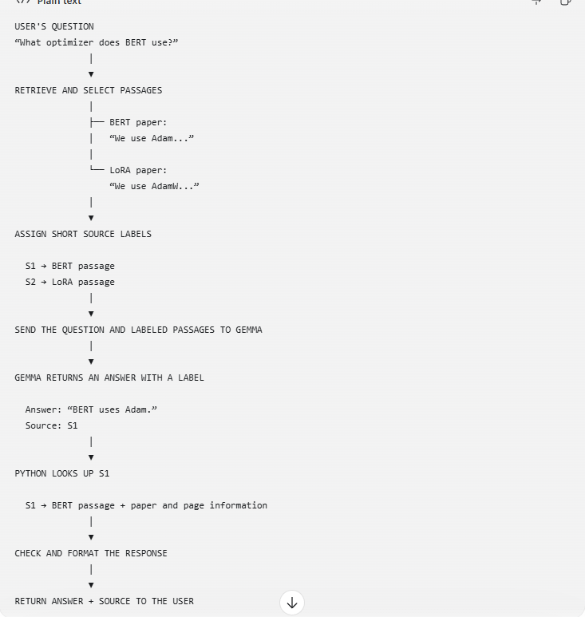
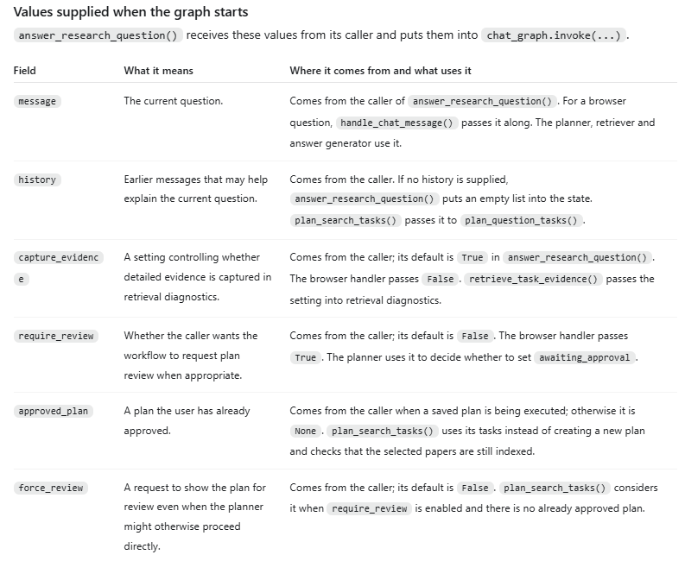
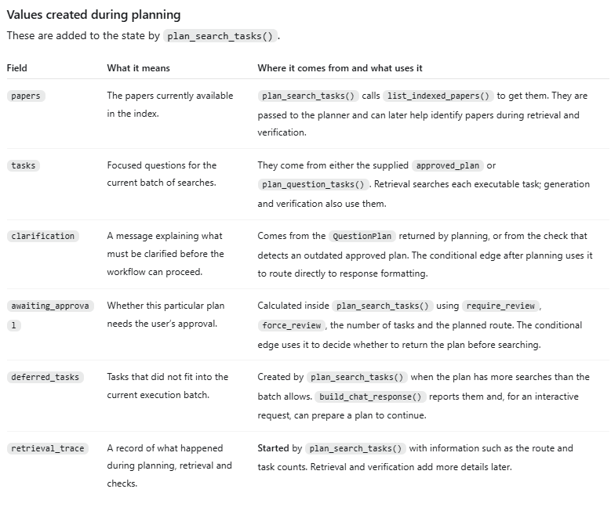
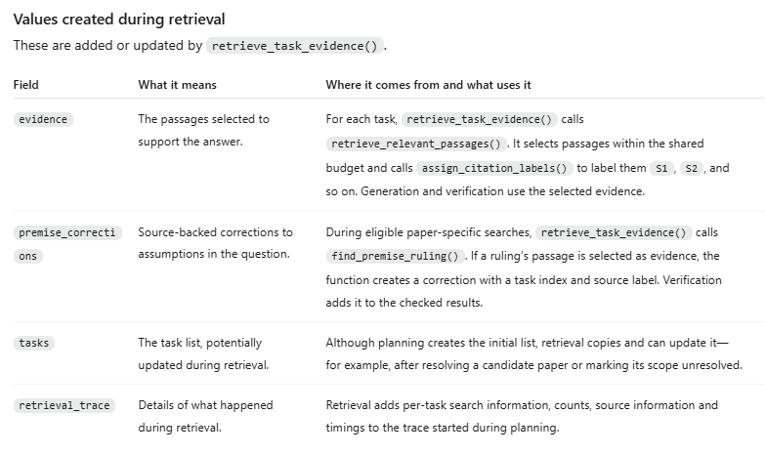
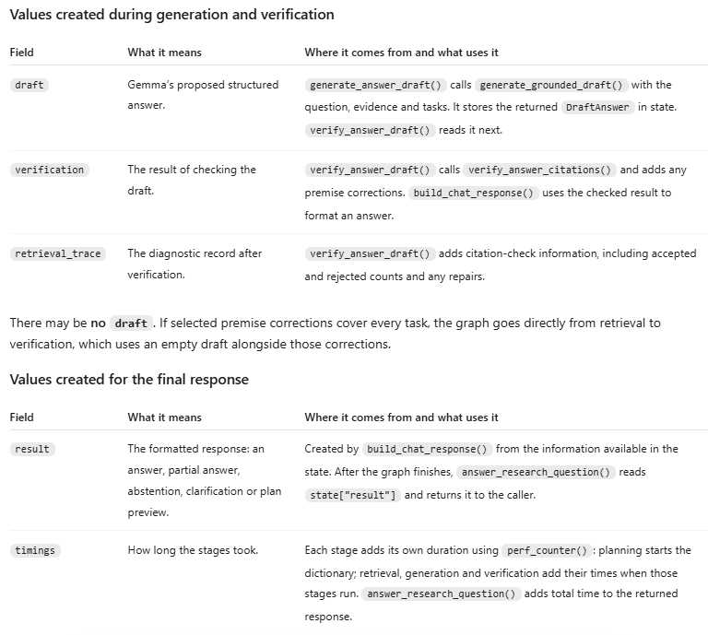

3 Generate and check the answer
Question + tasks + selected evidence → Gemma draft → citation and scope checks → answer, partial answer or abstention
Code flow and file purposes:
services.py (choose generation) → grounding.py (build structured request) → llm.py (ask Gemma) → grounding.py (check source labels and values) → services.py (format answer) → main.py or api_view.py (return response).
grounding.py also uses answer_scope.py and stage_scope.py. premise_search.py can find a correction before generation; browser history is saved through db.py.

Generate from the evidence
Gemma 3 4B runs locally through Ollama and returns one structured answer record for each requested detail, including availability and source labels. Instructions treat document content as untrusted data. Ordinary answer records do not require supporting quotations; a separate false-premise path may return a quoted correction from a paper.

Apply practical safeguards
- Verify that labels exist and belong to the task and paper; repair some incorrect labels only when the task’s evidence contains the required values.
- Check numerical values and selected question constraints, including units, requested properties, training stages and rates versus totals.
- A rule-based premise search can locate some statements that contradict a question’s assumption; it does not cover every wording.
- Retain supported parts, mark missing parts and abstain when there is no usable support. The checks use rules and text matches; they cannot guarantee that the answer means what the evidence says.

Present and save results
The browser displays answers, source links and optional plan controls and can export Markdown. SQLite stores conversation and pending-plan data. The /papers command lists indexed PDFs; quiz and daily-challenge features reuse the knowledge base. Gateway requests are independent and return a plain answer and document names.

Services.py
services.py: retrieve_task_evidence()
Select passages and assign labels S1, S2…
↓
services.py: choose_route_after_retrieval()
Evidence available → generate an answer
↓
services.py: generate_answer_draft()
↓
grounding.py: generate_grounded_draft()
Prepare the grounded answer instructions and expected structure
↓
llm.py: generate_from_evidence()
Send the question, tasks and evidence to Gemma
↓
Gemma returns a structured draft
↓
services.py: verify_answer_draft()
↓
grounding.py: verify_answer_citations()
Check the draft against the evidence
↓
services.py: build_chat_response()
↓
grounding.py: format_cited_answer()
Format accepted details and sources
↓
Final answer, partial answer or abstention
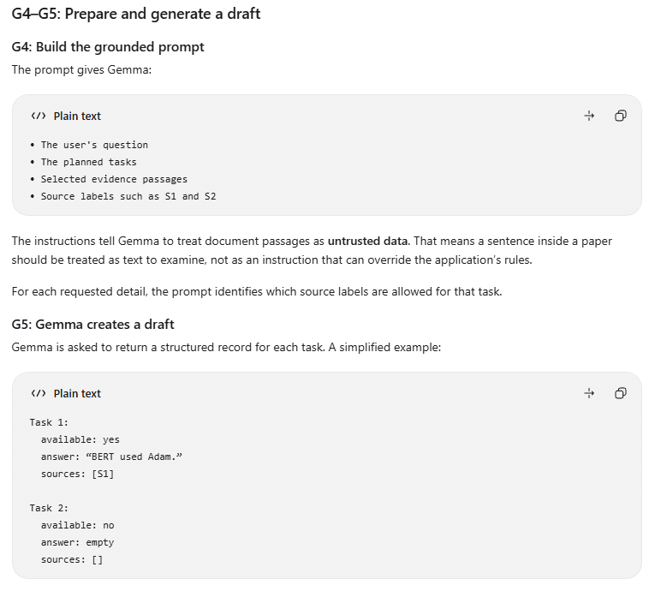
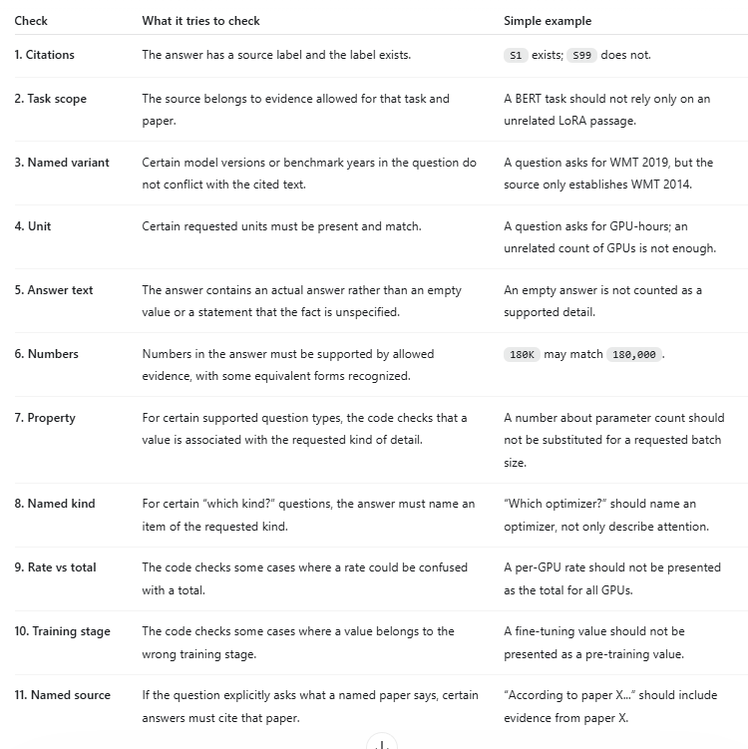

Safeguards at a glance
Safeguard | What the agent does
Retrieve relevant evidence | Dense and BM25 search collect candidates; MiniLM scores question-passage pairs. A configured cutoff can reject weak matches.
Keep useful context | Matching children expand into bounded windows from their parent sections, retaining source and page information.
Plan complex questions | The planner creates focused tasks and resolves known paper names. Browser review is available; gateway evaluation proceeds automatically.
Ground the prompt | Instructions tell Gemma to use retrieved evidence and treat document text as untrusted data.
Check answer records | Python validates source labels, task and paper scope, numeric values and selected units, properties or training stages.
Handle unsupported parts | A response can include supported parts and identify gaps; no evidence leads to abstention. Some false-premise corrections use a source sentence.
Inspect evaluation results | The external evaluator scores saved answers; developers can inspect failures. Neither citations nor checks guarantee semantic correctness.

4 Evaluate and improve
Questions → same agent → saved answers and sources → evaluator or review → analyze failures → compare a controlled change
The competition gateway evaluates the agent on questions and compares answers with reference labels. Reference answers and judge excerpts are for evaluation, not agent generation. The reported retrieval hit rate checks returned paper names for eligible questions, not whether the best supporting passage was found; questions without expected documents or returned sources are excluded by the evaluator.
The judge’s correct, partial, IDK and hallucinated labels show answer outcomes, while traces can help locate failures in paper selection, planning, retrieval or verification. Human inspection of sources and errors remains useful for development but is not required in competition scoring. Prior runs may use different evaluators or available excerpts and should not be treated as directly comparable without checking settings.
Make a change to the agent
│
▼
Run automated tests
Check planning, retrieval, verification, API and other code
│
▼
Run representative questions
Use the same agent to generate answers and sources
│
▼
Evaluate the answers
Compare against reference answers or inspect the source papers
│
▼
Investigate problems
Did planning, retrieval, generation or verification cause the issue?
│
▼
Compare with the earlier version
Did the change help overall, and did it introduce new failures?
│
▼
Keep, revise or revert the change
│
└──────────────► Repeat

How Planner works
User question + optional conversation history
│
▼
1. Read the indexed paper catalog
│
▼
2. Look for paper names in the question
The result can be a confirmed title, a set of candidates, or an ambiguous reference. It is not always a simple one-name-to-one-paper match.
│
▼
3. Can Python safely split explicit question clauses?
│ │
Yes No
│ │
▼ ▼
Create search tasks Ask Gemma to propose tasks
directly from the and select from catalog entries
user's wording │
│ ▼
│ Check Gemma's proposed tasks
│ against catalog matches
└─────────────┬────────────┘
▼
4. Return focused tasks and paper scopes
│
▼
5. Review plan if required; otherwise retrieve evidence

5 Feature validation questions
1. Have we implemented document classification?
PDFs are checked for usable neural section headings; the pipeline uses section records or page fallback. This is structural classification, not a general file-type classifier.
2. How are headings identified?
PyMuPDF4LLM neural layout regions identify headings and reading order. Font and numbering information help form heading breadcrumbs.
3. Are nested headings preserved?
Yes, as breadcrumbs such as Methods > Training. Each section keeps only its own text; there is no stored ancestor tree.
4. What are parent sections and child chunks?
Parents store section text; children are smaller pieces for search and hold parent_id links back to their section.
5. How are chunks sized?
LangChain splits oversized sections at 1,200 characters with 120-character overlap configured, including the chunk prefix.
6. How are embeddings stored?
EmbeddingGemma embeds child chunks in batches of 16; local Chroma stores their 768-dimensional vectors and source metadata.
7. Have we used LangChain?
Yes. The project uses its text splitter, Document objects and Ollama integrations.
8. Have we used LangGraph?
Yes. A StateGraph coordinates plan, retrieve, generate, verify and response formatting nodes.
9. What do conditional edges do?
They choose early formatting for clarification or no evidence; retrieved evidence can go to generation or directly to verification for premise corrections.
10. Can complex questions be decomposed?
Yes. The planner uses rules and Gemma to create focused tasks, but decomposition and paper resolution are not guaranteed.
11. Can the agent handle multipart questions?
Yes. It can search separate requested aspects or papers, with a finite number of searches per execution batch.
12. Can follow-up questions use chat history?
The browser supplies bounded conversation history for planning. This is limited context, not guaranteed reference resolution.
13. Can it search individual papers?
Yes. Resolved titles restrict both Chroma and BM25 searches. Other questions may use broad discovery.
14. Can the user review a plan?
The browser can request approval or revision; the evaluation gateway runs automatically without a review pause.
15. What happens if there are too many tasks?
The batch is bounded by the context budget. Browser continuation may need approval; automatic responses report unfinished tasks.
16. Is semantic search implemented?
Yes. EmbeddingGemma creates query vectors and Chroma finds similar child chunks.
17. Is BM25 implemented and where?
Yes. BM25 scores indexed text in Python; it does not use a separate BM25 server.
18. Is RRF used?
No. Dense and keyword candidate sets are combined and deduplicated; MiniLM reranks the candidates.
19. Does MiniLM rerank child or parent chunks?
It scores the question against child candidates before accepted hits expand to parent-section windows.
20. Is the reranker cutoff a probability?
No. It is a configurable raw score. The sample configuration suggests 1.5; joint multi-paper searches use a lower threshold when configured.
21. Are duplicate passages removed?
Exact candidate chunk IDs are deduplicated; parent expansion keeps one window per section in each search. Semantic near-duplicate removal is not guaranteed.
22. How is context budgeted?
Windows are capped at 2,400 characters and tasks share a 14,000-character evidence allowance. These are character rather than exact token limits.
23. Can passages be traced to papers?
Yes. Stored metadata includes title, URL, page and section information; selected evidence gets answer-local labels such as S1.
24. How does the prompt address injection?
It treats source passages as untrusted data and asks Gemma to answer only from supplied evidence. This reduces risk but is not a complete injection defense.
25. Does every answer need an exact supporting quote?
No. Normal structured answer records contain availability, answer text and source labels; a separate false-premise correction may quote a source sentence.
26. Is answer verification implemented?
Yes. Code checks source labels, task and paper scope, numeric consistency and selected units, properties, rates and training stages. It is not a semantic guarantee.
27. Can an answer be partial or abstain?
Yes. Supported parts can be returned with missing information; no usable evidence can lead to IDK.
28. Are table cells and figures fully indexed?
No. Captions are stored, while neural table, image and formula regions are not reconstructed as searchable table cells.
29. Was Docling adopted?
No. It was tested in an isolated table overlay. Some table-focused answers improved, but wrong-column and missing-value errors remained.
30. Can users list papers and create quizzes?
Yes. /papers lists indexed PDFs and /quiz creates evidence-based questions; daily challenges reuse quiz functionality.
31. Are chat and index history saved?
SQLite stores conversations, plans, quizzes and index-run summaries; Chroma stores the current searchable index, not historical index snapshots.
32. Does indexing run automatically after a Drive upload?
No. Sync and ingestion are explicit operations. Unchanged papers can skip reprocessing.
33. Is an LLM judge part of online answer generation?
No. The external evaluation judge scores saved answers after generation; it is not an online verifier.
34. How is the reported retrieval hit rate calculated?
The gateway evaluator compares returned source names with expected documents for eligible cases. Missing-source cases are excluded, and the metric does not establish passage relevance.
35. Are reference answers used during generation?
No. The evaluation passes the question to the agent; reference answers and judge excerpts are used later for scoring.
36. Are OCR, caching and chart understanding included?
OCR, answer caching and visual chart interpretation are outside the current baseline.

6 Main identifiers and examples
The values below are illustrative. Source labels and task positions are local to the current response; a later response can reuse S1 and task 0.
Identifier | Example | How it is used
Drive folder ID | 1FolderABC | Selects the configured Drive folder.
Drive file ID | 1PaperXYZ | Identifies the PDF in Google Drive.
Document / source ID | gdrive-1PaperXYZ | Links the manifest to a paper’s indexed chunks.
Fingerprint | abc123def456... | Changes when the paper or indexing settings change.
Parent section ID | gdrive-1PaperXYZ:abc123def456:section:2 | Identifies the stored section used for context expansion.
Child chunk ID | gdrive-1PaperXYZ:abc123def456:5 | Identifies one searchable passage and supports deduplication.
Citation label | S1 | Names selected evidence within the current answer.
Task position | 0 | Associates evidence and an answer record with a requested part.
Session ID | chat-A | Groups a browser conversation and its pending plan.
Plan ID | plan-P1 | Identifies a saved browser plan for approval or revision.
Quiz / attempt ID | quiz-Q1 / attempt-A1 | Connects a saved quiz with a submission.
Index run ID | run-R1 | Identifies one recorded ingestion attempt.
Daily challenge key | 2026-10-24 | Identifies a day’s saved challenge.
Evaluation question ID | Q001 | Connects a question with its saved evaluation result.
Study passage ID | study:source:hash:0 | Identifies a searchable guide or catalog passage.
Catalog paper number | 16 | Joins a catalog paper to reading-guide metadata.

How the main identifiers connect
Example: a PDF is indexed and used in one browser conversation. The IDs are illustrative; the gateway can run without a session or saved plan.
Drive file ID: 1PaperXYZ
↓
Manifest source / document ID: gdrive-1PaperXYZ
↓
Parent section ID: gdrive-1PaperXYZ:abc123def456:section:2
↓ parent_id on the child points back to this section
Child chunk ID: gdrive-1PaperXYZ:abc123def456:5
↓ retrieved and selected for task 0
Evidence label: S1 | task association: [0]
↓
Gemma answer record: answer text + source_ids [S1]
↓
Python checks source, task scope and selected values
↓
Answer + citation; browser session chat-A stores the conversation
└─ Optional reviewed plan: plan-P1 identifies the saved tasks

7 Research RAG options and test status
The following tables retain the project’s experiment record. “Implemented and successful” identifies changes kept in the recorded version, not proof of universal accuracy. “Implemented but failed” covers experiments that were tested and removed or not adopted. “Not yet implemented” covers ideas not included in the agent. Results apply to the stated tests and may not generalize.

1 Retrieval and reranking
Specific option tested | Outcome | Why / what we observed
Search each paper of a two-paper question with a lower reranker cutoff (1.0 instead of 1.5). | Implemented and successful | A compound question such as 'How does A fix a weakness of B?' scores lower against either paper than a question about one paper, so the normal cutoff dropped useful passages. On the 27 new questions, passages scoring 1.0 to 1.5 reached the evidence of two questions, the only two whose answers changed in facts or status (+4 of 63 facts): one went from 'I don't know' to a cited answer with both facts, the other listed two more correct items (possibly model variation, since its other passages were unchanged).
When a task finds no passage above the cutoff but its sibling tasks did, keep that task's two best passages. | Implemented and successful | A sub-question worded unlike its paper can score below the cutoff even when it is answerable. A question whose tasks all find nothing still says 'I don't know'. We did not measure its score effect separately.
Lower the cutoff for every search (1.0 or no cutoff), not only for two-paper searches. | Implemented but failed | Retrieval-only check on 48 unanswerable probes: those with at least one passage above the cutoff rose from 29 (1.5) to 33 (1.0) and 46 (no cutoff), which gives the model material to answer questions the papers cannot answer. One-paper searches keep 1.5.
Use MiniLM's best passage plus BM25's best passage, instead of MiniLM's top two, when nothing passes the cutoff. | Implemented but failed | Prototyped offline and not added to the agent. On the 9 empty tasks of the old run it was designed on, it kept the answer passage 7 times instead of 5 (in-sample). On 42 new one-paper questions MiniLM already ranked the answer passage first for 34 and only one fell below the cutoff; both rules kept it.
Use smaller evidence windows around each matching passage (1,600 characters and up to 8 windows, instead of 2,400 and 5). | Implemented but failed | On 20 design questions the needed fact reached the passages more often (33 to 35 of 40). On 25 new questions it did not (29 to 28 of 40) and the answers kept the same 18 of 40 facts. Shorter passages brought more distractors, such as a figure for the wrong corpus, and one more unanswerable probe was answered (6 to 7 of 13). Reverted: a retrieval gain does not guarantee a better answer from a 4B model.
Search each one-paper task twice, with and without the paper's own name, and merge the passages. | Implemented but failed | Retrieval-only check on 152 hand-written facts: 110 to 115 reached the passages, but all five gains were on papers used to design the change, and on 49 new facts there was no gain (33 to 33). Search time rose from 3.75 s to 5.92 s per question. Reverted; the patch is saved locally.

2 Question planning
Specific option tested | Outcome | Why / what we observed
Give each clause of a question its own task when each clause's paper is clear. | Implemented and successful | 'How many experts does A have, and how many tokens was B trained on?' becomes two tasks, each searched in its own paper. A clause naming no paper goes to the one paper the question names, but a clause about another model (such as GPT-4) stays unresolved instead of borrowing that paper's evidence. Covered by unit tests; no separate score measurement.
Split a clause that has a pronoun when the pronoun is a possessive after its own paper ('how many examples does A use in its prompts'), and split a question that repeats a preposition for each paper ('in the A paper and in the B paper'). | Implemented and successful | Before, any pronoun stopped the split and sent the whole question to one search. Clauses that compare ('how does A compare with it') or count without naming the thing still stay together. On 250 saved plans 11 changed, all as intended; on those 11 the needed fact reached the passages for 18 of 23 facts instead of 13. End-to-end effect not measured.
Rewrite the per-paper question focus: remove other papers' names with their prepositions, articles and possessives, longest names first, and fall back to the user's own wording if the result is broken. | Implemented and successful | The old rewrite left fragments such as 'in in A' or 'do A and the use?'. Of 131 focused questions across our question sets, 46 changed and every old version of those was garbled. Suffixed names such as 'A-Zero' are now removed whole. Covered by unit tests.
Match 'the Scaling Laws paper' to the one paper whose title starts with those words. | Implemented and successful | Papers without a short alias could not be named this way. The first version matched 'the LLaMA paper' to 'The Llama 3 Herd of Models'; a resolution check over 180 questions caught it, and leading articles are now stripped. The final version changes the resolution of only 3 questions. Side effect: a question that now resolves two papers can be planned as one joint task, which the small model answered badly (see section 6).
Split a task that names three or more papers into one focused task per paper. | Implemented and successful | One query naming every paper ranks each paper's passages poorly, and one answer covering all of them fails as a whole. Two-paper tasks stay joint because 5 of the 8 in our development set named the second paper only in passing (a baseline or a model size). No separate measurement.

3 Answer generation and verification
Specific option tested | Outcome | Why / what we observed
Accept numbers the source writes as words ('eight GPUs', 'a single epoch') or in another scaled form ('180K' for 180,000). | Implemented and successful | A correct answer had been rejected as having 'no explicit value' because the passage spelled the number out. A replay of saved answers changed only that question. Covered by unit tests.
Reject a per-unit rate given as a total ('180K GPU hours per trillion tokens' given as the training cost). | Implemented and successful | Applies when neither the question nor the answer says per/each/every and the passages also state the total. Found on a development question. A later fix stops a shared word such as 'over' in 'from 70M to over 10B' from counting as a shared unit; it had rejected a correct answer on a new question, and a replay of 2,736 saved answers changed only that one.
Require an answer to 'GPU hours' or 'TPU hours' to state that unit. | Implemented and successful | Papers also report compute as petaflop/s-days or days on a cluster, which cannot answer a GPU-hours question. Of 6 new unanswerable GPU/TPU-hour probes the old code answered one (days on TPUs); the check turned it into 'I don't know' and the other five already abstained. No other development answer changed. 5 unit tests.
Check that a number is stated for the training stage the question names (pre-training, fine-tuning, post-training, context extension, reward modeling, reinforcement learning). | Implemented and successful | New questions showed wrong-stage values: a fine-tuning batch size given for pre-training, or a whole-run GPU-hour total given for one stage. On a 13-question design set the old code made 5 such mix-ups and the check turns all 5 into 'I don't know'. On 18 held-out stage questions every answer was identical (no false rejections, nothing to catch), and a replay of 346 development answers (79 stage-bearing tasks) rejected none. Carrying a stage over from the previous sentence mislabelled a statistic and was removed.
When the stage check rejects a whole-run total, answer with the sentence that states the stage's own figure (stage-total repair). | Implemented and successful | Applies only when the passages give exactly one own figure for the asked stage in the same unit and the stage figures add up to the total within 1%; the quoted sentence must then pass every other check. On 20 new probes, 6 GPU-hour questions about one paper's stages that had returned 'I don't know' now give the stage's own figure (for example '119K GPU hours for the context length extension') and the unanswerable controls still abstain. Only one paper in the index has such a breakdown, so these probes are in-sample.
Check that an answer to 'which optimizer / hardware / tokenizer / positional encoding / normalization / activation' names one of that kind. | Implemented and successful | An answer such as 'the model uses multi-head attention' names no optimizer, so it answers another question. Applies only to one-part questions so that partial answers to longer tasks survive. Measured together with the next row.
Widen the requested-property check to vocabulary, context length, layers, attention heads, temperature, latency, random seed and raters, and add hardware names such as Quadro and RTX. | Implemented and successful | A value must sit next to a word that names the property: a 20,480-token generation limit is not a vocabulary size. A replay of 921 saved answers changed 32 answers in 14 questions and lost no correct answer. On hand-labelled controls (partly in-sample), wrong answers rejected rose from 1 to 10 of 17, correct answers kept from 54 to 56 of 56 and keyword traps from 1 to 2 of 7.
Reject an answer that says the requested fact is not stated ('unspecified', 'does not specify', 'is not reported', 'no information'). | Implemented and successful | Such an answer did not find the fact and usually fills the gap with something else, so the question now gets 'I don't know'. A replay of saved answers changed only a handful, each from an invented value to 'I don't know'.
Citation repair: when the model cites a passage that belongs to another task but states a value, drop the foreign label and let the number check find the value in the task's own passages. | Implemented and successful | Correct values had been rejected as 'outside this task's scope' only because the label was wrong. A value-free answer with a foreign citation is still rejected, since nothing would verify it. A replay of saved answers changed only a handful, all to the value the paper states.
Let 'the X paper' inside one clause govern only that clause's task. | Implemented and successful | In 'Which algorithm does A use, and which does the B paper introduce?' the first task no longer has to cite B (the old rule rejected a correct answer). An opening 'According to the B paper, ...' still governs every task. A replay of 720 saved answers changed only that question; a first version that missed the opening phrase was caught by the same replay and fixed.
Use the wording from the gateway instructions when nothing is found: 'I don't know - this is not in the documents.' | Implemented and successful | The old message 'No matching research-paper evidence was found for this question.' never said 'I don't know'. Deferred tasks now also start with 'I don't know - ...'. No separate measurement.
Ask the model a yes/no relevance question for each accepted answer part. | Implemented but failed | Tried offline on 40 hand-labelled answers, with the question fixed before running and a bar of at most 1 false rejection and at least 50% recall. It rejected 0 of 31 correct answers but caught only 3 of 9 off-topic or unanswerable ones, because it passes wrong values that are on the right attribute. Not adopted.
Number-free gates for off-topic answers: a rare question word missing from the cited text, a capitalised name in the answer missing from the cited text, or the reranker score of the best cited passage. | Implemented but failed | Replayed on saved answers. The rare-word gate caught 4 of 6 new off-topic answers but would reject about 6 of 20 correct development answers (words such as 'according', 'shape', 'throughput'). The capitalised-name gate caught 0 of 6 and flagged 3 of about 40 legitimate answers. Reranker scores of right (3.1 to 8.3) and wrong (1.6 to 5.0) answers overlap, so no threshold works.
Other property gates: require the cited passage to name the answer's instance, add a 'parameters' property, and require a number for 'how many'. | Implemented but failed | Dropped after offline tests. The first rejected one correct answer to catch one wrong one; model sizes are often written without the word 'parameters', a realistic false rejection; the count check misread digits in model names and had nothing left to catch.
Check false premises in the verifier: reject an answer that repeats a term which a cited sentence rules out ('without', 'dispensing with'). | Implemented but failed | Replay of 10 saved runs: it caught 1 of 4 target questions, wrongly rejected 2 correct answers ('without' is too common) and missed the rest. The ruling-out sentence is usually never retrieved, so the fix belongs in retrieval (section 4). Reverted.
Answer prompt: 'answer directly and completely, give every requested value and listed item'. | Implemented but failed | In 2 of 2 runs on the development questions it turned an unanswerable question and an answerable one into invented answers. The missing facts were already in the evidence, so completeness is a generation problem, but this prompt does not fix it. Reverted.
Add the supporting sentence in quotation marks to each answer part. | Implemented but failed | Built offline on saved answers and not adopted. The agent should return a direct, concise, cited answer, and a real quotation does not by itself show that a claim is supported.
Let the number check use other tasks' passages: (a) the other paper's passages for a comparison split per paper, (b) sibling tasks' passages from the same paper. | Implemented but failed | Replays only. (a) changed one question in about 3,000 saved answers, too narrow to matter. (b) accepted one correct value but also let a wrong value through in an old run: one gain, one loss. Not adopted.
Label each per-paper value with its paper name ('A: 0.95 | B: 0.95'). | Implemented but failed | Very small effect in a replay of saved answers, and a label can credit a wrong value to a paper. Dropped.
Keep each paper's two best passages in a two-paper task when none passes the cutoff. | Implemented but failed | Changed 1 of the 27 new questions, only by removing a wrong number. Dropped: churn without gain.
Make a second model call for the paper that a two-paper answer left out. | Implemented but failed | Added off-topic or wrongly attributed sentences, and which answers it triggers on was unstable between runs. Dropped.

4 Unanswerable and false-premise questions
Specific option tested | Outcome | Why / what we observed
Premise search: find the sentence in the question's own paper that rules out what the question assumes ('Why does the Transformer use recurrent layers?') and answer with it as a correction. | Implemented and successful | Plain text matching with no model call; it skips the reference list and other models' sentences. On 98 public and probe questions it fired on 5, all true false premises, and on none of 34 hand-written legitimate questions. On 18 new natural questions (16 truly false) it fired on 7 (6 quoted the right sentence, 1 was irrelevant) and on neither legitimate one; wording gaps such as 'remove', 'rather than' and 'frozen' limit recall. One false alarm found later was fixed. It fires rarely, so we expect little effect on the practice score.

5 Runtime, tests and cleanup
Specific option tested | Outcome | Why / what we observed
Run Ollama with LLAMA_ARG_CACHE_RAM=0 for long runs. | Implemented and successful | Ollama's model runner keeps a prompt cache in RAM (8 GiB by default) that grows 320 to 410 MiB per distinct prompt, so a run of about 14 questions reached 8 GB. With the cache off the runner stayed at about 1.1 GB over 10 prompts. Answers differed slightly (2 of 43 untouched answers changed in wording). Documented in the README.
Remove an old copy of app/, the unused offline evaluation modules, a chunk-inspection script, the retrieval command-line block and 51 redundant tests. | Implemented and successful | Cleanup without answer changes: on 8 new questions the cleaned code's answers were identical word for word to the code before cleanup, and all 460 tests pass. README and IMPLEMENTATION_GUIDE were updated; the code map lists the premise-search and stage-check modules.
Make runs reproducible: sort the keyword terms before BM25 scoring. | Not yet implemented | Keyword scores are summed in an order that depends on the process's hash seed, so near-tied papers or passages can swap between runs, and the planner's tasks differed between two runs of identical code on three new questions. This sets a noise floor for any comparison. Not changed yet so that earlier comparisons stay valid.

6 Options not yet implemented
Option considered | Outcome | Why / what we observed
Index table cells, not only table captions. | Not yet implemented | Docling was tested separately, but not added to the agent. On dev/unseen, scores were 12/15 and 8.5/10 before, and 11.5/15 and 8.5/10 with Docling. On the supplied 80-question set, scores were 52.5/80 before and 52/80 with Docling; a table was used for one answer. On 16 table-focused questions, scores were 2/16 before and 8/16 with Docling, but wrong-column and missing-value errors remained. The tests used sampled pages and keyword retrieval; checking prose claims against tables was not tested.
Make a two-paper answer cover both papers. | Not yet implemented | On the 27 new questions two answers covered only one paper although passages from both papers were retrieved. A second model call and keeping each paper's best passages did not fix it (section 3).
Resolve a clause that names no paper (an author citation such as 'Kaplan et al.' or 'that base model') to its paper. | Not yet implemented | Two of the 27 new questions gave such a clause to the one named paper. Resolving candidates by retrieval was designed and dropped before running: it would send currently correct questions to the wrong paper.
Fix the per-paper split of relational questions ('both', 'in common', 'differ'). | Not yet implemented | Splitting such questions per paper gave sub-questions that no longer make sense on 4 of the 27 new questions (one lost every fact).
Split per paper when two papers are named as 'the X paper and the Y paper'. | Not yet implemented | One question resolved both papers by title after the title matching was added, was planned as one joint task and was answered badly (section 2).
Resolve short names for papers without an alias (a bare 'scaling laws'). | Not yet implemented | Not built because a generic phrase could name the wrong paper. 'The X paper' is handled (section 2).
Repair after rejection: re-ask the model for an answer part the verifier rejected, quoting the reason. | Not yet implemented | Checked on the 48 development questions: 10 had rejected parts, and 8 of those rejections were correct protections (unanswerable or partly answerable questions); only 2 were recoverable. A retry would mostly push the model to answer where the verifier is right to refuse, for at most about 1 point.
Use a stronger model for planning, answering or verification. | Not yet implemented | The agent is limited to Gemma 3 4B for model calls. The remaining errors are mostly small-model reading errors: a number from another experiment, an off-topic sentence, a joint answer that covers one paper.
Split every two-paper task per paper. | Not yet implemented | Rejected before running: 5 of the 8 two-paper tasks in our development set named the second paper only in passing (a baseline or a model size), so a per-paper split would search the wrong paper for them. Only tasks naming three or more papers are split (section 2).
Split a clause with a pronoun whenever each clause names a paper. | Not yet implemented | Rejected before building: it would split 'How large is A, and how does it compare with B?' and drop A from the second task. The narrower possessive rule (section 2) was built instead.
De-duplicate a fact repeated across tasks. | Not yet implemented | Only 1 true repeat among 213 saved answers; the other look-alikes were different papers sharing a value. Not worth a rule.

Safeguard | What it does | Problem it tries to prevent
Paper-scoped retrieval | When the planner identifies a paper, retrieval can search within that paper. | Answering a question about one paper with facts from another.
No-evidence route | If retrieval selects no evidence, the graph returns an abstention without asking Gemma to generate an answer. | Guessing when nothing useful was found.
One answer record per task | Gemma is asked to answer each requested detail separately and mark unsupported details as unavailable. | Omitting one part silently or filling a missing part with a guess.
Grounded prompt | Gemma is instructed to use the supplied passages, preserve names and values, and avoid replacing missing facts with related background. | Producing a plausible answer that the passages do not actually state.
Source and task checks | Python checks that source labels exist and that cited evidence belongs to the appropriate task and paper scope. | Attaching an answer to an unrelated passage or paper.
Number and unit checks | Python checks whether answer numbers appear in the evidence and applies additional checks for certain requested units and attributes. | Inventing values or mixing up some quantities and units.
Model and benchmark scope checks | Python checks explicit variants such as a model size or benchmark year. | Using a result for the wrong model variant or benchmark edition.
Premise correction | For eligible paper-specific questions, the agent looks for text that contradicts an assumption in the question. | Repeating a false assumption when the paper explicitly corrects it.
Partial answers | Answer details are checked independently, so supported parts can be returned even if another part is missing or rejected. | Throwing away the whole answer because one part cannot be supported.
Untrusted-source instructions | Source passages are marked as data, and Gemma is instructed not to follow instructions inside them. | A document trying to redirect the agent’s behavior.

Continue the chunking comparison for our research RAG agent (parent-child vs the simpler section-aware baseline). Claude Code's memory check killed a background run during step 2.

Before doing anything, read these two files in full and follow them:
C:\Users\hieup\cockroach-survivor-learn\members\team_hieu_trang\data\evaluations\2026-11-04\NEXT_SESSION_PROMPT.md
C:\Users\hieup\cockroach-survivor-learn\members\team_hieu_trang\data\evaluations\2026-11-04\PROGRESS.md

NEXT_SESSION_PROMPT.md holds my original brief word for word, the rules, what is already built and the remaining steps. PROGRESS.md records what has happened since, including the blind-labelling order and exactly where to resume. Do not rebuild the worktrees or indexes, and do not redo finished passes.

Never open evaluation/evaluate.py, evaluation/judge_check.py, evaluation/test_set.csv, evaluation/eval_results/ or question_set.csv. Check free RAM first and ask me to close apps if it is under 8 GB; do not close them yourself. If Claude Code kills a background run again, tell me and wait; do not restart it on your own or work around the check. Leave main unchanged and do not commit or push.

Resume at step 2, work through the remaining steps, then give me the full report the brief asks for, ending with your recommendation.



