Answer Completeness Fixes — Team 1 RAG Agent
Oct 29, 2026 · Team 1 (Hieu & Trang)

Summary
The agent now scores 29.5 of 40 on the public practice questions, up from 23.5, graded by the official judge (gpt-4o-mini), with no new hallucinations.
- What changed: six fixes that stop the agent from discarding correct answers or answering what the papers do not support: unit-equal numbers, same-task citations, a narrower property check, first-author lookup for "X et al.", a routing bug fix, and one wording for every refusal.
- Safety: all 11 unanswerable questions now abstain (5.0 → 11.0 points); a made-up number is still rejected.
- Where: commit 3306ad4 on trang_branch, 4 files, +246 / −17 lines, 7 new tests; 334 tests pass. Not pushed.
- Still open: answers that are too brief, multi-paper answers that mix up papers, and false-premise questions.

Where points were lost
The agent lost most points by giving incomplete answers or abstaining on answerable questions, not by inventing facts.
Verdict | Answerable question | Unanswerable question
correct | +1 | –
partial | +0.5 | –
idk (abstains) | 0 | +1
hallucinated | −0.5 | −0.5 (any answer)
On an answerable question, answering pays off whenever it is right more than one time in three. Our last 65-question practice run scored 21: 38 answers were partial, 10 answerable questions got "I don't know", and 9 were hallucinated.
To find the causes without the hidden set, we ran 20 answerable public questions (12 from dev_set.csv, 8 from unseen_set.csv) and traced each partial or abstained answer to the step that removed it:
Question | Verdict | Cause
D02 | idk | Gemma cited passage 1; the model names were in passages 2 and 3, so the number check rejected a correct answer
D04 | idk | "Kaplan et al." was matched to the wrong paper: the catalog has no author list
D11 | idk | The new property check required "optimizer" next to the numbers of a five-part answer
D14 | partial | "2.5B words" rejected because the paper says "2,500M words"
D13 | partial | Gemma copied one paper's numbers into another paper's answer (rightly rejected)
U07 | partial | One false claim beside a correct one in a two-paper answer
D01, U02 | partial | A near-miss value, or extra and repeated facts
The same run also exposed a routing bug: any question containing "does" was matched to the paper titled "Does RL Really Incentivize…".

What changed
Six changes, all in Python; none adds a Gemma call or changes a prompt.
# | Fix | Before | After | File
1 | Unit-equal numbers | "2.5 billion words" rejected when the passage says "2,500M words" | Accepted: K, M, B, T and thousand/million/billion/trillion are compared by value | app/grounding.py
2 | Same-task citations | A number missing from the cited passage rejected the detail | The verifier checks the other passages retrieved for the same task and paper, each passing the existing scope and currency checks, and adds them as citations | app/grounding.py
3 | Narrower property check | A task naming corpus, batch size, steps and optimizer needed every property beside the numbers | Only a single-property task is checked; named benchmarks (GSM8K, MMLU, …) are always checked | app/grounding.py
4 | First-author lookup | "Kaplan et al." matched paper 27 by a title fragment | Matched to the paper whose author list starts with that surname, within 150 characters of the title; co-authors, citations and unclear names match nothing | app/paper_store.py, app/paper_catalog.py
5 | Question words are not paper names | "How does dropout help?" was routed to "Does RL Really…" | does, do, did, how, why, what, which, when, where, who are ignored when matching titles | app/paper_catalog.py
6 | One refusal wording | "No matching research-paper evidence was found" | Every refusal starts "I don't know -" | app/grounding.py
Tests: 7 new tests in tests/test_requested_scope.py, written with fictional papers like the rest of the suite. Suite: 334 passed.
Commit: 3306ad4 "Keep correct answers: unit-equal numbers, same-task citations, first-author lookup" on trang_branch. No .env change is needed.

Results
The score on 40 public questions rose by 6.0 points; unanswerable questions gained 6.0 and single-paper questions 1.5, offset by one false-premise question.
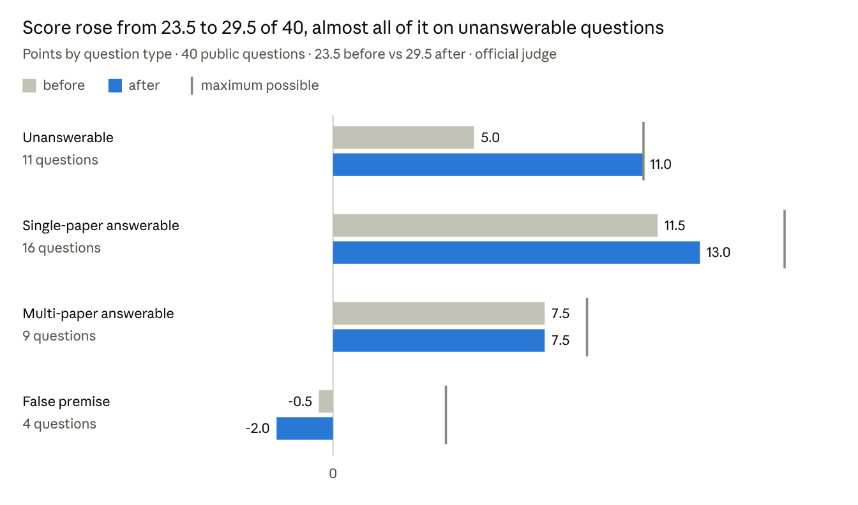
Official judge (gpt-4o-mini) on 40 public questions (dev_set.csv, unseen_set.csv) · before = original agent on unanswerable and false-premise questions, trang_branch on answerable ones · after = commit 3306ad4
Question | Before | After | Change | Fixed by
D15 | hallucinated | idk | +1.5 | earlier property check, still on
U12 | hallucinated | idk | +1.5 | rerank cut-off
U15 | hallucinated | idk | +1.5 | named-source check
U14 | judged correct (no "I don't know") | idk | +1.5 | 6. refusal wording
D02 | idk | partial | +0.5 | 2. same-task citations
D04 | idk | partial | +0.5 | 4. first-author lookup, 5. question words
D11 | idk | partial | +0.5 | 3. narrower property check
U20 | correct | hallucinated | −1.5 | none — Gemma's run-to-run variation
D15, U12 and U15 were fixed by the morning's hallucination checks, which these changes keep in place. Verdicts across all 40 moved from 18 correct / 6 partial / 10 idk / 6 hallucinated to 16 / 9 / 11 / 4. Total run time was 79 minutes before and 76 after on the CPU-only laptop.

Examples
In each case below the correct fact was already retrieved; the change lets it through.
D02 — "Which language models does the main multi-document QA experiment in 'Lost in the Middle' evaluate?" (fix 2)
- Before: "I don't know." Rejected: "Numbers absent from the cited passages: 1.3, 100, 13, 16." The names were in passages 2 and 3; Gemma cited passage 1.
- After: "… evaluates GPT-3.5-Turbo, GPT-3.5-Turbo (16K), MPT-30B-Instruct, LongChat-13B (16K), Claude-1.3, Claude-1.3 (100K) … [S1] [S2]" — all four ground-truth models, now citing S2.
D04 — "According to Kaplan et al., how does language model loss scale, and how much does architecture shape (width/depth) matter?" (fixes 4, 5)
- Before: "No matching research-paper evidence was found." Searched paper 27 only.
- After: "… loss scales as a power-law with model size, dataset size, and the amount of compute … more than seven orders of magnitude." The width/depth part is still missing.
D11 — "What pre-training setup does BERT use in terms of corpus, batch size, number of steps, optimizer and learning-rate schedule?" (fix 3)
- Before: "I don't know." Rejected: "No cited sentence states the answer's values as the requested optimizer."
- After: "BERT uses a batch size of 256 sequences (… 128,000 tokens/batch) for 1,000,000 steps." Correct, but two of five properties.
D14 — Wikipedia data used by RAG, LLaMA and BERT (fix 1)
- Before: BERT part rejected: "Numbers absent from the cited passages: 2.5."
- After: "BERT uses the BooksCorpus (800M words) and English Wikipedia (2.5B words) for pre-training." Accepted; the LLaMA part, which borrowed BERT's "800", is still rejected.
U14 — "How many parameters does GPT-4 have?" (fix 6, not in the papers)
- Before: "No matching research-paper evidence was found for this question." Judged correct against the ground truth "Not in the documents" — which scores −0.5 on an unanswerable question.
- After: "I don't know - No matching research-paper evidence was found…" Judged idk, +1.

Hallucination safety
Every fix lets through only text the retrieved passages already state, and all 11 unanswerable questions abstained after the change.
Fix | Still rejected
1. Unit-equal numbers | A value the passage does not state in any form: "3.1 billion words" against "2,500M words"
2. Same-task citations | A number found only in another task's or another paper's passage (D13's and D14's borrowed figures stay rejected)
3. Narrower property check | Single-property tasks and named benchmarks: D15's batch size from a context-size sentence, U12's WebShop result for a GSM8K question
4. First-author lookup | Co-authors and citations: "Brown et al." and "Smith et al." match no paper rather than the wrong one
6. One refusal wording | Wording only; no answer becomes a refusal or the reverse
The unanswerable questions ran first so a regression would show early. All 11 abstained — D09, D10, D15, U09–U16 — including the wrong-paper trap U15 ("According to the LoRA paper, … Mixtral"), where fix 2 could in principle have added a citation; the named-source check still required a LoRA passage.
The one score drop, U20 (a false-premise question), comes from Gemma's run-to-run variation: it was answered correctly in two earlier runs and wrongly in two, with no related code change.

Still open and next steps
Nine of the 25 answerable public questions remain partial; the largest cause is answers that are correct but too short.
- Too-brief answers (next). The answer prompt asks for direct, brief answers and to omit extra measurements. D11 gave 2 of 5 requested properties; D04 answered one of its two parts. Next: ask for every requested property and test that unanswerable questions still abstain.
- Multi-paper mix-ups. With five papers in one prompt, Gemma moves one paper's numbers into another's answer (D13, D14). The number check blocks them, so the result is partial instead of wrong. Option: one small answer call per paper.
- False premises. Gemma follows a wrong assumption in the question ("Which proprietary datasets did LLaMA use?"). A prompt instruction did not help in an earlier test.
Caveats. 40 questions, one run each, on one Intel CPU laptop; Gemma's output varies between runs, as U20 and U23 showed. The refusal-wording result applies the new wording to the saved answers of the test run, which started before that change. Confirm the gain with a full run on the hidden test set through the API.
To use the change: pull trang_branch and restart the server; no .env change is needed.

