**VOLTA_1.1 user manual**

**Installation instructions**

VOLTA runs as a standard geoprocessing tool in ArcGISTM and can be downloaded from<https://github.com/williamjames/volta>. ArcGISTM version 10.2.2 is supported: other versions may work but have not been tested.

VOLTA requires Python 2.7, which is normally pre-installed as part of with ArcGIS 10.2.2. Additionally VOLTA requires the Scipy site package to be installed as part of the Python installation. This is available through the VOLTA GitHub site <https://github.com/williamjames/volta/blob/master/scipy-0.16.0-win32-superpack-python2.7.zip>.

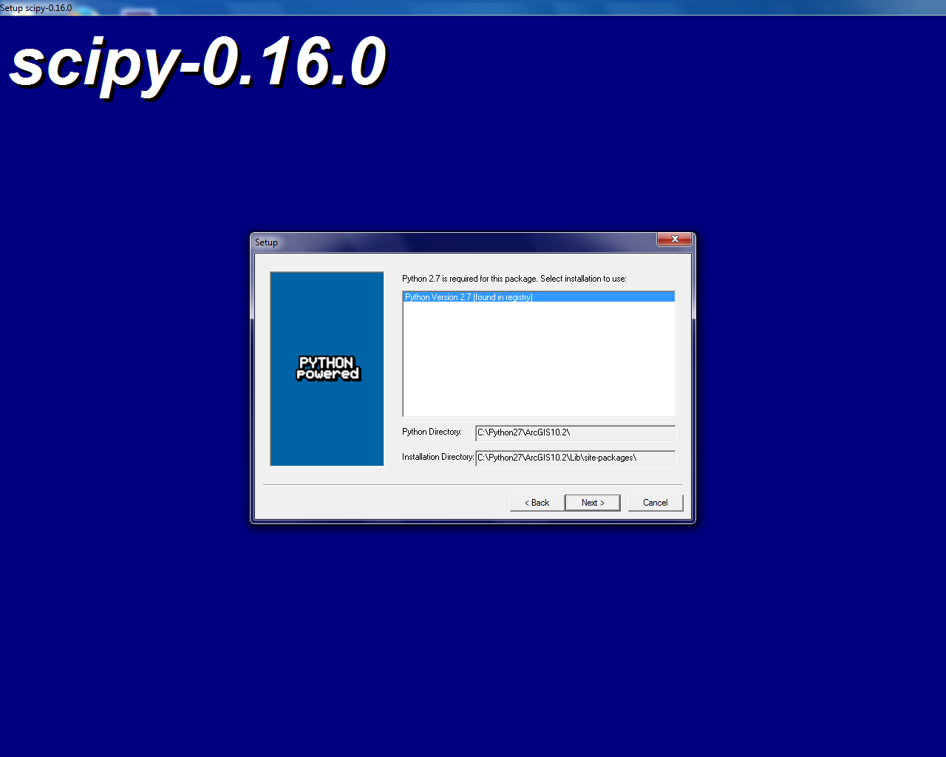If you do not have Scipy installed, please install it to the Python directory used by ArcGIS (fig 1).

**Fig. 1.** Setting the Installation of Scipy to the Python directory used by ArcGIS

**Setup and test data**

VOLTA is supplied as an ArcGIS geoprocessing package with a small test dataset and example results. To open the geoprocessing package, download and double click ‘volta_1.1.gpx’. This will automatically launch ArcGIS and load the test data/results (fig 2).

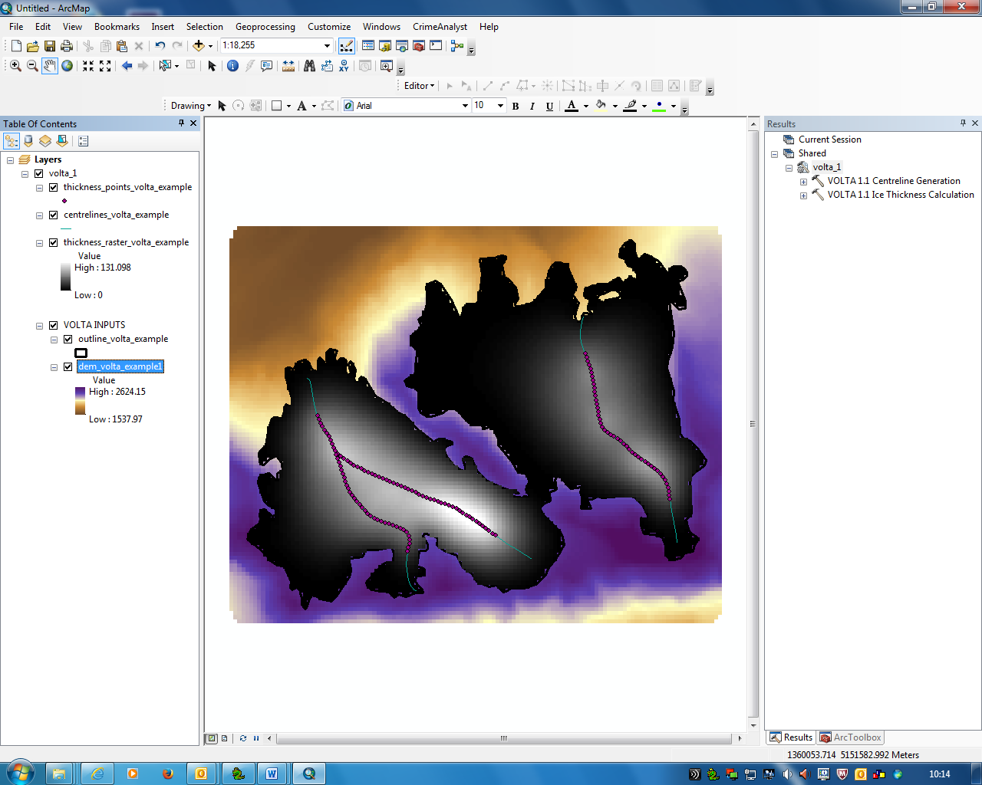

**Fig 2.** VOLTA test dataset loaded in ArcGIS

Once launched, you will see the example results and the input files (fig 2.)

VOLTA can be accessed through the ‘Results’ window (fig 2.). If this is not visible in ArcGIS, it can be enable from the Geoprocessing toolbar > Results.

VOLTA consists of 2 separate tools: Centreline generation and Ice Thickness Generation. The centreline tool should be used first, followed by the Ice Thickness Generation.

**STEP 1: CENTRELINE GENERATION**

To launch the centreline generation tool, double click on the ‘VOLTA 1.1 Centreline Generation’ tool in the results window. This will open the tool dialogue box (fig 3.)

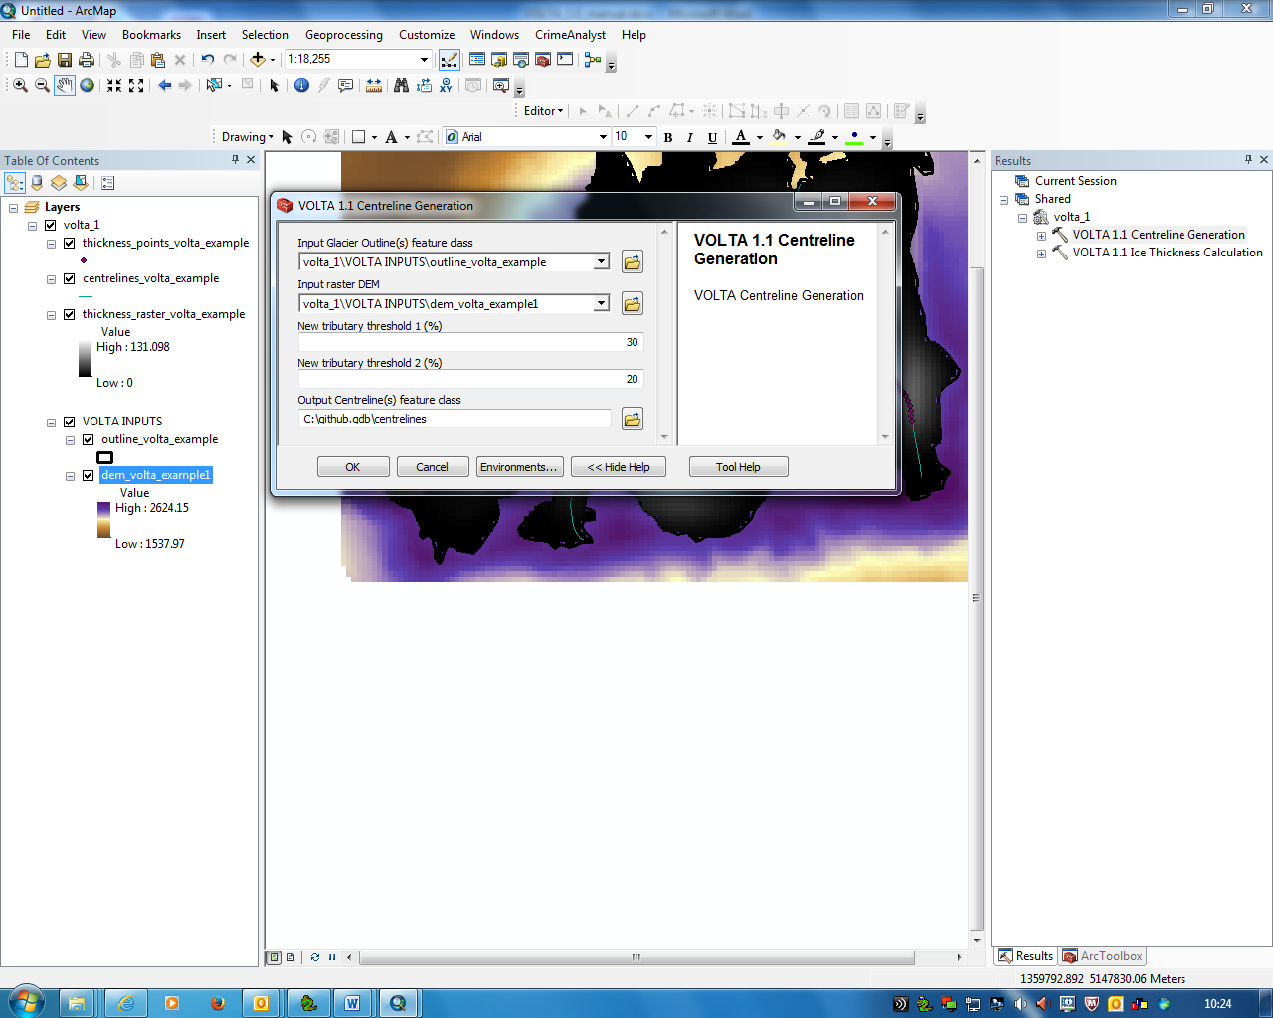

**Fig. 3** Centreline generation tool

The parameters for centreline generation are as follows:

* **‘Input Glacier Outline(s) feature class’:** the glacier polygons (in ArcGIS feature class format)
* **‘Input raster DEM’:** the ice surface DEM
* **‘New tributary threshold 1’ and ‘New tributary threshold 2’** Thresholds determine when VOLTA will split a glacier into separate tributaries (and multiple centrelines).

VOLTA uses a novel ‘upstream area’ approach to delineate separate tributaries, allowing multiple centrelines to be generated. Iteratively working down the initial centreline, upstream area is calculated. Total area will steadily increase down-centreline, but a marked increase occurs when a new tributary enters. VOLTA calculates area at an interval equal to 1 % of centreline length with a new tributary identified if the area increase between points is greater than threshold 1. Any new tributary must also have an area greater than threshold 2 (a % of the full glacier area). By default, ‘threshold 1’ is set to 30 % and ‘threshold 2’ is set to 20%, although these values may be changed if required.

* **Output Centreline(s) feature class:** the output centreline file to be created. This should be in saved in an ArcGIS file geodatbase. Fig 4. Shows an example of centrelines produced using the sample data.

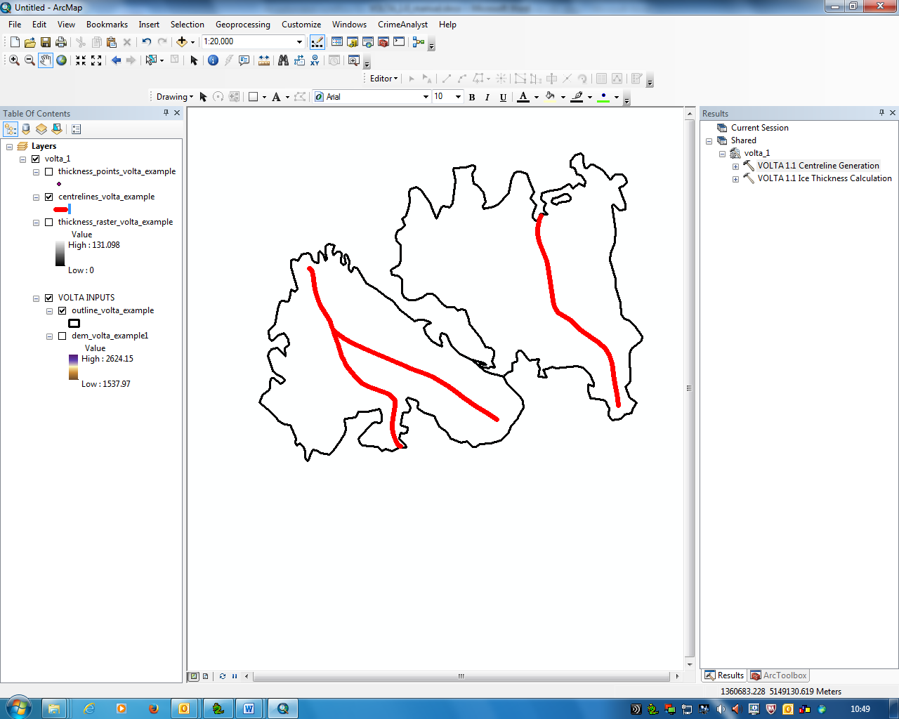

**Fig. 4.** Centrelines produced using the sample data

**STEP 2: ICE THICKNESS ESTIMATION**

Once centrelines have been created using the centreline generation tool, ice thickness can be calculated. To launch the ice thickness calculation tool, double click on the ‘VOLTA 1.1 Ice thickness calculation’ tool in the results window. This will open the tool dialogue box (fig 5.)

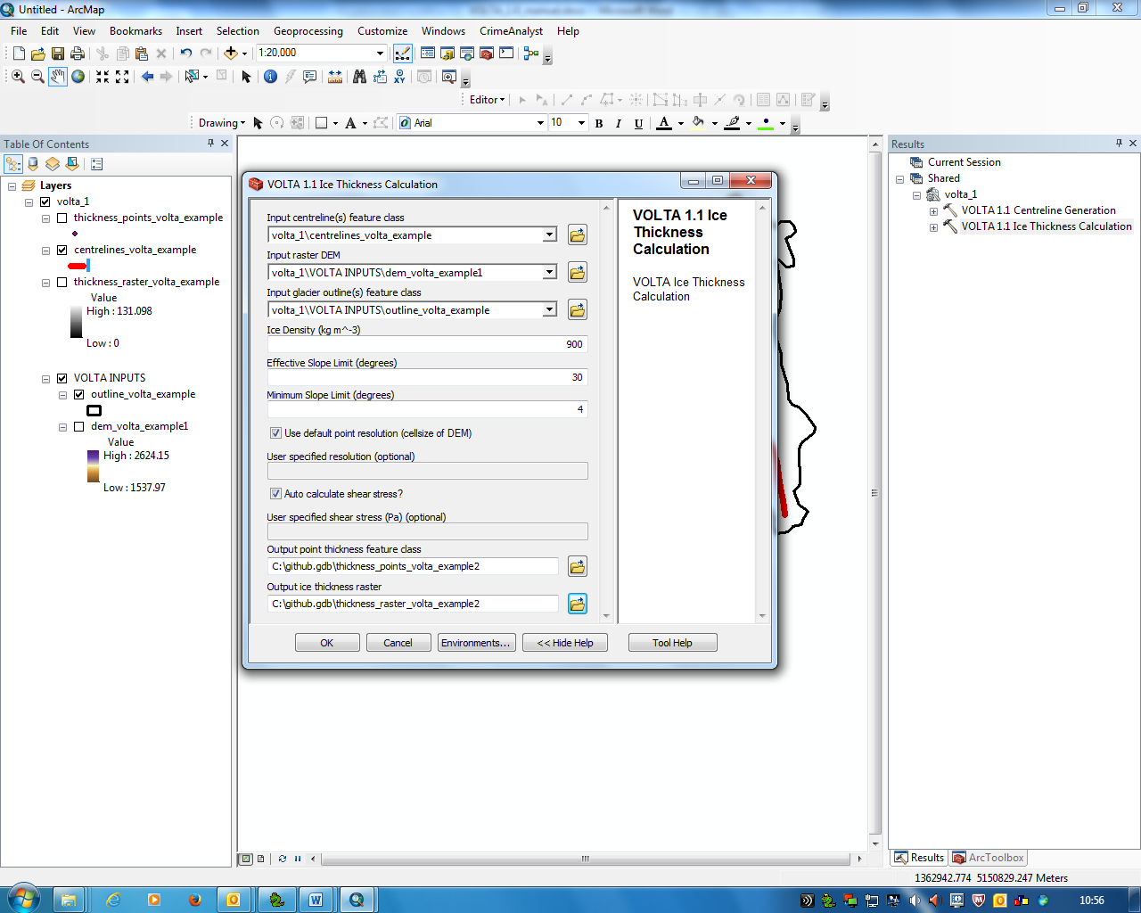

**Fig 5**. Ice Thickness Calculation tool

The parameters for ice thickness calculation are as follows:

* **Input centreline(s) feature class:** Centrelines created using the ‘centreline generation’ tool (or manually if required)
* **‘Input raster DEM’:** the ice surface DEM
* **Input Glacier Outline(s) feature class’:** the glacier polygons (in ArcGIS feature class format)
* **Ice Density:** the average ice density of the glacier (default = 900 kg m-3)
* **Effective Slope limit:** The slope angle above which areas of ice will not be included in the force-balance equation (default = 30o)
* **Minimum slope limit:** The centreline gradient at which any lower values will be set to. This is to stop over estimation of ice thickness in very flat regions (default = 4o)
* **Use default point resolution:** If checked (default), ice thickness will be generated along the centreline at an interval equal to that of the DEM resolution
* **User specified resolution:** If ‘Use default point resolution’ is unchecked, the interval between points can be defined. This may be useful if processing large datasets with a high resolution DEM as processing times will be improved with a larger interval.
* **Auto Calculate Shear Stress?**: if checked (default), the shear stress is automatically calculated for each individual glacier
* **User specified shear stress**: if ‘Auto Calculate Shear Stress?’ is unchecked, a shear stress value can be manually entered
* **Output point thickness feature class**: the output points to be created. Fig 6. Shows an example of thickness points produced using the sample data.
* **Output Ice thickness raster**: the output raster to be created. Fig 7. Shows an example of the raster produced using the sample data.

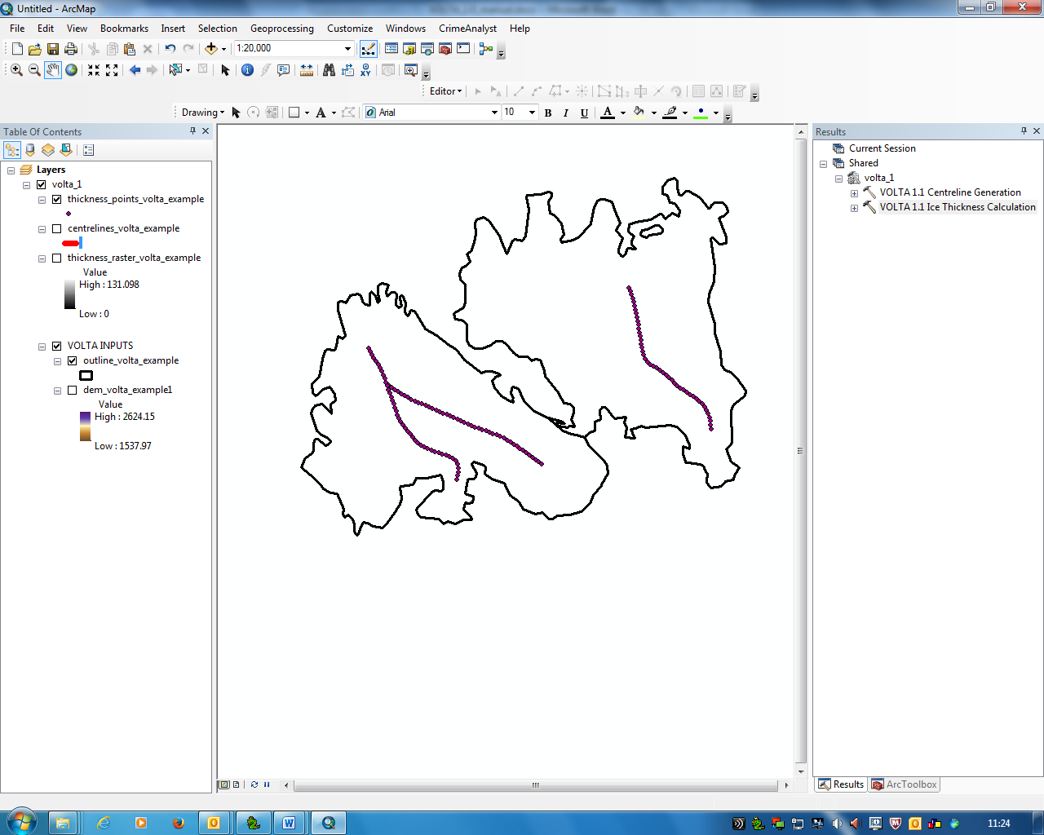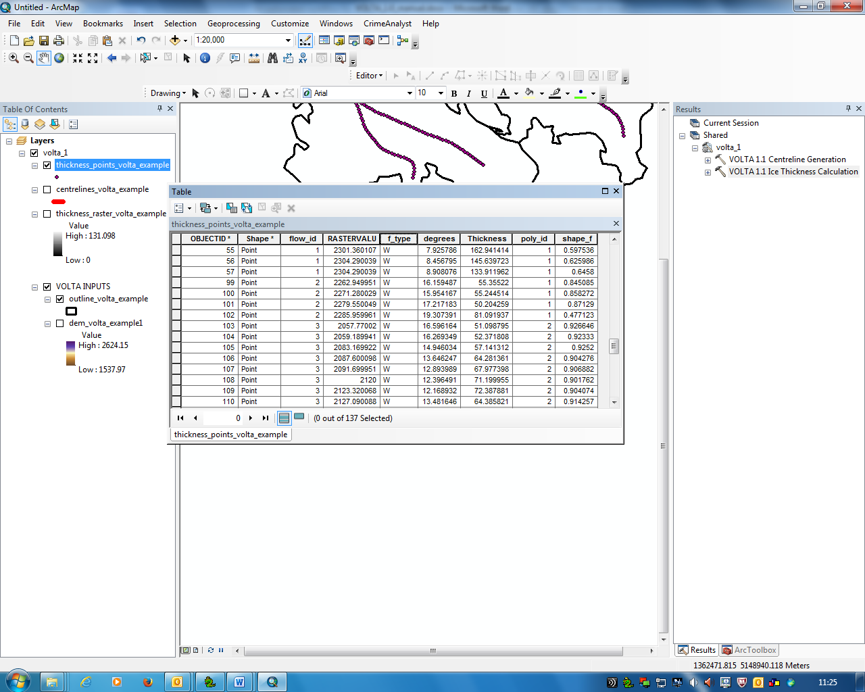

**Fig 6. Output points and attribute table created using the ice thickness estimation tool**

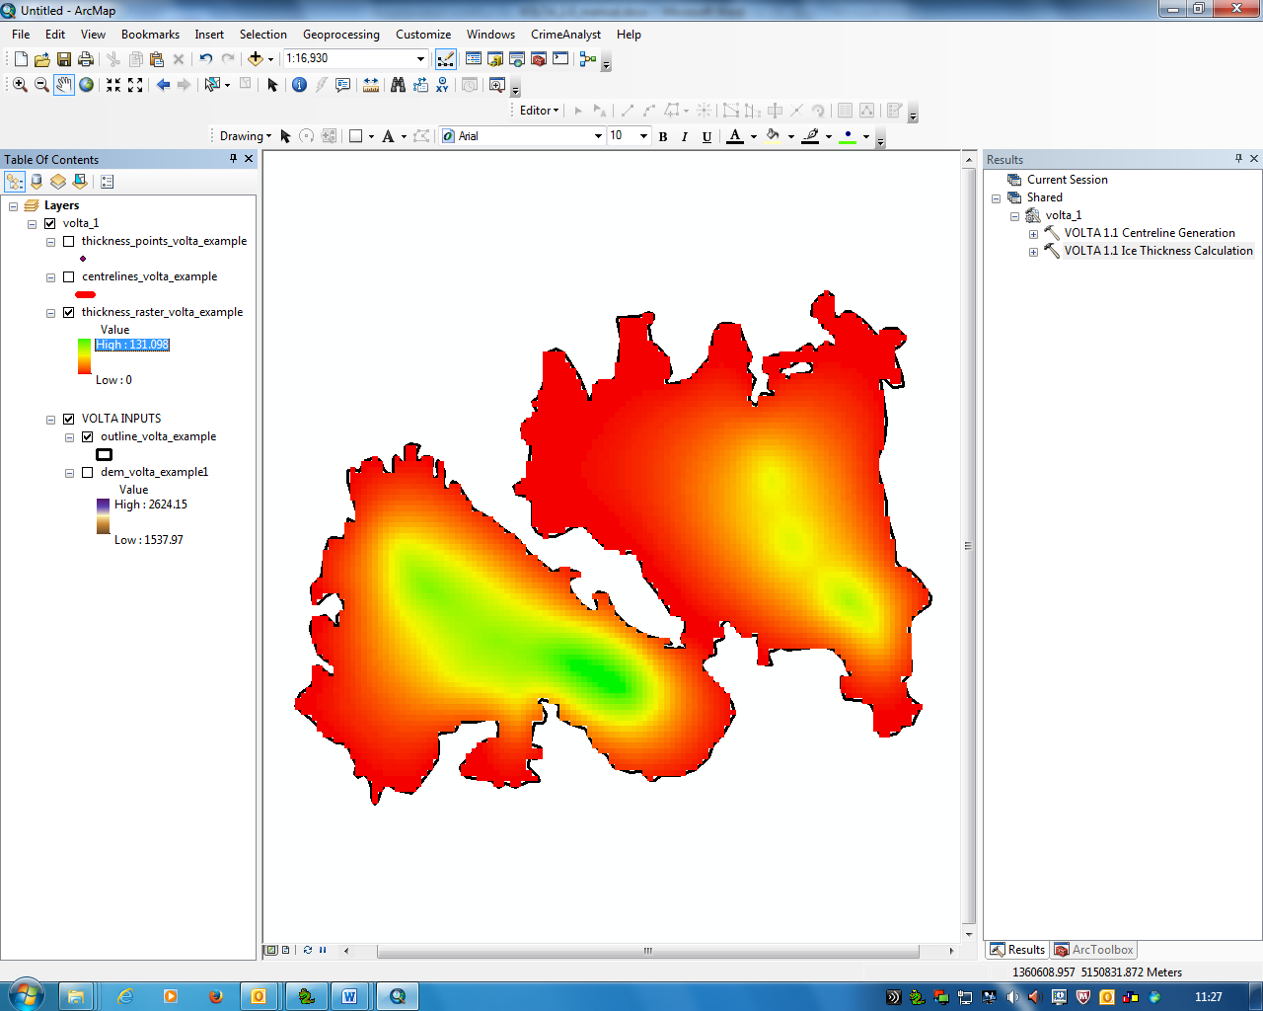

**Fig. 7 Ice thickness raster created using the ice thickness estimation tool**

**Interpreting the results**

* The ice thickness raster (Fig. 8) shows the interpolated distributed ice thickness for each glacier.
* Additional fields of ‘volume’ and ‘stress_kpa’ (calculated shear stress) will be added to the outlines layer.
* The output point file (Fig 7.) contains the ice thickness and other calculations at each point. Fields in the attribute table are:
  + Flow_id: identifies which centreline the point is on (relates to OBJECTID field in centreline layer)
  + RASTERVALU: the elevation of the ice surface (from the DEM)
  + F_type: the method used for calculating thickness – ‘W’ denotes the width of the glacier at the point has been taken into consideration, whilst ‘A’ denotes it has been calculated using the average value for the tributary.
  + degrees: the distance-averaged slope of the centreline for the point
  + Thickness: the calculated thickness
  + Poly_id: identifies which glacier outline the point is part of (relates to OBJECTID field in outline layer)
  + Shape_f: the calculated ‘shape factor’