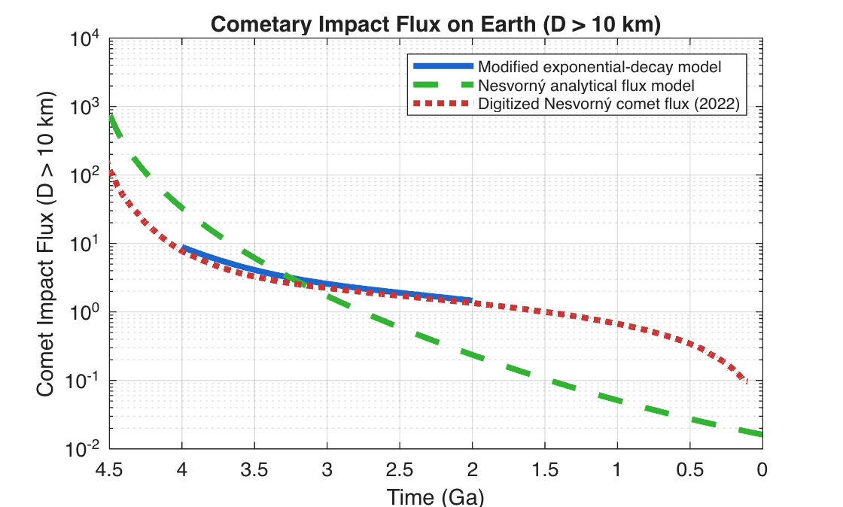

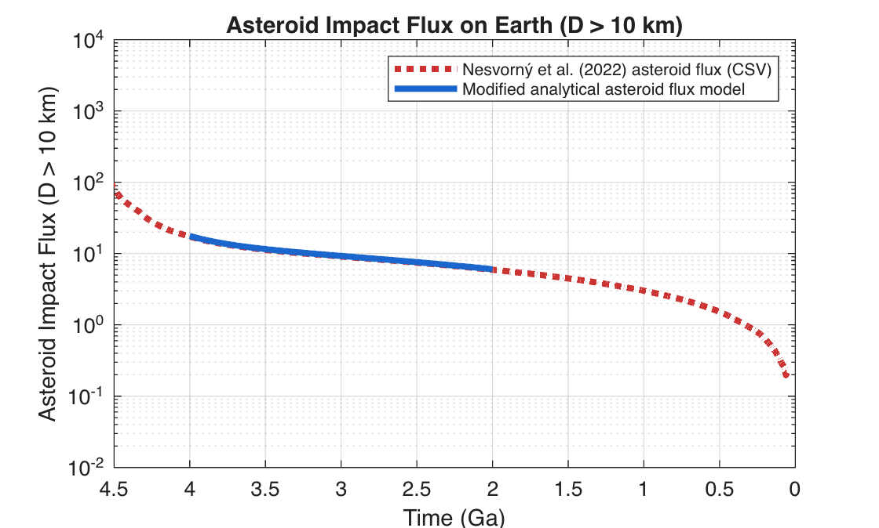

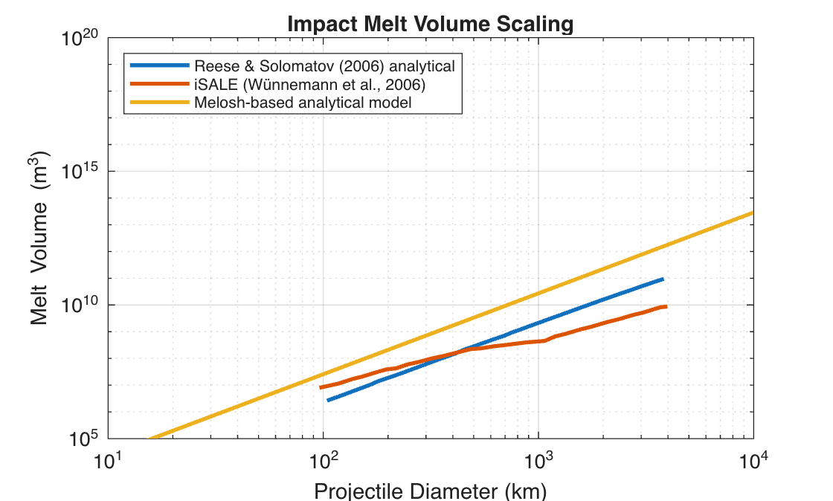

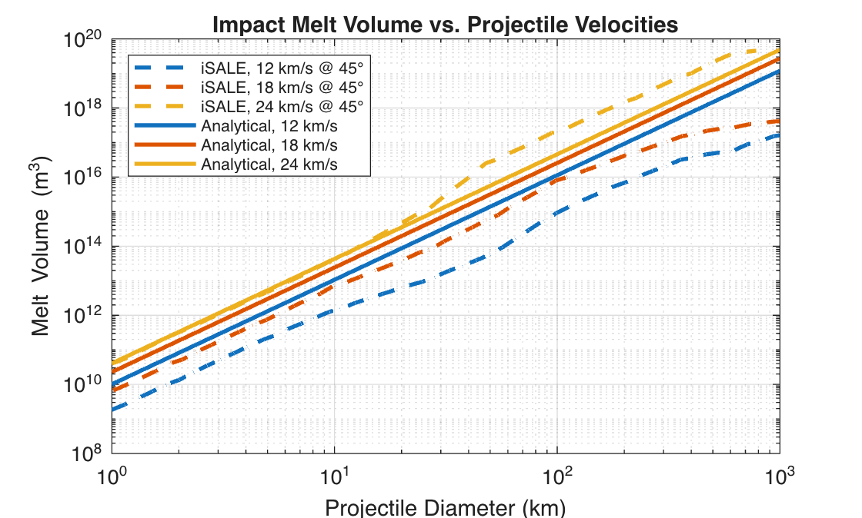
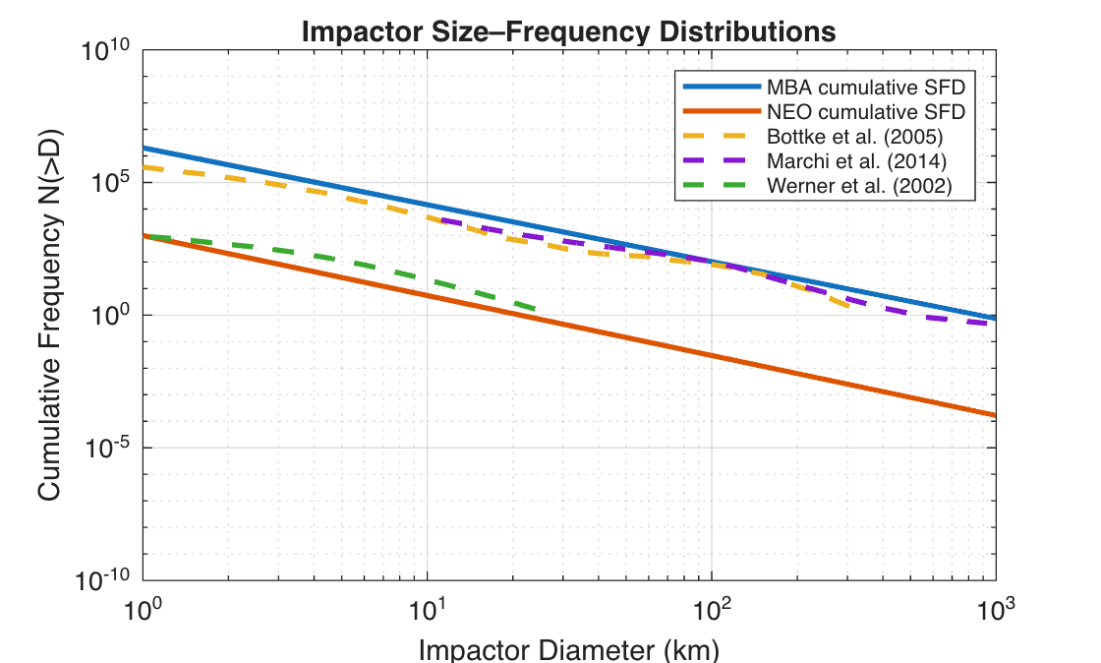

New References:
Bottke Jr, W. F., Durda, D. D., Nesvorný, D., Jedicke, R., Morbidelli, A., Vokrouhlický, D., & Levison, H. (2005). The fossilized size distribution of the main asteroid belt. Icarus, 175(1), 111-140.
Werner, S. C., Harris, A. W., Neukum, G., & Ivanov, B. A. (2002). The near-Earth asteroid size–frequency distribution: A snapshot of the lunar impactor size–frequency distribution. Icarus, 156(1), 287-290.
Reese, C. C., & Solomatov, V. S. (2006). Fluid dynamics of local martian magma oceans. Icarus, 184(1), 102-120.
Wünnemann, K., Collins, G. S., & Osinski, G. R. (2008). Numerical modelling of impact melt production in porous rocks. Earth and Planetary Science Letters, 269(3-4), 530-539.

