Autonomous Driving Training Platform - MLOps Architecture & Workflow Overview
This document provides a high-level summary of the machine learning architecture and workflows for an autonomous driving training platform. It is organized into three core subsystems: Collection Management, Experiment Management, and Resource Management.
Figure 1: Overview

Figure 2: Architecture
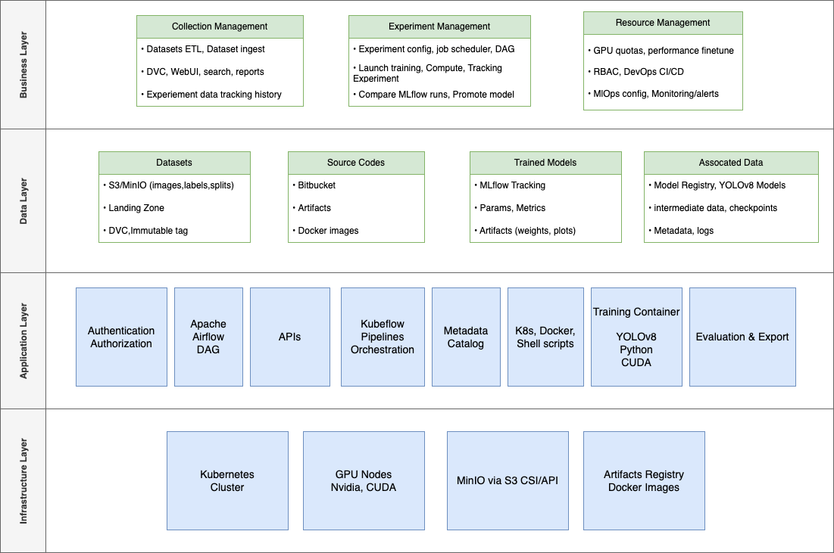
Figure 3: End-to-end overview - training data is collected and processed into datasets (left), fed into automated training pipelines (center), and results in a trained YOLO model registered for deployment (right).
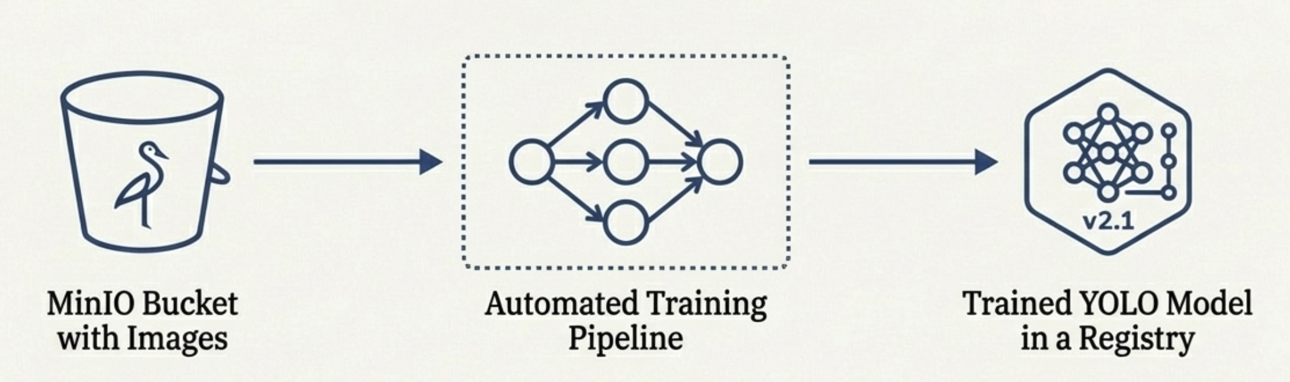

1. Collection Management
This subsystem handles data ingestion and dataset preparation.
Figure 4: Collection Management Workflow

Data Ingestion & Preprocessing
- Raw driving data (images and labels) are uploaded to a Landing Zone, an internal portal for collecting new training data.
- A Python ETL service periodically scans the Landing Zone for new uploads and performs:
  - Image preprocessing and validation (e.g., using PyTorch)
  - Annotation parsing and metadata extraction
  - Data Versioning (DVC). DVC (Data Version Control) enforces dataset versioning and lineage tracking as new data is added.

Storage & Eventing
- Processed data images/labels are moved into AWS S3/MinIO object storage for long-term retention.
- Each successful upload triggers a MinIO Server-Side Event (SSE) notification.
- Events are published to Apache Kafka with dataset identifiers and storage locations to trigger downstream processing workflows (indexing, caching, and UI notifications).

Metadata & Indexing
Downstream microservices consume Kafka messages to update metadata and indexes
- Dataset metadata stored in PostgreSQL (Assets database)
- Collection and annotation of data stored in MongoDB
- Frequently accessed metadata cached in Redis
- Records indexed in Elasticsearch for search and analytics

Collection Management UI
A WebUI (React + Node.js) provides:
- Dataset collections (owners, categories, version tags, relationships with experiment data)
- Asset views (image previews, labels, metadata)
- Ingestion and job status monitoring
- RESTful APIs to upload supplementary data (e.g., edge cases, validation sets) directly to MinIO to augment existing collections
- Web forms for uploading additional metadata (e.g., sensor calibration, weather conditions) to enrich the dataset context
- Real-time ingestion progress and system logs are streamed via WebSocket / SSE, enabling immediate feedback for data engineers
The Collection Management subsystem ensures raw driving data is efficiently collected, validated, stored, indexed, and versioned, producing high-quality training datasets with full traceability for downstream ML workflows.

2. Experiment Management
Experiment Management covers the model training workflows, from orchestration to tracking and model governance. It uses Kubeflow Pipelines orchestrator over K8S.
Figure 5: Experiment Management Workflow
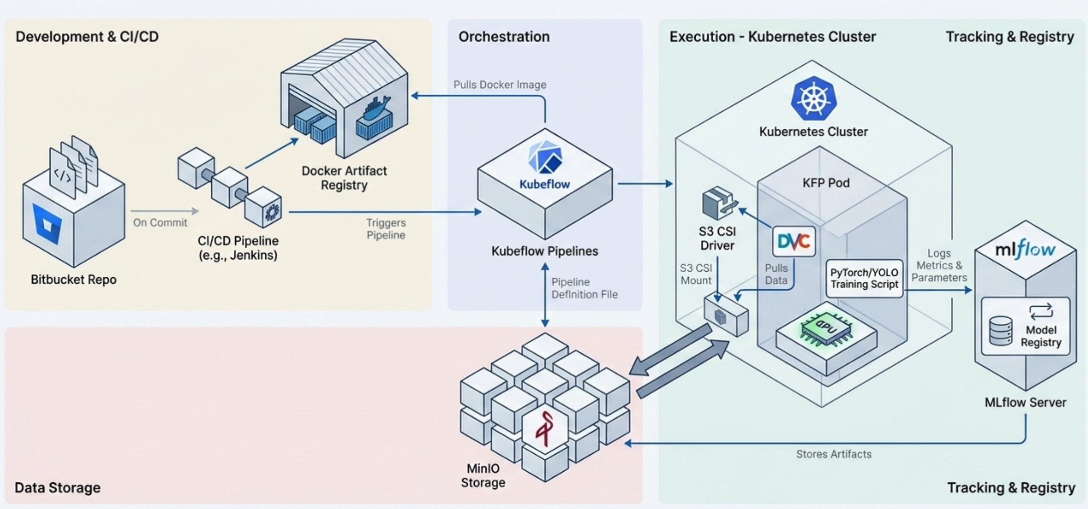
- The platform adopts Kubeflow Pipelines (KFP) to orchestrate end-to-end ML workflows.
- Kubeflow Pipelines are Kubernetes-native and better aligned with the full ML lifecycle.
- Pipelines are composed of custom components for each stage:
  - Data preparation
  - Training
  - Evaluation
  - Model export
- When a new experiment runs:
  - Datasets are pulled from MinIO
  - Training code is retrieved from pre-built container images
  - An S3 CSI driver is often used to mount MinIO buckets directly into pods for efficient data access

Training Execution & Tracking
- Training steps execute in isolated Kubernetes pods, leveraging NVIDIA GPUs.
- All experiment results (metrics, parameters, artifacts) are logged to MLflow.
- MLflow records run metadata and stores trained model artifacts for traceability and comparison.

CI & Reproducibility
- A CI pipeline (e.g., Jenkins) builds and version-tags Docker images for training jobs.
- This ensures reproducible and consistent training environments across experiments and environments.

Output & Summary
- Each experiment produces:
  - A registered model in the MLflow Model Registry
  - Associated metrics and metadata
- Models are ready for deployment or further evaluation.
Experiment Management provides a structured framework to develop, orchestrate, and track model training from code commit to trained model, supporting both ad-hoc experimentation and reliable production pipelines.

3. Resource Management
Resource Management oversees the infrastructure and operational tooling that supports both data collection and experiment pipelines.
Figure 6: Resource Management
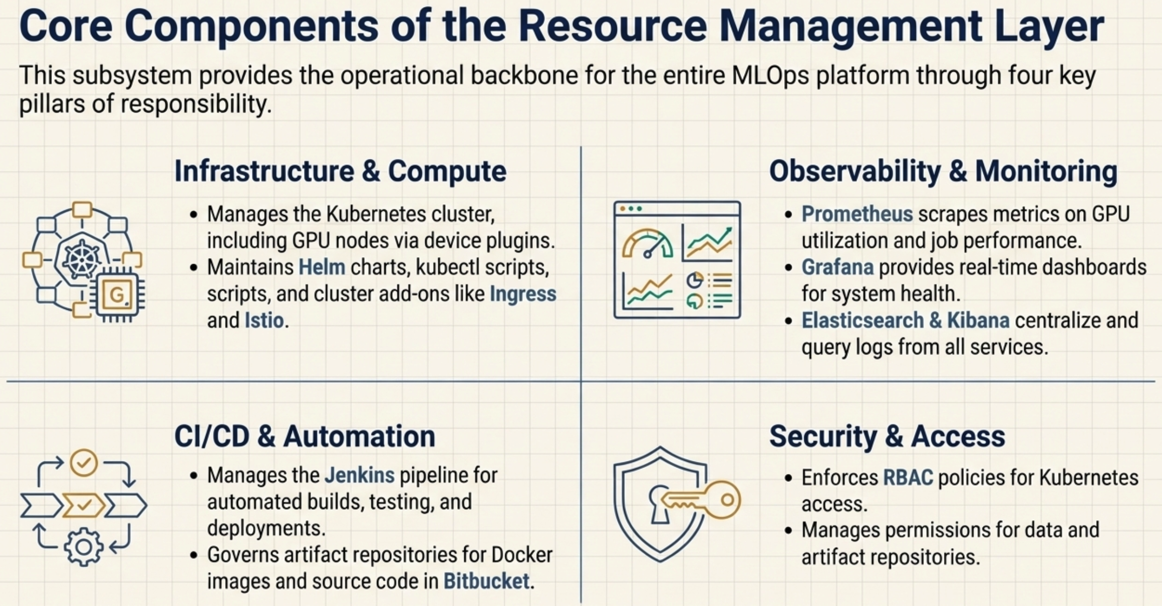
Area | Components | Purpose
Infrastructure | Kubernetes cluster, GPU nodes, Helm charts, Istio | Core execution platform for training and data processing
Platform Services | Kubeflow, MLflow, Collection APIs | ML workflow orchestration and experiment tracking
Storage & Artifacts | MinIO, Bitbucket, Container Registry | Datasets, source code, and container images
Monitoring | Prometheus, Grafana, Elasticsearch, Kibana | Metrics collection, visualization, and log analysis
CI/CD | Jenkins | Automated build, test, and deployment
Security | RBAC, Access Policies | Cluster access control and data permissions

Resource Management delivers infrastructure stability, observability, security, and automation for the platform.

