**Supplementary Material S3**

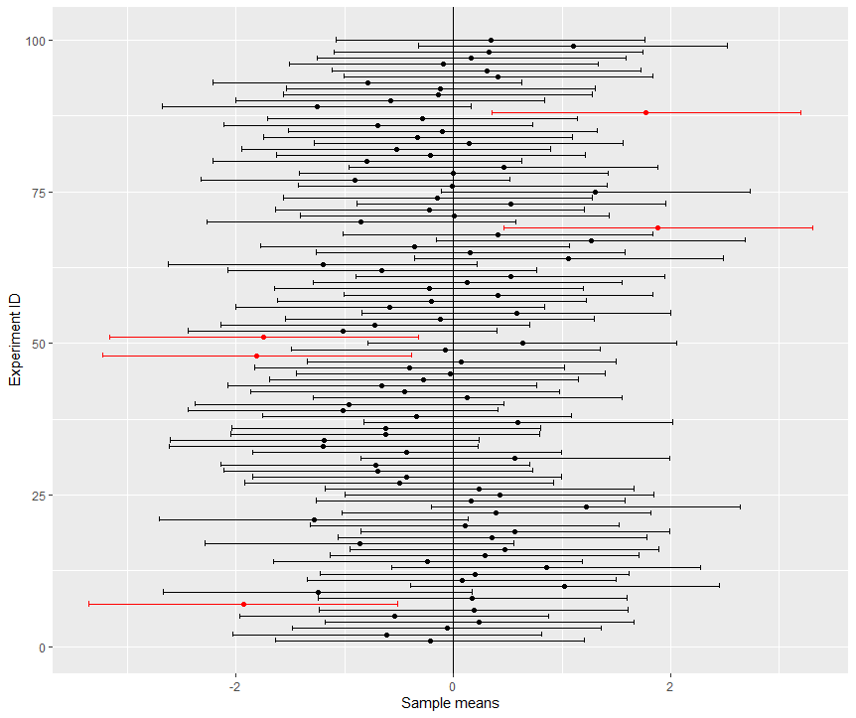

**Figure 1.** This figure illustrates the meaning of a 95% confidence interval from a frequentist’s point of view. A confidence interval represents one possible interval that either contains the true population parameter (vertical line) or not. A 95% confidence interval is constructed so that (on average) out of 100 identically repeated experiments (Experiment ID), 95 calculated confidence intervals (black) will contain the true population parameter and 5 (red) will not contain the true population parameter. See R code for details.