Space Physics Laboratory Logbook
Princeton University - 171 Broadmead

April 24, 2026 (Friday)
08:00 – LYK
Open the lab with William. We are going to do RGA scan and the ion source ignition.
08:45 – LYK
Completed the RGA scan for science chamber. The overall trend is better but there is still a spike near 102 (likely sapphire related).
09:09 – LYK
Change the IS beam to 1keV proton at IS = 1E-6 Torr. MCP is now at 1400 V. Open the SC GF and Beamline GV. Going to slowly ramp up MCP to 1800 V.
09:13 – LYK
We saw about 30 Hz in the ‘baseline’ mode, i.e., open aperture. Close the beamline GV.
Turn off the SC ion gauge to do dark count test.
The plan for today is as follows:
- Dark count test
- Carbon Foil
  - Electron yield test with 1 keV p+
- Move to Graphene
  - Electron yield test with 1keV p+
- Change the beam to 4keV p+
- Move to Carbon Foil
  - Electron yield test with 4keV p+
- Graphene
  - Electron yield test with 4keV p+
- Repeat the scattering test with 4keV p+
09:24 – LYK
IS pressure drops during the dark count test, so adjust it back from 8E-7 Torr to 1E-6 Torr
09:37 – LYK
Close the BL GV to change the IS pressure from 1E-6 to 1E-5 Torr because the count rates are too low (~2.07 Hz) when in electron yield test.
This is what we see with 5 V on deflector plate….
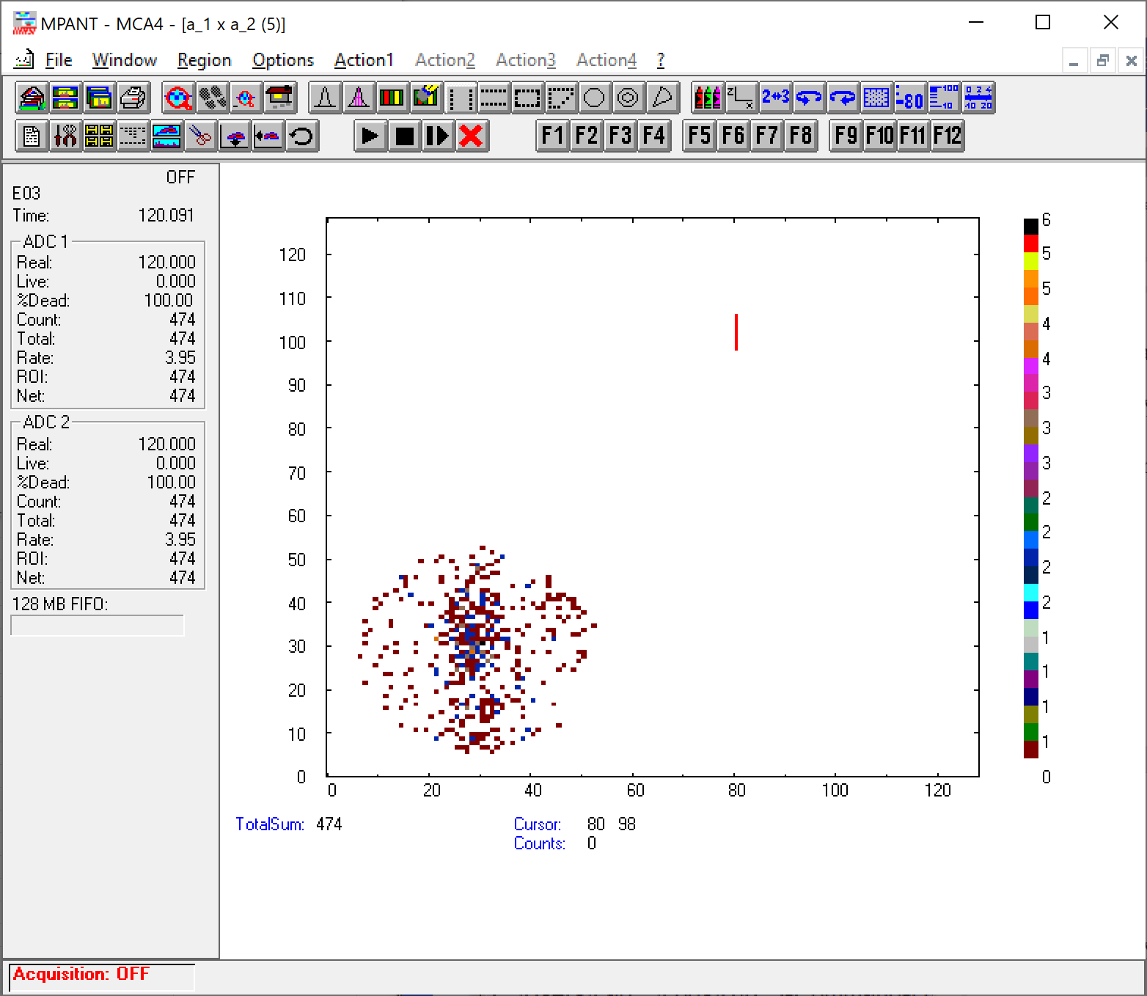

Changing it to 6V to see how the distribution changes. See below.
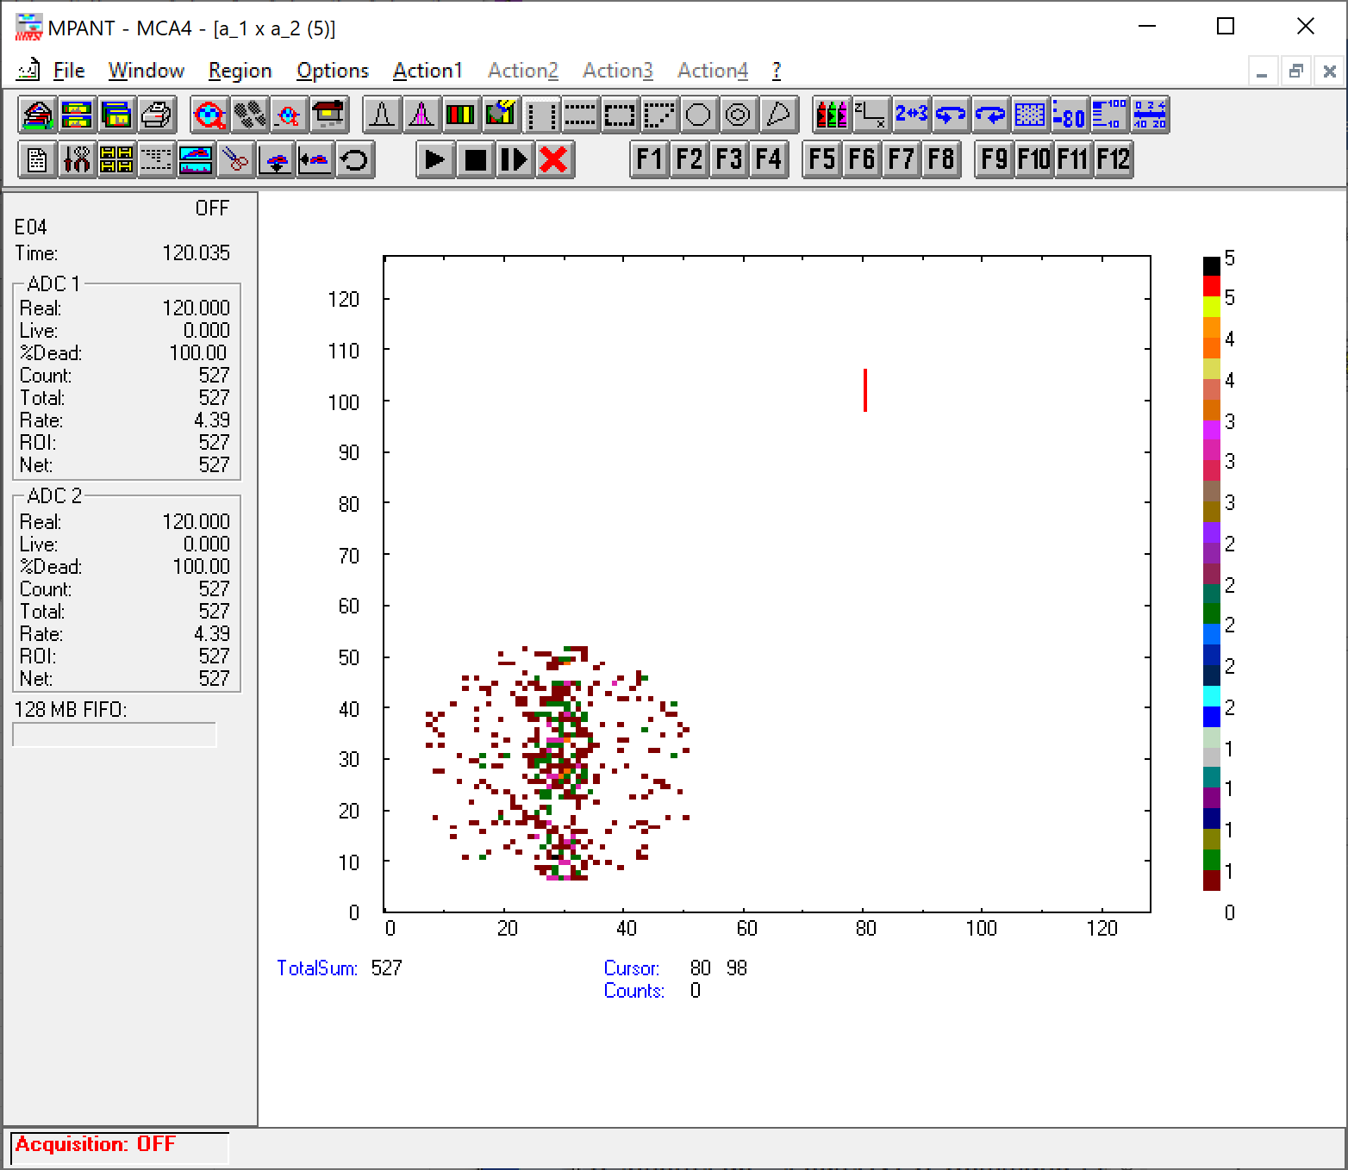
09:48 – LYK
Close the BL GV to change the IS pressure again to 2E-5 Torr to improve the statistics because we still don’t quite see the electrons. It could be a result of a poor statistics.
With 8V deflection plate bias:
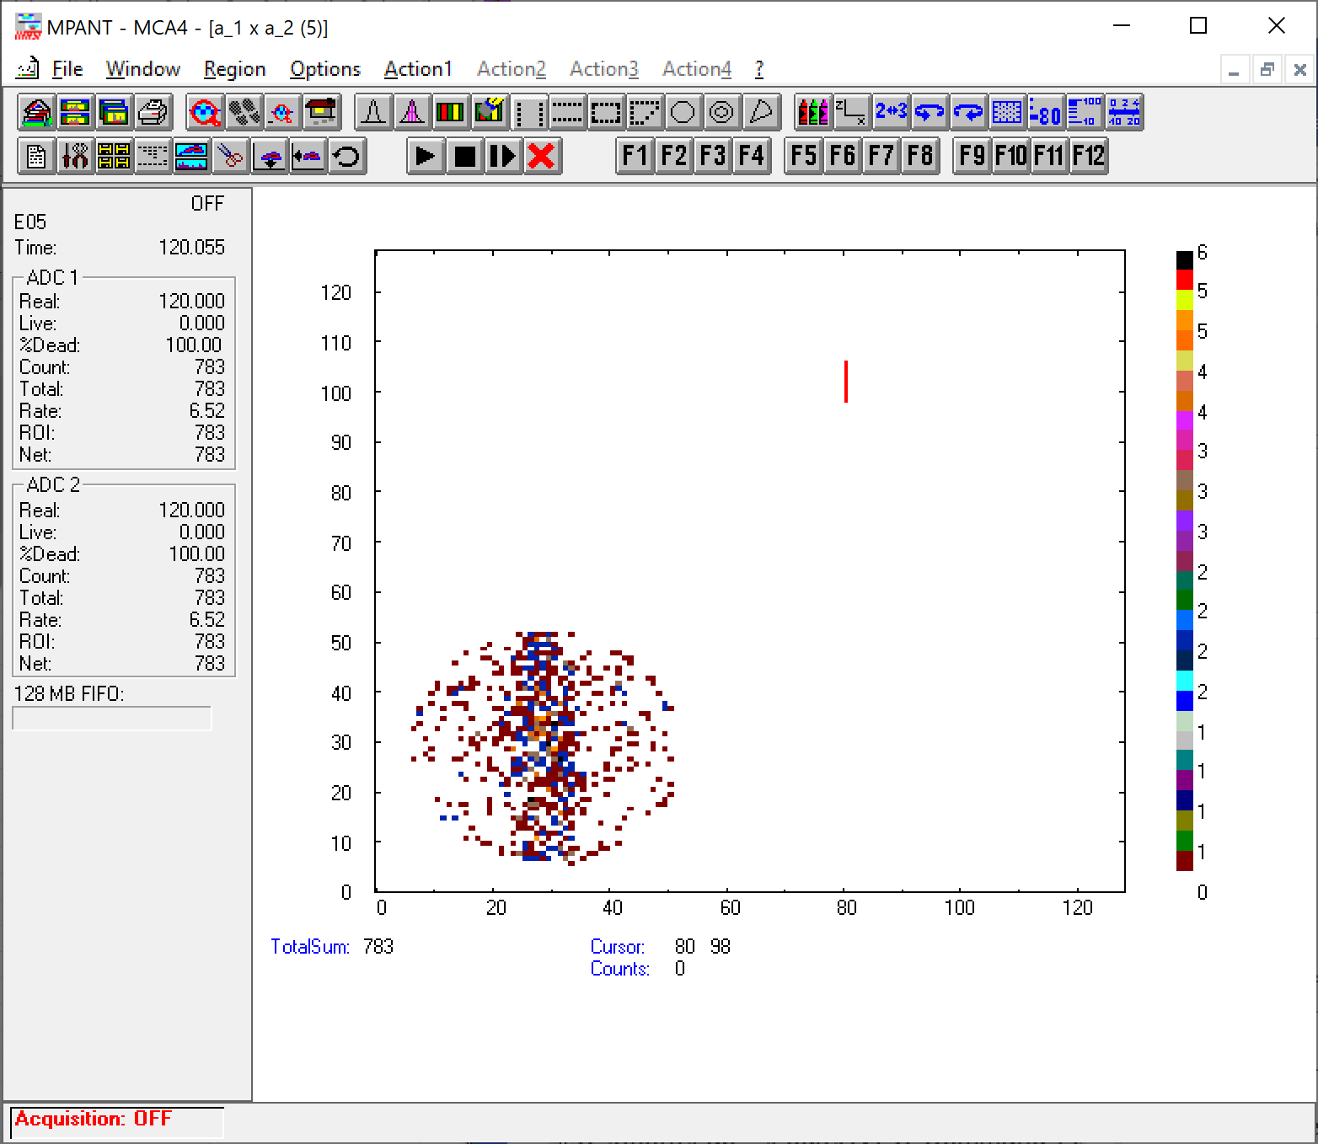
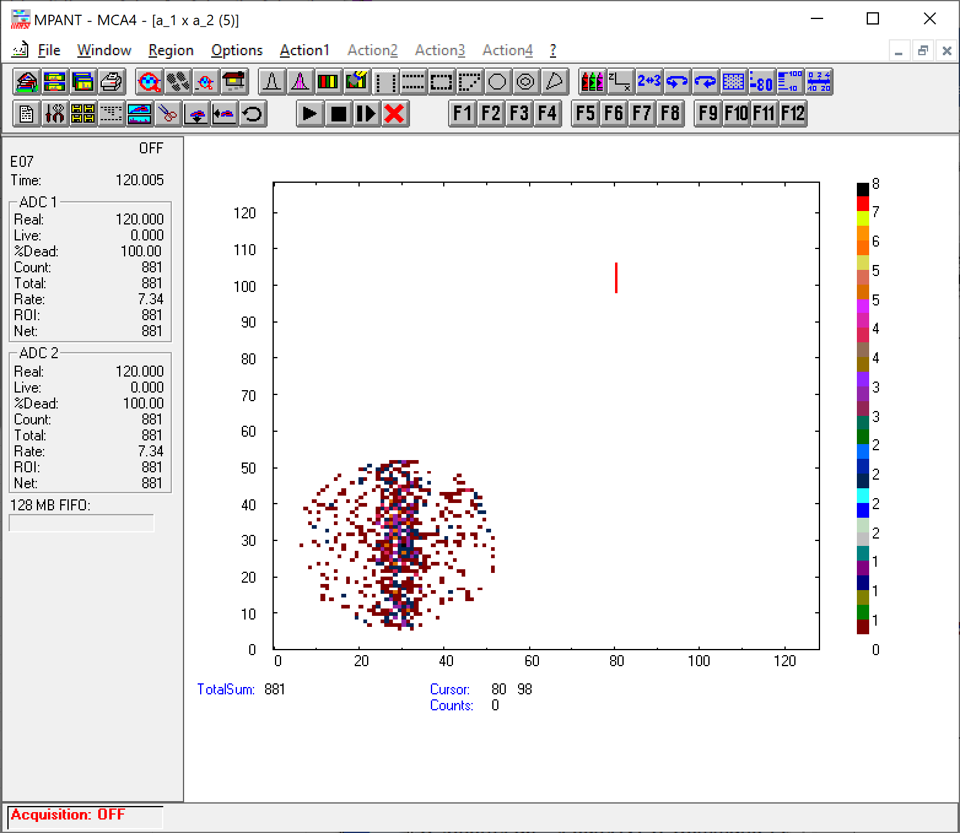



10:23 – LYK
Close the beamline GV to change to Graphene with deflection plate at 4V, 5V, and 6V.
10:25 – LYK
Open the beamline GV as the instrument is now at Graphene.
10:34 – LYK
Close the beamline GV to change the beam to 4keV proton. The IS pressure is at 2.3E-5 Torr. We are still at Graphene. Will repeat the test with 4keV p+ at 4, 5, 6V deflection plate.
10:35 – LYK
Open the beamline GV and start the test. Still seeing nothing, but we learn from lit search that Graphene has lower stopping power and thus lower secondary electron emission, hydrophilic (might explain why it doesn’t see the neutrals because of the thick crud layer), should generate ~the same fraction of neutrals and ions compared to amorphous carbon foil.
11:07 – LYK
Close the BL GV. We completed the electron yield tests. Maybe the statistics are low but we didn’t see the electron strips..
We should inspect the MCP after all these tests to make sure that we didn’t work the MCP too had…

