2019
Secure App Development
Secure login assignment documentation
William Nolan | C00216986
Table of Contents
Introduction 2
Register 2
Development 2
Test Cases 4
XSS through username 4
Password Complexity 4
Unsuccessful Authentication Attempt 4
Development 4
Test Cases 5
XSS through username 5
Brute force 5
Successful Authentication 5
Test Cases 5
Authenticated user view page that an unauthenticated user has no access to 5
Logout Securely 5
Logout due to inactivity 5
Logout due to max session duration 5
Password Change 6
Test Cases 6
Unauthenticated user tries to change password 6
Password Complexity 6
Expire Active Session after password change 6
CSRF 6
Event Log & ADMIN User 6
Test Cases 6
Event Log Page 6

Introduction
This document includes all the documentation of the development and testing process for my secure app login assignment.

Register

Development
The first thing I considered when developing this part of the assignment was how to salt and hash the passwords. I used the md5 hash method and created my own salting method which returned a 62-character long string with random lowercase letters, uppercase letters and numbers.
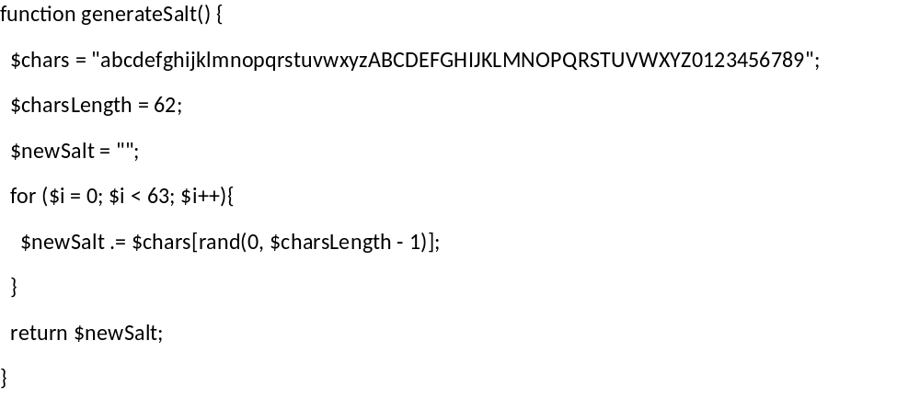
Figure 1: Salt Method
Next thing I worked on was the user’s password complexity. Each password needed to have at least one lowercase letter, one uppercase letter, a number, a special character and be at least 8 characters in length. I wrote a method which made use of PHP’s preg_match to check if the password had a matching pattern, i.e. [A-Z] for uppercase letters. If the password doesn’t match the pattern, I add an appropriate error message to the return string and output it on the page.
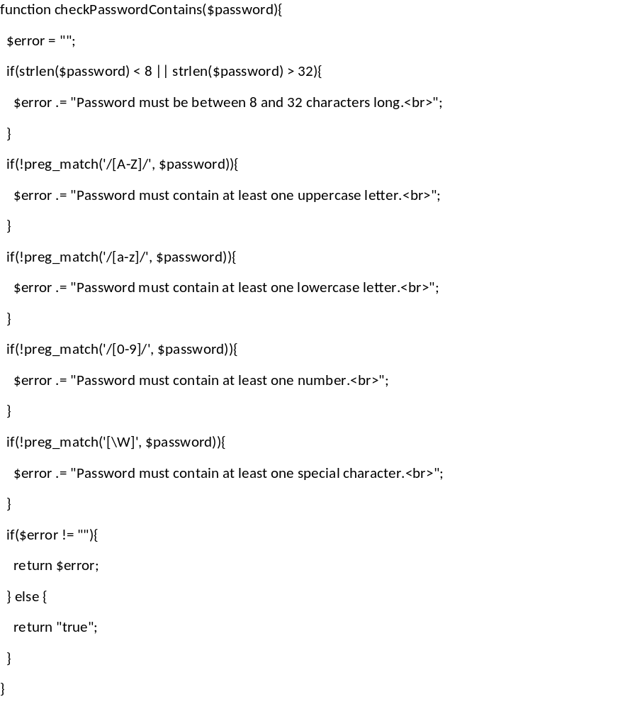
Figure 2: Password Complexity method
The last thing I did was sanitize the username to prevent XSS if the username is reflected to the screen. Here I just replaced any possibly malicious characters with their Unicode Decimal Code.
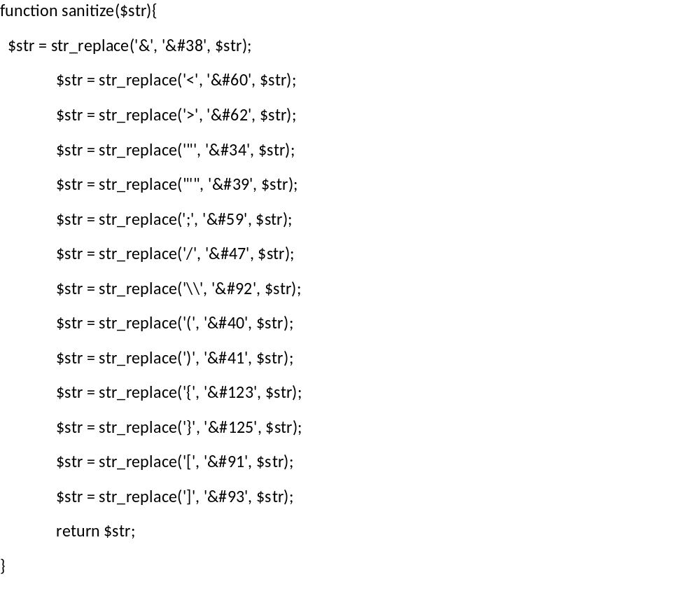

Test Cases

XSS through username
Security Feature | XSS through username
Test Performed | Try to register a user with a script tag as their username (i.e. <script>alert(‘Test’);</script>).
Results | The system informs the user that username isn’t valid.

Password Complexity
Security Feature | Password Complexity
Test Performed | Try to register a user with an unsecure password (i.e. less than 8 characters long, no uppercase letter, no lowercase letter, no number or no special character).
Results | The system informs the user they need to make their password more complex (i.e. “Password must contain at least one special character.”).

Unsuccessful Authentication Attempt

Development
Here I reused my sanitize function from earlier to prevent any XSS when if the username got reflected to the screen.
For the lockout functionality, each time the user had a failed login I recorded it in my database along with their IP and User Agent. When they got to 5 attempts, I set the locked variable in the database to TRUE and the lockedoutTime variable to 3 minutes from the current time. I held whether the user was locked out or not in a session variable and that got updated whenever the page was reloaded to prevent the user from just opening an incognito browser. This also allowed me to unlock the user when their timeout period was over.

Test Cases

XSS through username
Security Feature | XSS through username
Test Performed | Try to login using a script tag as username to get it to be reflected on the page (i.e. <script>alert(‘Test’);</script>).
Results | The username is reflected back to the page sanitized. No scripts are run.

Brute force
Security Feature | Brute force
Test Performed | Try to brute force the login by attempting a user’s password multiple times.
Results | The user is locked by their IP and User Agent after 5 unsuccessful attempts for 3 minutes.

Successful Authentication

Development
To login the user, I salt and hashed the password they supplied and compared it to the corresponding password in the database. If the passwords matched, I called the session_regenerate_id method to update the session id with a new one and then set the respective session variables an authenticated user would have.
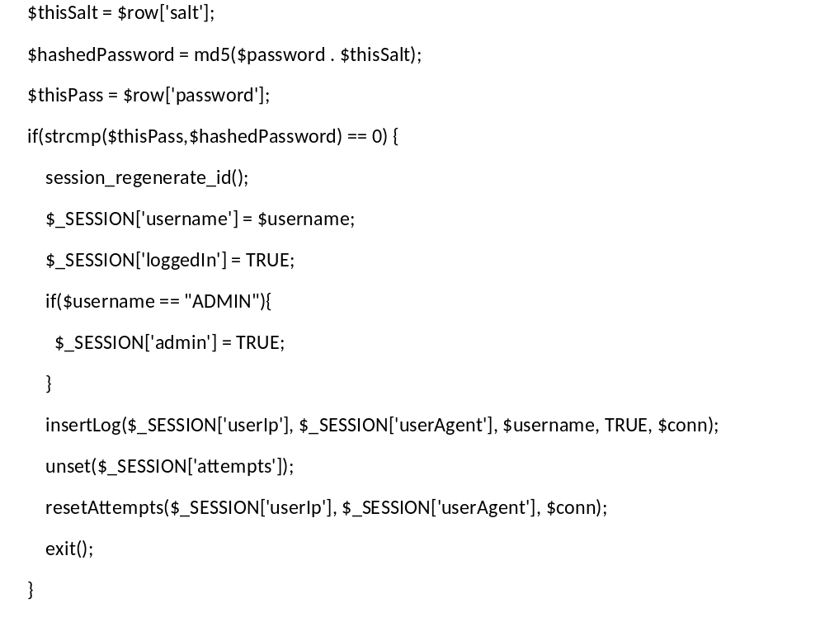
Figure 3: Authenticated Session code
I added a check at the top of each page to prevent unauthenticated users accessing pages they shouldn’t have access to. This just check to see if the loggedIn session variable was set. If it wasn’t set, I destroy the session and redirect the user to the login page.
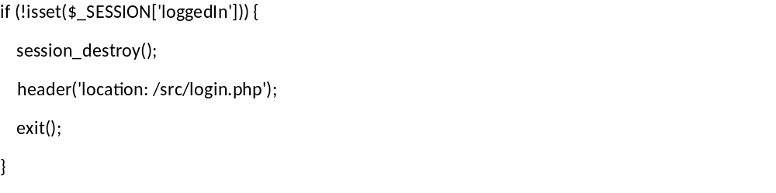
Figure 4: Unauthenticated User code
To log the user out securely I just unset and destroy the session then redirect them back to the login page.
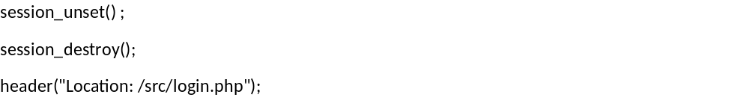
Figure 5: Logout code

Test Cases

Authenticated user view page that an unauthenticated user has no access to
Security Feature | Authenticated user view page that an unauthenticated user has no access to
Test Performed | Unauthenticated user tries to view the page without logging in through the page’s URL.
Results | Unauthenticated user is redirected to login page.

Logout Securely
Security Feature | Logout Securely
Test Performed | Logout an authenticated user.
Results | The session is unset and destroyed. Redirects to login page.

Logout due to inactivity
Security Feature | Logout due to inactivity
Test Performed | Set logout due to inactivity time to 30 seconds for testing. Leave the user inactive for 30 seconds. Try to navigate to another page within the application.
Results | The user is logged out after the set time when they try to navigate to another page within the app.

Logout due to max session duration
Security Feature | Logout due to max session duration
Test Performed | Set logout due to max session duration time to 30 seconds for testing. Wait 30 seconds. Try to navigate to another page within the application.
Results | The user is logged out after the set time when they try to navigate to another page within the app.

Password Change

Development
I applied the same password complexity, session expired (i.e. logout) and authenticated users only methods here as I did in previous tasks.

Test Cases

Unauthenticated user tries to change password
Security Feature | Unauthenticated user tries to change password
Test Performed | Unauthenticated user tries to access change password page.
Results | User is redirected to the login page.

Password Complexity
Security Feature | Password Complexity
Test Performed | User tries to change password to an unsecure password (i.e. less than 8 characters long, no uppercase letter, no lowercase letter, no number or no special character).
Results | The system informs the user they need to make their password more complex (i.e. “Password must contain at least one special character.”) and redirects back them to the change password page.

Expire Active Session after password change
Security Feature | Expire Active Session after password change
Test Performed | Successfully change a user’s password.
Results | The user is logged out and redirected to the login page. The session is unset and destroyed.

CSRF
Security Feature | CSRF
Test Performed | Run the site through ZAP. Fill out the change password form but use the incorrect current password. Get the GET request from that form submission where you can see all the form parameters in the URL. Remove the CSRF Token parameter from the URL and resend the request.
Results | An error message appears stating the CSRF Token is invalid. The user is logged out. The session is unset and destroyed.

Event Log & ADMIN User
I applied the same authenticated user only method here as I did in previous tasks except it was ADMIN specific and only redirected an authenticated user that is not an admin back to the welcome page instead of logging them out.

Test Cases

Event Log Page
Security Feature | Only admin has access to event log page
Test Performed | Log in as a regular user and try to access the event log page.
Results | Regular users are redirected to the welcome page when they try to access the event log page.

