Exploratory Analysis EHSC 8310

William Norfolk

11/3/2019

library(readxl)  
library(dplyr)

##   
## Attaching package: 'dplyr'

## The following objects are masked from 'package:stats':  
##   
## filter, lag

## The following objects are masked from 'package:base':  
##   
## intersect, setdiff, setequal, union

library(tidyverse)

## -- Attaching packages ------------------------------------------------- tidyverse 1.2.1 --

## v ggplot2 3.2.1 v readr 1.3.1  
## v tibble 2.1.3 v purrr 0.3.2  
## v tidyr 0.8.3 v stringr 1.4.0  
## v ggplot2 3.2.1 v forcats 0.4.0

## -- Conflicts ---------------------------------------------------- tidyverse_conflicts() --  
## x dplyr::filter() masks stats::filter()  
## x dplyr::lag() masks stats::lag()

library(forcats)  
library(ggthemes)  
library(knitr)  
library(naniar)  
library(visdat)  
library(gridExtra)

##   
## Attaching package: 'gridExtra'

## The following object is masked from 'package:dplyr':  
##   
## combine

library(ggpubr)

## Loading required package: magrittr

##   
## Attaching package: 'magrittr'

## The following object is masked from 'package:purrr':  
##   
## set_names

## The following object is masked from 'package:tidyr':  
##   
## extract

#load data. path is relative to project directory  
clean_data <- readRDS("../Data/processed_data/data_cleaned.rds")

glimpse(clean_data)

## Observations: 22  
## Variables: 11  
## $ sample_id <fct> P1, P2, H1, H2, VM1, VM2, P1, P2, H1, H2, V...  
## $ last_rain <chr> "38 (3.73)", "38 (3.73)", "38 (3.73)", "38 ...  
## $ date <chr> "9.11.19", "9.11.19", "9.11.19", "9.11.19",...  
## $ ambient_air_high_c <dbl> 35.61111, 35.61111, 35.61111, 35.61111, 35....  
## $ ambient_air_low_c <dbl> 22.22222, 22.22222, 22.22222, 22.22222, 22....  
## $ water_temp <dbl> 21.52, 22.93, 22.85, 23.82, 34.50, 26.50, 2...  
## $ conductivity <dbl> 0.119, 0.077, 0.139, 0.212, 0.049, 0.062, 0...  
## $ ph <dbl> 7.60, 8.09, 10.46, 8.45, 10.59, 8.90, 7.82,...  
## $ final_ecoli <dbl> 40.0, 425.0, 6450.0, 4300.0, 2.5, 2.0, 190....  
## $ exceeds_epa <chr> "No", "Yes", "Yes", "Yes", "No", "No", "No"...  
## $ salmonella <chr> "N/A", "yes", "N/A", "N/A", "N/A", "no", "n...

site_vs_ecoli <- ggplot(clean_data, aes(x = sample_id, y = final_ecoli)) + geom_bar(stat = "identity")  
  
site_vs_ecoli + xlab("Site Name") + ylab("Final E. coli (cfus)")

## Warning: Removed 2 rows containing missing values (position_stack).

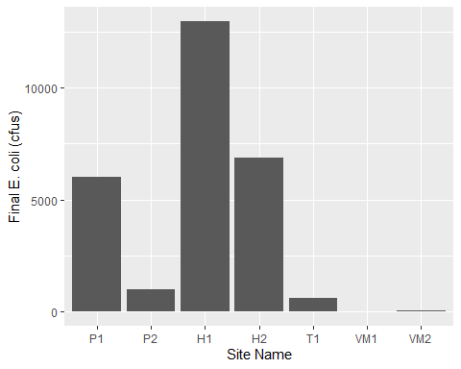

Lets look at final E. coli as an oucome.

ecoli_high_temp_air <- ggplot(clean_data, aes(x = final_ecoli, y = ambient_air_high_c, color = sample_id)) + geom_jitter() + xlab("Final E. coli") + ylab("Ambient Air Temp High (C)")  
  
ecoli_high_temp_air

## Warning: Removed 2 rows containing missing values (geom_point).

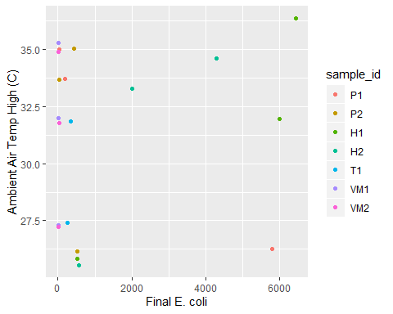

ecoli_low_temp_air <- ggplot(clean_data, aes(x = final_ecoli, y = ambient_air_low_c, color = sample_id)) + geom_jitter() + xlab("Final E. coli") + ylab("Ambient Air Temp Low (C)")  
  
ecoli_low_temp_air

## Warning: Removed 2 rows containing missing values (geom_point).

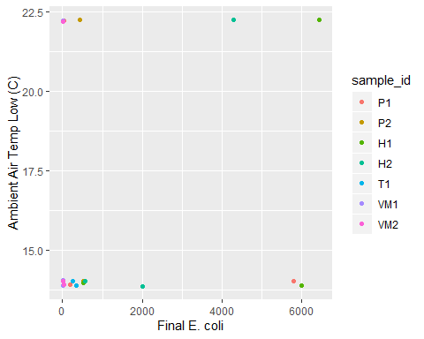

ecoli_water_temp <- ggplot(clean_data, aes(x = final_ecoli, y = water_temp, color = sample_id)) + geom_jitter() + xlab("Final E. coli") + ylab("Water Temp (C)")  
  
ecoli_water_temp

## Warning: Removed 2 rows containing missing values (geom_point).

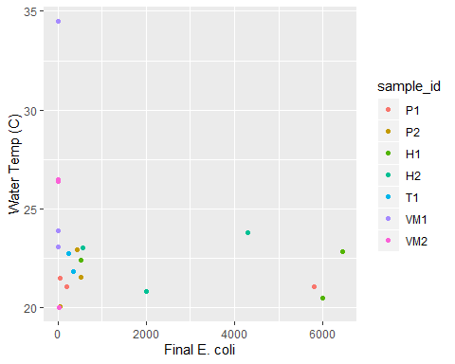

ecoli_cond <- ggplot(clean_data, aes(x = final_ecoli, y = conductivity, color = sample_id)) + geom_jitter() + xlab("Final E. coli") + ylab("Conductivity")  
  
ecoli_cond

## Warning: Removed 2 rows containing missing values (geom_point).

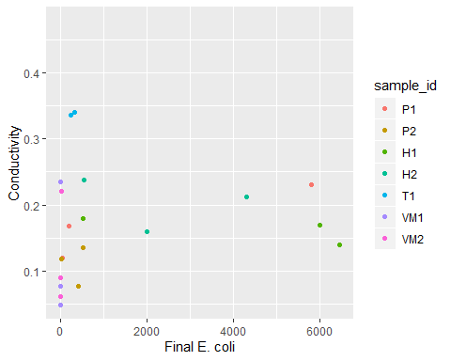

ecoli_ph <- ggplot(clean_data, aes(x = final_ecoli, y = ph, color = sample_id)) + geom_jitter() + xlab("Final E. coli") + ylab("pH")  
  
ecoli_ph

## Warning: Removed 2 rows containing missing values (geom_point).

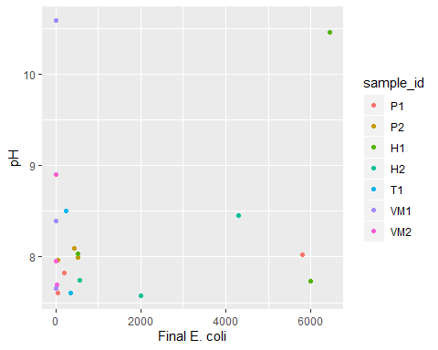

ggarrange(ecoli_high_temp_air, ecoli_low_temp_air, ecoli_water_temp, ecoli_cond, ecoli_ph, ncol = 3, nrow = 2, common.legend = TRUE, legend = "bottom")

## Warning: Removed 2 rows containing missing values (geom_point).  
  
## Warning: Removed 2 rows containing missing values (geom_point).  
  
## Warning: Removed 2 rows containing missing values (geom_point).  
  
## Warning: Removed 2 rows containing missing values (geom_point).  
  
## Warning: Removed 2 rows containing missing values (geom_point).  
  
## Warning: Removed 2 rows containing missing values (geom_point).

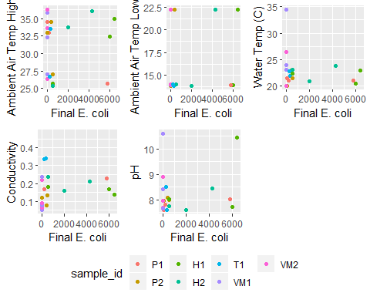

add_week_count <- clean_data %>% dplyr::mutate(week_count = recode(date,  
 "9.11.19" = 1,  
 "9.23.19" = 2,  
 "9.30.19" = 4,  
 "10.3.19" = 5))

date_freq <- ggplot(add_week_count, aes(x = week_count, y = final_ecoli, color = sample_id)) + geom_line()  
  
date_freq + xlab("Week Number") + ylab("E. coli (CFUs)")

## Warning: Removed 2 rows containing missing values (geom_path).

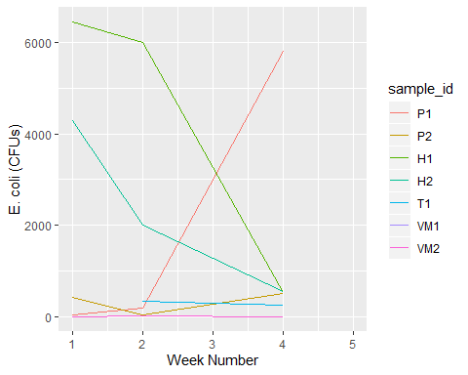

y <- ggplot(add_week_count, aes(x = sample_id, y = week_count))   
  
y + geom_tile(aes(fill = final_ecoli)) +xlab("Site Name") + ylab("Week Number")

