IST 263

Lab 05

This lab covers:
- Saving and editing images with Photoshop
- Layers, selection, text and rasterizing in Photoshop

Setup
We are going to work on two images in lab today. We will scale down the giant LinkedIn logo you put on your contact page and create a new image for our bio page.
- Create a folder in your GitHub repository folder on your computer called lab05. Copy the contact.html file from lab04 and your bio file from lab02 there.
- You probably don't have Photoshop installed on your computer. The iSchool lab computers have Photoshop. To open Photoshop through Remote Lab:
  - Remote lab allows you to connect to a computer at the iSchool and work on that computer as if you were sitting in the lab. We will connect with RDP (remote desktop connection). Instructions are here: https://su-jsm.atlassian.net/wiki/spaces/ischool/pages/150145003/Remote+Labs+-+RDS
  - Once you've logged in to remote lab, press the start button at the bottom and choose Adobe Photoshop 2024 from the list of programs. If it asks you to sign in use your SU email address and password.

Scaling down the linkedin logo
Photoshop will run in a window on your computer, but you are working on a virtual lab computer at the iSchool. Because this is a totally different computer, we need to copy files back and forth between the two.
- Locate your LinkedIn logo from the last lab. It should be in the images folder inside your GitHub repository.
- Copy the file and paste it to the desktop of the remote lab computer, or to your OneDrive.
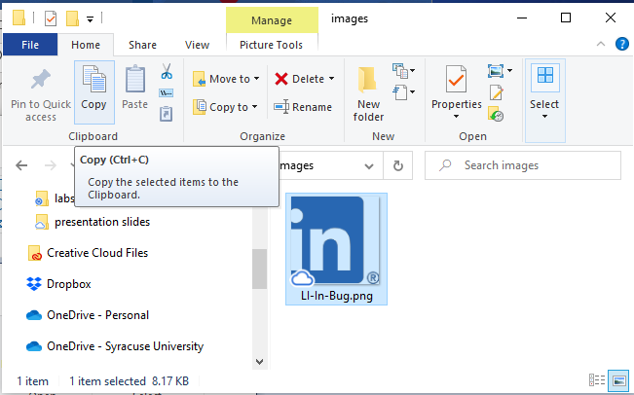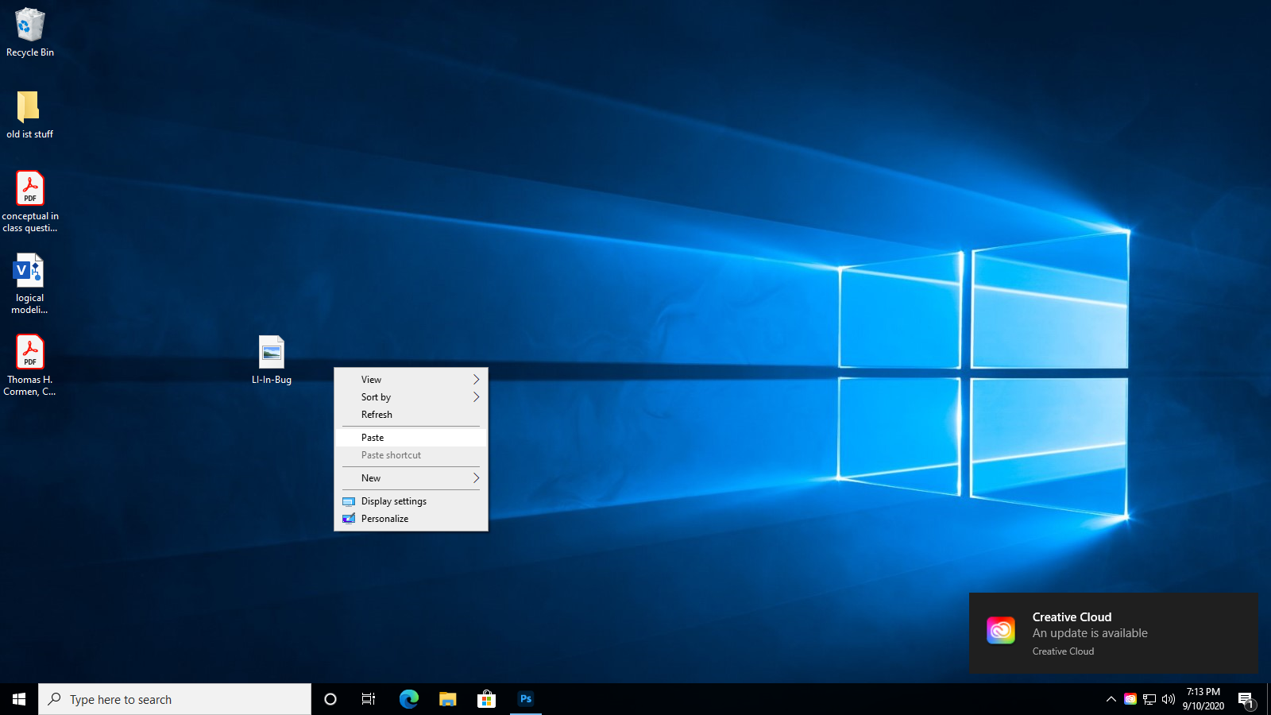
- Open the LinkedIn logo in Photoshop by going to File -> open and locating the logo on the desktop (or in your OneDrive).
  - If you are opening an SVG file, Photoshop will display a “Rasterize SVG Format” dialog. Hit OK.
- Resizing:
Depending on which LinkedIn logo you choose to use, you may see a checkerboard in the background in Photoshop. That is showing you which part of the image is transparent.
  - From the image menu, choose Image Size.
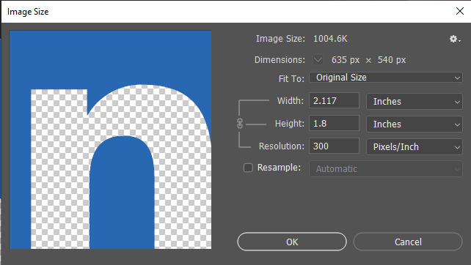
  - First click resample if it's unchecked.
  - Next change the resolutions to 72. Recall that for the most part, computer screens display images at 72 ppi. Higher resolutions just make the images bigger and your website takes longer to load. Press OK.
  - We are going to do the scaling down now. You might have to play around with sizes to find an image size you like. You also might have chosen a different logo than me. I'm going to scale my logo down to 75 pixels wide. Photoshop will adjust the height as I change the width to maintain the aspect ratio (ratio of the width to the height of an image or screen).
  - A couple things to note… you must recheck resample. You should drop down the units to change from inches to pixels. Click ok.
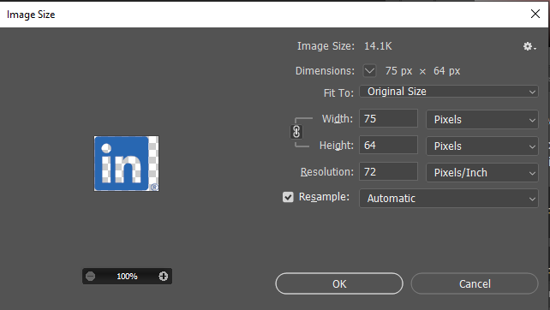
- Saving for the web
  - From the File menu choose -> Export -> Save for Web (Legacy). Choose the 2-Up tab at the top to see your original image next to the version we are going to save. Choosing gif, jpeg or png might make the file quality worse.
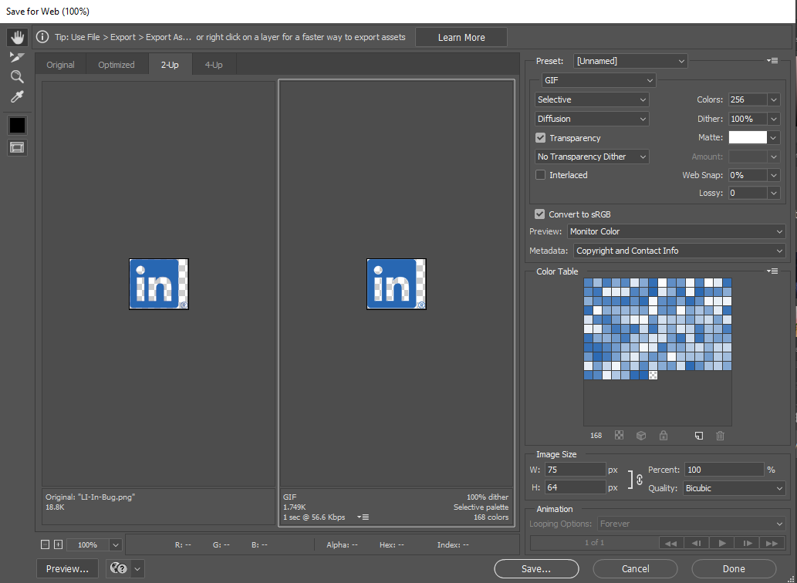
  - Images that are not photos are usually most efficiently saved in the png-8 format. On the right-hand side just under Preset choose PNG-8. Check the file quality for your image on the right and make sure it still looks good.
  - Click the save button and save your image on the desktop (or in your OneDrive) with a new name like logo-sized.png.
  - Minimize Photoshop and copy then paste the file you just created from the desktop on the remote lab computer to your GitHub images folder on your computer.
  - Open the contact page and edit your image tag so it loads the new photo you just created. Hint: All you need to do is change the file name in the image tag to be the new image's file name.
- If you scaled your image in the code (with a width attribute or css), take that out. We want to make sure you photo is properly scaled.

Creating an original image
The second task is to create and original image for your bio page. This task was inspired by many marketing images I have worked on in the past. The photo of a person is combined with text and an object or background image to bring across a theme. Below is an example of an image made in this style for a campaign to buy Hawaiian pineapples.

We are going to create our own image in Photoshop to communicate something about ourselves. We will post this image on our bio page. For this assignment I require your image uses three different parts (layers in photoshop):
- An image of yourself
- Some text
- An image of something else, could be an object or background, etc.

Plan your image

What do you want to communicate about yourself? Think about how you can communicate this. In the pineapple example image the photo of the model is fun. The pineapple is wearing sunglasses. The model has a playful look on her face. There’s a tagline about wearing a crown – that relates the leaves on the pineapple to the viewer of the ad. All of that is communicating to the user.
The labs for the semester add up to a portfolio website. Brainstorm what you want in your image for your portfolio website. What should the photo look like? What text do you want to include? What should the other object be? What do you want to communicate about yourself?

get your pieces together
- Either take a photo of yourself or use an existing photo. You might want to ask someone in class to go out onto the quad to take a photo if you don’t have one.
- Do an image search for the second image you want to include.
- Write the text you are adding to this image.

decide on image size
Do you want a medium sized rectangle or a large banner across the top of your entire site? We will talk later in the class about screen resolutions but for now…
- RECOMMENDED - Large rectangle at top of screen 1024 x 400 (width x height)
- Image floating on the right or left of the browser 450 x 600 (width x height)
- In Photoshop go to file -> new. On the right side of the New Document dialog box change the width and height to whatever you decide above and click the Create button. Don’t worry, you can change this later if you want.

sizing and Cutting out the photo
We are going to bring the photo of you into photoshop document you are working on.
- Start by going to File -> Place Embedded. Locate the photo of you and click the Place button.
- When that photo comes into Photoshop, you can move it around and resize. When you have the photo placed and sized the way you want it, double click on it.
Next, we are going to remove the background from your photo. To do this we will use the new “Remove Background” tool.
- Click your photo, and the above toolbar will display. Click “Remove background” and Photoshop uses AI to remove the background.
Congratulations! You have an image of yourself with no background.

Adding Text Layer
We are going to add your slogan, tag line, or other text about yourself. When you Click the text tool, it will create a new layer in Photoshop.
- Click the text tool on the left.
- Click in the document where you want to put the text and type your text.
- A menu at the top should appear for you to change text sizes, fonts color, etc. Play around with it until you get the look you want. Fonts can communicate a lot about your image.

Adding Other Image
- Click on the background layer to get yourself out of text editing mode.
- Repeat what you did above to bring in your photo but now do it with your second image. Do you need to remove the background, or can it be used as is?

Layers
At this point you might be having trouble with layers overlapping sizing issues. If you want to move a layer behind another layer, click the layer and move it below the other layer in the layers window on the right.

Saving your image for the Web
Use the skill from the LinkedIn logo resize above to save this for the web. Think about which file format will work best for this since it is a combination of text and images.

What will You hand IN?
Create a word document, pdf or use the "write submission" option in blackboard to provide the following:
- Submit the GitHub URL for the contact page with your LinkedIn logo on it.
Submit the GitHub URL for the bio page with your photoshop image on it.
- Answer the following: HTML has a way to scale an image down by entering a smaller width in the width attribute of the img tag. Why is scaling it down in Photoshop a better idea?
- Answer the following: What main message where you trying to communicate with your original image? Explain how the different parts you put together helped communicate that message.
- Submit answers to the following:
  - What questions did you have about the lab?
  - What was the hardest part of the lab?
  - Rate your comfort level with this week's topics.
1 ==> I can do this on my own and explain how to do it.
2 ==> I can do this on my own without any help.
3 ==> I can do this with help or guidance from others.
If you choose this level, please indicate HOW this person helped you.
4 ==> I don't understand this at all yet and need extra help.

