IST 263

Lab 04

This lab covers:
- Tables
- Forms
- Sending Emails with Formspree

tables Setup
- This week we will be working on two different pages. Start your lab by creating a new page with the required HTML tags. If you forgot how to do this, refer to lab 1. The title of your page should be "Skills".
- Save it in a new folder called lab04 in your GitHub repository on your computer as skills.html.

tables
To work on HTML tables, we are going to create a table for our portfolio site that lists your technical skills and competency with each. Here's a screen shot of a few rows of mine.
Tables are coded in HTML one row at a time with each cell in the table marked with a td tag. Your browser will figure out how to render all the data in neat columns.
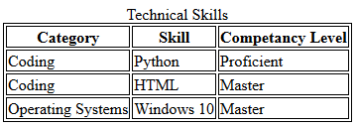
Captions
Let's talk about a couple of features of this table. First there's a title centered over the top of the table. This is done with the <caption> element. Caption tags appear right after the <table> tag like this:
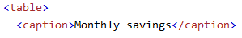
Borders
There are lines around all the cells in this table. To do this I'm going to show you a preview of Cascading Style Sheets. CSS is a way to set up the layout and appearance of your website.
One way to tell the web browser how you want an item to appear is to put CSS code between your <head></head> element at the top of the page. CSS requires <style> tags and then you describe the HTML element you are changing using CSS rules. Here's what the top of the page looks like for my table borders.
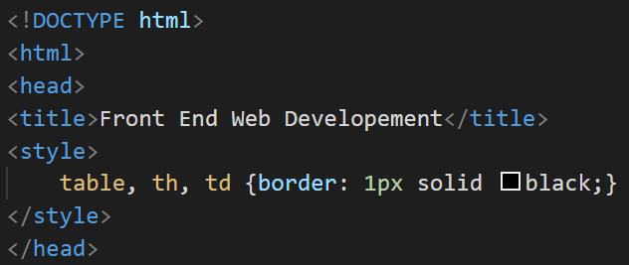
The <style> tag and everything inside of it is a rule to tell the web browser to draw borders around the table, table headers and table data cells.
Before you begin the question below, refresh your memory about table parts and format at w3school.com here: https://www.w3schools.com/html/html_tables.asp or check out the code from lecture in blackboard.
- Create your own personalized skills table. Yours can have completely different headings then mine but it must meet the following requirements:
  - Table must have a caption
  - Table must have a border
  - Table must have at least 3 columns
  - Table must have at least 10 rows including headers

Forms Setup
- In either the Finder or File Explorer, copy the contact.html file from the lab03 folder to your lab04 folder.

Forms
In this part of the lab, we are going to add a form to the bottom of our contact page. That page is starting to look like a hot mess with a ton of different parts to it, but we will fix the layout during the CSS unit so don't worry about that.
Contact form
Take a moment to look over the w3schools.com reference page on forms. Here are a few things to pay attention to:
- The form tag has a begin and end and all the form field tags must go inside it.
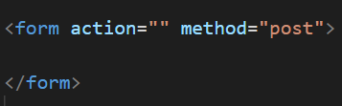
Recall that the action attribute describes how the form is going to be sent. In this lab we will use Formspree to email form data to you. The Formspree instructions are in the next section. We also have a method attribute with a value of post.
- Look through the form elements documentation. I went over a few of the most common in Monday’s lecture. A few things to recall about form elements:
  - All form elements need labels. To associate the label with the field the label should have a for attribute that matches the name of the id attribute in the form element. 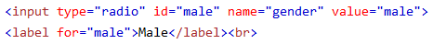
- Tip: Feel free to copy code from my lecture video examples or the W3Schools website to get started on your form fields.
- Create a form at the bottom of all the other content on your contact page with the following:
  - A text field
  - a radio button, checkbox or select
  - a textarea
  - a submit button
  - leave the action blank for now
Note: Your form can ask for anything from the user that would be useful for this page. It can contain extra fields if you need them.

Formspree – for emailing form data
What is Formspree? Emailing form data is processed on the backend of a webserver. This class is called “Intro to Frontend Web Dev”, so we don’t cover backend processing. No worries. Formspree is a company that provides a free way to email form data. When your user presses submit on your form, all the data they entered will show up in your inbox.
- Go to https://formspree.io/ and press the “Get Started” button at the top.
- Fill in the registration info and press the register button.
- Check your email to verify your email address.
- Press the “New Form” button.  Copy the endpoint Formspree provides. Here’s what mine looks like:
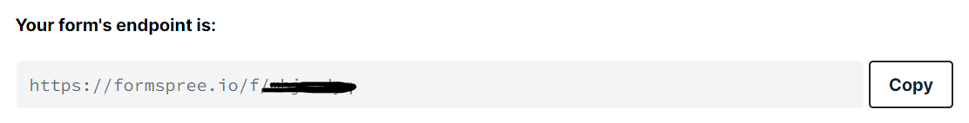

- Paste the endpoint from above into your form action. Make sure it is your custom endpoint. This is what it looks like with my endpoint:
That’s it for Formspree. They have lots of other features and things you can download but we’re not going to use those features. From now on when you create a form you will use your Formspree endpoint as your action. Make a note of it. You will need it again.

Validation and checking your work
- Before you finish you must validate your HTML. Go to the https://validator.nu/ and correct any errors that appear in validating.

What will You hand IN?
Create a word document, pdf or use the "write submission" option in blackboard to provide the following:
- Submit the GitHub URL for the skills page.
- Submit the link to the validation for the skills page.
- Submit the GitHub URL for the contact page.
- Submit the link to the validation for the contact page.
- Fill out and submit the form you made above. Submit a screen shot of the email you received with your form data.
- Submit answers to the following:
  - What questions did you have about the lab?
  - What was the hardest part of the lab?
  - Rate your comfort level with this week's topics.
1 ==> I can do this on my own and explain how to do it.
2 ==> I can do this on my own without any help.
3 ==> I can do this with help or guidance from others.
If you choose this level, please indicate HOW this person helped you.
4 ==> I don't understand this at all yet and need extra help.

