IST 263 Project Milestone 3 – Site Media
Name: William Piecyk
Description:
My proposal for my website is an tourist/American guide to rome. Im studying abroad there next semester and I want to put my research to good permanent use. My site will go through romes history, point out significant buildings/artworks, food, and even mention cultural centers as well as neighborhood history. My aim for the website is to give americans (targeting east costars) a taste of what rome is like without ever being there physically.
URL to Images on Github:
Login to github.com and navigate to your images folder for the project. Copy the url and paste it here. | https://github.com/williampiecyk/ist263/tree/main/project/Media

Example Site Media Entries
Media Thumbnails | Page | Usage Rights | Citation (if applicable)
 | Home Page | Creative Commons License
Video: https://youtu.be/pQN-pnXPaVg | About Page | NA
 | Home Page | I own this image

NOTE: You need to legally use all your images. The options for usage writes should be: I own this, creative commons, free stock, or some other way you legally use the image. Embedded content gets the NA (not applicable).

Your turn! Enter your images below. FYI – the images you find need to be quite large to look good on your website. If the image you find is tiny, keep looking.
Media Thumbnails | Page | Usage Rights | Citation (if applicable)
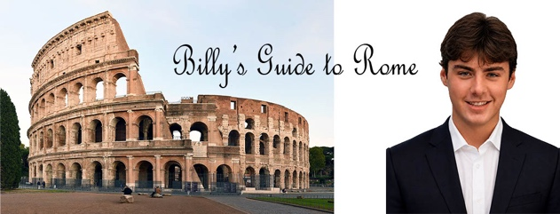 | Home page | I own this image
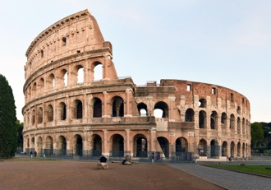 | The Colosseum: A Brief History | Creative Commons | “Looking east from the Piazza di Santa Francesca Romana, 2020” by FeaturedPics via Wikimedia Commons, licensed under CC BY-SA 4.0.
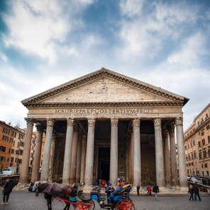 | The Pantheon: A Brief History | Creative Commons | “Pantheon’s façade” by ParsonsPhotographyNL via Wikimedia Commons, licensed under CC BY-SA 4.0.
https://www.youtube.com/watch?v=80i_FUllRVU | Home Page | NA

