IST 263 Project Milestone 4 – Wireframes
Name:Wiliam Piecyk
Description:
My proposal for my website is an tourist/American guide to rome. Im studying abroad there next semester and I want to put my research to good permanent use. My site will go through romes history, point out significant buildings/artworks, food, and even mention cultural centers as well as neighborhood history. My aim for the website is to give americans (targeting east costars) a taste of what rome is like without ever being there physically.

Research:
Write down the urls of three websites you looked at to research layout for the type of site you are creating. For example, if I was creating an auction website, I might look at pages on https://www.ebay.com/.
url1 | https://www.visitsyracuse.com/plan-your-visit/visitors-guide/
url2 | https://www.rome.net/
url3 | https://www.romesightseeing.net/monuments-rome/
Wireframes:
Use MockFlow or another diagraming software to create layouts for your pages. Consider the following:
- Where is your navigation going to be located on every page.
- Will you need a footer?
- How can you make a layout that is visually interesting and helps communicate your site content?
- Don’t forget you must have at least 2 distinctly different page layouts.

Paste Your 3 Page Layouts Below
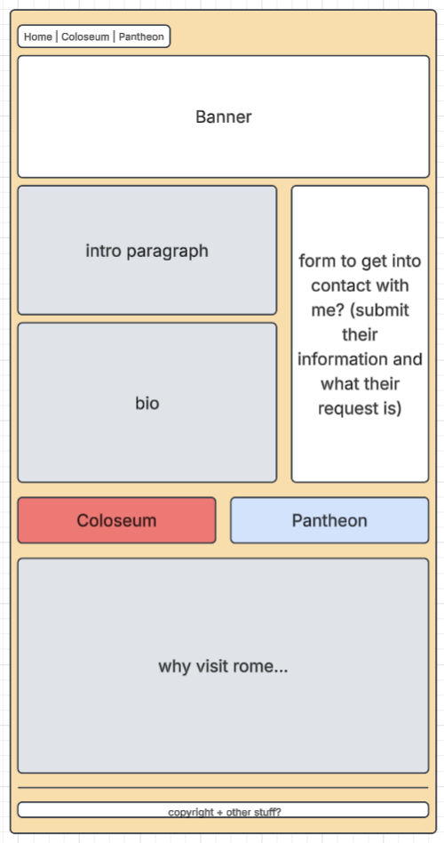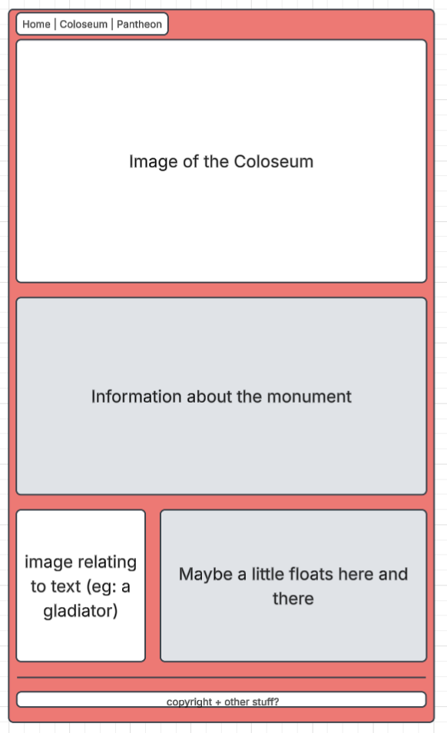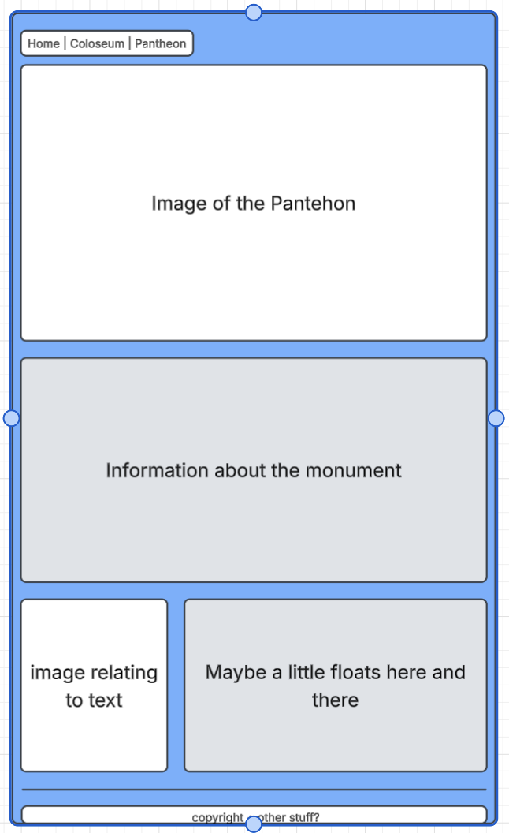
https://lucid.app/lucidchart/b1ef36cb-5a8c-4f47-89ce-d87f200a2e1f/edit?viewport_loc=215%2C396%2C1038%2C610%2CTaCEQ6JtFw.3&invitationId=inv_b9ec87ab-52ac-4856-a13e-f5d7c6b9ca53

