MLOps Project Report
Customer Value, Damage Risk and Damage Amount Prediction
William Plancke
June 2026
Repository
github.com/williamplancke/mlops-project

Submission links
GitHub repository: https://github.com/williamplancke/mlops-project
Demo video: [Insert public Panopto link before submission]
Submission check: The repository returned a 404 when tested without an authenticated GitHub session. Change its visibility to Public before submitting the report.

1. Project overview
The project predicts three related business outcomes for hotel customers: expected profit, whether a customer will cause damage, and the damage amount when an incident is predicted. The objective of the assignment is not only model quality, but a reproducible training, deployment and automation lifecycle.
The main training dataset is train_V2_cleaned.csv. It contains numeric customer, behaviour, booking, insurance and survey-related features, together with explicit missing-value indicator columns. The targets are outcome_profit, outcome_damage_inc and outcome_damage_amount.

Models and preprocessing
- Profit: GradientBoostingRegressor in a pipeline with StandardScaler.
- Damage incidence: GradientBoostingClassifier with SMOTE, random undersampling and probability calibration.
- Damage amount: GradientBoostingRegressor trained on log1p(damage amount), using only rows where damage occurred.
Each model is trained separately so that the algorithms and evaluation metrics match the target type. The deployable training script records the ordered feature list and median defaults in model_metadata.json. During inference, omitted fields are filled with those medians, which keeps the frontend simple while preserving the exact model input schema.
The API applies an additional business rule: if the damage classifier predicts no incident, the returned damage amount is forced to zero. A ranking extension compares the predicted net customer value against score_cleaned.csv and assigns a percentile-based grade from A+ to F.

2. Task 1 - Cloud AI training
Training is implemented as an Azure Machine Learning command job. training/azure_job.yml defines the source directory, command, Conda environment, compute target and model output. training/train.py is the single training entry point used locally and in Azure ML.
The cpu-cluster is configured with a minimum of zero and a maximum of one node. This decision limits cost and directly supports the requirement that temporary training resources are shut down after use. The workflow also executes a final scale-to-zero step with if: always(), so cleanup is attempted even when training or registration fails.
For demonstration runs, Azure ML uses the --quick option. It samples the dataset and reduces model complexity, because the assignment evaluates the MLOps process rather than an expensive hyperparameter search.
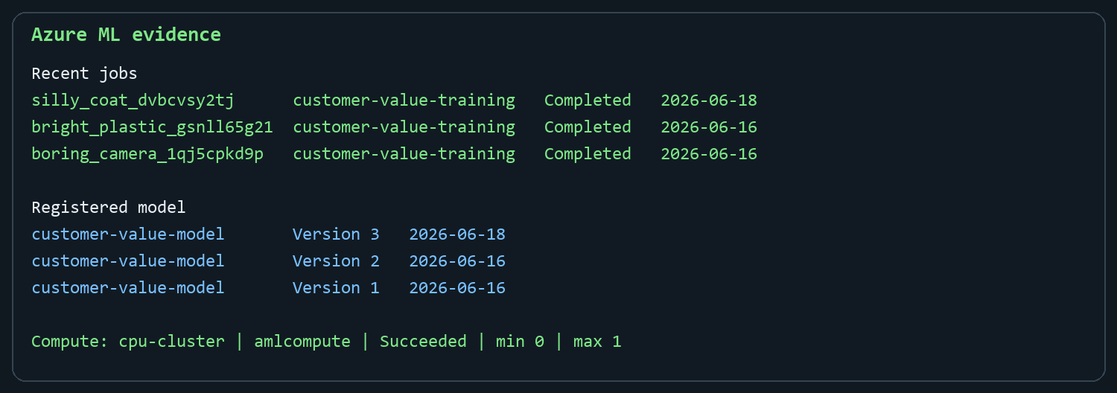
Figure 1. Azure ML evidence: completed cloud training jobs, registered model versions and scale-to-zero compute configuration.
Successful jobs register a custom Azure ML model named customer-value-model. Azure ML automatically increments its version; three versions were registered during development. This registry is the hand-off point between retraining and deployment.

3. Task 2 - Kubernetes deployment
Implementation choice: The report brief mentions local k3d, but this implementation uses a managed AKS cluster. This is a deliberate cloud-oriented deviation: the Kubernetes manifests remain portable, while AKS adds a managed control plane, Azure LoadBalancer and Azure Disk-backed persistence. If k3d evidence is mandatory in the rubric, the same manifests should also be demonstrated on a local k3d cluster.
The deployment uses four application responsibilities: a static frontend, a FastAPI inference service, PostgreSQL for prediction logs, and NGINX as the public reverse proxy. Each component has its own Deployment and ClusterIP Service. Only the NGINX service is exposed externally through a LoadBalancer.
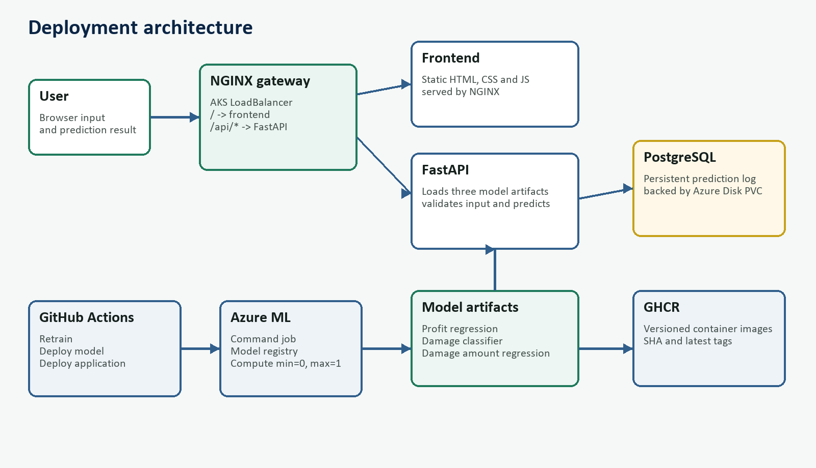
Figure 2. Application, model and automation architecture.

Microservice communication
- The browser connects to the public NGINX LoadBalancer.
- NGINX routes / to the static frontend service and /api/* to FastAPI.
- FastAPI loads the three joblib model artifacts and score_cleaned.csv from its image.
- Prediction requests and responses are persisted in PostgreSQL.
- PostgreSQL stores its data on a PersistentVolumeClaim backed by Azure Disk.
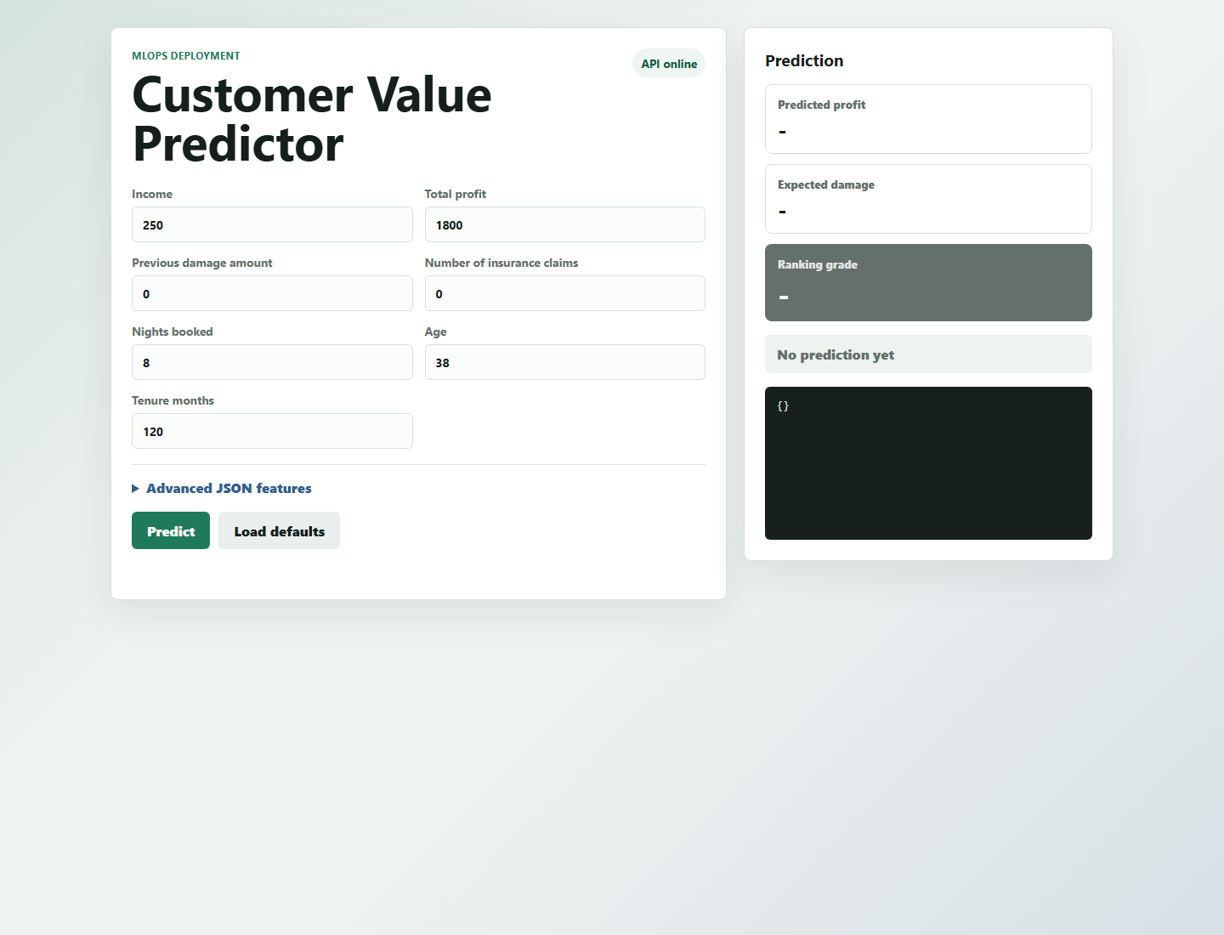
Figure 3. Customer Value Predictor frontend served through the production NGINX path.
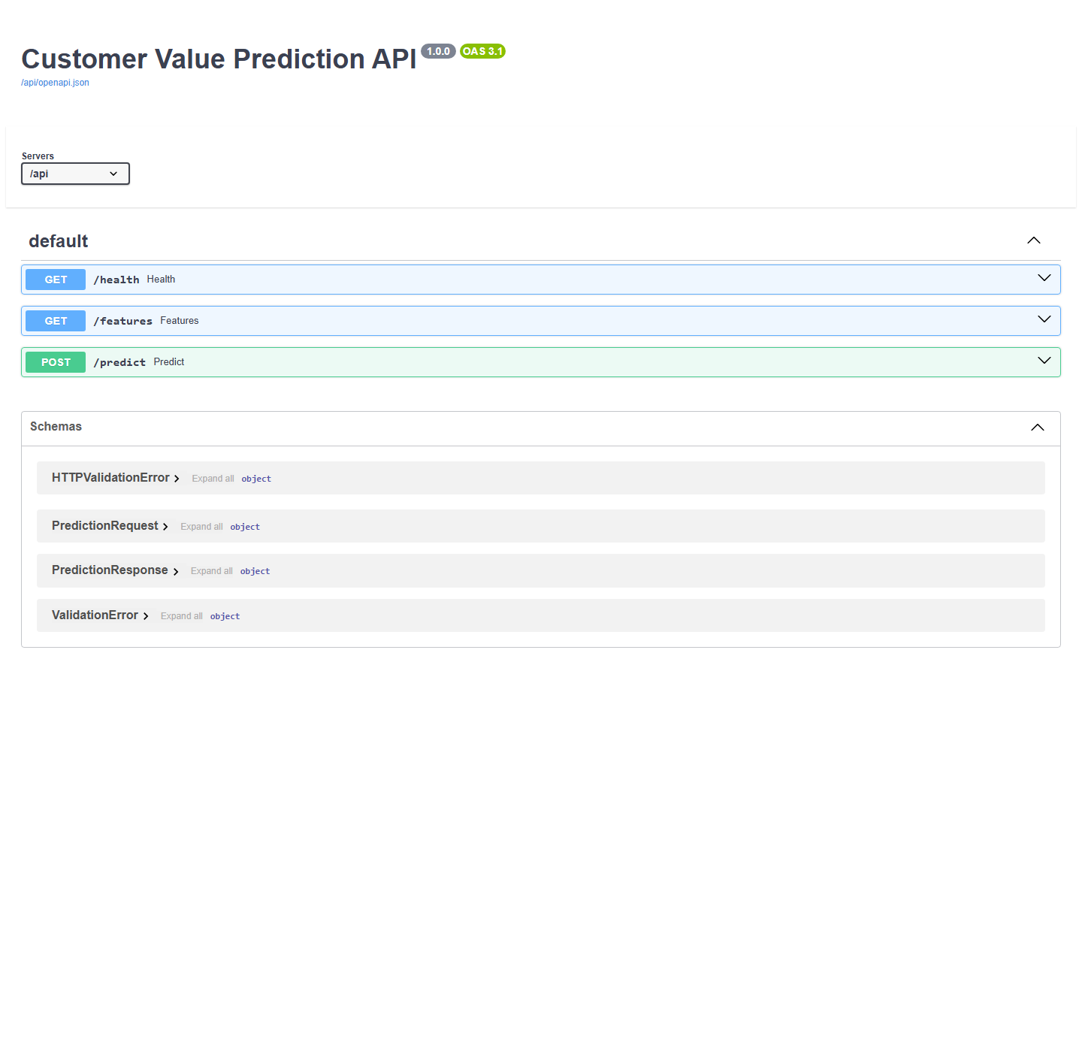
Figure 4. FastAPI OpenAPI documentation behind the /api reverse-proxy path.
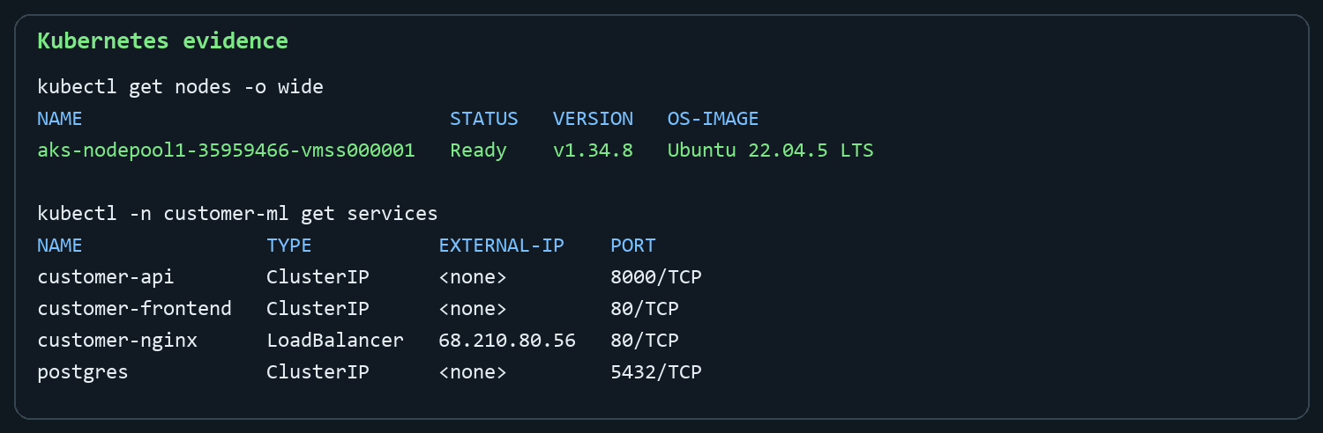
Figure 5. AKS node and Kubernetes services, including the public NGINX LoadBalancer.

Production-oriented details
- Stateless services use two replicas and RollingUpdate with maxUnavailable=0 and maxSurge=1.
- Readiness and liveness probes prevent traffic from reaching unhealthy API, frontend or NGINX pods.
- The API image uses a multi-stage build so dependency installation does not leave build-time files in the runtime layer.
- Private GHCR images are pulled with a Kubernetes docker-registry secret created by GitHub Actions.
- PostgreSQL uses PGDATA in a subdirectory because an Azure Disk mount contains lost+found at its root.
- Docker Compose provides the same service topology for local development and screenshot/demo preparation.

4. Task 3 - CI/CD automation
The automation is split into three workflows so each assignment requirement has an explicit trigger and responsibility.

Task 3.1 - Retrain models
.github/workflows/retrain-model.yml runs after changes to training/**, api/model_artifacts.py or train_V2_cleaned.csv on master. It authenticates to Azure through GitHub OIDC, creates missing Azure ML resources, submits the command job, validates all four artifacts, registers a new model version and scales compute to zero.

Task 3.2 - Deploy a trained model
.github/workflows/deploy-model.yml is triggered by workflow_run only when the retraining workflow completes successfully. It checks out the exact training commit, downloads the newest registered Azure ML model, builds a new API image, publishes immutable SHA and latest tags, and updates only the customer-api Deployment.
The Kubernetes strategy is RollingUpdate with zero unavailable replicas and one surge replica. This was selected because inference traffic should continue while a new model image starts and passes its readiness probe. Kubernetes retains a short revision history for rollback.

Task 3.3 - Deploy application changes
.github/workflows/deploy-application.yml runs when API, frontend, NGINX, Compose, Kubernetes or ranking data changes on master. It restores the latest registered model, builds the three application images through Docker Compose, pushes them to GHCR, applies the manifests and waits for all rollouts.
Both deployment workflows share a concurrency group. This prevents a model rollout and an application rollout from changing the AKS cluster simultaneously.

Version and pipeline control
- Source versions are tracked by Git commits on the master branch.
- Container images receive the Git commit SHA as an immutable tag, plus latest for convenience.
- Azure ML stores numbered customer-value-model versions.
- Path filters avoid unnecessary workflows when unrelated files change.
- workflow_run creates a clear hand-off from successful training to model deployment.
- Manual steps are limited to maintaining GitHub secrets, keeping the GHCR PAT valid, starting/stopping AKS and merging changes.

5. Extensions
Several extensions were implemented beyond the minimum deployment:
- Customer ranking: predictions are compared with score_cleaned.csv and converted to an A+-to-F percentile grade.
- Persistent prediction history in PostgreSQL for auditability and future monitoring.
- OIDC-based Azure authentication instead of storing a long-lived Azure client secret.
- Private GHCR images with cluster pull credentials.
- A local Compose environment that mirrors the production microservices.
- A production reverse-proxy root path so Swagger works correctly behind /api.

6. Reflection
The easiest part was turning the existing notebooks into a repeatable Python entry point and serving the joblib artifacts through FastAPI. Docker Compose also made it straightforward to validate communication between the API, frontend, NGINX and PostgreSQL before deploying.
The most difficult work was at the boundaries between cloud services. The Azure for Students subscription restricted deployment regions and VM families, which required checking policy and quota data before creating AKS in Austria East. GitHub OIDC initially failed because the app registration had neither a federated credential nor a role assignment. Azure ML also exposed path-resolution and explicit model-version requirements that were not visible during local development.
Kubernetes introduced further production details: private GHCR images required an imagePullSecret, Azure Disk required a PostgreSQL PGDATA subdirectory, and Swagger needed a root path when served behind NGINX. These issues demonstrated that a successful model is only one part of an operational ML system; identity, networking, storage, versioning and rollout behaviour are equally important.
The main improvement I would make next is automated model-quality gating. A future workflow could compare the candidate metrics with the currently deployed model and only register or deploy when agreed thresholds are met. Monitoring prediction drift and API latency would be the next logical operational extension.

7. Demo video plan
The final Panopto recording should remain between one and three minutes:
- Open the frontend and submit one customer prediction.
- Show predicted profit, expected damage and the colour-coded ranking grade.
- Open /api/docs and briefly show the health, features and predict endpoints.
- Run kubectl get nodes and kubectl -n customer-ml get pods,services.
- Show the three GitHub Actions workflows and one successful Azure ML training run.

Pre-submission checklist
- Make the GitHub repository publicly accessible and test the link in a private browser window.
- Insert the final Panopto video link in the Submission links section.
- Refresh GHCR_PAT and rerun the deployment workflow so all AKS pods are Ready before recording.
- If the assessor strictly requires k3d, deploy the same manifests to k3d and add one local cluster screenshot.
- Replace or supplement Figure 1 with an Azure Portal pipeline screenshot if preferred.

