

**RTA**

***Real Time Action*TM**

**User Manual**

The material contained herein is proprietary and confidential to the William Ryan Group, Inc. (“WRG”). The recipient shall not copy, modify, adapt, reverse engineer, transmit, sell, distribute or otherwise use this document or the information contained and referenced herein except as expressly approved in advance in writing by WRG. The material will be returned immediately upon the request of William Ryan Group, Inc.

**Contents**

1. APPLICABILITY AND PURPOSE 4

2. REFERENCES 4

3. DEFINITIONS 4

4. RTA USER INTRODUCTION 5

SLOT EVENT PROCESSING 5

SUPERVISOR MODULE 5

5. USING THE REAL TIME ACTION MOBILE APPLICATION 7

5.1 How to Login 7

5.2 Welcome to RTA – HOME Screen 8

5.3 How to Navigate the Mobile Device - SUPERVISORS 9

5.3 How to Navigate the Mobile Device - ATTENDANTS 10

6. STATUS 11

6.1 AREAS 11

Area Assignment for Other Employees 12

6.2 BREAK 13

Break Status 13

6.3 OOS 14

6.4 Logout 15

How to Log Out 15

7. EVENTS 16

7.1 Assigned Event 16

7.2 Accept an Event 17

7.3 Manually Reject an Event 17

7.3 Manually Reject an Event 18

7.4 Respond to an Event 18

7.5 Complete an Event 19

7.6 Phantom / No Event 19

7.7 Auto Event Rejection 20

7.8 High Priority Reassignment 21

7.9 Escalate Event (Inactive) 22

8. CREATE EVENTS / EMPLOYEE CARD IN 23

8.1 CREATE EVENTS 23

8.2 EMPLOYEE CARD IN EVENTS 23

9. ALERTS (Supervisor Only) 25

9.1 Alert Listing 26

9.2 Alert Configuration 27

10. SCORECARDS (Supervisor Only) 28

10.1 Scorecard Listing 28

10.2 FLOOR DASHBOARD 30

EVENT INFORMATION 30

Event Admin 32

EMPLOYEE INFORMATION 32

Employee Admin 33

10.3 ATTENDANT DASHBOARD 34

11. MESSAGING 35

11.1 Send a Message 35

11.2 Check Messages 37

11.3 Voice Messaging 37

12. System Configuration Options 40

12.1 Associated Areas 40

12.2 Event REASSIGNMENT and HIGH PRIORITY events 41

12.3 Area of Last Event Assignment 42

12.4 Multiple Events Status 43

12.5 Multiple Jackpot Events 45

13. TROUBLESHOOTING 46

USING RTA 46

TAKE BREAK 47

EVENTS 47

AREAS 49

SCORECARDS 50

SEND MESSAGE 50

ALERTS 51

14. APPENDIX 1: Local Escalation Procedures 52

TROUBLE REPORTING AND ESCALATION 52

# APPLICABILITY AND PURPOSE

This manual provides guidance and instruction for property supervisors and managers using the Real Time Action (RTA) device application as a valuable add-on Supervisor Module to complement their Real Time Slot Service (RTSS) suite of products.  This module is supported on mobile devices, including iOS devices, ANDROID OS devices, and Microsoft smart phone devices.

Supervisors and managers will use the mobile devices to receive real time information on how the floor is operating and use this information to improve customer service and employee utilization.

The primary goal of this user manual is to answer the employee question, “How do I…?” as simply and clearly as possible.

This is NOT a technical manual.  For technical details needed to install or maintain this application, please refer to the documents listed in section 2.0, References.

# REFERENCES

1. RTSS_RTA_ApplicationInterfaceDiagrams
2. RTA_MobileApplication_InstallationGuide

# DEFINITIONS

This is a list of the common terms used in the Real Time Action software documentation and what they mean. It is provided as a quick reference for users.

**Term Definition**

RTA Real Time Action

RTSS Real Time Slot Service

Tier Player's card level/rank

OOS Out of Service

# 

# RTA USER INTRODUCTION

## SLOT EVENT PROCESSING

The RTA Supervisor Module does not require the RTA Attendant Module to be active, it will work when a RTSS manual/radio module is deployed for attendant event management. Wi-Fi access is recommended and if supervisors will be using this module to handle events, it should be available to the entire floor to facilitate adequate response and completion times.

The guest and/or their slot machine generate an event which is sent to the RTSS event management system. RTSS receives, records, and prioritizes events based on rules entered by management as to how service is to be delivered. Once an event is opened for a specific location, a second event will NOT be opened until the first event has been completed. Employee mobile devices are assigned to specific Area(s) via user log in, and will receive events on their devices when they are marked as available in the system (not on break, out of service (OOS), or assigned to another event). When an employee acknowledges (accepts) the event, RTA monitors all subsequent activities until completion of the event. By accepting responsibility for this electronically dispatched event on their mobile device, the employee assumes the responsibility to deliver the appropriate service according to the standards established by the property.

RTA also supports employee log-in/out, going on/off break, going out of service (OOS) to perform non machine generated activities, messaging, event response/acceptance, completion and rejection with comment fields, e.g. high-priority, guest waiting, machine down, etc., to a specific supervisor and/or slot technician.

## SUPERVISOR MODULE

A key feature of RTA is the unique Scoreboards and Real Time Alerts. These features empower your floor management with real-time business intelligence about your guest, their need, their location and the exact level of service required. Real time performance metrics are also collected on all employee activities.

Your frontline and mid-level management are aligned toward consistent delivery of guest service based on your specific standards and goals.

Critical service delivery metrics (including performance time, employee response engagement, rejected events, and tier performance) are monitored in real time and displayed in Targeted Scoreboards on your supervisor’s mobile device.

Management access to this critical real time information provides the oversight of all employee activities, individual event status, overall event volume, and recognition of trends to adjust staffing levels and to resolve other service issues immediately. The RTA technology also enables Management to send specific messages to the individual employee`s mobile device (free form text or from canned drop down message options). Examples of these messages might be “good job”, “take a break”, “come to office”, etc. These drop down messages are configurable and can be modified by WRG IT or Local IT after an internal PROPERTY HELPDESK TICKET is opened requesting the modification, the process is reviewed; and then approved by the property and WRG IT.

Real Time Alerts are configured to your specific settings and leverage the on the fly analytic components of RTA to recognize opportunities to improve employee engagement and the guest satisfaction. These Alerts are generated in real time rather than waiting for service failures reported after the fact.

# 

# USING THE REAL TIME ACTION MOBILE APPLICATION

Once the mobile device is turned on, the user must initialize the RTA application by clicking on the icon on the device home screen. The RTA - Welcome screen will be displayed. This confirms the Server Version (e.g. 1.0.457) and the App Version (e.g. 2.00.335), and Device PIN number (IP ADDRESS) of the device connected to the application.

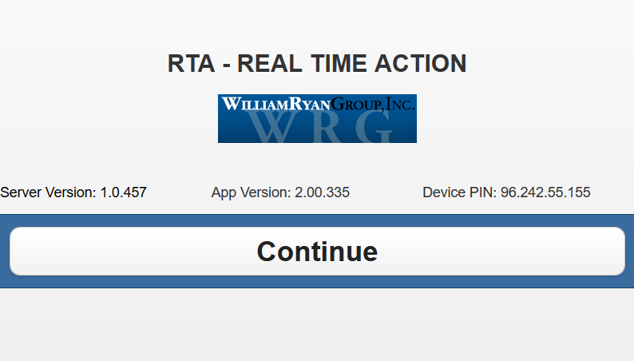

1. Press <Continue>
2. If Server Version or App Version or Device PIN do not appear, see Section 8.0 Troubleshooting

## 5.1 How to Login

You are associated with a specific mobile device based on the Device ID (IP ADDRESS) upon login to the application.

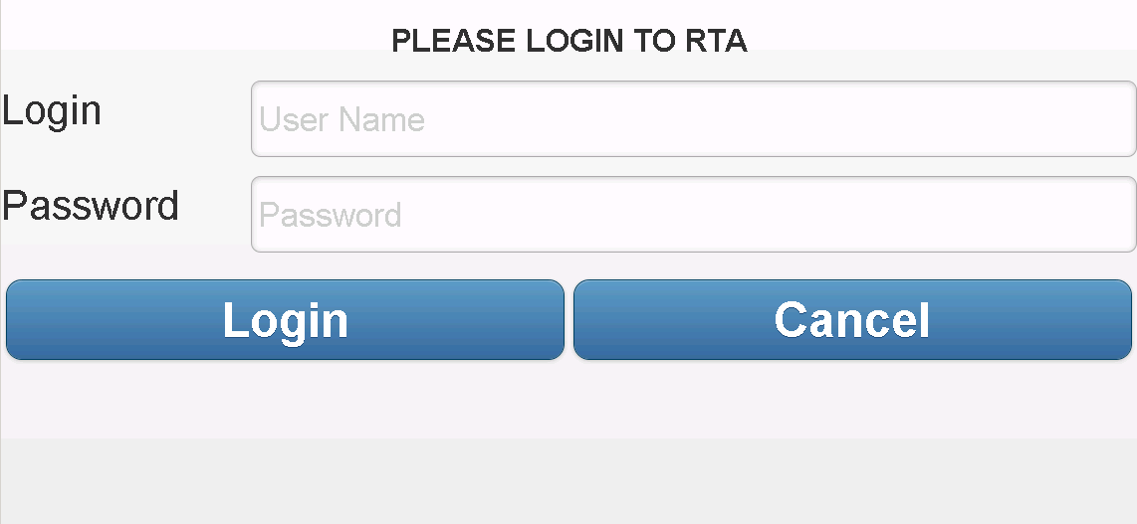

1. Enter your Password
   1. These are not case sensitive
2. Press <Login>
3. If you are taken to MAIN menu screen, you are now logged into the system
   1. If you are not taken to the MAIN screen and receive a login failure messages:
   2. Confirm your password is valid
   3. Repeat Step 1

## 5.2 Welcome to RTA – HOME Screen

Your name will be displayed on the mobile device along with your current status. Navigation buttons are provided based on your Job Type (Attendant/Technician, Supervisor). The ALERTS, SCORECARDS, ADMIN and CREATE EVENT buttons are only available to employees designated in the system as a Supervisor. The refresh button can be used to refresh the main screen if necessary.

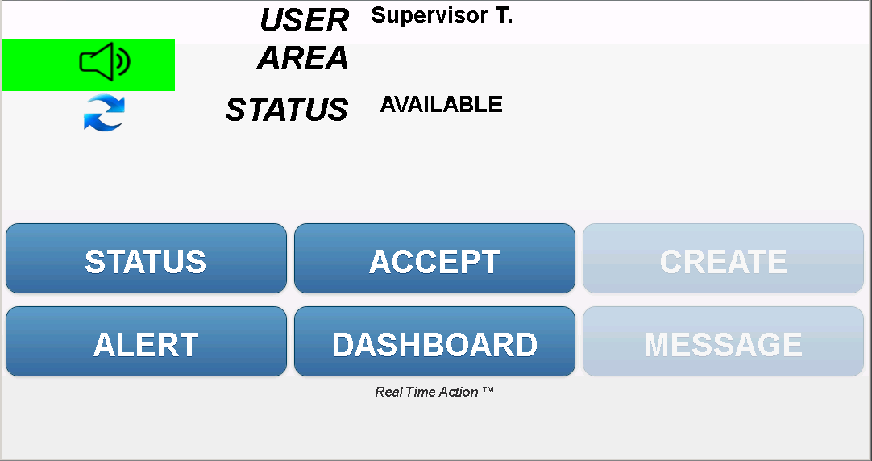

To make changes to your Name and/or Job Type requires access to the RTSS system with Administrative rights (see References 2.0 - Real Time Slot Service User Manual).

The Main screen also allows the user to activate sound functionality for new events/messages. This is done by clicking on the speaker icon. When the sound is off, the icon will be red with a line through it. When it is on, the icon will be green.



SOUND OFF SOUND ON

The refresh button can be used to refresh the main screen if necessary. Simply click on the refresh button shown below to reload the main screen.



## 5.3 How to Navigate the Mobile Device - SUPERVISORS

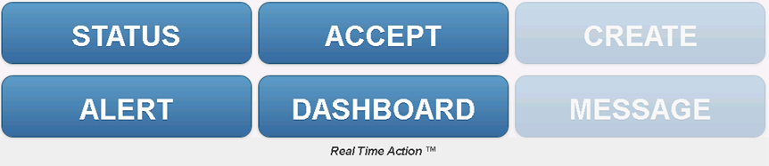

1. Choose the tool you want to use by pressing one of the following option buttons:

|  |  |  |
| --- | --- | --- |
| **Button** | **Description** | **Section** |
| **STATUS**  *Sub Categories:*  *AREAS*  *BREAK*  *OOS*  *LOGOUT* | Link yourself with one or more Areas  Set your assigned areas  Remove you from all Areas and begin your break  Put yourself "Out of Service"  Logout of the application | 6 |
| **EVENT** | Display and accept assigned event | 7 |
| **ALERT** | Display the list of pending events requiring attention by tier, by location and/or employee – accessible only by a Supervisor | 9 |
| **DASHBOARD** | Evaluate event volume, adjust staffing levels in Areas, monitor break activity, understand rejected events and/or issue early outs based on business needs and activity levels – accessible only by a Supervisor | 10 |
| **MESSAGE** | Send and read messages | 11 |

## 5.3 How to Navigate the Mobile Device - ATTENDANTS

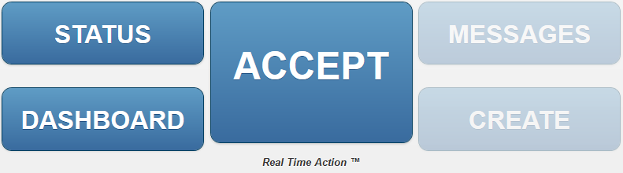

1. Choose the tool you want to use by pressing one of the following option buttons:

|  |  |  |
| --- | --- | --- |
| **Button** | **Description** | **Section** |
| **STATUS**  *Sub Categories:*  *AREAS*  *BREAK*  *OOS*  *LOGOUT* | Link yourself with one or more Areas  Set your assigned areas  Remove you from all Areas and begin your break  Put yourself "Out of Service"  Logout of the application | 6 |
| **ACCEPT** | Accept and display assigned event | 7 |
| **ALERT** | Display the list of pending events requiring attention by tier, by location and/or employee – accessible only by a Supervisor | 9 |
| **DASHBOARD** | Evaluate event volume, adjust staffing levels in Areas, monitor break activity, understand rejected events and/or issue early outs based on business needs and activity levels – accessible only by a Supervisor | 10 |
| **MESSAGE** | Send and read messages | 11 |

# STATUS

From the HOME Screen, press <STATUS> to view the Status menu below.

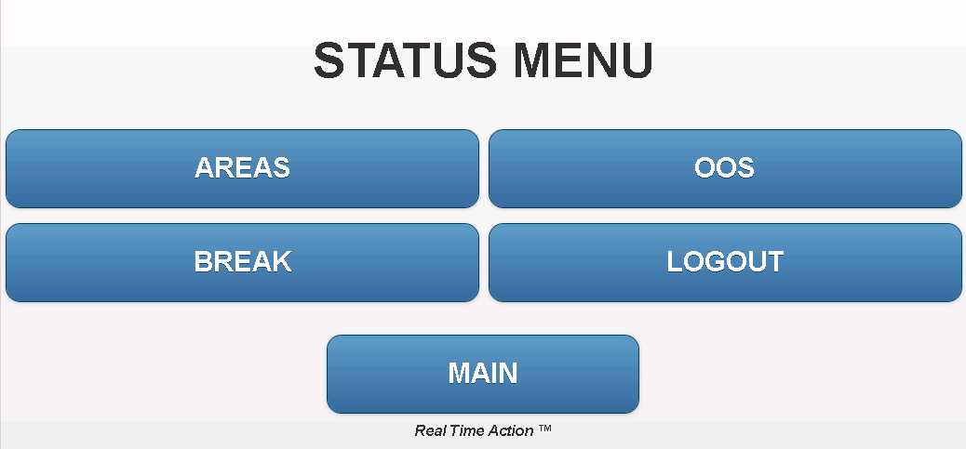

## 

## 6.1 AREAS

Areas are used to distribute the workload and maintain the highest level of guest services. RTSS accepts up to one hundred Areas (00 – 99). When a user assigns themselves to an Area(s), they are now available to receive events from the defined Area(s).

When a user is assigned to an Area they will be able to receive events defined for that user role. This will include machine events, events created using the CREATE EVENT button, their own card in events, events escalated to their user role, and other events defined by the property. When a user is not assigned to any Areas, they will still receive events created using the CREATE EVENT button and their own card in events.

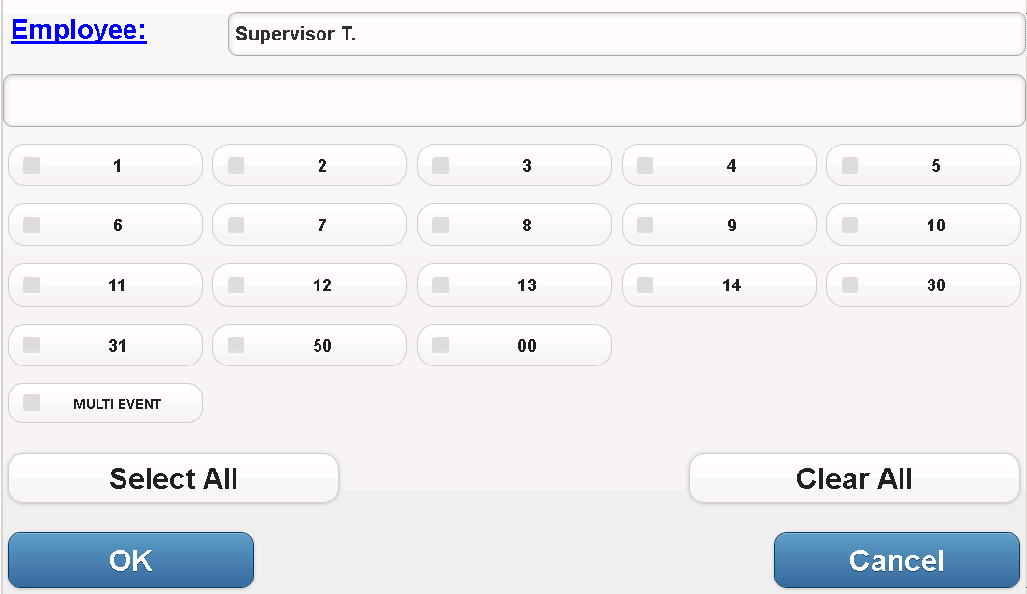

1. Press <AREAS>
2. Click on the desired AREA or STATUS options and a check mark will appear next to each
3. Press <SELECT ALL> to select all Areas or <CLEAR ALL> to clear all selections
4. Press <OK> to confirm assignment or <CANCEL> to return to Main Menu

### Area Assignment for Other Employees

Supervisors have the ability to assign or re-assign other employees to Areas. Clicking on the 'Employee' link in the area assignment screen, will display a list of all employees logged into the RTA mobile application.

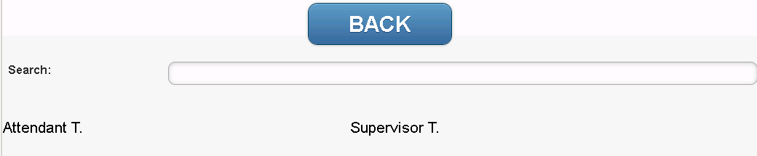

Selecting an employee will update the AREA screen to display the Areas that employee is currently assigned to. From here you may update the Areas that employee is assigned to just like you would adjust your own Areas. Once you are done, click 'OK'.

## 6.2 BREAK

You will be removed from all Area assignments and no events will be routed to your mobile device during your break. Break types and times are configurable by property or WRG IT.

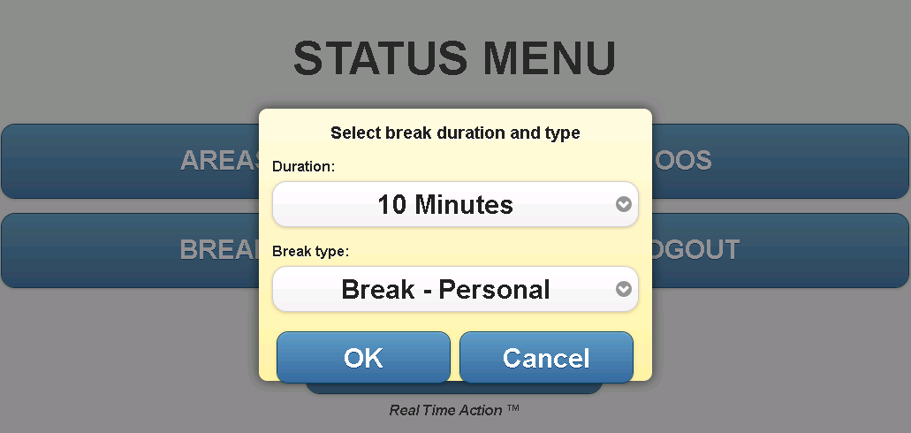

1. Select the duration of your break (in minutes)
2. Select the Break Type (e.g. Personal, Scheduled or Game Play) from the Drop down Menu.
3. Press <OK>
4. Press <CANCEL>to return to the Main Menu

### Break Status

Once your break has started, the Break status screen displays your break duration, start time, end time, and time remaining in your Break.

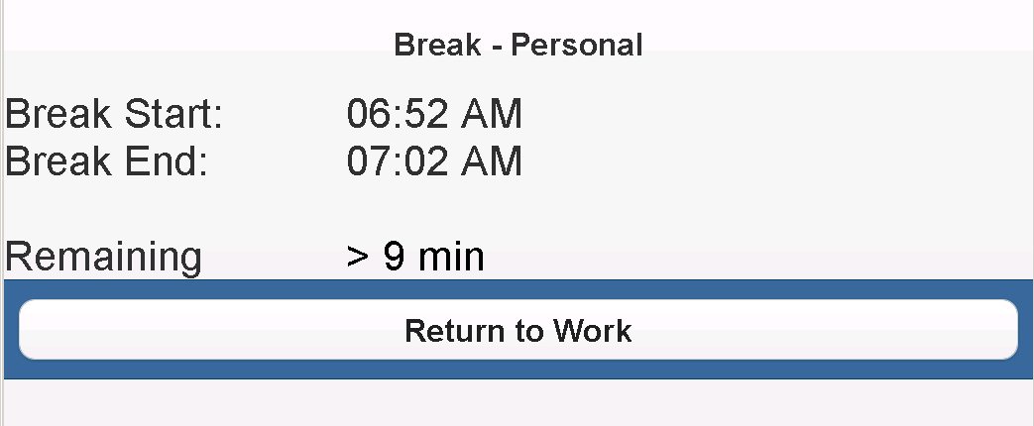

1. Press <Return to Work> to end your Break
2. You will be taken to the Area assignment screen to confirm/modify Area assignment.

***Note: You must re-assign yourself to an Area(s) to successfully return to work!***

## 6.3 OOS

In the case where the user needs to make themselves unavailable to receive machine events, but they are not taking a ‘Break’, the OOS (Out Of Service) option is available for this purpose. OOS (Out Of Service) allows the user to define other work being performed outside of machine generated events. This process allows the system to capture and record other work the user is performing while logged in to the RTA application.

The user can place themselves OOS, and define the reason for the OOS. These reasons are configurable at the server level by WRG or PROPERTY IT. The user may enter an optional comment and/or location to provide additional details for the OOS event

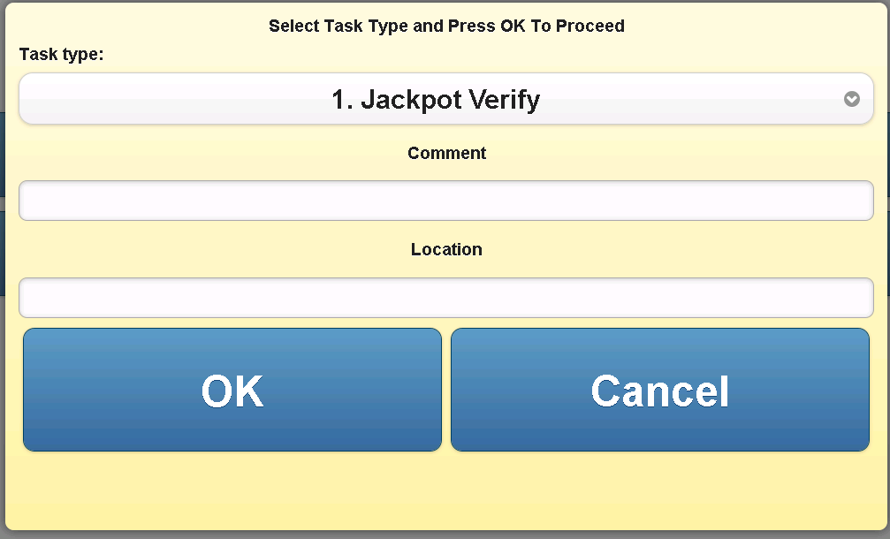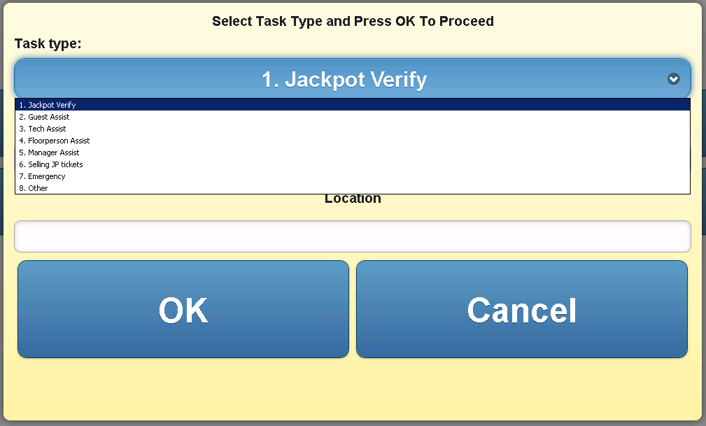

1. Press <OOS>, and the Task Dialogue Box appears
2. Select a ‘Task Type’ and hit <OK> to confirm, or <CANCEL> to close the task window.
3. Selecting <OK> will place you on the selected OOS type.
4. The system will track the OOS type and start and completion time.

Supervisor Attendant

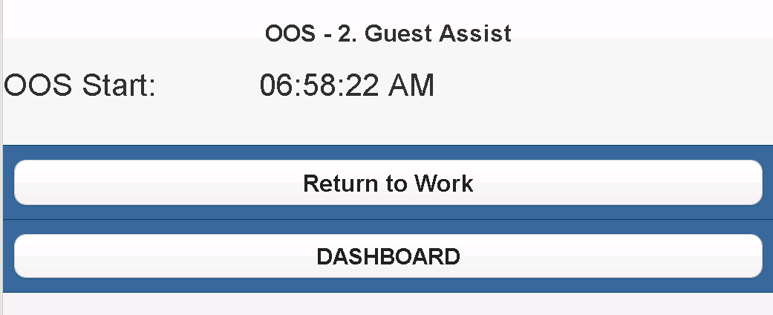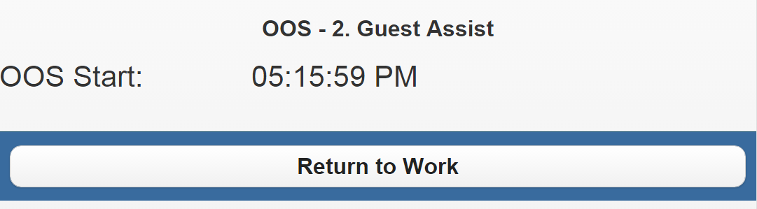

1. Press <RETURN TO WORK> to end the OOS task.
2. You will be automatically re-entered into the Areas you were in prior to going out-of-service
3. Supervisor users will have access to the DASHBOARDS while on OOS by selecting the <SCORECARDS> button

## 6.4 Logout

### How to Log Out

1. Select Logout
2. A Dialogue Box appears

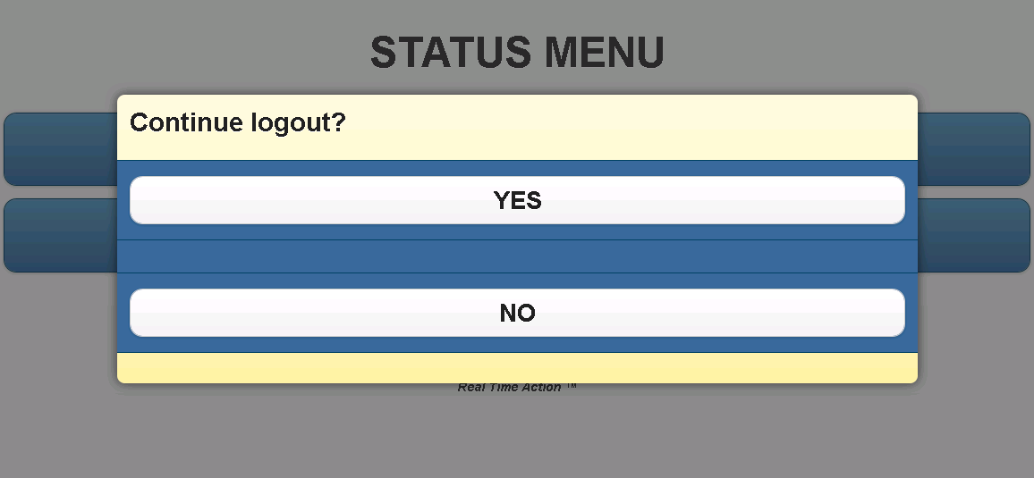

1. Press<Yes> to logoff the system and un-assign your Areas
2. Press <No> to return to the Main Menu
3. A Logout Status screen appears

***Note: DO NOT TURN OFF YOUR PHONE DURING THE LOGOUT PROCESS!***

***If the device is turned off during the login process, turn the device on, and start the RTA application. Confirm that the user is not logged in to the application through the user’s device,***

***and the supervisor ASSIGNED AREAS scorecard***

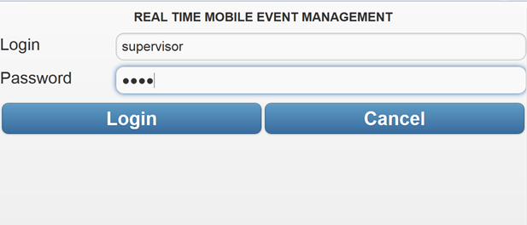

1. The Login Screen appears following the completion of the Logout process
2. Press the <CANCEL> button on the MAIN screen to leave the application.

# EVENTS

Events are prioritized based upon RTSS rules-based management settings and sent to a mobile device based on Area(s) assignment. You may 'Accept', or 'Reject' an event.

The method of dispatch implemented is defined below:

1. Auto Assign to available Employees
   1. Events are automatically assigned to employees based their Area assignment and longest time available.
   2. User has ability to Accept or Reject the event assigned
      1. Upon acceptance the user will stay assigned to the event until they reject or complete it.
      2. Upon rejection, the event will be auto assigned to the next available employee in the designated Area
      3. When an event is accepted, the user has the ability to complete the event from the device, or from the machine (if configured).

## 7.1 Assigned Event

If enabled, you will automatically be assigned events based on your assigned Area(s) and the length of time available as compared to other employees.

When an event is assigned:

1. The words NEW EVENT will appear on the main screen in RED.
2. The ACCEPT button will also be highlighted in RED.
3. If the sound is turned on, a sound will play to alert the user of the new event
4. If enabled by your property, your device will also vibrate to alert the user of the new event

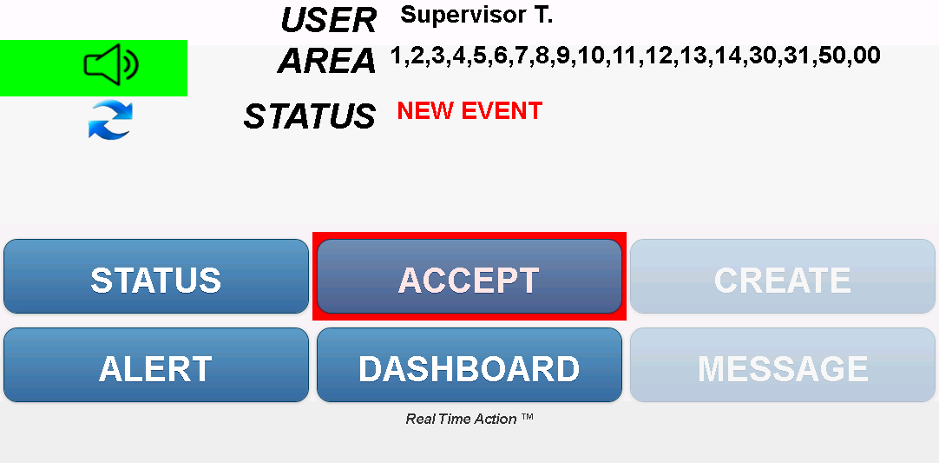

Push the ACCEPT button to view the event details.

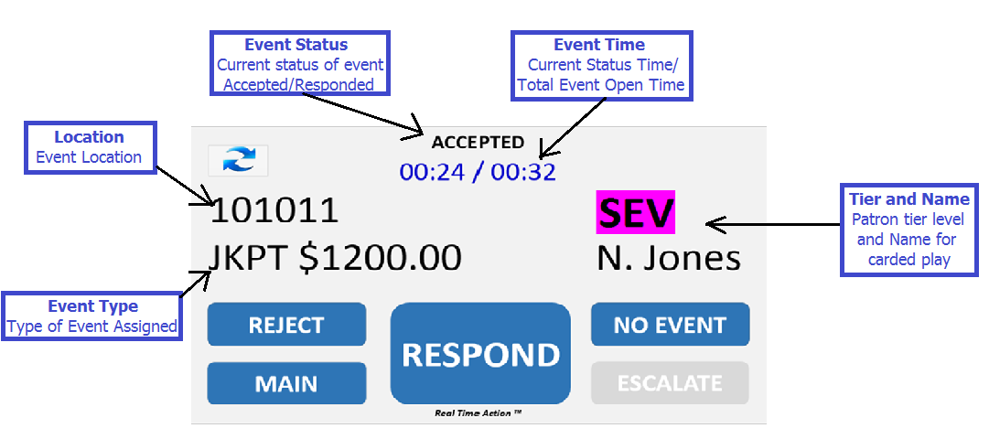

## 7.2 Accept an Event

This should be your default action. If an event has been assigned to you, you should select this option to accept it. Once you have accepted it, you will not be available to be assigned other events until you have completed this one.

## 7.3 Manually Reject an Event

You may defer an event for various reasons (e.g. proximity, guest assistance, lunch, etc.). Once an events is rejected, it is sent to the next available employee in that Area and an Event Rejection Alert is sent to the Supervisor.

1. Enter in a reason in order to REJECT an event by either
   1. Selecting a reason from the DROP DOWN menu
   2. Entering free-form text into the COMMENT field (if available)
2. Press the <REJECT> button.
3. Upon manually rejecting the event, you will be required to go on an OOS event, so that no further events are assigned to you.
4. Upon completion of the OOS task that caused the rejection of the event, you will be available to process further event.

***Note: To receive no additional Pending Event(s), you must ‘Take a Break’, go on ‘OOS’, or ‘Log Out’***

***and notify your supervisor.***

## 7.3 Manually Reject an Event

You may defer an event for various reasons (e.g. proximity, guest assistance, lunch, etc.). Once an events is rejected, it is sent to the next available employee in that Area and an Event Rejection Alert is sent to the Supervisor. When user rejects an event, they will need to select an OOS type, and go OOS.





## 7.4 Respond to an Event

Once you have arrived at the location of the event, you can click the respond button to let the system know you are at the event and beginning to service the event. This button is configurable and may or may not be displayed on your screen. Please follow all local procedures for responding to an event.

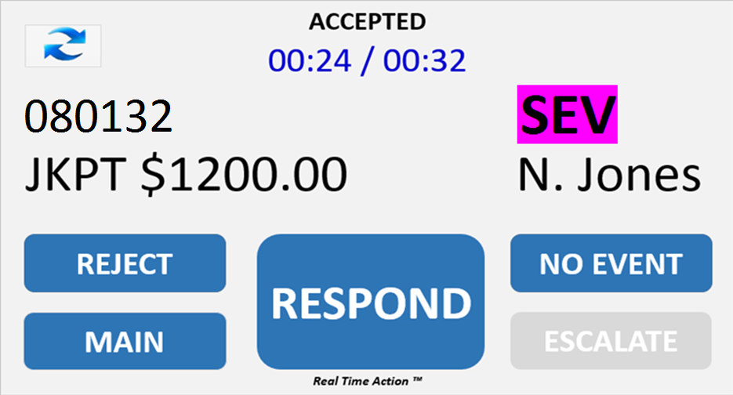

## 7.5 Complete an Event

You are encouraged to ‘Complete an Event’ in accordance with local procedures at the game. Use this procedure only as an exception.

1. Press the <COMPLETE> button.
2. You will receive the next Pending Event(s)
3. If no event(s) are open, you will return to the MAIN screen.

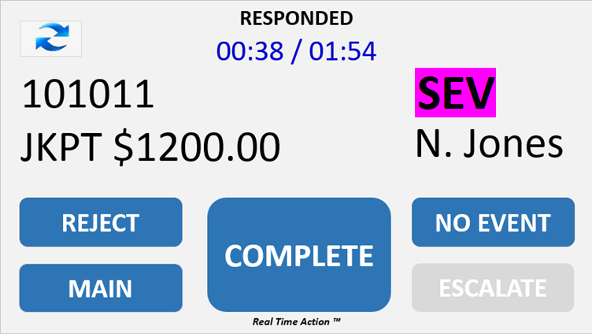

***Note: Your Name, Complete Time, and Comment are permanently linked to the Event.***

When an event is processed using the REJECT, COMPLETE or REFRESH button, the pop up box below will appear while the device communicates the information to the server.

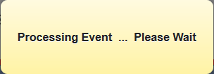

## 7.6 Phantom / No Event

If you have accepted an event, and upon arrival you find that there is no event, you can select the "Phantom" or "No Event" button. Selecting this button will immediately complete the event and note in the system that there was no event. The text of this button is configurable.

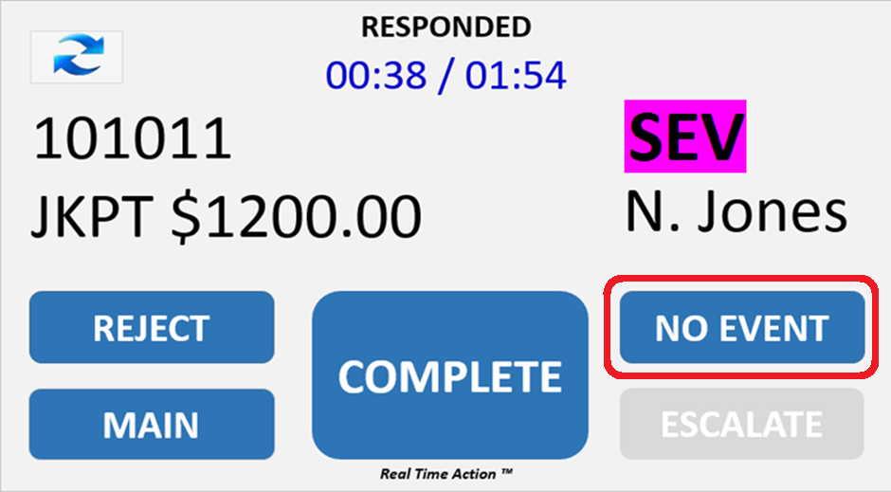

## 7.7 Auto Event Rejection

RTA will allow events to be automatically rejected at the device level, if the user has not ACCEPTED the event in a set amount of time (default = 30 second)

1. The event detail screen has an ACCEPT button.
2. Upon receipt of a new event, the user will have X seconds (configurable by user on backend in database) seconds to hit the ACCEPT button to confirm the acceptance of the event.
3. If the button is not pushed, the event will be automatically rejected by the device, the REJECT REASON will be set to AUTOREJECT, and the event will be placed back into queue for the next user.
4. If they are looking at the device, the user will only see a ‘Processing request’ message when an event is auto rejected by the system.

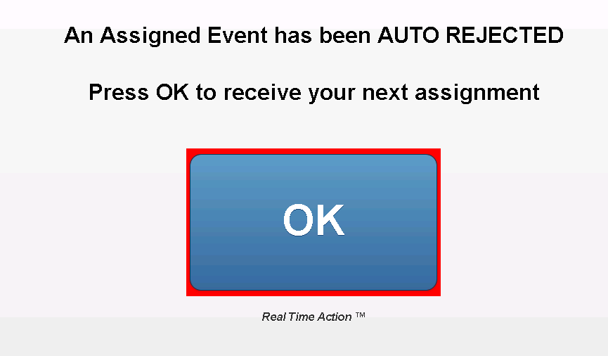

## 7.8 High Priority Reassignment

RTA allows HIGH-PRIORITY events to be REASSIGEND to a user that is currently in an ASSIGNED or ACCEPTED state on a LOW PRIORITY event. The user will be prompted with a HI-PRIORITY EVENT popup, to which they can ACCEPT or REJECT the reassignment. ACCEPTING the reassignment, will place the current low priority event back into the queue, and display the hi-priority event on the device. REJECTING the reassignment will keep the current low priority event assigned to the user.

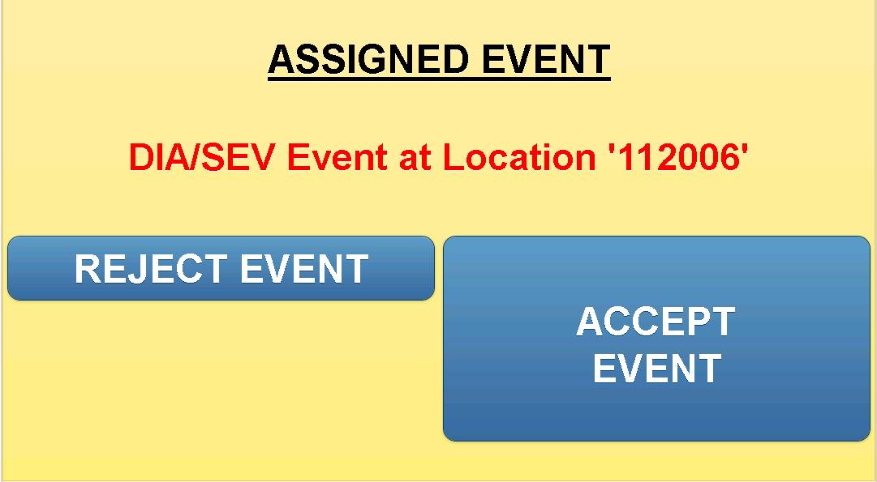

Clicking ACCEPT on the HI PRIORITY event assignment will place the current event back in the queue, and display the reassigned event on the device. If the user does not respond to the reassignment in 15 seconds (configurable setting), it will be auto rejected, and the user will remain on the current event.



## 7.9 Escalate Event (Inactive)

RTA allows events to be escalated to other user types (Supervisor, Technician, or Attendant if enabled). The event will remain open on the original user’s device, allowing them to complete the event independently of the escalated event.

1. Once the user has hit ACCEPT and RESPOND, the ESCALATE button will appear
2. Hitting ESCALTE will bring up a selection menu with the user types available for escalation. You may also add an optional Comment with additional event information. Press the desired user type, or hit CANCEL to return to the event details screen.

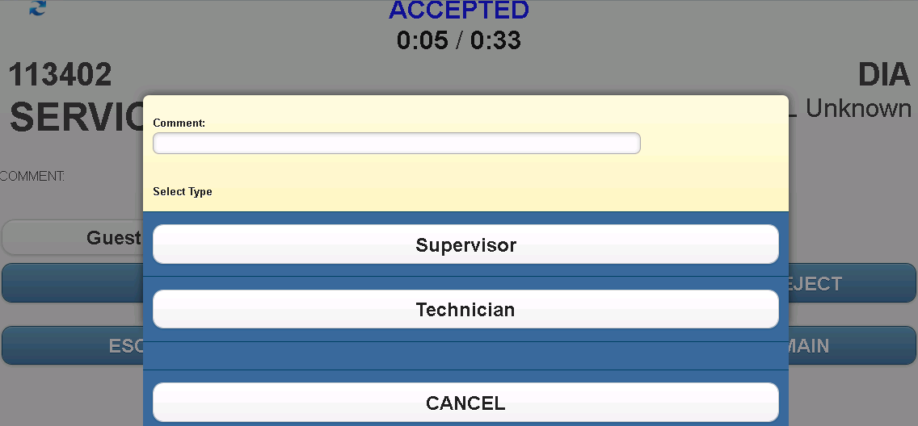

1. When the event has been escalated successfully, a confirmation window will appear. The user can now remain on the event, or compete it to receive their next event.

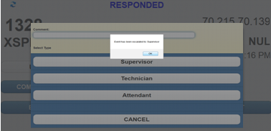

When escalating a JACKPOT event, the comment will be automatically populated with "JP VERIFY".

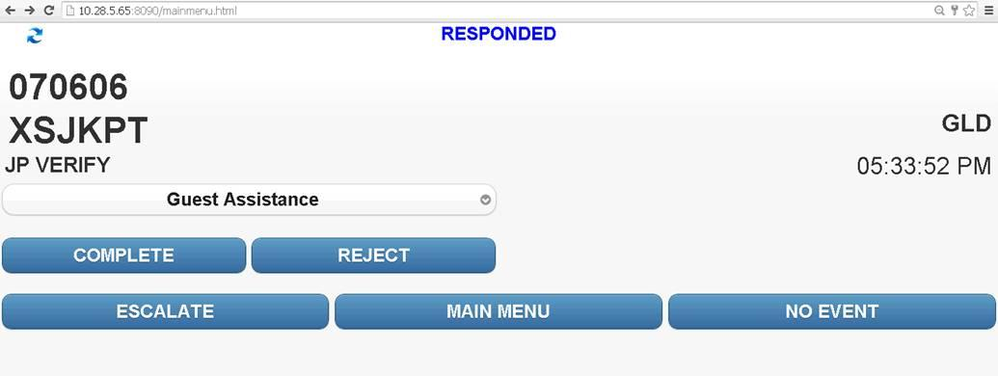

# CREATE EVENTS / EMPLOYEE CARD IN

## 8.1 CREATE EVENTS

The CREATE EVENTS button gives supervisors the ability to open events based on things they see happening on the floor and are not captured by the slot system.

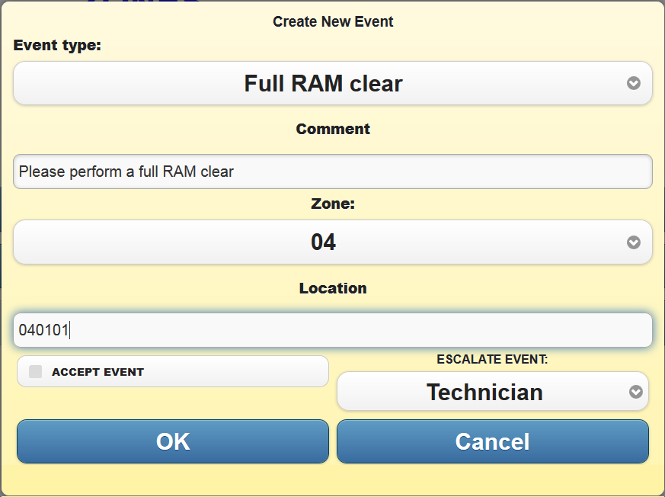

1. Use the drop-down list to select the type of event you would like to open
   1. This list is configurable and new event types can be added if needed
2. Enter the proper Area and optional comment and location
3. Select 'Accept Event' to assign and accept that event for yourself
4. Select a job type within the 'Escalate Event' drop-down to send this event to that group
5. Click 'OK' to open or 'CANCEL' go back
6. If you accepted the event, you will immediately be sent to the EVENT screen with this event being accepted
7. You will then be able to respond and complete the event like any other even type
8. If you escalated the event, you will then be taken back to the MAIN screen and the event will be placed in the proper group queue for the next available employee

## 8.2 EMPLOYEE CARD IN EVENTS

When an EMPLOYEE inserts their card into a machine and there is an event already at that location, then the employee will authorize that event and if they have a mobile device, the event will be displayed on their screen. If another employee was assigned to that event, then they are removed from it and made available for a new event.

When an EMPLOYEE inserts their card into a machine and there is no event currently open at that location, RTSS will open an EMPCARD event.

If the EMPLOYEE is on TICKET RESTOCK status, then this EMPCARD event will be automatically assigned type TKT STOCK and completed.

If there is no mobile device id assigned to the employee who created the event, then the EMPCARD event will be immediately completed.

If the employee does have a device id and is not on TICKET RESTOCK, then that employee will be brought to the EVENT screen with that event assigned to them. If the employee already has an event on their EVENT screen, the EMPCARD event will display over this, and they will be brought back to their previous event once they have completed the EMPCARD event.

The EMPCARD event will stay assigned to that employee as EMPCARD events will not be auto-rejected and the reject button is disabled. The employee will be able to accept, respond, and complete the EMPCARD event like any other event.

Using the drop-down on screen, you may also select the reason you are at that location.

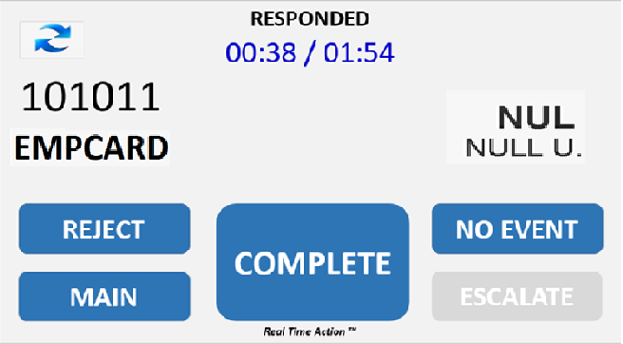

Accept, Respond, and Complete the event just like any other event

# ALERTS (Supervisor Only)

An alert provides management with the ability to react to a current situation in real time – not after the fact. The alert listing is available to supervisors and can be accessed and refreshed manually. Alerts may be configured to display for all supervisors logged into RTA, or just to supervisors assigned to the Areas where the alert event occurred.

The following are types of alerts that can be received in the system:

|  |  |
| --- | --- |
| **Alert** | **Description** |
| Event Not Assigned ALL | An event has been open but not assigned for more than X seconds |
| Event Not Assigned by TIER | An event has been open but not assigned for more than X seconds |
| Event Not Authorized ALL | An event has been open and assigned but not authorized for more than X seconds |
| Event Not Authorized by TIER | An event has been open and assigned but not authorized for more than X seconds |
| Event Not Completed ALL | An event has been open, assigned, and authorized but not completed for more than X seconds |
| Event Not Completed by TIER | An event has been open, assigned, and authorized but not completed for more than X seconds |
| Event Rejection | An event has been rejected by an attendant |
| JP Alert | A Jackpot event has occurred and the amount is greater than X dollars (configurable at the RTSS Workstation through the ADMIN console) |
| Late Break | A break has ended after the specified time for that break type |
| Multiple Auto Rejects | Identifies a user that has automatically rejected X consecutive events |
| Network Status | Identifies a user that may have lost connectivity on their device |
| One Attendant in Zone | There is only one attendant signed into a zone |
| Variance - ALL Authorization | An event has not been accepted or authorized in X minutes; generated after event has been responded to |
| Variance - ALL Completion | An event has not been completed in X minutes; generated after event has been completed |
| Variance - OOS Completion | An OOS event has not been completed in X minutes |
| Zone 00 | An event has been created by a machine not assigned to a zone |

**Please note that t**he alerts for rejected events will not be displayed if your property is not using the RTA Attendant module.

## 9.1 Alert Listing

The alert listing contains alerts awaiting review by a supervisor user. The System Settings generating the Alert Message can be found in the RTA Technical Manual.

When alert notifications are active, the system will send the user the details of a new alert, as a direct pop up message. The alert details will be presented to the user, rather than a message notifying the user of a new alert. The user can then CONFIRM or DISMISS the alert directly from the pop up message.

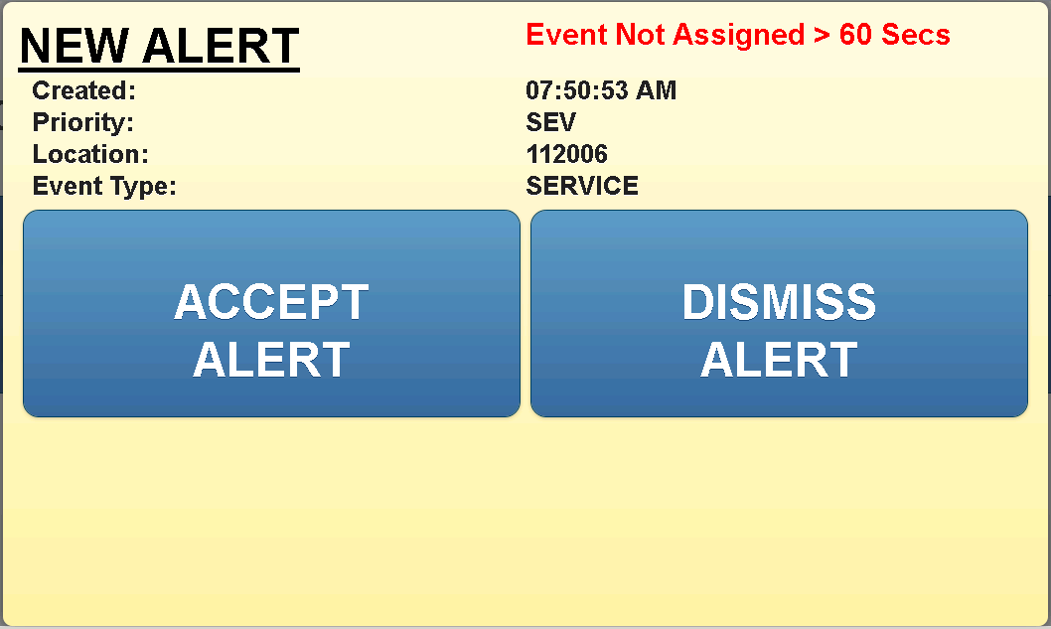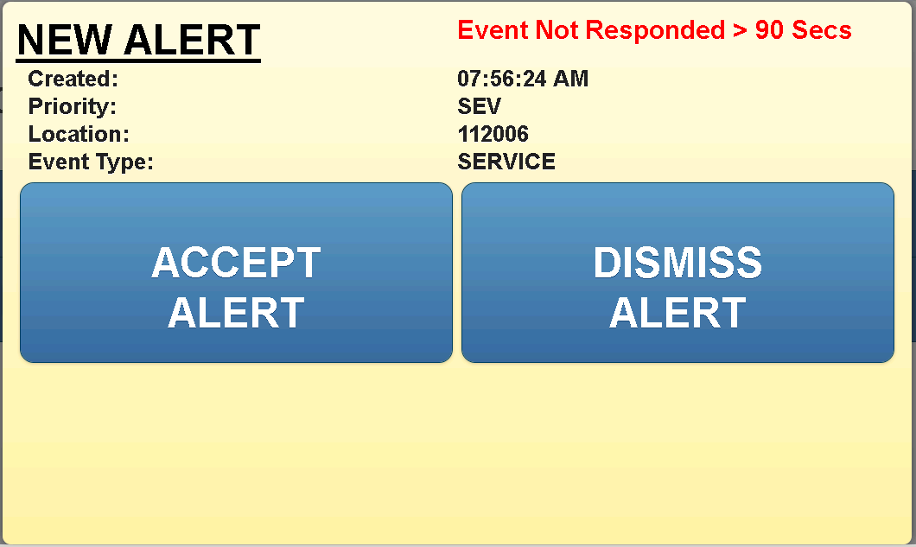

Alert Listing

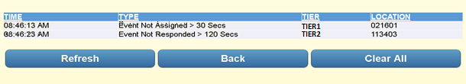

1. Click on the alert to review the details of the Alert
2. Press <Confirm> to confirm the details of the alert and remove it from the listing. This will record the confirmation time.
3. Press <Dismiss> to delete the highlighted alert. This will record the dismissal time.
4. Press <Back> to return to the Alert listing.

## 9.2 Alert Configuration

Supervisor users with access to the Customizable options function in the RTSSWS application, can enable/disable alerts, and update time and setting configurations.

When logged in to RTSSWS, go to ADMIN – CUSTOMIZABLE OPTION, and choose RTA ALERTS from the drop down listing to view the current active alert configurations.

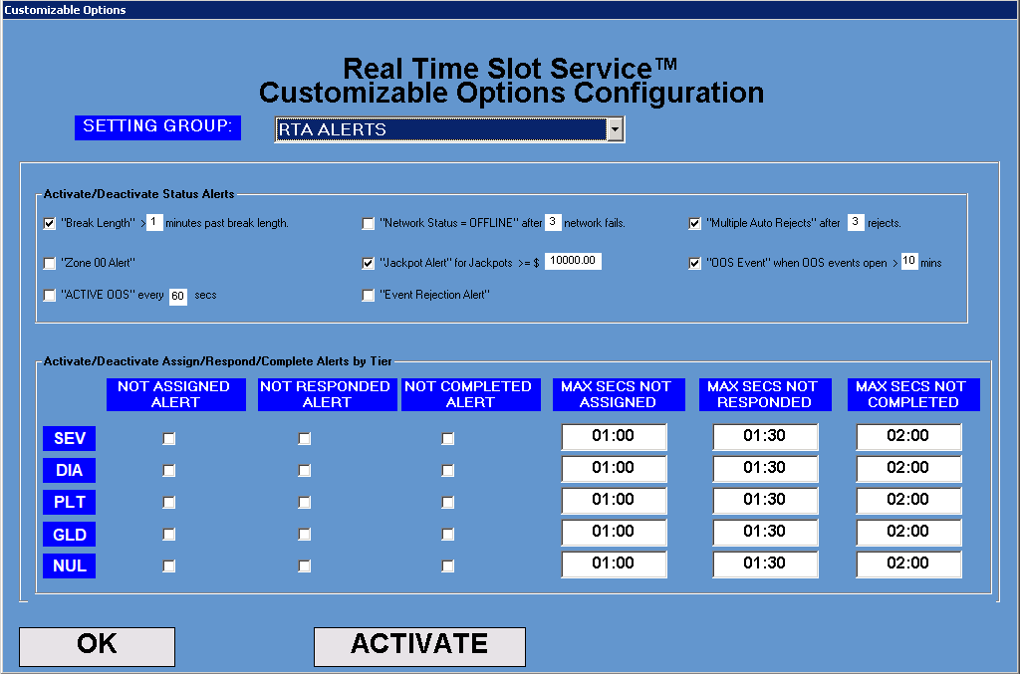

# SCORECARDS (Supervisor Only)

Scorecards help supervisors and managers in responding to the volume of events by adjusting staffing levels in Areas, monitoring break activity, and evaluating the impact of rejected events. The following list of scorecards can be listed in any order per property requirements.

## 10.1 Scorecard Listing

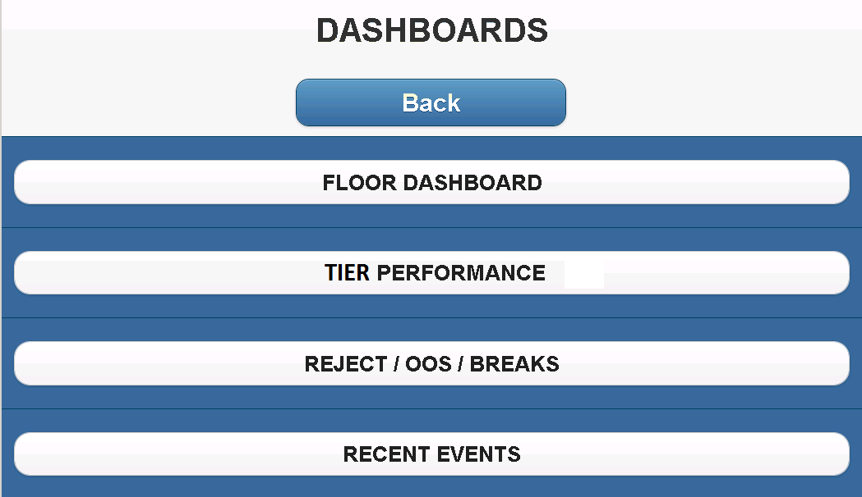

|  |  |
| --- | --- |
| **Scorecard** | **Description** |
| FLOOR DASHBOARD | Displays details of all open events along with all employees that are currently logged into RTA. Provides event location, type, status, time, employee, and customer information. |
| TIER PERFORMANCE | displays the number of open and pending events along with the number of attendants in each Area |
| REJECT / OOS / BREAKS | displays the number of events by tier in each Area |
| RECENT EVENTS | displays a list of all employees currently on break |

## 

## 10.2 FLOOR DASHBOARD

This will be you main scorecards where you can review the status of all employees and events currently in the system.

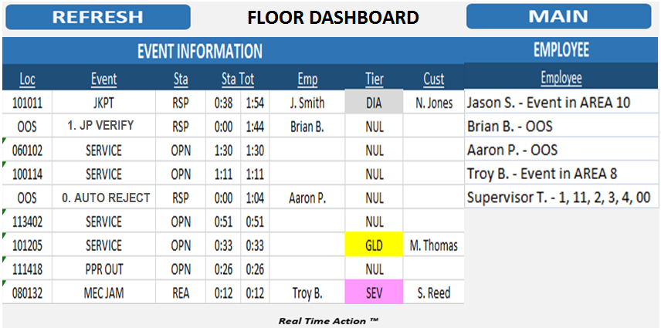

1. The scorecards will automatically refresh, but can also be manually refreshed
2. Press <Refresh> to update the information on screen
3. Press <Go Back> to return to the Scorecard Listing

### EVENT INFORMATION

Provide overview of the events currently opened on the floor.

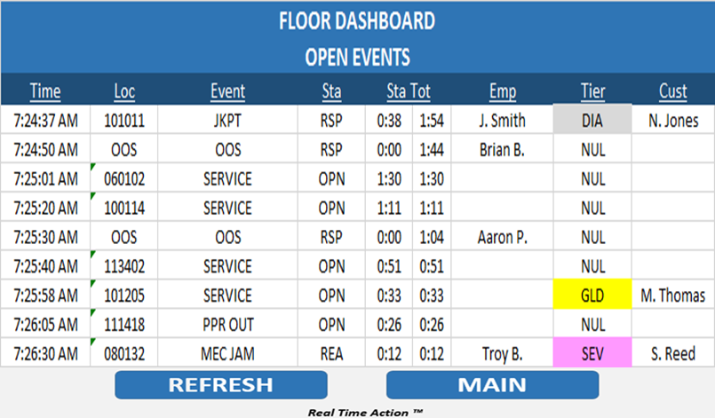

1. The scorecards will automatically refresh, but can also be manually refreshed
2. Press <Refresh> to update the information on screen
3. Press <Go Back> to return to the Scorecard Listing

Clicking on any of the headers will sort the scorecard by that column. Clicking on a header again, will sort the scorecard by that column in the opposite order.

Clicking on the FLOOR DASHBOARD header will bring you back to the FLOOR DASHBOARD.

Clicking on the name of an event ('EVT') will display the STATUS DETAILS of that event.

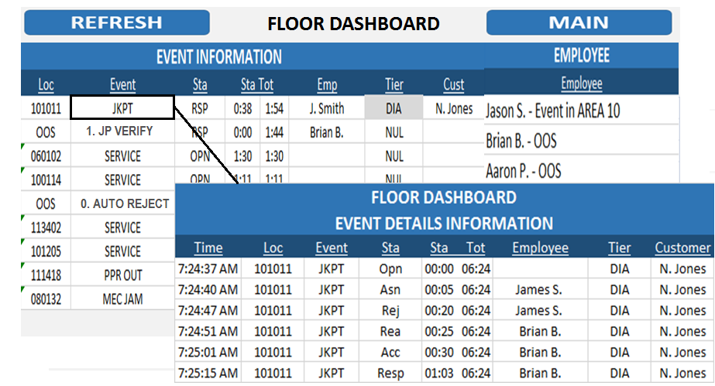

Clicking on the Customer name will show event history for that customer

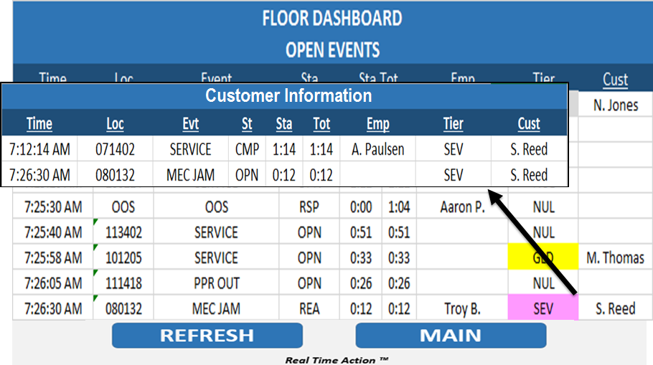

Clicking on the Location name will show event history for that location

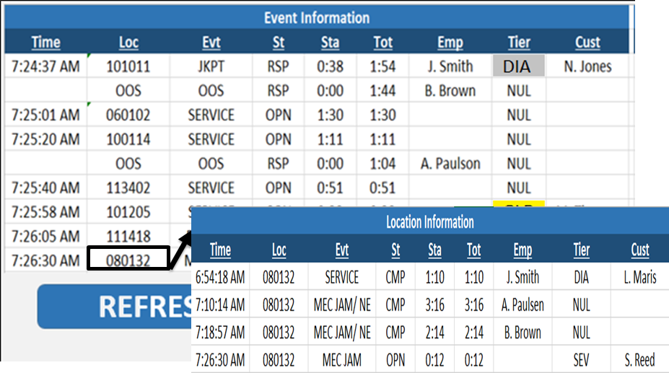

### Event Admin

If enabled, clicking on the status ('St') of an event will bring up the following menu. From this menu you can COMPLETE or ESCALATE (if enabled) an event.

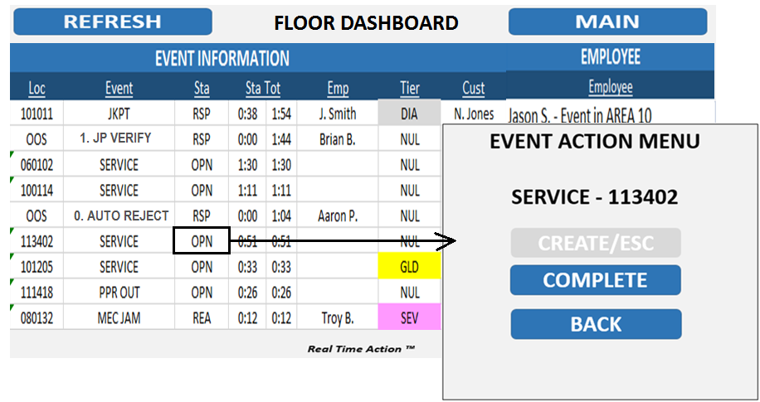

### EMPLOYEE INFORMATION

Provides a list of all employees that are currently logged in and what their status is.

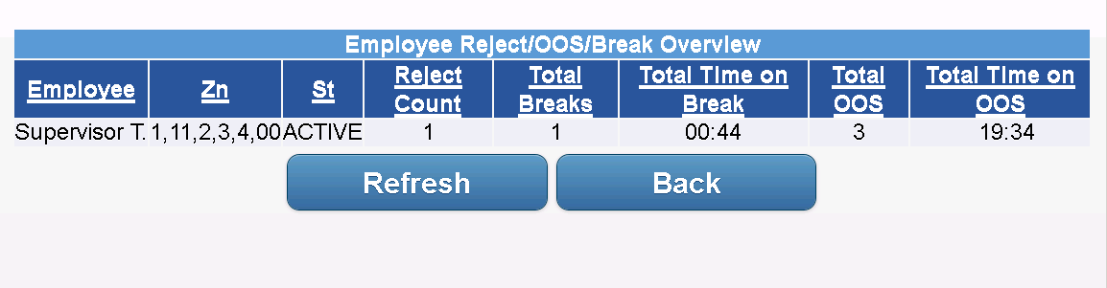

1. The scorecards will automatically refresh, but can also be manually refreshed
2. Press <Refresh> to update the information on screen
3. Press <Go Back> to return to the Scorecard Listing

Clicking on any of the headers will sort the scorecard by that column. Clicking on a header again, will sort the scorecard by that column in the opposite order.

Clicking on the FLOOR DASHBOARD header will bring you back to the FLOOR DASHBOARD.

Clicking on an employee name ('Emp') will display a list of events the employee has been associated with during their shift ('Assoc').

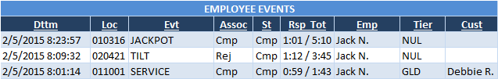

### Employee Admin

If enabled via SYSTEMSETTINGS, clicking on the status 'St' of an employee from the Employee Status scorecard, will bring up the following menu. From this menu you can start/end an employee's break or OOS as well as log them off, or change their AREA assignment. When taking these actions, the associated employee will see the result on their mobile device.

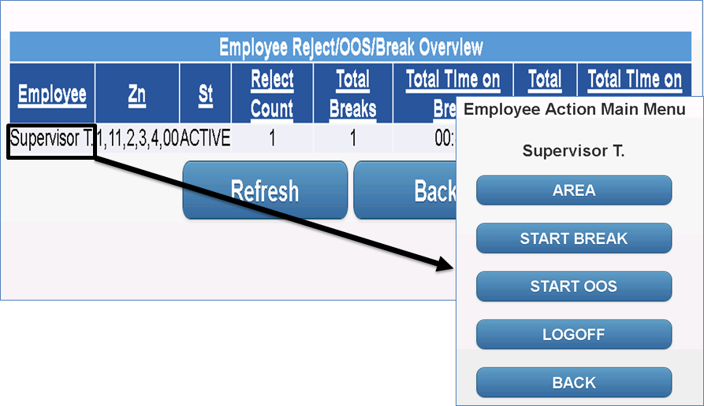

## 10.3 ATTENDANT DASHBOARD

Attendants now have access to view their response performance for current day, yesterday, and last 7 days. Information is displayed for ALL TIERS, and DIA/SEV only.

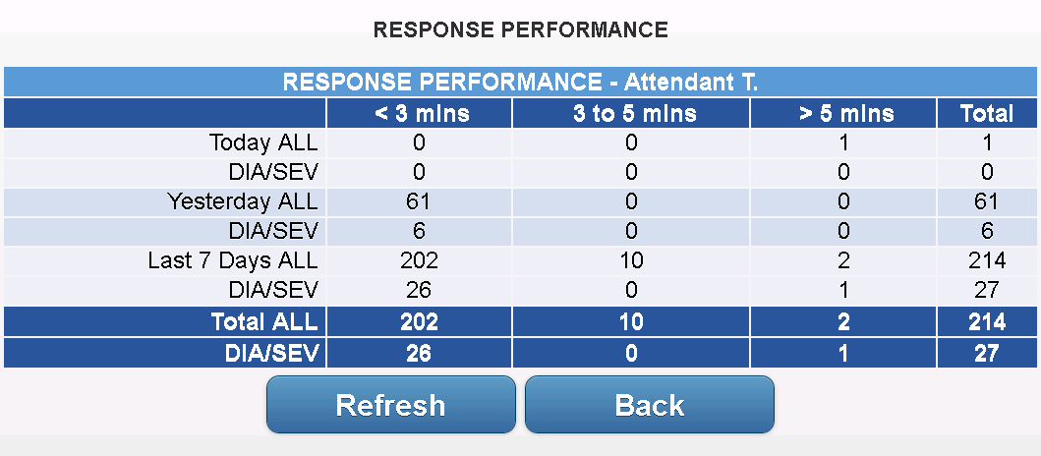

# MESSAGING

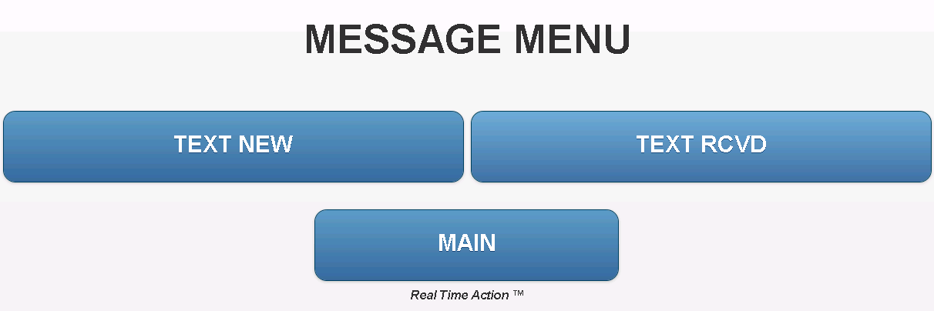

## 11.1 Send a Message

Users are able to communicate directly with you, providing important information, words of encouragement, request assistance, etc.

1. Press the MESSAGES > NEW MESSAGE button from the main screen. 

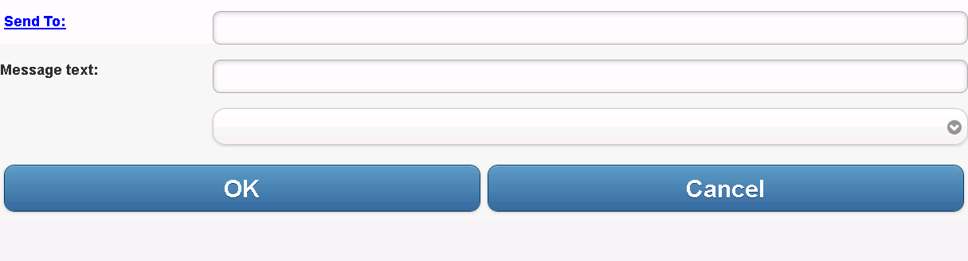

1. Click 'Send To:' to select the recipients you would like to send a message to. Once clicked, you will see a list of employees. Employees that are currently active will be displayed at the top in black, while inactive employees are listed below them in grey. If you send a message to an employee that is not currently active, they will get the message the next time they log in. The ATTENDANT, SUPERVISOR, and TECHNICIAN groups are also listed. Sending a message to a group will send a message to each employee currently assigned to that group.

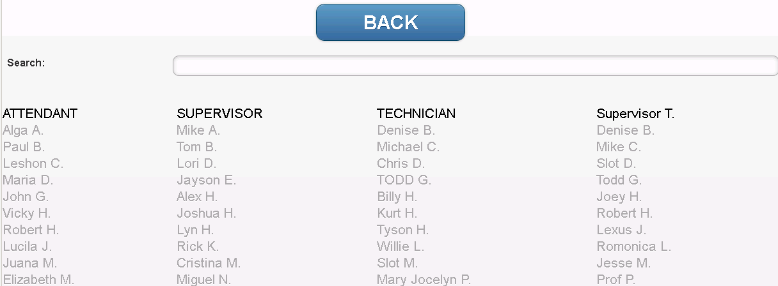

1. You can also use the 'Search' box to find an employee. Start typing the first name of an employee and the list of employees will get filtered down to only those that match the current
2. Click on an employee name to add them to the recipient list

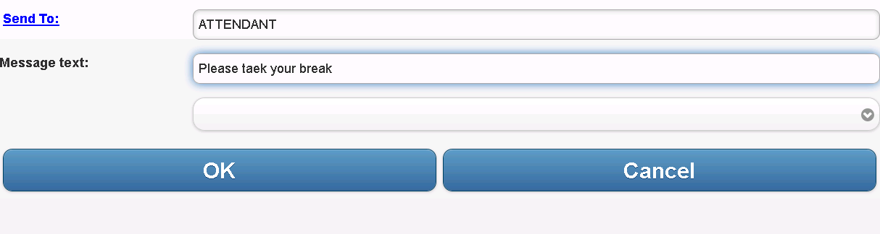

1. You can remove recipients by selecting the 'Send To:' button and going back to the list of employees. The employees in the 'Send To:' line will be listed in red and if you click on their name, they will be removed as a recipient.

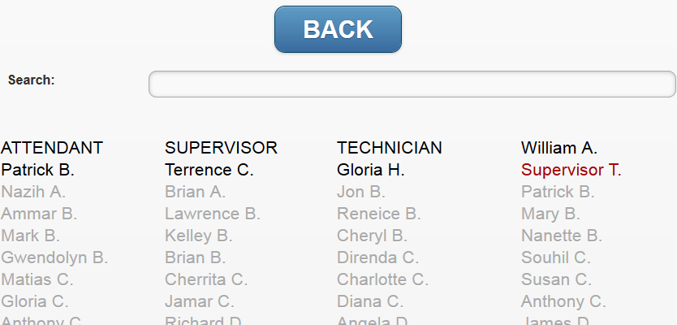

1. Once you have selected your recipients, you can enter a message using
   1. Text into text box (if available)
   2. Drop-down selection of "canned" message (if available)
   3. *** If both options are available and a message is entered for each, both messages will be sent
2. Press <OK> to send the message

**Send to email-**

If enabled and configured at your property, a list of emails address may be visible within the employee listing as well.

## 11.2 Check Messages

In order to view new or previous messages, press the MESSAGES button on the main screen. A listing will appear displaying all the available messages

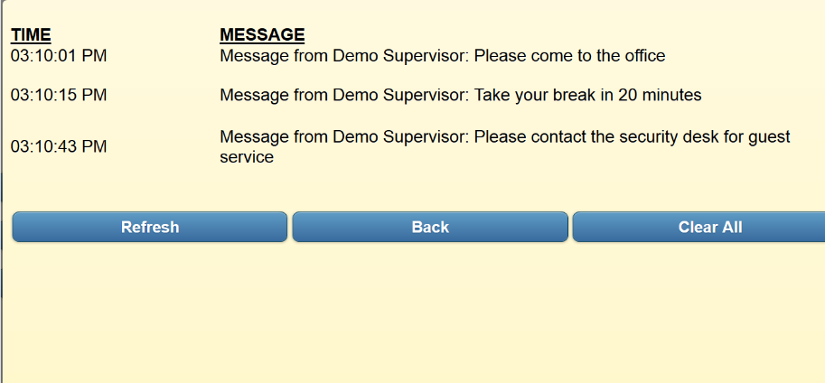

1. On the Messages screen, you can view message details, refresh the message list, Clear All messages, or go back to the main screen. Messages will display on this screen for X number of days based on your properties configuration.
2. Press the message you would like to view in detail.
3. When the message window appears, you can choose to 'Reply' or 'Reply All' to the message. Reply will populate a new message with the name of the original sender. 'Reply All' will populate a new message with the original sender along with the other recipients of the original message.

## 11.3 Voice Messaging

If enabled at your property, you will have the ability to send voice messages to other employees. Voice messaging uses the same screens and options as text messaging with the following new features.

Currently voice messaging is only available for Apple iOS devices.

**Record and send a new message-**

When you go to the 'Send Message' screen, you will see four buttons - Record, Stop, Play, and Delete

Record - Press this to start recording a new message

Stop - Press this to stop the current recording or message playback

Play - To start playback on your recorded message

Delete - Delete your recorded message

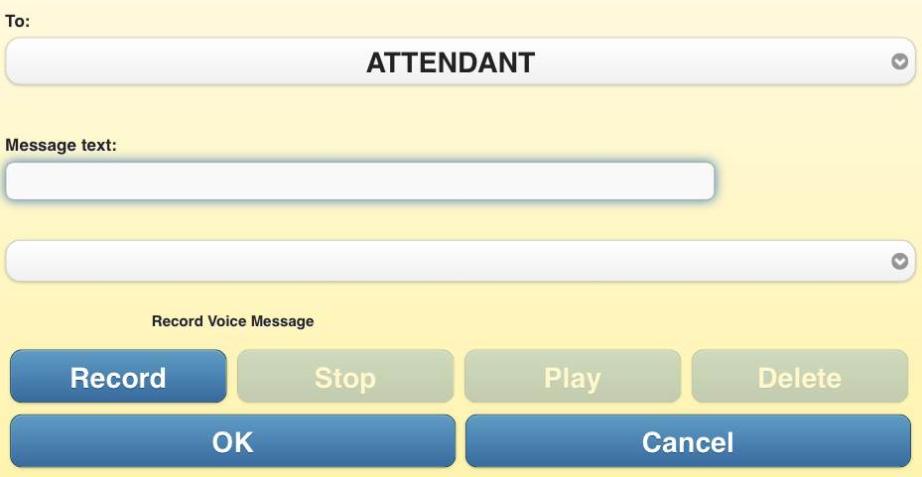

To record a message, press the 'Record' button. Speak into the phone and press 'Stop' once complete.

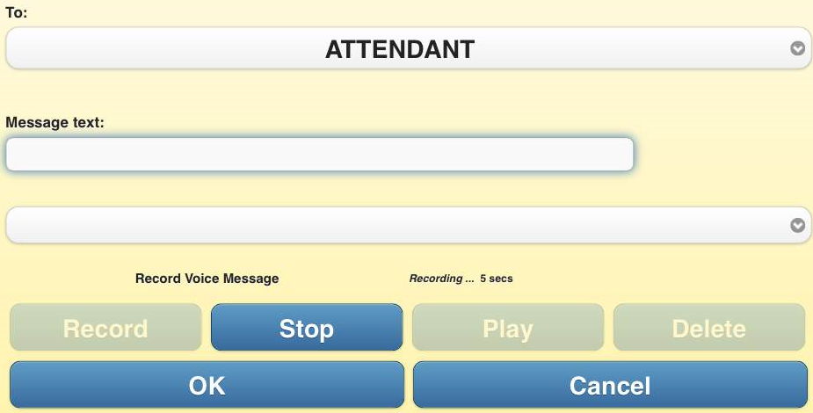

You can then listen to your message by pressing the 'Play' button, or 'Delete' it if you would like to record the message again.

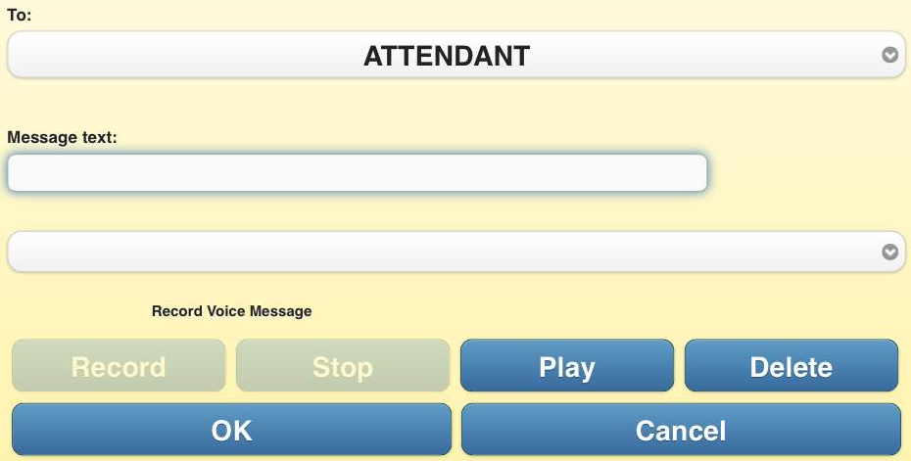

Once you are ready to send the message, make sure you have selected the appropriate recipient from the drop-down, then press 'OK'.

You may also press the 'Cancel' button to return to the main screen and not send a message.

**Listen to a received message-**

You will receive notification that you have been sent a voice message the same way you are notified you have a text message.

If the message you have received is a voice message, when you go into your 'Messages' and click on the new message to view the details, you will see a 'Play' button.

Click to the 'Play' button to listen to the voice message.

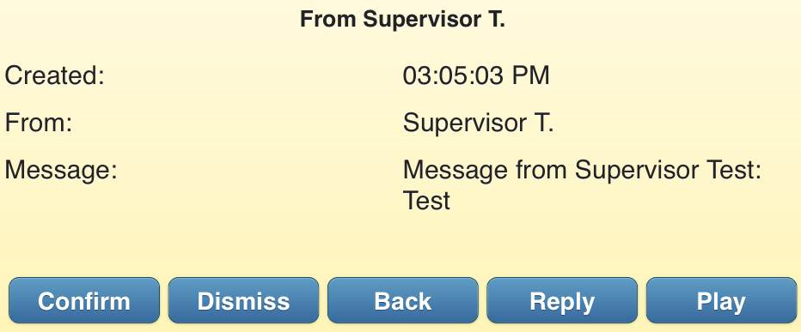

**Reply to a received message-**

You can reply to a received voice message just like you would a text message. From the message detail screen, press the 'Reply' button. You will then be brought to the send message screen where you can record a voice message or simply reply with a text message.



# System Configuration Options

The following section outlines system configuration options that can be set up for multiple event processing rules in the RTA system.

## 12.1 Associated Areas

Associated Area configuration is available through the RTSSWS client application. The configurations allows the RTA system to assign events to users based on their assigned area, and the areas that are directly associated with their assigned area.

Multiple areas can be associated with a single area, allowing for the setup of an ‘Area Hierarchy’. This hierarchy allows the system to identify available employees in the event area, as well as the associated areas defined by this configuration.

The screen below is available in the ADMIN section of the RTSSWS application. Multiple configurations can be setup to accommodate different associated area rules based on day of week, time of day, etc. Once a configuration is created, area association entries can be added by clicking the ADD button at the bottom of the screen. The AREA column represents the area the event will occur in.

The ASSOCAREA column represents the area an employee is in that can be associated with the events area. The PRIROITY column represents the level of priority this AssocArea takes for the defined Area, with the highest priority value being the first AssocArea accessed for an available employee.

The screen will also allow existing entries to be edited, and deleted by the end user.

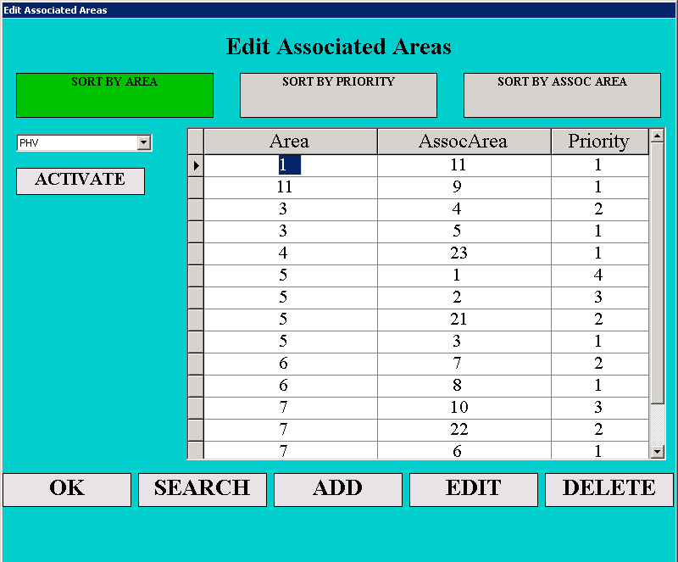

## 12.2 Event REASSIGNMENT and HIGH PRIORITY events

Event reassignment allows the system to assign a HIGH PRIORITY event to a user that has already been assigned a NON HIGH PRIORITY event. The system will allow the ‘TIER’ level(s) that can be defined as a HIGH PRIORITY event. The system will then follow the logic defined below when assigning these events to a user.

The system also provides settings to activate SUPERVISOR PRIORITY event assignment. This feature will allow the supervisor type users to receive HIGH PRIORITY events that have been opened for X seconds, where X can be configured in the application database settings. Once a HIGH PRIORITY event has reached this time threshold and no attendant type users are available, then the event can be assigned to a supervisor.

1. Assignment For NON HIGH PRIORITY event
   1. Assign event to attendant (or supervisor, if assigned to area) in ASSIGNED AREA
   2. If no ATTENDANT is available in an assigned area, check for an available attendant (or supervisor, if assigned to associated area) in an ASSOCIATED AREA
   3. If no ATTENDANT is available in associated area, event will be placed back in queue.
2. Assignment For HIGH PRIORITY event
   1. Assign event to attendant in ASSIGNED AREA
   2. If no attendant is available in ASSIGNED AREA, and REASSIGNMENT process is enabled:
      1. REASSIGNMENT PROCESS for ASSIGNED AREA
      2. Event will be reassigned to attendant in assigned area, who is ‘assigned but not accepted’ on a NON HIGH PRIORITY event. (make this configurable so that the DO NOT REASSIGN events/tiers can be defined)
      3. If no ATTENDANT is ‘assigned but not accepted’ in assigned area, then system will assign event to ATTENDANT in assigned area who is ‘accepted but not responded’ on a NON HIGH PRIORITY event.
      4. If no ATTENDANT is ‘accepted but not responded’ then move to next assignment process.
      5. Provide setting to activate the following feature:
         1. ATTENDANT will be presented with event pop up stating ‘HIGH PRIORITY Event at location ABC’ in RED, with buttons ACCEPT or REJECT.
         2. ACCEPT will reject the current assigned event, and accept the HIGH PRIORITY event. REJECT will auto reject the HIGH PRIORITY event and leave them on current event.
         3. If user does not hit ACCEPT or REJECT in X seconds (default 10) then event will auto reject and leave user on current assigned event.
   3. If no ATTENDANT is available for REASSIGNMENT in ASSIGNED AREA, then look for an AVAILABLE attendant in an associated area
   4. If no ATTENDANT is available in an associated area, check for an attendant for REASSIGNMENT in an associated area
   5. If SUPERVISOR PRIORITY event assignment is active and the time difference between tout and NOW is greater than the defined setting (default = 60)
      1. Assign event to supervisor in ASSIGNED AREA
      2. If no supervisor is available in ASSIGNED AREA, and REASSIGNMENT process is enabled:
         1. REASSIGNMENT PROCESS for ASSIGNED AREA
         2. Event will be reassigned to supervisor in assigned area, who is ‘assigned but not accepted’ on a NON HIGH PRIORITY event. (make this configurable so that the DO NOT REASSIGN events can be defined)
         3. If no SUPERVISOR is ‘assigned but not accepted’ in assigned area, then system will assign event to SUPERVISOR in assigned area who is ‘accepted but not responded’ on a NON HIGH PRIORITY event.
         4. If no SUPERVISOR is ‘accepted but not responded’ then move to next assignment process.
         5. Provide setting to activate the following feature: SUPEVISOR will be presented with pop up prompt stating ‘HIGH PRIORITY Event at location ABC’ with buttons ACCEPT or REJECT. ACCEPT will auto reject their current event, and accept the HIGH PRIORITY event. REJECT will auto reject the HIGH PRIORITY event and leave them on current event.
      3. If no SUPERVISOR is available for REASSIGNMENT in ASSIGNED AREA, then look for an AVAILABLE SUPERVISOR in an associated area
      4. If no SUPERVISOR is available in an associated area, check for a SUPERVISOR for REASSIGNMENT in an associated area
      5. If no SUPERVISOR is available for REASSIGNMENT in ASSOCAITED AREA, then look for an AVAILABLE SUPEVISOR in an NO AREA
      6. If no SUPERVISOR is available in NO AREA, check for a SUPEVISOR for REASSIGNMENT in NO AREA

## 12.3 Area of Last Event Assignment

If active, the system will utilize the area of a user’s ‘Last Event’ to assign their next event. This feature will allow the system to assign events to the closest available user, based on last event processed. If this feature is inactive, then the user’s assigned area will be used for next event assignment.

This feature is configurable in the database settings.

## 12.4 Multiple Events Status

If active, the system will allow a user to select the MULTIPLE EVENTS status from the STATUS- AREAS menu. When selected, any event that has been responded to by a user, will remain with that user when they respond to another event.

If inactive, the initial assigned event will be released to the event queue, when the user responds to (EMPCARDs) a second or third machine. There is no limit to the number of responded events a user can have when MULTIPLE EVENTS status is active.

Activate the MULTI EVENT Status by clicking on the button in the AREA screen, shown below

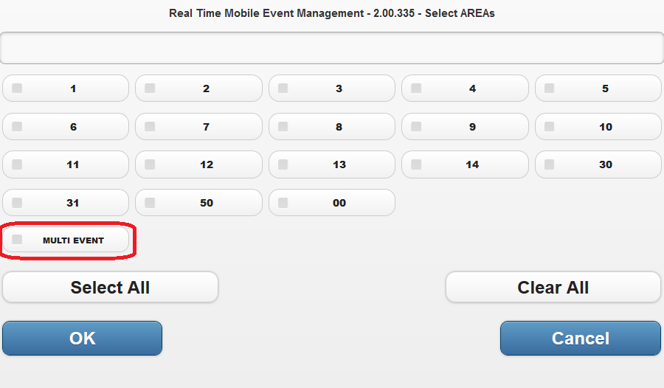

When this is active, the user will see MULTI EVENT on their MAIN screen, shown below

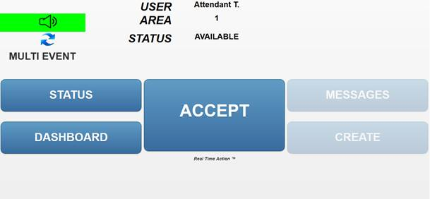

On the FLOOR DASHBOARD, when a user responds to multiple events, the last responded event will show in the ‘Rsp’ status. The prior responded events will show in the ‘RspP’ status.

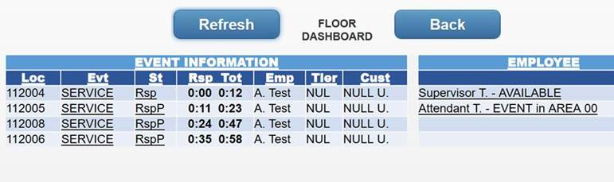

## 12.5 Multiple Jackpot Events

If active, the system will allow Multiple Jackpots to be opened at one location. If a jackpot is opened at location A123, and while in process, a second jackpot comes from location A123, the second jackpot will also open and be placed into the event queue.

All actions received from the machine will be credited to the first open Jackpot, until it is completed. Then the actions received from the machine will be credited to the second jackpot.

# TROUBLESHOOTING

## USING RTA

My mobile device won’t turn on!

Check with your supervisor to determine if other devices are experiencing the same issue. If so, the supervisor should follow the local escalation procedures.

Can/Did you turn your mobile device off/on?

Can/Did you remove/replace your mobile device’s battery?

Is your battery fully charged?

I can’t login (or logout)!

Are there any Error Messages?

Did you change your password?

Can you access the internet from the mobile device?

Check with your supervisor if other devices are experiencing the same issue.

If so, your supervisor should follow local escalation procedures.

If not, is your mobile device connected to the network?

I can’t get events!

Are there any Error Messages?

Have you assigned your mobile device to Area(s)?

Can you un-assign/reassign Area(s)?

Can you manually accept Events?

Is your dispatch terminal working?

Is the Slot Floor down?

My mobile device doesn’t alert me when there are new events!

Did you mute the ring/alert tones?

Are there any Error Messages?

Have you assigned the mobile device to Areas?

Can you un-assign/reassign Areas?

Can you manually accept Events?

My mobile device is frozen (can’t exit application, can’t logoff, can’t turn off)!

Can/Did you turn your mobile device off/on?

Can/Did you remove/replace your mobile device’s battery?

Is your battery fully charged?

Did you remember to logoff from your last session?

My mobile device is slow!

Are any other mobile device(s) with the same problem? How Many?

Is your dispatch terminal active?

Are there any property issues or events going on?

I cannot connect to the network (there are no connection bars)!

Check with your supervisor to determine if other devices are experiencing the same issue. If so, the supervisor should follow the local escalation procedures.

Can/Did you turn your mobile device off/on?

Can/Did you remove/replace your mobile device’s battery?

Is your battery fully charged?

My company logo does not appear!

Report this issue to your supervisor. Your supervisor should follow local escalation procedures.

The Server Version and/or App version do not appear on the Welcome screen!

Report this issue to your supervisor. Your supervisor should follow local escalation procedures.

My Name/Job type is incorrect!

Report this to your supervisor. Your supervisor should confirm your employee name and job type are set up correctly.

The Main Menu is not coming up!

Report this issue to your supervisor. Your supervisor should follow local escalation procedures.

I don’t see the Navigation buttons!

Logout of the application completely and Log back in.

Report this issue to your supervisor

## TAKE BREAK

I can't select a break type or duration!

Leave the break screen pressing <ESC> on the mobile device, re-enter the screen, and try again.

Logout of the application completely and Log back in to the application.

Report this issue to your supervisor

I can't select Yes/No option!

Leave the Yes/No screen pressing <ESC> on the mobile device, re-enter the screen, and try again.

Logout of the application completely and Log back in to the application.

If the issue persists, escalate this to your supervisor.

I cannot return to work!

Leave the break screen pressing <ESC> on the mobile device, re-enter the screen, and try again.

Logout of the application completely and Log back in to the application.

If the issue persists, escalate to your supervisor.

## EVENTS

I am not receiving any events!

Are there any error messages?

Have you assigned your mobile device to Area(s)?

Can you un-assign/reassign Area(s)?

Can you manually accept Events?

Is your dispatch terminal working?

Is the Slot Floor down?

I can't accept an event!

Are there any error messages?

Are other features of RTA operating normally?

Is your mobile device connected to the network?

Logout of the application completely and Log back in to the application.

If the issue persists, escalate to your supervisor.

I can't reject an event!

Are there any error messages?

Are other features of RTA operating normally?

Is your mobile device connected to the network?

Logout of the application completely and Log back in to the application.

If the issue persists, escalate to your supervisor.

I can't enter in a reject comment!

Are there any error messages?

Are other features of RTA operating normally?

Is your mobile device connected to the network?

Logout of the application completely and Log back in to the application.

If the issue persists, escalate to your supervisor.

I can't select ‘Forward’ on the event screen?

Are there any error messages?

Are other features of RTA operating normally?

Is your mobile device connected to the network?

Logout of the application completely and Log back in to the application.

If the issue persists, escalate to your supervisor.

I can't select an employee from the Forward To list!

Are there any error messages?

Are other features of RTA operating normally?

Is your mobile device connected to the network?

Are there Supervisor/Technician type users?

Logout of the application completely and Log back in to the application.

If the issue persists, escalate to your supervisor.

I can't select a comment from the comment list!

Are there any error messages?

Are other features of RTA operating normally?

Is your mobile device connected to the network?

Logout of the application completely and Log back in to the application.

If the issue persists, escalate to your supervisor...

I can't enter a comment to complete or reject an event!

Are there any error messages?

Are other features of RTA operating normally?

Is your mobile device connected to the network?

Logout of the application completely and Log back in to the application.

If the issue persists, escalate to your supervisor.

My screen/status does not change from Open to Accepted!

Are there any error messages?

Are other features of RTA operating normally?

Is your mobile device connected to the network?

Logout of the application completely and Log back in to the application.

If the issue persists, escalate to your supervisor.

I rejected an event but a new event does not appear!

Are there any error messages?

Are other features of RTA operating normally?

Is your mobile device connected to the network?

Logout of the application completely and Log back in to the application.

If the issue persists, escalate to your supervisor.

I forwarded an event but a new event does not appear!

Are there any error messages?

Are other features of RTA operating normally?

Is your mobile device connected to the network?

Logout of the application completely and Log back in to the application.

If the issue persists, escalate to your supervisor.

I completed an event but a new event does not appear!

Are there any error messages?

Are other features of RTA operating normally?

Is your mobile device connected to the network?

Logout of the application completely and Log back in to the application.

If the issue persists, escalate to your supervisor.

## AREAS

I don’t see certain Areas in the list!

Are there any error messages?

Logout of the application completely and Log back in to the application.

If the issue persists, escalate to your supervisor.

Your Supervisor must validate desired Area(s) exists.

## SCORECARDS

I cannot access the Scorecards screen?

Are you defined as a SUPERVISOR user?

Are there any error messages?

Logout of the application completely and Log back in to the application.

If the issue persists, escalate to your supervisor.

I cannot access certain scorecards!

Are you defined as a SUPERVISOR user?

Are there any error messages?

Logout of the application completely and Log back in to the application.

If the issue persists, escalate to your supervisor.

Make note of the scorecards that cannot be accessed.

There is no data in a certain scorecard!

Scorecards only show data for REAL TIME events; completed events are not included unless they have been ‘Rejected’. ‘Rejected events’ scorecard displays rejected event counts for the current shift.

Are there any error messages?

If the issue persists, escalate to your supervisor.

Make note of the scorecards in question.

## SEND MESSAGE

I can't select an employee from the ‘To list’!

Are there ATTENDANT users?

Are there any error messages?

Are other features of RTA operating normally?

Is your mobile device connected to the network?

Logout of the application completely and Log back in to the application.

If the issue persists, escalate to your supervisor.

I can't select a comment from the comment list!

Are there any error messages?

Are other features of RTA operating normally?

Is your mobile device connected to the network?

Logout of the application completely and Log back in to the application.

If the issue persists, escalate to your supervisor.

## ALERTS

I can't confirm an alert!

Are there any error messages?

Are other features of RTA operating normally?

Is your mobile device connected to the network?

Logout of the application completely and Log back in to the application.

If the issue persists, escalate to your supervisor.

I can't dismiss an alert!

Are there any error messages?

Are other features of RTA operating normally?

Is your mobile device connected to the network?

Logout of the application completely and Log back in to the application.

If the issue persists, escalate to your supervisor.

I can't Go Back!

Are there any error messages?

Are other features of RTA operating normally?

Is your mobile device connected to the network?

Logout of the application completely and Log back in to the application.

If the issue persists, escalate to your supervisor.

# APPENDIX 1: Local Escalation Procedures

The following section describes procedures that will go into effect when the product is transitioned to support. During the field trial, the property will work directly with the development team to resolve issues as they are encountered.

## TROUBLE REPORTING AND ESCALATION

End User:

1. Problem Encounter.

2. Basic Troubleshooting/Service Restoration using Q & A guide

3. Escalation to Help Desk

Help Desk (Level 1 Support):

1. Troubleshooting/Restoration (with End User) Using Q & A Guide and Checklist

2. Problem Resolution or Isolation/Description

3. Create Remedy Ticket/Callout

a. To Local IT (server HW, system/server restarts…)

b. To Tier 2 Support (all others – root cause analysis, systemic)

Local IT (Hardware Troubleshooting/Repair):

1. Windows Services Restarts

2. Server HW Reboot.

3. Workstation Repair/Replace/Reimage

4. AD/Exchange Server Issues

5. Escalate to Tier 2 Support

Tier 2 Support

1. Problem (Root Cause) analysis/repair

2. System Settings and Parameters

3. Escalation to Vendor

Vendor:

1. Application Issues not previously addressed.

2. Database Repair/Restart/Upgrade (Work thru Local IT)