Crowning a Corner 3 King

The corner 3 is slightly closer than a 3 above the break, and thus, deemed an easier and more valuable shot. Some players are often relegated to the corner on offensive possessions. This can happen for many reasons, such as:

* skill & shot-making inabilities,
* team scheme,
* role on team.

P.J. Tucker’s tenure with Houston is a good example that highlights each of these. He never averaged more than 2 assists/game and of his 395 successful 3-pointers, 392 were assisted. The Rockets didn’t rely on his playmaking. That was James Harden’s job and Tucker was a willing beneficiary of Harden’s assists. Tucker’s role was to play solid defense and hit open shots. Below is his shot chart from the 2018-19 regular season, in which he shot 39% on corner 3s. He has earned his reputation as a corner 3 specialist. Who else deserves this title?

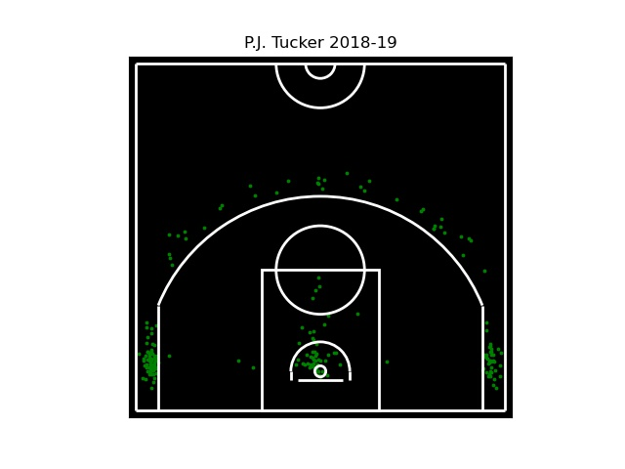

To determine this, I’ve looked at data from 2000-01 to 2019-20 and excluded players with less than 100 3PA in a season. For example, Darren Collison’s 2011-12 season (94 3PA) was omitted and his 2012-13 season (136 3PA) was included in the dataset. To crown a Corner 3 King, the following qualifiers were created:

* attempt a significant number of 3s (satisfied by the 100 3PA filter),
* attempt a significant number of corner 3s,
* shoot efficiently on corner 3s,
* satisfy the above requirements over multiple seasons.

The first qualifier filters out a significant portion of players and seasons but there are still 3,521 player seasons in the dataset. This includes duplicates of players; i.e. Antoine Walker’s 2001 (603 3PA) and 2002 (645 3PA) seasons account for 2 of the 3,521 entries.

To satisfy the second qualifier, we’ll look into the proportion of corner 3s attempted to total 3s attempted. Basketball-Reference captures this information as %3PA under the *Corner 3s* header in the *Shooting* table for an individual (<https://www.basketball-reference.com/players/w/walkean02.html#shooting::none>). Any player that attempted less than half of their 3s from the corner was excluded. Below is a histogram with quantities of player seasons by %3PA. Our king owns at least one of the 212 seasons to the right of the dashed line.

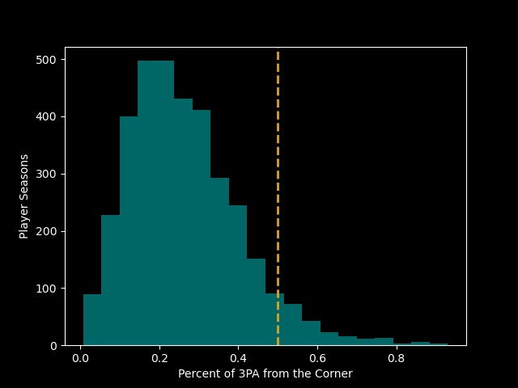

In the timeframe explored, the league average 3P% ranged from 34.7% to 36.7% (https://www.basketball-reference.com/leagues/NBA_stats_totals.html#stats). Looking for average shooters isn’t useful though—we are trying to crown a king. We will exclude any player seasons with a corner 3P% less than 40% (below the dashed line).

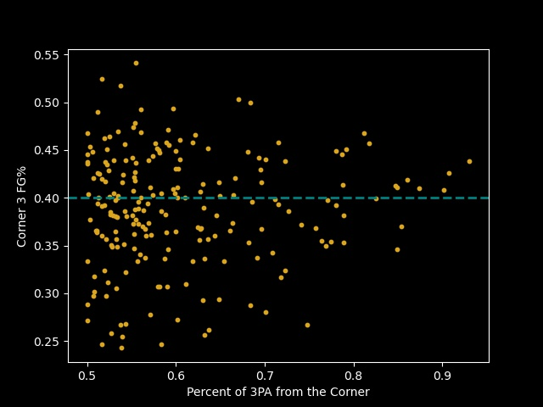

This gives us 98 seasons provided by 66 unique players. To further reduce the candidate pool, players who appear on the list only once were removed, yielding a workable 18 different players. And finally, here is a summary of that list, showing a player’s season with their most corner 3s and their best corner 3 FG% in a season:



For reference, plotted below are the above players highlighted along with the all players in the timeframe examined with at least 100 3PA. Any teal points in the upper right quadrant are players who satisfied the requirements for only a single season.

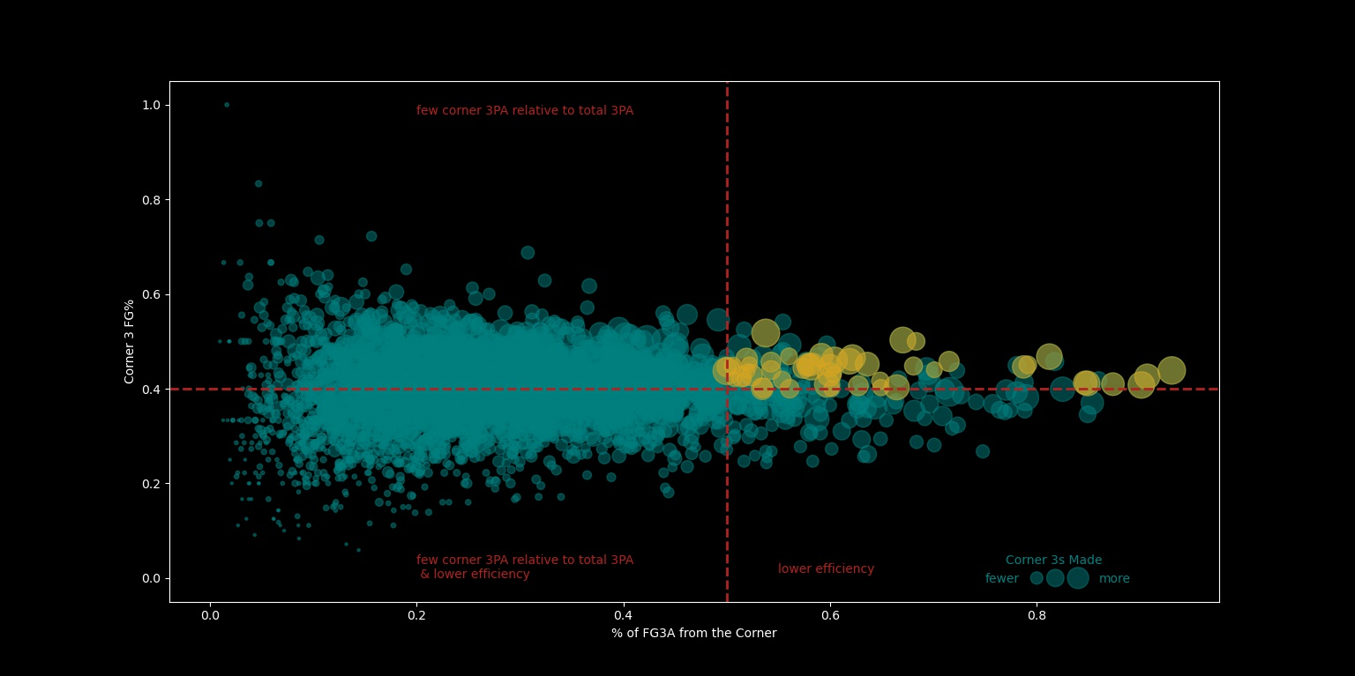

Sorting by each of corner 3s made, percent of 3PA from the corner, and corner 3 FG% yields the following lists:

**Corner 3s Made in a Season:**

1. Joe Johnson (103, 2004-05)
2. Bruce Bowen (100, 2005-06)
3. Morris Peterson (98, 2005-06)
4. Shane Battier (97, 2006-07)
5. Bruce Bowen (93, 2004-05)

**Percent of 3PA from the Corner in a Season:**

1. Bruce Bowen (93%, 2005-06)
2. Bruce Bowen (91%, 2007-08)
3. Bruce Bowen (90%, 2004-05)
4. P.J. Tucker (87%, 2013-14)
5. Bruce Bowen (85%, 2006-07)

**Corner 3 FG% in a Season:**

1. Joe Johnson (51.8%, 2004-05)
2. Anthony Parker (50.3%, 2006-07)
3. Richard Hamilton (50.0%, 2005-06)
4. Bobby Simmons (47.1%, 2008-09)
5. Richard Hamilton (46.8%, 2007-08)

We can remove any players that aren’t on these leaderboards. Because a winner is not immediately clear, looking at corner 3 statistics over each of these eight player’s careers, including seasons in which the above criteria wasn’t met, is the logical next step.



As controversial as it may be, I am crowning Bruce Bowen as the Corner 3 King, recognizing that Joe Johnson had the single best season in the corners in 2004-05 when he sank 103 at 52%. However, Johnson could do it from all over the court evidenced by the shot chart below. The corners were in no way, *his* kingdom. Battier also has a legitimate claim to the throne, but gets knocked for the same reason as Johnson. PJ Tucker could overtake Bowen with a couple more good seasons as well.

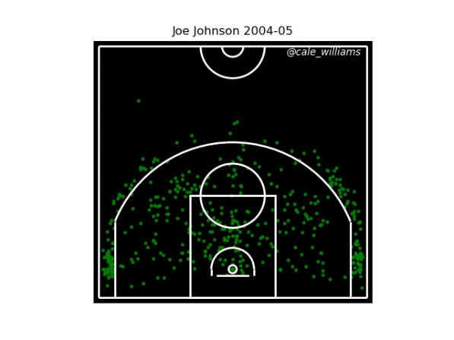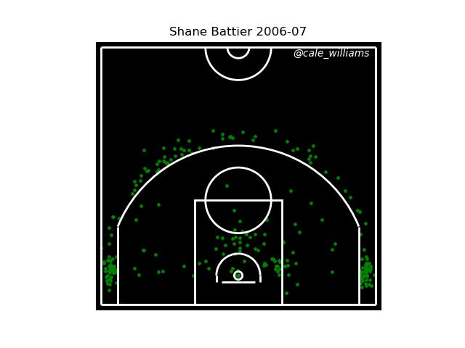

So with that being settled, here is the Corner 3 King’s career shot chart:

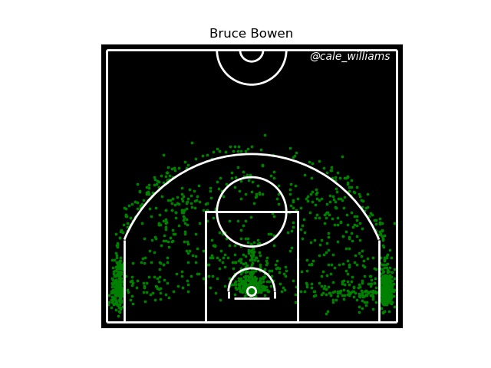

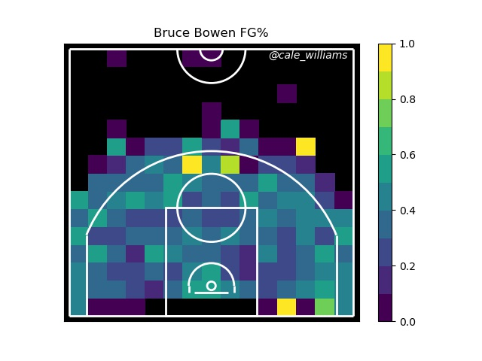

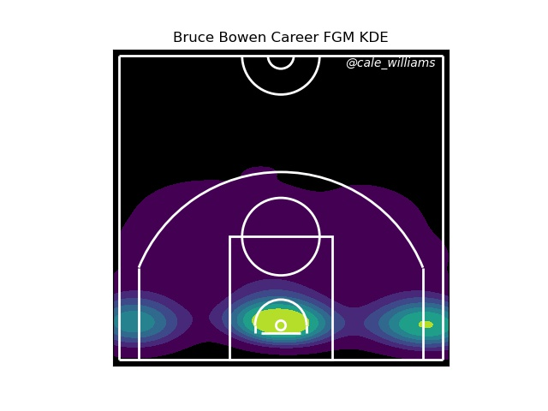

Data from NBA.com/Stats and Basketball-Reference.