In mid-January, the Spurs are 5-5 with their share of awful losses at the hands of the Jazz and Timberwolves but with dramatic wins against both Los Angeles squads. So far, it’s been a story of inconsistency that has manifested as a bland, unrevealing win-loss record. Digging deeper into the numbers behind the record, though, can provide some possibly valuable insight.

From the 1969-70 to the 2018-19 seasons, 240 teams have started with a 5-5 record. On average, those teams end the season with a 42-40 record. The best team to start 5-5 was the ’85 Lakers with 62 wins who went on to win the championship. The worst team to start 5-5 was the 2011 Cavaliers with a 19-63 record, including a losing streak of 26 games. Quite the range of teams there. Because win-loss record this early in the season doesn’t correlate well with a team’s final record, perhaps point differential would be more relevant.

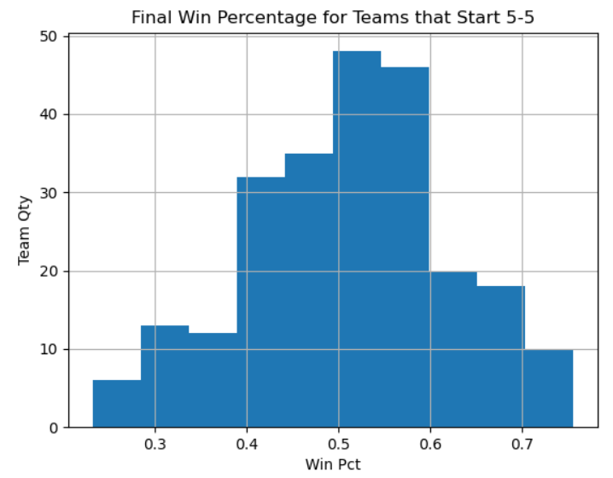

The Spurs have a point differential of -20, or -2 points per game. Of the 86 teams in the same timeframe used above that have a point differential similar to this squad (point differential within -15 and -25 through 10 games), the average final record is 37-45. The best team was the 57 win Mavs in 2002 and the worst was the 1994 Pistons with a record of 20-62. Still quite a spread, but using point differential instead of current record has narrowed the wins spread by 6 games.

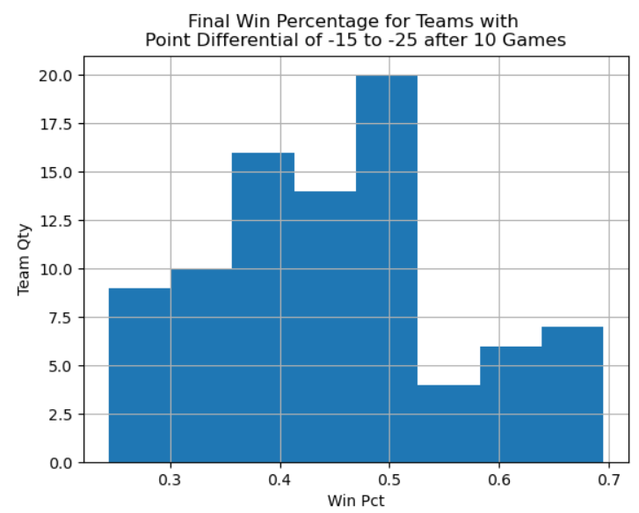

So is there any hope for the Spurs? Of course there is. Most importantly, the old adage “past performance is no guarantee of future results” is true here. That is evident in the large range of final outcomes. The season is only ten games old and due to injuries and personal reasons, the Spurs have missed at least one of LaMarcus Aldridge, DeMar DeRozan, and Derrick White for each. White has only played in one game, a loss against the Lakers, before injuring his toe and being sidelined for 4-6 weeks.

To err on the hopefully conservative side, this timeframe reinserts White into the lineup on February 22 against the Pacers. We will use win shares (an imperfect, but acceptable, metric) to estimate how White will change the success of the team upon return. Win shares are an estimate of a player’s contribution to the overall team’s success in terms of wins. Last season, White was credited with 4.2 win shares. Accounting for his missed games, if he has the same effect this season, we can assume he will add 3.2 wins. Obviously, the hope is that he will have improved in the offseason but injuries and a shortened offseason may prove that to be untrue. Simply adding that to the average wins by teams with similar records and point differentials through 10 games gives us estimates of 45 and 40 wins, respectively.

*Stats through 01/11/21. Stats per NBA.com/Stats & Basketball-Reference.com.*