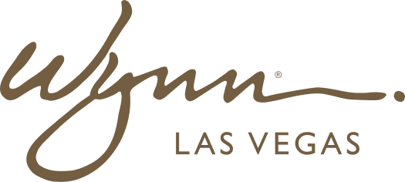 | WYNN RESORTS  Office of the CFO | Regulatory Compliance  INTERNAL USE ONLY

INTERNAL AUDIT REPORT
Regulatory Filing Calendar -- FY2025

Fiscal Year | 2025
Prepared By | Director of Tax & Compliance
Date | January 2025
Review Cycle | Quarterly

Regulatory Filing Obligations -- FY2025

Filing Type | Jurisdiction | Frequency | Next Due Date | Responsible Party | Status
SEC Form 10-K | Federal (SEC) | Annual | February 28 2025 | CFO / Controller | Filed
SEC Form 10-Q (Q1) | Federal (SEC) | Quarterly | May 12 2025 | CFO / Controller | Pending
SEC Form 10-Q (Q2) | Federal (SEC) | Quarterly | August 11 2025 | CFO / Controller | Pending
SEC Form 10-Q (Q3) | Federal (SEC) | Quarterly | November 10 2025 | CFO / Controller | Pending
Nevada Gaming Tax Return | Nevada Gaming Control Board | Monthly | 20th of each month | Dir. Tax | Current
Massachusetts Gaming Tax | Massachusetts Gaming Commission | Monthly | 20th of each month | Dir. Tax | Current
AML Suspicious Activity Report | FinCEN | As required (30-day trigger) | Rolling | Chief Compliance Officer | Current
Currency Transaction Report | FinCEN | Daily as required | Rolling | Casino Finance | Current
Nevada Modified Business Tax | Nevada Dept. of Taxation | Quarterly | April 30 2025 | Dir. Tax | Pending
Federal Corporate Income Tax Est. | IRS | Quarterly | April 15 2025 | VP Tax | Pending
Annual Report to Shareholders | SEC / NASDAQ | Annual | April 30 2025 | CFO / IR | In Preparation
Form 8-K Material Events | Federal (SEC) | As required | Rolling | CFO / Legal | Current

