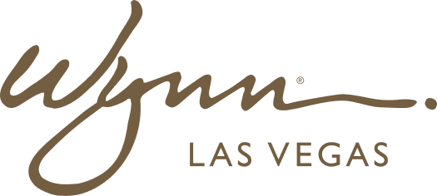 | WYNN RESORTS  Office of the CFO | Investor Relations  STRICTLY CONFIDENTIAL

INTERNAL AUDIT REPORT
Investor Relations Q&A Response Log -- FY2024 Earnings Cycle

Earnings Date | February 2025
Prepared By | VP Investor Relations
Status | Approved by CFO and Legal

Approved Q&A Response Register

Category | Question | Approved Response | Sensitivity
Guidance | Why is FY2025 guidance range so wide? | Reflects uncertainty in baccarat hold normalization and H2 convention demand. Will tighten at Q1 earnings. | Medium
Baccarat Hold | How much of FY2024 upside was hold-driven? | ~$68M of the $100M revenue beat was hold-rate driven. Underlying volume grew 4.1% YoY. | High
Leverage | When do you reach 3.0x target? | Expect 3.0x net debt/EBITDA by end FY2025 assuming base case EBITDA. | Medium
Capital Return | Will you resume buybacks in 2025? | Board reviews capital return policy annually. Priority is deleveraging to 3.0x. | High
Boston | Boston growth was only 2.1% -- path to acceleration? | Boston reflects a maturing market. Focus is F&B and hotel revenue growth. | Medium
AML | Has AML remediation from 2023 Nevada examination been completed? | All findings remediated and independently validated. No outstanding matters with Nevada Gaming Control Board. | High
Competition | How are you responding to new Strip resort openings? | We compete on quality, not price. NPS of 74 in FY2024 is the highest in our history. | Low
M&A | Are you evaluating acquisitions? | We do not comment on M&A speculation. | High
ESG | Progress on sustainability targets? | Reduced carbon intensity 8.4% in FY2024, on track for 2030 targets. Full sustainability report publishes in April. | Low
Macro | How does a recession affect your numbers? | We do not provide recession scenario guidance publicly. Refer investors to sensitivity analysis in investor day materials. | High
Liquidity | What is your minimum cash threshold? | We target minimum liquidity of $1.0B across the enterprise. We ended FY2024 at $1.87B, well above that threshold. | Medium
Labor | Are labor savings sustainable? | Approximately $18M of the $24M FY2024 savings are structural from Workday. $6M reflected H1 vacancies now filled. | Medium

