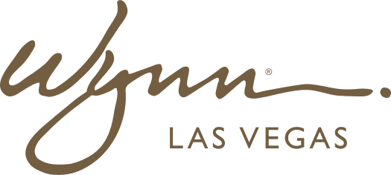 | WYNN RESORTS  Office of the CFO  INTERNAL USE ONLY

INTERNAL AUDIT REPORT
CFO Communication Standards and Style Guide

Version | 1.4
Owner | CFO
Effective | September 2024

Approved Terminology

Use This | Instead Of | Rationale
Net revenue | Revenue (unqualified) | Wynn reports net of promotional allowances
Adjusted EBITDA | EBITDA (unqualified) | Excludes pre-opening costs and stock compensation
Hold rate normalization | Hold rate headwind | Neutral framing for analyst audiences
Capital returns program | Dividends or buybacks | Preserve optionality in language
Regulatory examination | Audit | Examinations are regulatory; audits are financial

Messaging Hierarchy by Audience

- Board of Directors: Emphasis on risk, capital stewardship, long-term value; numerical precision required; no rounding above $1M
- Institutional Investors / Analysts: Emphasis on earnings quality, free cash flow, leverage trajectory; forward-looking statements require IR/Legal pre-clearance
- Retail Investors: Plain English, no jargon; emphasize stability and brand strength
- All-Hands / Employees: Emphasize team achievement; avoid specific financial figures not already public
- Media: Refer all financial queries to IR; approved statements vetted by Legal and IR before distribution
Key Messages FY2025

- Wynn delivered record revenue and EBITDA in FY2024 on the strength of our brand and team
- We are deleveraging toward 3.0x target while investing in property improvements our guests and regulatory obligations require
- FY2025 guidance reflects confidence in durability of Las Vegas demand and operational discipline
Things to Avoid

- Never reference specific competitor financials or guidance in any external communication
- Never confirm, deny, or speculate about M&A activity in any forum
- Never provide guidance outside of earnings calls or approved investor day materials
- Never reference pending regulatory or legal matters beyond what is disclosed in SEC filings

