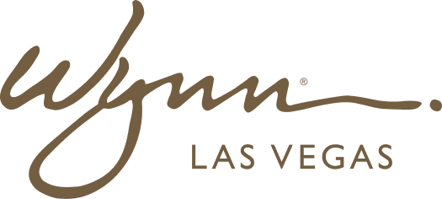 | WYNN RESORTS  Office of the CFO | Treasury & Risk  STRICTLY CONFIDENTIAL

INTERNAL AUDIT REPORT
Insurance Program Summary -- FY2025

Policy Year | 2025
Broker | Marsh McLennan
Total Annual Premium | $18.4M
Date | January 2025

Insurance Coverage Schedule

Coverage Type | Carrier | Limit | Deductible | Annual Premium | Renewal Date
Property (All Risk) | AIG / Swiss Re (consortium) | $2.1B per occurrence | $2.5M | $6,840,000 | Jan 1 2026
General Liability | Zurich Insurance | $100M per occurrence | $500K | $1,420,000 | Jan 1 2026
Directors & Officers (D&O) | Berkshire Hathaway Specialty | $150M aggregate | $5M | $3,210,000 | Jan 1 2026
Cyber Liability | Beazley / Lloyd's Syndicate | $50M aggregate | $1M | $2,180,000 | Jan 1 2026
Crime / Fidelity | Chubb | $25M per loss | $250K | $840,000 | Jan 1 2026
Workers Compensation | Liberty Mutual | Statutory | $500K retention | $1,920,000 | Jan 1 2026
Umbrella / Excess Liability | Travelers | $200M excess of $100M primary | $0 | $980,000 | Jan 1 2026
Employment Practices Liability | Hartford | $25M aggregate | $1M | $640,000 | Jan 1 2026
Liquor Liability | Markel | $10M per occurrence | $250K | $280,000 | Jan 1 2026
Aviation (charter fleet) | Global Aerospace | $500M per occurrence | $100K | $90,000 | Jan 1 2026

