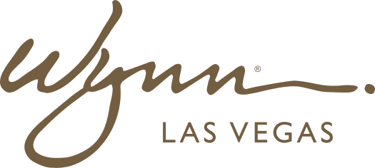 | WYNN RESORTS  Office of the CFO | Financial Planning & Analysis  STRICTLY CONFIDENTIAL

INTERNAL AUDIT REPORT
FY2025 Scenario Planning and Sensitivity Analysis

Base Case Date | January 2025
Model Owner | VP FP&A
Scenarios | 3 (Bear / Base / Bull)
Model Tool | Anaplan

Scenario Financial Summary

Metric | Bear Case | Base Case | Bull Case
Net Revenue ($M) | 2,187 | 2,395 | 2,542
YoY Revenue Growth | (5.3%) | +3.7% | +10.0%
EBITDA ($M) | 641 | 757 | 842
EBITDA Margin | 29.3% | 31.6% | 33.1%
Free Cash Flow ($M) | 187 | 342 | 478
Net Debt / EBITDA | 3.8x | 3.2x | 2.7x
DSCR | 1.42x | 1.78x | 2.14x
Covenant Threshold (DSCR) | 1.25x minimum | 1.25x minimum | 1.25x minimum

Key Assumptions by Scenario

- Bear Case: Baccarat hold reverts to 13.5%; US consumer confidence falls 12 points; RevPAR flat YoY; energy costs +8% vs budget
- Base Case: Baccarat hold 15.0%; Las Vegas RevPAR growth 3.2%; Boston RevPAR flat; two new F&B concepts contribute from Q3
- Bull Case: Baccarat hold 16.5%; convention business reaches record high; both properties achieve +5% ADR vs budget; slot handle +6% from floor modernization
Financial Implications & Triggers

- Bear Case DSCR of 1.42x remains above 1.25x covenant minimum; however 200bps further deterioration would trigger covenant breach requiring lender notification
- If Q1 2025 actuals track 8% or more below Bear Case revenue, CFO will convene emergency review of discretionary CAPEX
- Bull Case free cash flow of $478M would enable $200M additional debt reduction and potential resumption of capital returns program at Q3 Board meeting

