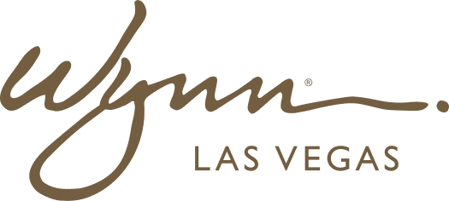 | WYNN RESORTS  Office of the COO | Project Management  INTERNAL USE ONLY

INTERNAL AUDIT REPORT
RACI Matrix: New Fine Dining Outlet Launch -- Wynn Las Vegas

Project | Lakeside Kitchen Launch
Target Open Date | June 2025
Project Sponsor | COO

RACI Matrix -- Lakeside Kitchen Launch

Activity | COO | VP F&B | VP Marketing | VP HR | VP Facilities | VP Legal | VP Finance
Concept approval | A | R | C | I | I | I | C
Menu development | I | R | C | I | I | I | I
Staffing plan and recruitment | A | C | I | R | I | C | C
Marketing campaign development | I | C | R | I | I | C | C
Construction and fit-out | A | C | I | I | R | I | C
Health department approval | A | C | I | I | C | R | I
Liquor license application | A | I | I | I | I | R | I
IT systems setup (POS, reservations) | I | C | I | I | C | I | R
Staff training program | I | R | I | R | I | I | I
Soft opening event planning | A | R | R | C | C | I | C
Media and PR launch | I | C | A/R | I | I | C | I
Budget tracking | A | C | C | C | C | I | R
Post-launch performance review | A | R | C | C | I | I | C
Guest feedback collection | I | R | C | I | I | I | I
Regulatory compliance sign-off | A | I | I | I | C | R | I
Vendor contract execution | C | R | I | I | C | A | C
Pricing strategy | A | R | C | I | I | I | C
Reservation system launch | I | R | C | I | I | I | I
Supply chain setup | I | R | I | I | C | C | C
Six-month business review | A | R | C | C | I | I | R

