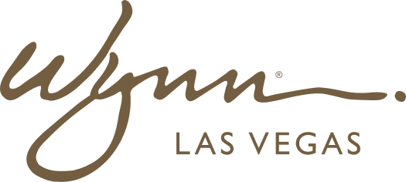 | WYNN RESORTS  Office of the COO | Operations  INTERNAL USE ONLY

INTERNAL AUDIT REPORT
Interdepartmental Service Level Agreement: IT Services to Operations

Agreement Parties | IT Department / Hotel Operations
Version | 2.1
Effective | January 2025
Review | January 2026

Service Level Agreement -- IT Services to Operations

Service | Tier | Response SLA | Resolution SLA | Measurement Method | Escalation Point
Opera PMS outage | P1 Critical | 15 minutes | 4 hours | ServiceNow auto-ticket | CTO + COO immediately
Point of sale system failure | P1 Critical | 15 minutes | 4 hours | ServiceNow auto-ticket | CTO + VP F&B immediately
Slot management system (IGT Advantage) failure | P1 Critical | 15 minutes | 2 hours | Automated monitoring alert | CTO + VP Casino Ops immediately
Casino surveillance system degradation | P1 Critical | 15 minutes | 2 hours | Automated monitoring alert | CTO + Security Director
Guest WiFi outage (public areas) | P2 High | 1 hour | 8 hours | ServiceNow ticket | Dir. IT Ops
Hotel key card system failure | P2 High | 30 minutes | 4 hours | ServiceNow ticket | Dir. IT Ops + Front Office Mgr
Concierge tablet/device failure | P3 Medium | 4 hours | 24 hours | ServiceNow ticket | IT Service Desk
ServiceNow service request delays | P3 Medium | 4 hours | 24 hours | ServiceNow reporting | IT Service Desk Mgr
Back-office reporting tools | P4 Low | 8 hours | 72 hours | Email ticket | IT Service Desk
Non-critical hardware replacement | P4 Low | 24 hours | 5 business days | ServiceNow ticket | IT Service Desk

