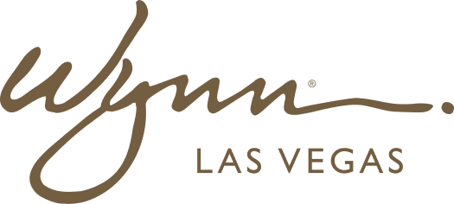 | WYNN RESORTS  Office of the COO  INTERNAL USE ONLY

INTERNAL AUDIT REPORT
COO Executive Scorecard -- February 2025

Period | February 2025
Prepared By | Director of Operations Analytics
Distribution | COO, Department VPs

COO Executive Scorecard -- February 2025

KPI | Category | Owner | Target | Actual | RAG Status | Trend
NPS Score | Guest Experience | VP Hotel Ops | 74 | 72 | Amber | Stable
VIP Check-In Wait Time (min) | Guest Experience | VP Hotel Ops | Less than 3 | 3.8 | Red | Improving
Amenity Delivery Accuracy (%) | Guest Experience | Dir. Concierge | 97% | 93.1% | Red | Stable
Guest Complaint Resolution (hrs) | Guest Experience | Duty Mgr | Less than 2 | 2.9 | Amber | Deteriorating
Hotel RevPAR ($) | Financial | VP Hotel Ops | $598 | $611 | Green | Improving
F&B Revenue per Cover ($) | Financial | VP F&B | $72 | $76 | Green | Stable
Casino Floor Cleanliness Score | Operations | Dir. Housekeeping | Greater than 90% | 88.4% | Amber | Stable
Room Readiness On-Time (%) | Operations | Dir. Housekeeping | 98% | 95.1% | Amber | Improving
F&B Order-to-Delivery (min) | Operations | VP F&B | Less than 18 | 20.2 | Red | Improving
Table Game Downtime (min/day) | Operations | VP Casino Ops | Less than 10 | 7.4 | Green | Stable
Staff Absenteeism (%) | People | VP HR | Less than 3.5% | 4.1% | Red | Stable
Open Roles (# unfilled) | People | VP HR | Less than 25 | 38 | Red | Deteriorating
eNPS Score | People | VP HR | Greater than 25 | 22 | Amber | Improving
Incident Reports per 1000 Guests | Safety | Dir. Security | Less than 2.0 | 2.3 | Amber | Stable
Energy Consumption (MWh/guest night) | Sustainability | Dir. Facilities | Less than 12.4 | 12.1 | Green | Improving
Water Usage (gallons/guest night) | Sustainability | Dir. Facilities | Less than 84 | 82.7 | Green | Stable
Vendor SLA Compliance (%) | Procurement | Dir. Procurement | Greater than 95% | 93.2% | Amber | Stable
Preventive Maintenance Completion (%) | Facilities | Dir. Facilities | Greater than 98% | 96.4% | Amber | Improving
Food Safety Audit Score | F&B Compliance | VP F&B | Greater than 95% | 97.2% | Green | Stable
Training Completion Rate (%) | People | VP HR | Greater than 90% | 86.3% | Amber | Improving

