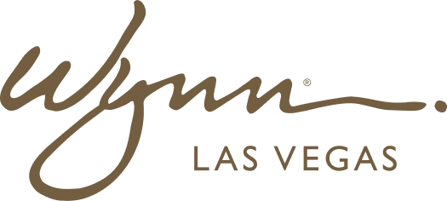 | WYNN RESORTS  Office of the COO | Procurement  STRICTLY CONFIDENTIAL

INTERNAL AUDIT REPORT
Strategic Vendor Performance Scorecard -- Q4 2024

Quarter | Q4 2024
Prepared By | Director of Procurement
Review Meeting | January 15 2025

Vendor Performance Scorecard -- Q4 2024

Vendor | Category | Tier | Quality Score | On-Time Delivery | Contract Compliance | Issue Count | Overall Rating
Sysco Corporation | Food & Beverage | Strategic | 87/100 | 94.2% | 98.1% | 2 | Good
US Foods | Food & Beverage | Strategic | 84/100 | 91.7% | 97.4% | 3 | Good
Aramark Uniform Services | Uniforms / Laundry | Preferred | 91/100 | 96.3% | 99.2% | 1 | Excellent
Johnson Controls | HVAC Maintenance | Strategic | 79/100 | 88.4% | 94.7% | 6 | Needs Improvement
Cintas Corporation | Linens & Towels | Preferred | 93/100 | 97.1% | 99.6% | 0 | Excellent
Otis Elevator Company | Elevator Maintenance | Preferred | 88/100 | 92.8% | 97.3% | 2 | Good
Ecolab | Cleaning & Sanitation | Strategic | 95/100 | 98.4% | 99.8% | 0 | Excellent
AVI-SPL | AV / Event Technology | Approved | 76/100 | 84.1% | 91.2% | 8 | Poor
Primo Water Solutions | Bottled Water / Dispensing | Approved | 89/100 | 95.7% | 98.4% | 1 | Good
Interior Logic Group | FF&E Procurement | Preferred | 82/100 | 87.3% | 93.6% | 4 | Needs Improvement
Trane Technologies | Refrigeration Systems | Preferred | 90/100 | 94.6% | 98.7% | 1 | Good
ADT Commercial | Security Systems | Strategic | 86/100 | 96.1% | 99.1% | 2 | Good
Nespresso Professional | Coffee Systems (F&B) | Approved | 94/100 | 99.2% | 100% | 0 | Excellent
Carrier Global | Fire & Safety Systems | Strategic | 88/100 | 95.4% | 98.2% | 2 | Good
ASSA ABLOY | Door Hardware & Access | Preferred | 92/100 | 97.8% | 99.4% | 1 | Excellent

