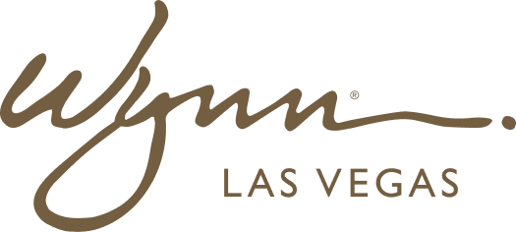 | WYNN RESORTS  Office of the COO | Procurement & Legal  STRICTLY CONFIDENTIAL

INTERNAL AUDIT REPORT
Critical Vendor Contract Register -- Active Agreements

As Of | March 2025
Prepared By | VP Procurement
Total Annual Spend Under Contract | $47.2M

Critical Vendor Contract Register

Vendor | Category | Annual Value | Contract Start | Contract End | Auto-Renew? | Key Terms | Risk Tier
Sysco Corporation | Food & Beverage | $8.4M | Jan 2024 | Dec 2025 | Yes (90-day notice) | Pricing locked through Q2 2025; CPI adjustment H2 2025 | High
US Foods | Food & Beverage | $6.1M | Jan 2023 | Dec 2025 | Yes (60-day notice) | Volume rebate of 2.1% above $5M threshold | High
Johnson Controls | HVAC Maintenance | $3.2M | Mar 2022 | Feb 2027 | No | SLA: 4-hour response for P1 HVAC events; 8 preventive maintenance visits/year | Critical
Aramark Uniform Services | Uniforms / Laundry | $2.8M | Jul 2023 | Jun 2026 | Yes (90-day notice) | Custom uniform program; 5-day turnaround SLA | Medium
Ecolab | Cleaning & Sanitation | $1.9M | Jan 2024 | Dec 2026 | No | Price locked for full contract term; annual audit rights | Medium
AVI-SPL | AV / Event Technology | $4.7M | Jan 2023 | Dec 2025 | Yes (60-day notice) | Event support SLA: 2-hour on-site response; RENEW OR REPLACE decision needed Q3 2025 | High
Trane Technologies | Refrigeration Systems | $2.1M | Sep 2021 | Aug 2025 | No | Critical: Contract expires Aug 2025; successor contract negotiation in progress | Critical
ADT Commercial | Security Systems | $3.4M | Jan 2024 | Dec 2028 | No | 5-year term; annual performance reviews; termination for cause with 90-day notice | Low
Interior Logic Group | FF&E Procurement | $6.8M | Mar 2024 | Feb 2027 | No | Project-based; master agreement with call-off orders; NTE limits per project | Medium
Cintas Corporation | Linens & Towels | $2.3M | Jan 2024 | Dec 2026 | Yes (90-day notice) | Quality SLA: 0.5% defect rate maximum; replacement within 24 hours | Low
Carrier Global | Fire & Safety Systems | $1.8M | Jan 2023 | Dec 2025 | No | Regulatory compliance requirement; must renew before Dec 31 2025 | Critical
Otis Elevator Company | Elevator Maintenance | $3.7M | Jun 2022 | May 2027 | No | 48 elevators across both properties; 2-hour response SLA; annual code compliance | Low

