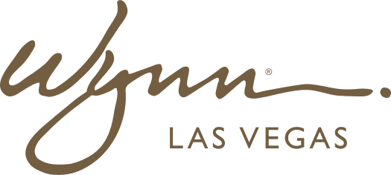 | WYNN RESORTS  Office of the COO | Human Resources  STRICTLY CONFIDENTIAL

INTERNAL AUDIT REPORT
Employee Engagement Survey -- FY2024 Results

Survey Date | November 2024
Participation Rate | 74%
Administered By | Gallup
Total Respondents | 3,847

Engagement Survey Results by Dimension

Dimension | Score (%) | Benchmark | Gap | YoY Change
Overall Engagement | 64% | 72% (hospitality sector) | (8pp) | (2pp)
I know what is expected of me at work | 78% | 82% | (4pp) | +1pp
I have the materials and equipment I need | 71% | 76% | (5pp) | (1pp)
My manager cares about me as a person | 69% | 74% | (5pp) | +2pp
I have had development opportunities this year | 51% | 63% | (12pp) | (4pp)
My opinions seem to count at work | 54% | 61% | (7pp) | (3pp)
I would recommend this company as a great place to work | 62% | 71% | (9pp) | (2pp)
I see myself working here in 2 years | 58% | 67% | (9pp) | (4pp)
Senior leadership communicates a clear direction | 61% | 69% | (8pp) | (1pp)
I am recognized for doing good work | 63% | 70% | (7pp) | (1pp)

Top 3 Themes Requiring Action

- Development & Growth (51% score, -12pp vs benchmark): Team members, especially in F&B and Housekeeping, report feeling stuck with no clear career path. Only 28% of frontline staff participated in any formal training in FY2024. Immediate action required: structured development pathway and quarterly career conversations with all team members
- Retention Intent (58% score, -9pp vs benchmark, -4pp YoY): Declining retention intent directly correlates with absenteeism increases. Exit interview data shows 64% of voluntary resignations cited lack of growth opportunity as primary reason. Urgent retention interventions required for high performers
- Voice and Influence (54% score, -7pp vs benchmark): Team members do not feel their input shapes decisions. 71% of respondents reported that suggestions submitted through the suggestion box were never acknowledged. Implement a structured idea-to-action pipeline and close-the-loop communications

