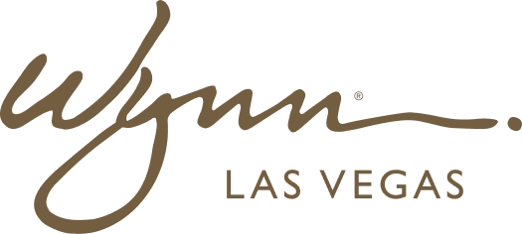 | WYNN RESORTS  Office of the COO | Organizational Excellence  INTERNAL USE ONLY

INTERNAL AUDIT REPORT
Change Management Playbook -- Standard Approach

Version | 2.0
Owner | COO
Effective | January 2025

Phase 1: Change Readiness Assessment

Before any change initiative is approved for execution, a structured change readiness assessment must be completed. The assessment covers: organizational capacity (is the team able to absorb another change given concurrent initiatives?), leadership alignment (do all affected department leaders support the change?), historical change success rate (what is the track record of similar change types?), and frontline readiness (are the people most affected ready and able to change?). The assessment is scored and any initiative scoring below 60% readiness requires a change readiness plan to be developed and approved before proceeding.
Phase 2: Stakeholder Mapping

Stakeholder Group | Influence Level | Support Level | Change Impact | Engagement Strategy | Owner
Executive Sponsors | High | Must be High | Low | Monthly briefings; direct input on key decisions | COO
Department VPs (affected) | High | Varies | High | Bi-weekly working sessions; named as change champions | COO
Frontline Supervisors | Medium | Varies | High | Weekly team huddles; early involvement in design | Dept VP
Frontline Team Members | Low-Medium | Varies | High | Town halls; feedback channels; training | Dept VP + HR
Union Representatives (if applicable) | High | Must engage early | High | Joint planning sessions; transparent communication | VP HR
IT Department | Medium | High | Medium | Technical working group membership | CTO

Phase 3: Communication Planning

- Lead with why, not what: All change communications must start with the business rationale and personal impact, not the mechanics of the change
- Cascade model: COO to VPs to Supervisors to Frontline; each level must receive communications 48 hours before the next level
- Channel mix: Town hall (launch), team huddle (weekly), digital dashboard (ongoing status), FAQ document (always available)
- Two-way communication: Every communication should include a feedback channel; all feedback must be responded to within 5 business days
Phase 4: Training Framework

All change initiatives impacting frontline roles require a structured training program completed before go-live. Training must be role-specific, not generic. Minimum completion threshold is 90% of affected staff trained before launch. No change initiative may go live without VP sign-off confirming training completion rates. Post-training assessment required within 14 days of completion; pass mark of 75%.
Phase 5: Resistance Management

- Identify resistance hotspots during readiness assessment; do not wait for resistance to emerge organically
- Categorize resistance: rational (person has a valid objection that should change the design), emotional (person needs support and acknowledgment), political (person is protecting their interests)
- Rational resistance: modify the change design if valid
- Emotional resistance: provide additional support, coaching, and visible executive engagement
- Political resistance: escalate to COO for direct intervention if VP-level resistance is obstructing implementation
Phase 6: Reinforcement & Sustainment

- Define sustainment KPIs before launch: what does 90-day, 180-day, and 12-month success look like?
- Conduct 30-day adoption check: if adoption is below 70%, immediate course correction is required
- Celebrate early wins: identify 3-5 quick wins within first 30 days and communicate them broadly
- Integrate change into standard operating procedures and performance management within 90 days to prevent regression

