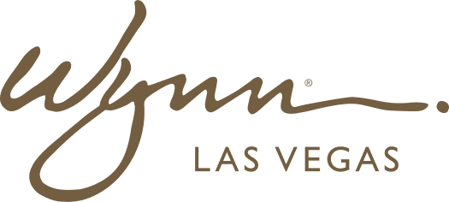 | WYNN RESORTS  Office of the CTO | Information Security  STRICTLY CONFIDENTIAL

INTERNAL AUDIT REPORT
Information Security Incident Log -- FY2024

Period | FY2024
Owner | CISO
Distribution | CTO, CEO, General Counsel, Board Risk Committee

Security Incident Log -- FY2024

Incident ID | Date | Classification | Affected Systems | Root Cause | Detection Method | Response Time | Business Impact | Lessons Learned
INC-2024-001 | Jan 14 2024 | Phishing / Credential Theft | Microsoft 365 (3 accounts) | Targeted spear phishing email bypassed ATP filters | User reported suspicious email | 2 hours to containment | No data exfiltration confirmed; accounts reset | ATP policies updated; DMARC enforcement improved
INC-2024-002 | Mar 8 2024 | Unauthorized Access Attempt | Oracle ERP (blocked at firewall) | Credential stuffing attack using leaked username list from third-party breach | Palo Alto NGFW blocked and alerted | 45 minutes to investigation close | No access gained; attack blocked | Password policy strengthened; MFA enrollment accelerated
INC-2024-003 | Apr 22 2024 | Malware Detection | 3 endpoint workstations (F&B department) | User downloaded infected PDF from vendor email (not Wynn email) | CrowdStrike Falcon detected and quarantined | 30 minutes to quarantine; 4 hours to full investigation | No lateral movement; devices reimaged | Vendor email security awareness training added to onboarding
INC-2024-004 | Jun 11 2024 | Data Loss Prevention Alert | SharePoint Online | Employee shared confidential payroll file externally via personal email | Microsoft 365 DLP policy triggered alert | 1 hour to investigation; file access revoked | No confirmed external data access; policy violation logged | SharePoint external sharing policies tightened; employee counseled
INC-2024-005 | Aug 3 2024 | Network Intrusion Attempt | Guest WiFi (isolated segment) | Bot scanner probing for open ports on guest network | Meraki IDS alerting | 20 minutes to block | No access to corporate network; guest network isolated per ADR-2024-003 | Zero-trust guest network isolation confirmed effective
INC-2024-006 | Sep 19 2024 | Vendor API Compromise (Third-Party) | Sysco vendor portal (external) | Sysco disclosed breach of their vendor portal; Wynn credentials potentially exposed | Sysco breach notification | 4 hours to credential rotation | Sysco portal access suspended; credentials rotated; no Wynn system access detected | Third-party risk assessment process strengthened; vendor MFA requirements being formalized
INC-2024-007 | Nov 4 2024 | Privileged Access Abuse | Oracle ERP -- GL module | IT contractor used admin account outside of approved change window | Oracle audit log review during post-change validation | 6 hours to detection; contractor access revoked immediately | No data modified; access log reviewed; no material impact | PAM solution evaluation initiated; all contractor access now monitored in real-time
INC-2024-008 | Dec 18 2024 | DDoS Attempt | Wynn.com public website | Volumetric DDoS attack targeting booking engine | Azure DDoS Protection auto-mitigation | Automatic -- no manual intervention required | Website experienced 4-minute degraded performance; booking engine unaffected | Azure DDoS Protection confirmed effective; runbook updated

