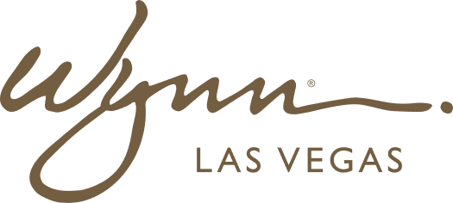 | WYNN RESORTS  Office of the CTO | Technology Strategy  STRICTLY CONFIDENTIAL

INTERNAL AUDIT REPORT
Technology Business Case: Next-Generation Loyalty Platform

Project | TECH-2025-008
Investment Required | $12.8M
Submitted By | VP Product Technology
Date | February 2025

Business Problem & Context

The current Wynn Loyalty Platform is a custom-built application developed in 2017 on PHP 5.6 (unsupported). It serves 1.4M active loyalty members and processes 847,000 point transactions per month. The platform has zero API integration with Salesforce CRM, no mobile app capability, and cannot support the personalization features required for the FY2026 digital guest experience strategy. Technical debt item TD-001 identifies this as a Critical priority. A decision is required in Q2 2025 to allow sufficient lead time for implementation before the current platform's end of support in Q4 2026.
Build / Buy / Partner Analysis

Option | Description | Pros | Cons | Estimated Cost | Timeline | Risk
Build (Internal) | Rebuild loyalty platform from scratch using Azure microservices + React Native mobile app | Full control; deep integration with Wynn systems; no vendor lock-in | 12-18 month timeline; requires 8+ senior engineers; historically our builds run over budget | $14.2M (5-year TCO) | 18 months | High -- see CAPEX-2023-011 precedent
Buy (Salesforce Loyalty Management) | Implement Salesforce Loyalty Management on existing Salesforce platform | Built on existing Salesforce investment; rapid deployment; strong mobile features | $4.1M additional annual license; limited casino-specific features; Salesforce roadmap dependency | $11.8M (5-year TCO) | 8 months | Medium -- integration with Opera PMS complex
Buy (Oracle CrowdTwist) | Implement Oracle CrowdTwist loyalty platform | Casino industry focus; Oracle integration; strong API layer | Additional Oracle licensing; Oracle roadmap uncertainty post-acquisition; $3.2M annual cost | $13.4M (5-year TCO) | 10 months | Medium
Partner (Custom SaaS) | Partner with Loyalty Juggernaut (hospitality-focused SaaS) | Hospitality expertise; fast time-to-value; modern mobile app included | Vendor dependency; less customization; $2.8M annual license | $12.8M (5-year TCO) | 6 months | Low-Medium -- vendor viability risk

Recommended Approach

The evaluation team recommends the Buy (Salesforce Loyalty Management) option. This recommendation reflects: (1) Wynn already has Salesforce as the primary CRM platform, eliminating the largest integration complexity; (2) the 8-month timeline is the second fastest and avoids the execution risk of a full internal build; (3) 5-year TCO of $11.8M is the second lowest; and (4) Salesforce's stability and roadmap investment significantly reduces vendor risk compared to Oracle CrowdTwist's uncertain post-acquisition trajectory. The Loyalty Juggernaut partner option remains viable as a contingency if Salesforce Loyalty Management fails to meet the casino-specific requirements in the proof of concept phase.
Financial Model

Cost / Benefit Item | Year 1 | Year 2 | Year 3 | Year 4 | Year 5
Implementation Cost ($M) | 7.4 | --- | --- | --- | ---
Annual License ($M) | 4.1 | 4.1 | 4.1 | 4.1 | 4.1
Maintenance & Support ($M) | 0.6 | 0.6 | 0.6 | 0.6 | 0.6
Current Platform Cost Avoided ($M) | --- | 0.8 | 0.8 | 0.8 | 0.8
Incremental Loyalty Revenue ($M) | --- | 2.4 | 4.8 | 5.6 | 6.1
Net Annual Cash Impact ($M) | (12.1) | (1.5) | +0.9 | +1.7 | +2.2
Cumulative NPV ($M) | (12.1) | (13.4) | (12.8) | (11.4) | (9.4)

