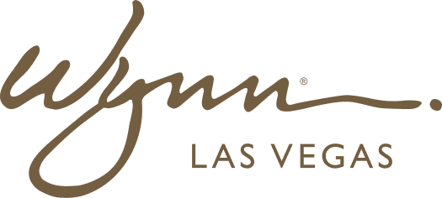 | WYNN RESORTS  Office of the CTO | Engineering  STRICTLY CONFIDENTIAL

INTERNAL AUDIT REPORT
Engineering Headcount Plan and Skills Gap Analysis -- FY2025

Planning Cycle | FY2025
Owner | VP Engineering
Date | January 2025

Engineering Headcount Plan and Skills Gap Analysis

Team | Current HC | Approved Adds | Priority Roles | Key Skills Needed | Gap Severity | Target Fill Date
Platform Engineering | 12 | 3 | Senior Platform Engineer (x2), DevOps Engineer | Kubernetes, Terraform, Azure DevOps, CI/CD pipeline design | High | Q2 2025
Data & Analytics | 8 | 2 | Senior Data Engineer, ML Engineer | Python, dbt, Azure Data Factory, Databricks, LLM fine-tuning | Critical | Q1 2025
Guest Technology (Mobile) | 6 | 2 | Senior iOS Engineer, React Native Engineer | Swift, React Native, push notification infrastructure | High | Q2 2025
Casino Technology | 9 | 1 | Senior Casino Systems Engineer | IGT Advantage API, casino protocol expertise, C# / .NET | Critical -- niche skills | Q3 2025
Cybersecurity | 5 | 2 | Security Engineer, Cloud Security Architect | SIEM, Sentinel, Defender for Cloud, CSPM, penetration testing | Critical | Q1 2025
Enterprise Applications | 11 | 1 | Salesforce Technical Architect | Apex, LWC, Salesforce Data Cloud, CPQ, integration patterns | High | Q2 2025
Network & Infrastructure | 7 | 0 | No additional headcount approved | Cisco Meraki, Palo Alto, Azure networking, SD-WAN | Medium | N/A
IT Service Desk | 14 | 1 | IT Support Specialist (Boston) | ITSM, ServiceNow, hardware support, casino tech familiarity | Low | Q1 2025

Critical Gaps Requiring Immediate Action

- Data & Analytics -- ML Engineer: Wynn has no in-house ML capability; personalization and revenue optimization initiatives in FY2025 plan require this skill immediately; recommend recruiting and using Toptal for interim capacity
- Casino Technology -- Senior Casino Systems Engineer: IGT Advantage expertise is extremely rare; only 4-6 qualified engineers in the Las Vegas market; compensation offer may need to exceed band by 15-20% to be competitive
- Cybersecurity -- Cloud Security Architect: Zero-trust ADR and NIST CSF remediation require this expertise; recommend using Deloitte Cyber retainer for 6 months while permanent hire is recruited

